

**Children at the Heart:**

**Understanding the experiences and needs of informal kinship carers across Tasmania**

***Executive Summary***

**November 2023**



**About Carers Tasmania**

Carers Tasmania is the Peak Body representing the more than 80,000 informal carers (hereafter carers) in the State.

Carers Tasmania’s vision is for an Australia that values and supports carers.

Our mission is to work to improve the health, wellbeing, resilience and financial security of carers and to ensure that caring is a shared responsibility of family, community, and government.

Our values drive everything we think, say, and do.

* **Carers first** – we listen to what carers need, commit to their desired action plan, and deliver results that matter most to carers
* **Care in all we do** – we care for our work, about each other, about Tasmania’s family and friend carers, and the bigger world we all share
* **Integrity always** – we are transparent, act ethically, own when things don’t go to plan and do what we say we will
* **Quality every time** – we don’t accept ‘good enough’ because carers deserve our very best every time
* **Speed that matters** – we are agile and don’t put off what can be done today.

These values represent how we engage with and serve carers, how we work with each other, and our commitment to the broader community. Carers Tasmania encourages partnership with governments and health and community sectors to enhance service provision and improve conditions for family or friend carers through policy development, research and advocacy.

We acknowledge and support people of all genders, sexualities, cultural beliefs, and abilities and understand that carers in Tasmania, whilst sharing the common theme of caring for a family member or friend, are diverse individuals with varying beliefs, experiences, and identities. We value and respect the diversity of carers, their lived and living experiences, and recognise that carers are the experts in their own lives.

Carers Tasmania has offices in Moonah, Launceston and Burnie.

Please direct any enquiries about this report to:

Samantha Fox

Chief Executive Officer Phone: (03) 6144 3700

Email: [ceo@carerstasmania.org](mailto:ceo@carerstasmania.org)

Contents

1. Background 4
2. Introduction 5
3. Formal and Informal Kinship Care 7
4. The health of informal kinship carers 8
5. The circumstances of children in informal kinship care 10
6. Difficulties associated with providing informal kinship care 11
7. The positive aspects of informal kinship care 12
8. Summary of Significant Findings 12
9. Recommendations 13

# Background

Carers Tasmania is the Peak Body representing the more than 80,000 informal carers within the state.

A carer is a person who provides unpaid care and support to a family member, or friend, with disability, mental ill health, a chronic or life-limiting condition, alcohol or other drug dependence, or who is frail or aged. Informal kinship carers who care for a child under the age of 18, because the parent is unable to, are also recognised as carers. Carers are predominantly family members, but may also be friends, neighbours, or colleagues. Informal carers are not to be confused with paid support workers who are often called ‘carers’, with the difference being that support workers are fully employed and remunerated with all the benefits of employment. On the contrary, informal carers perform their caring duties without remuneration, other than minimal carer payments and allowances from the Australian Government.

In addition to representing carers through the Peak Body activities, Carers Tasmania provides support to carers living in Tasmania through its service delivery arm, Care2Serve. The Commonwealth Carer Gateway program is delivered through Care2Serve in Tasmania, as are other supports and services, such as the Tasmanian Government’s Home and Community Care program.

The Carer Gateway program provides a range of services and supports for carers which are designed to build resilience, increase wellbeing, improve quality of life, and sustain carers to effectively continue their caring roles. The available supports include the provision of information, advice and referrals, holistic identification of carer strengths and needs through a carer support planning process, professional counselling, peer support, and coaching which aims to support carers in achieving specific goals.

Care2Serve, through the Carer Gateway, has capacity to fund certain instances of planned, practical support services such as in-home respite, personal care, domestic assistance, and meal preparation. Care2Serve may also fund items such as laptops to assist carers who are studying or trying to enter the workforce. Care2Serve also coordinates the provision of emergency support during instances where a carer may be unable to provide the care that they usually do, resulting from unexpected illness or injury of the carer.

# Introduction

A carer is a person who provides unpaid care and support to a family member, or friend, with disability, mental ill health, a chronic or life-limiting condition, alcohol, or other drug dependence, or who is frail or aged. Informal kinship carers who care for a child under the age of 18, because the parent is unable to, are also recognised as carers.

In June 2020, the Department of Communities Tasmania commissioned Mr Frank Ogle to undertake a review of informal kinship care in Tasmania. Mr Ogle provided the Review Report, sharing his findings with the Department of Communities Tasmania on 22 December 2020.

The Review included four items within its Terms of Reference:1

* 1. Recommend how an informal kinship care support and liaison service pilot program could operate; the preferred location for a pilot, and how a pilot program could better meet the needs of the relevant cohort;
  2. Examine the current funding to the Grandchildren Living with Grandparents Program that is administered through the Department of Communities Tasmania;
  3. Identify the options to extend existing Tasmania Government programs and subsidies to improve support to the cohort, including the effectiveness of the Grandchildren Living with Grandparents Program; and
  4. Align the components of the proposed services to the work being undertaken by the Foster and Kinship Carer’s Association of Tasmania.

The Informal Kinship Care Review Report delivered eight recommendations that were accepted by the Tasmanian Government with the intention of improving the support available for informal kinship carers:

1. Establish and pilot an Informal Kinship Care Support and Liaison Service.
2. Expand the eligibility of the Grandchildren Living with Grandparents Program.
3. Expand the availability of training and awareness-raising programs.
4. Improve the availability of information and resource material for informal kinship carers.
5. Review relevant Child Safety Service Client Files.
6. Examine policy options to improve support.
7. Consider changes to the *Children, Young Persons and Their Families Act 1997*.2
8. Continue national advocacy.3

In April 2023, the Tasmanian Carer Recognition Act was enacted. The carer definition within the Act includes informal kinship carers. The Tasmanian Government sought the advice of Carers Tasmania, as the peak body representing carers in the State, about the experiences and needs of informal kinship carers. The project aimed to identify and engage with informal kinship carers across Tasmania to understand their current experiences, alongside their service and support needs. The project commenced on 1 July 2023 and concluded on 30 September 2023.

1 Department of Communities Tasmania. (2021). *Informal Kinship Care Summary Review Report 2021*. https://publicdocumentcentre.education.tas.gov.au/library/Shared%20Documents/Informal-Kinship-Care- Summary-Review-Report.pdf

2 *Tasmanian Children, Young Persons and Their Families Act* (1997). https://[www.legislation.tas.gov.au/view/html/inforce/current/act-1997-028](http://www.legislation.tas.gov.au/view/html/inforce/current/act-1997-028)

3 Department of Communities Tasmania. (2021). *Informal Kinship Care Summary Review Report 2021*. https://publicdocumentcentre.education.tas.gov.au/library/Shared%20Documents/Informal-Kinship-Care- Summary-Review-Report.pdf

During the project, engagement sessions were held in nineteen locations across the State with about 25 informal kinship carers participating alongside employees from the various child and family centres and kinship groups.

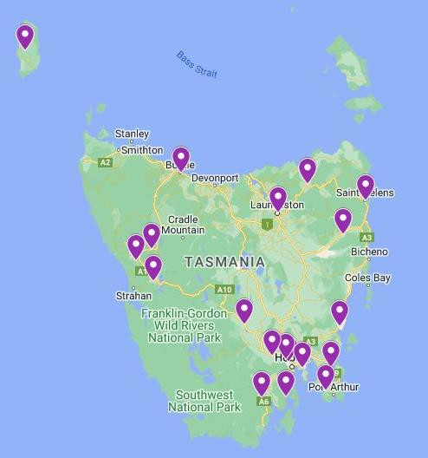

*Figure 1: Community discussion locations*

A survey was also circulated, with 52 current informal kinship carers responding. Respondents were predominantly aged between 35 and 54 years, identified as female, and spoke English at home. Many of those who responded reported having their own health concerns or disability. The consultation highlighted that many informal kinship carers are hidden or don’t realise they are an informal kinship carer. Of the informal kinship carers who responded to the survey, their subjective wellbeing, as measured using the Personal Wellbeing Index,4 was found to be significantly below average levels when compared to the wellbeing of the general population.

The community discussions and the survey were promoted to all public, private, and independent schools in Tasmania. They were also shared with Child and Family Centres, neighbourhood houses, local councils, community services stakeholders, informal kinship care programs and networks, via email and social media, and on community notice boards.

Carers Tasmania thanks and acknowledges the feedback and experiences shared by informal kinship carers across Tasmania throughout the duration of this project. We are privileged to be able to provide a voice for informal kinship carers. It is important to highlight that the experiences shared within this report are not statistically representative of all informal kinship carers in Tasmania, rather they represent the views and needs of the informal kinship carers we engaged with.

4 International Wellbeing Group (2013). *Personal Wellbeing Index:* 5th Edition. Melbourne: Australian Centre on Quality of Life, Deakin University <http://www.acqol.com.au/instruments#measures>

We also thank the numerous services and community groups who engaged with us as part of this project, helping us to connect with informal kinship carers and understand the services that are available within Tasmania.

# Formal and Informal Kinship Care

Informal kinship care is a form of care where a child or children live with a relative, such as a grandparent, without any court order or formal arrangement in place. The parents of the child remain the legal guardians, but the informal kinship carers take on the primary responsibility of raising the child. Informal kinship care is different from formal kinship care, which is supervised by the Child Safety Service and involves legal orders or agreements.5

The Australian Bureau of Statistics describes kinship care arrangements as *“families where there is a grandparent-grandchild relationship present, and no parent-child relationship present.”6* It is estimated that there are 1,548 grandparent families in Tasmania,7 and over 1,100 children in some form of kinship care, however, there is no solid and reliable data on the total amount of informal kinship carers in Tasmania.

Informal kinship carers often face various challenges, such as financial, legal, emotional, social, and health issues. They sometimes have difficulties accessing information and support services.

Children generally end up in the care of other family members either through court orders initiated by the Family or Magistrates Court or through informal arrangements in discussion with the parent and Child Safety Services. Sometimes children are abandoned by parents without discussion or agreement as to the care of the children. These scenarios can be difficult for both informal kinship carers and the children involved.

Whilst most kinship carers are grandparents or other parental figure relatives, kinship carers may also be young people. Kiraly et al., (2021) conducted research on young kinship carers aged between 16 and 30 who took on full-time care of other people’s children, while also at a critical stage in their own development. Kiraly et al reported:

“*The years from the late teens through the twenties are when young people in industrialised countries lay the foundations of their life trajectories through education, employment, and establishment of intimate relationships.”* 8

5 Department of Communities Tasmania. (2021). *Informal Kinship Care Summary Review Report 2021*. https://publicdocumentcentre.education.tas.gov.au/library/Shared%20Documents/Informal-Kinship-Care- Summary-Review-Report.pdf

6 Australian Bureau of Statistics. (2016) *Census Fact Sheets*: https://[www.abs.gov.au/websitedbs/censushome.nsf/home/factsheetsgp?opendocument&navpos=450](http://www.abs.gov.au/websitedbs/censushome.nsf/home/factsheetsgp?opendocument&navpos=450)

7 Australian Bureau of Statistics. (2021). *Census of Population and Housing: Household and families data summary, 2021*. Extracted from Table 4. Grandparent Families by State and Territory. Accessed 15 Sep 2023 [Household and families: Census, 2021 | Australian Bureau of Statistics (abs.gov.au)](https://www.abs.gov.au/statistics/people/people-and-communities/household-and-families-census/latest-release#data-downloads)

8 Kiraly, M., Hoadley, D. & Humphreys, C. (2021). The nature and prevalence of kinship care: Focus on young kinship carers. *Child & Family Social Work*, 26(1), pp. 144-152. doi:10.1111/cfs.12797

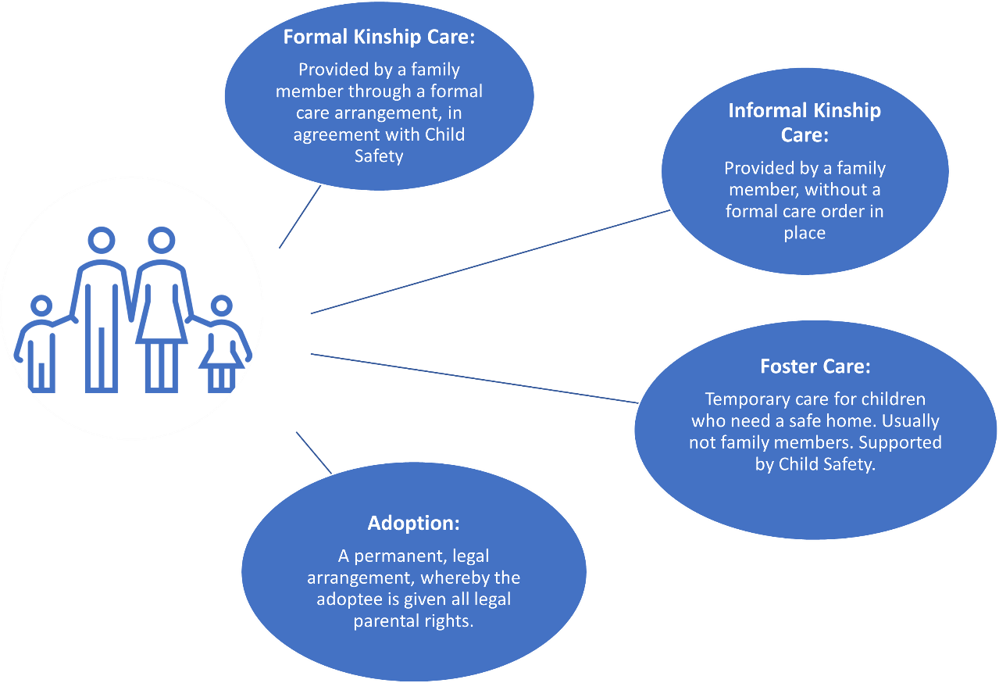

*Figure 2: Different forms of non-parental care*

# The health of informal kinship carers

The survey asked respondents to indicate if they had a disability or health concern of their own. Responses to this question indicated there were significant disability and health concerns experienced by informal kinship carers. This included chronic diseases such as heart disease, diabetes, and mental health conditions including bipolar disorder, anxiety, and depression. Figure 3 below outlines some of the common personal health conditions listed by informal kinship carers.

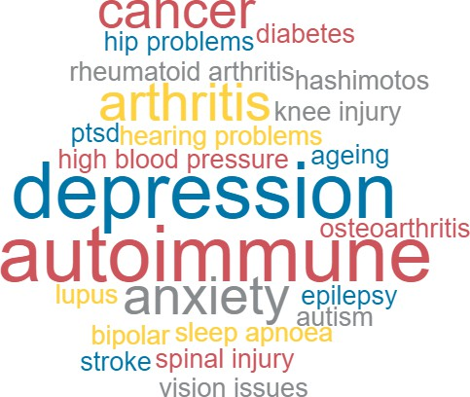

*Figure 3: Health concerns of informal kinship carers*

Carers Tasmania sought to understand the personal impacts of providing informal kinship care. The Personal Wellbeing Index – Adult (PWI-A 2013) was used to measure elements of informal kinship carer satisfaction with factors that have been found to influence wellbeing. The Personal Wellbeing Index comprises of the following domains and assesses how satisfied a person is with:

* Their life as a whole
* Their standard of living
* Their personal health
* What they are achieving in life
* Their personal relationships
* Their personal safety
* Their community connectedness
* Their future security.9

The Personal Wellbeing Index has also been used in other national surveys for carers to examine carer wellbeing.10, 11

Twenty-four respondents fully completed the Personal Wellbeing Index questions. As per Figure 4 below, the average satisfaction score reported by respondents for ‘life as a whole’ was 6 out of 10.

# of carers



9

8

7

6

5

4

3

2

1

0

Satisfaction with life as a whole

8

5

3

2

2

2

2

0

0

0

0

*Figure 4: Informal kinship carers’ satisfaction with life as a whole*

The average wellbeing score from the combined Personal Wellbeing Index questions was 67.7 out of 100 (67.7%). This score is below the normative wellbeing range for Australia, which is 70%. Scores within the range of 50% to 69% are regarded as indicating ‘compromised’ levels of wellbeing.12 These findings are consistent with findings of poor

9 International Wellbeing Group (2013). Personal Wellbeing Index: 5th Edition. Melbourne: Australian Centre on Quality of Life, Deakin University <http://www.acqol.com.au/instruments#measures>

10 Carers NSW. (2020). *National Carer Survey 2020 Summary Report.* https://[www.carersnsw.org.au/uploads/main/Files/5.About-us/Our-research/Summary_Report_HighRes.pdf](http://www.carersnsw.org.au/uploads/main/Files/5.About-us/Our-research/Summary_Report_HighRes.pdf) 11 Carers Australia. (2022). *Caring for Others and Yourself*. 2022 Carer Wellbeing Survey. https://[www.carersaustralia.com.au/wp-content/uploads/2022/10/2022-CWS-Full-Report_221010_FINAL.pdf](http://www.carersaustralia.com.au/wp-content/uploads/2022/10/2022-CWS-Full-Report_221010_FINAL.pdf)

12 International Wellbeing Group (2013). Personal Wellbeing Index: 5th Edition. Melbourne: Australian Centre on Quality of Life, Deakin University <http://www.acqol.com.au/instruments#measures>

wellbeing for carers more broadly.13,14 Figure 5 below shows the overall wellbeing score for each informal kinship carer who responded to all of the Personal Wellbeing Index questions.

Overall wellbeing score out of 100

100

90

80

70

60

50

40

30

20

10

0

92.9

95.7

92.9

95.7

82.9

87.1

82.9

75.7

80

81.4

58.658.6

60

54.3

60

80

68.668.6

62.9

42.9

45.7

40

32.9

24.3

Individual scores

*Figure 5: Overall personal wellbeing score*

Informal kinship carers were also asked about their ability to attend to their own needs such as taking care of their personal daily activities, taking time out to have fun with family and friends, treating themselves, receiving appropriate health care, feeling good about themselves, and feeling good about their financial future.

# The circumstances of children in informal kinship care

The Survey asked about the children who were being cared for through informal kinship care arrangements. Of the 33 respondents, 18 informal kinship carers had been caring for more than two years, with 27 of the children in kinship care younger than 10 years, and 23 children aged between 10 and 18 years.

The majority of survey respondents (57%) stated that the child or children they were providing informal kinship care to had additional care needs and/or a disability.

The disabilities, health concerns, and additional needs specified included:

* Neurodiversity such as Autism and Attention Deficit Hyperactivity Disorder
* Oppositional Defiant Disorder
* Acute Myeloid Leukaemia
* Acquired Brain Injury
* Celiac Disease
* Global Developmental Delay
* Foetal Alcohol Spectrum Disorders
* Trauma, and/or Post Traumatic Stress Disorder
* Mood disorders
* Poliomyelitis

13 Carers NSW. (2020). *National Carer Survey 2020 Summary Report.* https://[www.carersnsw.org.au/uploads/main/Files/5.About-us/Our-research/Summary_Report_HighRes.pdf](http://www.carersnsw.org.au/uploads/main/Files/5.About-us/Our-research/Summary_Report_HighRes.pdf) 14 Carers Australia. (2022). *Caring for Others and Yourself*. 2022 Carer Wellbeing Survey. https://[www.carersaustralia.com.au/wp-content/uploads/2022/10/2022-CWS-Full-Report_221010_FINAL.pdf](http://www.carersaustralia.com.au/wp-content/uploads/2022/10/2022-CWS-Full-Report_221010_FINAL.pdf)

* Visual impairment
* Crohn's Disease.

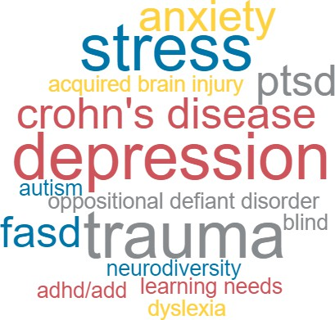

*Figure 6: Additional needs of children in informal kinship care*

The Survey asked respondents to provide further detail on the reasons they were providing informal kinship care. Alcohol and other drug dependence, along with mental ill health were the most prevalent responses. Other reasons included that the birth parents were not able to provide the care needed due to incarceration, prostitution, abandonment, or domestic violence, and in some instances, a parent had died. There were also circumstances highlighting that parental separation had negatively impacted the financial, practical, and emotional capacity to properly care for the child.

# Difficulties associated with providing informal kinship care

Several informal kinship carers had experienced difficulties when liaising with government services (e.g., Service Tasmania, Public Housing, Child Safety, and Services Australia.) They also described difficulties with school enrolment processes and providing consent for excursions. It was also reported that there was little to no known support available to assist children with their trauma.

Informal kinship carers described significant difficulties associated with Child Safety Services, financial hardship, and being ignored due to not having guardianship or being recognised as an informal kinship carer. We note that Recommendation 9.17 in the Tasmanian Commission of Inquiry Report outlines significant proposals such as changing the structure, quality, and practices of Child Safety Services, the Strong Families, Safe Kids Advice and Referral Line, and Out of Home Care.15

There was a limited understanding about support for kinship carers outside of organisations such as Grandparents Raising Grandchildren, Kin Raising Kids, and the Foster and Kinship Carers Association of Tasmania.

15 Commission of Inquiry. (2023). *Commission of Inquiry into the Tasmanian Government’s Responses to Child Sexual Abuse*. https://[www.commissionofinquiry.tas.gov.au/](http://www.commissionofinquiry.tas.gov.au/) data/assets/file/0011/724439/COI_Full-Report.pdf

# The positive aspects of informal kinship care

There are many benefits for children in informal kinship care arrangements including the opportunity to experience a sense of belonging to a family and stability of relationships. Often the family member taking on the care of the child will also have a good understanding of the needs and general routines of the child.

For informal kinship carers, they described many benefits of taking on such roles. Informal kinship carers expressed the importance of being able to spend time helping the children they care for to thrive, having the reassurance that the child is safe and supported, and being able to provide a loving and nurturing environment.

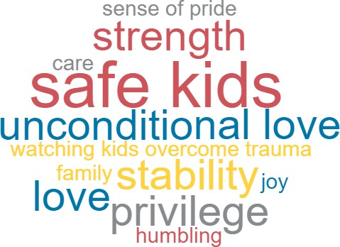

*Figure 7: Best things about being an informal kinship carer*

# Summary of Significant Findings

Following is a summary of the concerns and issues raised during consultation with informal kinship carers across Tasmania:

* From the viewpoint of some informal kinship carers, some Government departments appear fragmented and lacking in coordination, resulting in informal kinship carers often not receiving adequate support in a timely manner.
* Some concerns were expressed around the capacity of Child Safety services.
* Services and support must be streamlined to make navigating the system easier.
* There is poor community understanding and identification of informal kinship care.
* There is some fear of asking for help via the advice and referral line.
* There is often stigma attached to informal kinship care.
* Informal kinship carers rarely felt good about their financial future.
* Informal kinship carers rarely engaged in self-care or rewarded themselves.
* It’s rare for informal kinship carers to take time to have fun with friends and/or family.
* Some informal kinship carers were not clear on the progress of the recommendations of the 2020 *Informal Kinship Care Review*.16

16 Department of Communities Tasmania. (2021). *Informal Kinship Care Summary Review Report 2021*. https://publicdocumentcentre.education.tas.gov.au/library/Shared%20Documents/Informal-Kinship-Care- Summary-Review-Report.pdf

* Concerns were expressed about the lack of data available on the number of informal kinship carers supported through the Community Kinship Care Program.
* There was some uncertainty about the achievements and appropriateness of the support provided to through the Community Kinship Care Program funding.
* Carers commented that any updates to the Tasmanian *Carer Action Plan 2021- 202417* must include better accountability, specific actions, KPIs, and reporting mechanisms.
* There was uncertainty in the community about who informal kinship carers are, what supports exist for them, and how supports can be accessed in a way that feels safe.
* Ongoing psycho-social support services for informal kinship carers need to continue when and if the child leaves their care. A transitional period of support is needed, as when informal kinship care stops, the impacts are often ongoing for the carer.

# Recommendations

Based on the consultation undertaken and the insights provided by informal kinship carers, Carers Tasmania recommends:

* Carers Tasmania and the Tasmanian Government continue to advocate for the Australian Government to recognise informal kinship care within the *Carer Recognition Act 2010* (Cth).18
* All outstanding actions in the *Informal Kinship Care Review19* are implemented and the outcomes are reported in an accessible format for informal kinship carers.
* The Tasmanian Government considers mechanisms to increase support for informal kinship carers, consistent with the *Informal Kinship Care Review.20*
* The current arrangements for the provision of support to informal kinship carers through the Informal Kinship Care Support and Liaison Service are reviewed and co- designed with informal kinship carers, to ensure they are accessible, effective and feel safe for carers. This may include standardised processes for informal kinship carer intake, assessment, review, and referral to other services including free, independent legal and financial support services.
* The Tasmanian Government ensures that supports and services available for informal kinship carers continues for at least six months after their caring role ceases.
* The Tasmanian Government improves communication relating to the supports (information, resources, legal, financial) that are available for informal kinship carers and how they can be accessed.
* The Tasmanian Government recommences and expands education and awareness- raising strategies (utilising co-design with informal kinship carers) to increase community awareness of informal kinship carers and reduce stigma.
* The Tasmanian Government embeds opportunities for co-design when developing policy and programs and reviewing services, supports, and resources for informal kinship carers.

17 Department of Premier and Cabinet Tasmania. (2021). *Supporting Tasmanian Carers: Tasmanian Carer Action Plan 2021-2024*. https://[www.dpac.tas.gov.au/](http://www.dpac.tas.gov.au/) data/assets/pdf_file/0026/246248/Supporting-our-Carers- Action-Plan-2021-24_-JULY-2021.pdf

18 Commonwealth Carer Recognition Act. (2010). thttps://[www.legislation.gov.au/Details/C2010A00123](http://www.legislation.gov.au/Details/C2010A00123)

19 Department of Communities Tasmania. (2021). *Informal Kinship Care Summary Review Report 2021*. https://publicdocumentcentre.education.tas.gov.au/library/Shared%20Documents/Informal-Kinship-Care- Summary-Review-Report.pdf

20 Ibid.

* The Tasmanian Government undertakes authentic engagement and evaluation with people who have interacted with Child Safety Services to facilitate continuous improvement.

## “I definitely love him like he was my own, it is an experience that is dreadfully hard and taxing, but I would do it all over again to help him.”

– carer quote