### **Tasmania’s Disability Strategy 2025-2027 – Easy Read**

April 2025

**What is in this book**

About this book 3

About Tasmania’s Disability Strategy. 3

Vision 5

Principles 5

Language 6

Ableism 7

The Social Model of Disability. 9

Tasmania 10

Australia’s Disability Strategy. 11

Areas for Action 12

Tasmanian Disability Strategy Actions 13

Employment and Financial Security. 14

Inclusive Homes and Communities. 15

Safety, Rights and Justice. 16

Personal and Community Support 17

Education and Learning 18

Health And Wellbeing 19

Community Attitude 20

More information 21

A red black and yellow flag.
Black at the top horizontal through the middle red under the black and a yellow circle in the middle of the page. This is the Australian Aboriginal Flag.

The Tasmanian Government acknowledges Tasmanian Aboriginal people as the Traditional Custodians of lutruwita/Tasmania.

We recognise their continuing connection to Land, Sea, Waterways, Sky and Culture and pay our respects to Elders, past and present.

The Tasmanian Government acknowledges the lived experience of people with disability and their families, carers and supporters.

We acknowledge that people with lived experience of disability have helped to make this Strategy.

We acknowledge the people that have worked to make sure people with disability have their human rights.

# About this book

The Tasmanian government wrote this.

When you see the words ‘we’ or ‘us’ it means “The Department of Premier and Cabinet”.



We wrote it in a way that is easy to read.

We use pictures to explain some ideas.

The word bold is written twice, once is  thick wide dark letters, the other in normal text. There is a check mark next to the bold lettering.
Some hard words are written in **bold**.

This means the letters are thicker and darker. We explain what the hard words mean.



You can ask for help reading this book.

You could ask a friend, family member, support person or advocate.

# About Tasmania’s Disability Strategy.



The Tasmanian Government would like to make a plan so that all parts of government work together for people with disability.

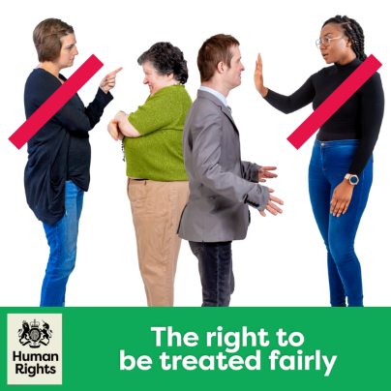The plan is called: Tasmania’s Disability Strategy.

We will call it **the strategy** for short.

It means people with a disability will be treated fairly.

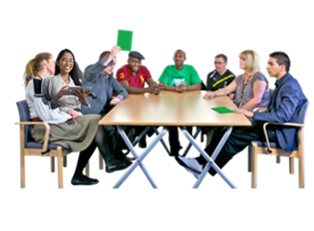

The government worked with lots of people to understand the needs of people with disability in Tasmania.

# Vision

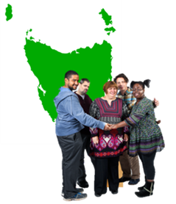The Tasmanian Government wants all Tasmanians with a disability to be treated fairly.

They want people with disability to be a part of the community.

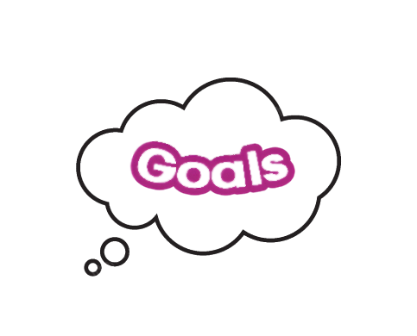People with a disability should be able to:

* Follow their dreams
* Make their own choices
* Have a say in things that affect them.

# Principles

We made this Strategy using the rules from:

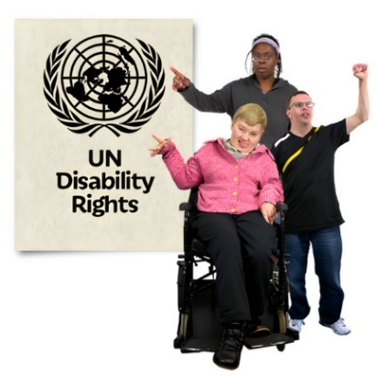**The United Nations Convention on the Rights of Persons with Disabilities**, UNCRPD for short.

The **UNCRPD** is an international law that the Australian government agreed to.

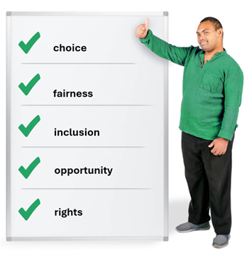Under the rules of UNCRPD you can:

* make your own choices
* be treated fairly.
* be included in everything.
* be given the same **opportunities** as everyone else**.**

**Opportunities** means to be given the same choices.

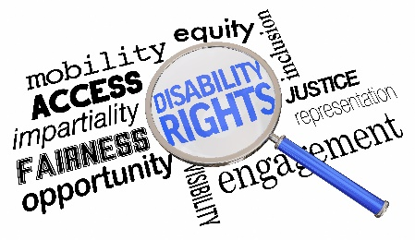

The strategy makes sure that people with disability have their rights met.

# Language

A group of people with and without disability standing in front of a sign saying 'empowering words', they have their arms raised in celebration.

We want to make sure that the words we

use in the strategy are right.

A person in a red shirt shaking a person's hand in a wheelchair. They are saying lovely to meet you.


Words can:

* Change the way people think.
* Show we care and respect people with disability.

## Ableism

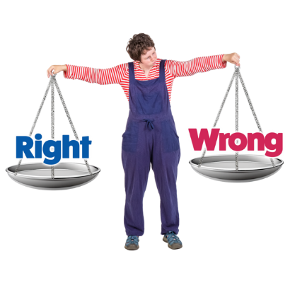

**Ableism** can make life hard and unfair.

**Ableism** means to treat people with disability unfairly.

Australian Indigenous flag:
Top half black
Bottom half red. 
Yellow sun in in the middle. 

Ableism can affect many groups but can be worse for:

* Aboriginal and Torres Strait Islanders.
* LGBTIQA+ people.
* Older and younger people

It is important to treat everyone fairly.

Everyone should have the same chances and be safe and free from harm.

## The Social Model of Disability

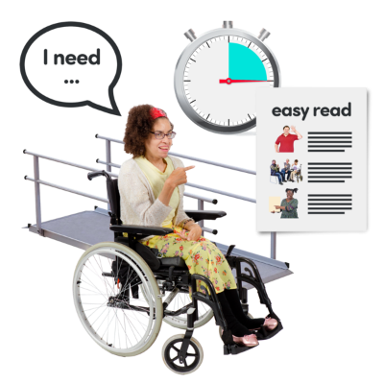Tasmania’s Disability Strategy uses the Social Model of Disability.

This model says that **barriers** stop people with disability from being part of their community.

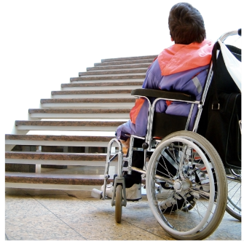A **barrier** is something that stops you from doing what you want to do

Barriers can be:

* 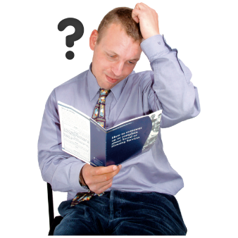Physical
* Social
* Communication
* The opinion of others

The social model says we should change other things, not the person with disability.

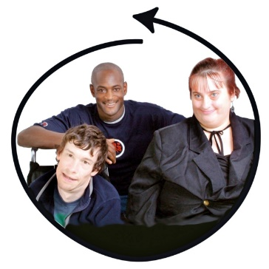

This means changing the community and how other people think.

This helps people with disability to be included.

# Tasmania

There are lots of people living with disability in Tasmania.

People in Tasmania can find things hard because of:

* A large magnifying glass with pictures inside it. There are 9 groups of people including older people, people with disabilities, families. and with various skin colours.
  Where they live
* Age
* Disability
* Gender
* Religion or culture

Everyone with a disability has different experiences.

# Australia’s Disability Strategy.

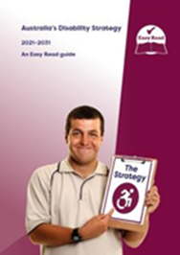Australia has a Disability Strategy.

2021- 2031

It is a plan to make sure the government works together to support people with disability live good lives.

## Areas for Action

It has 7 goals for people with Disability:



1. **Employment and financial security**

You should get help to find a job and have enough money to live well.

1.  **Inclusive Homes and community**

You should be able to live in a home that meet your needs.

Communities should be accessible and inclusive.

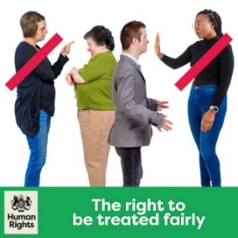

1. **Safety, Rights and Justice**

Everyone should be told their rights and be treated fairly by the law.

1. 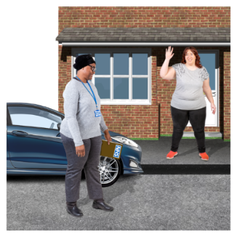**Personal and community support** You should be able to get help if you live alone and to access the community.

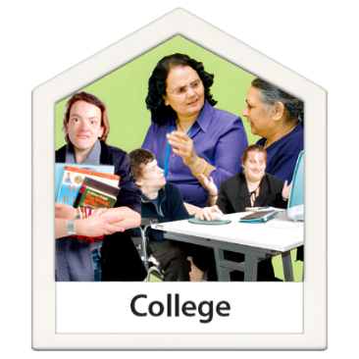

1. **Education and learning**

Support to go to school and learn new things.

1. A doctor in an office taking a blood pressure of a person
    **Health and Wellbeing.**

Have access to healthcare that suits your needs.

1. 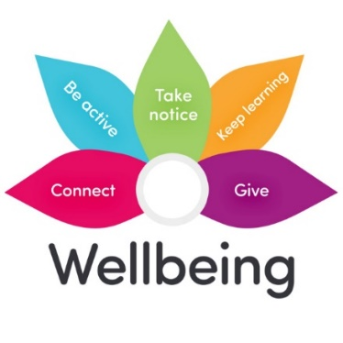**Community attitudes.**

This is about helping everyone understand and support the needs of people with disability.

# Tasmanian Disability Strategy Actions

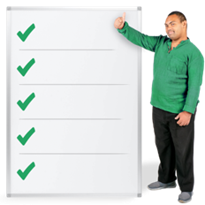

The Tasmanian Disability Strategy also has 7 goals for people with disability.

## Employment and Financial Security.

A young woman putting money in a piggy bank

We want people with disability in Tasmania to have enough money to feel safe.

We want you to be able to plan for your future.

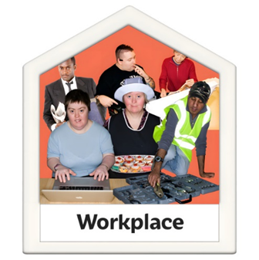We will work on:

1. More jobs for people with disability
2. Making it easier for young people to move from school to work
3. People with disability have more control over their money

## Inclusive Homes and Communities.

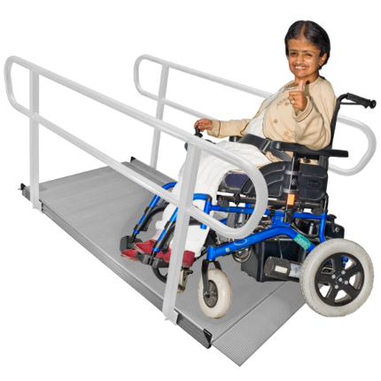People with disabilities should:

* live in homes and communities that are easy to access and welcoming.

We will work on:

1. 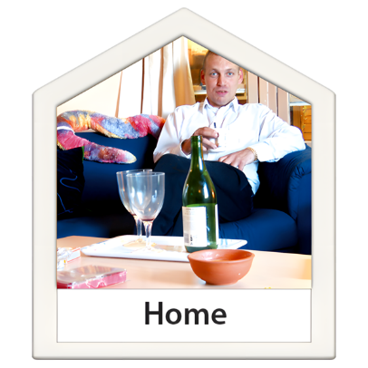Making homes more budget friendly.
2. We think that you should choose where you live and who you live with.
3. Being able to join in activities in the community.
4. A green and black bus

   AI-generated content may be incorrect. Everyone being able to access buildings and outdoor areas.
5. Transport should be easy for everyone.
6. Information and communication should be easy and work well for everyone.

## Safety, Rights and Justice.

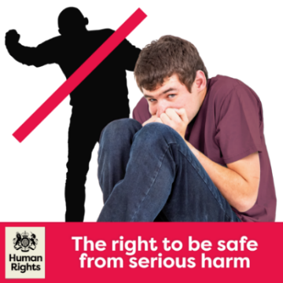People with a disability:

* Should have their rights protected; and
* Feel safe and be treated fairly by the law.

We will work on:

1. People being safe and free from harm and abuse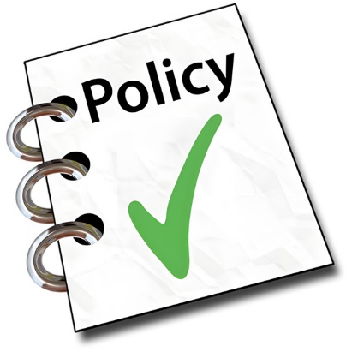.
2. Better rules and policies to support for people who have experienced trauma.
3. 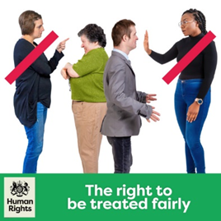The rights of people with disabilities should always be supported and protected.

This means making sure they are treated fairly.

1. People with a disability being told their rights and being treated fairly by the law.
2. The justice system having rules to help people with disability be treated fairly.

## Personal and Community Support

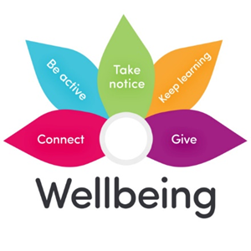People with a disability should get help to:

* live on their own.
* join in with their community.

We will work on:

1. A support worker holding the hand of a young woman in a wheelchair, she is helping her make a sandwich. They are both laughing. 

   People getting the right support for them.
2. People on the NDIS getting the right support and tools that meet their needs.

A support worker assisting a person making a pizza



1. We understand and support the role of **informal supports**.

**Informal supports** are the unpaid help from family and friends.

1. People having tools and technology that help with their disability.

## Education and Learning

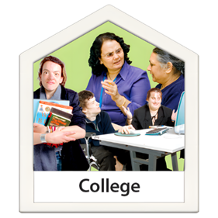

People with disability should:

* Have access to a good education
* Learn in the best way for them.

We will work on:

A teacher and a child painting



1. Children with disability getting good care and early education.
2. A person in a wheelchair using a computer

   All teachers being able to work with students with disability.
3. More options for learning.

These options should be easy to access.

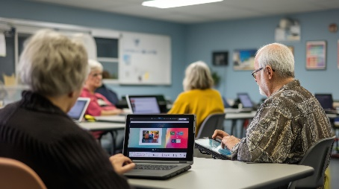

1. More options for being able to learn at any stage of life.

## Health And Wellbeing

People with a disability should be able to live healthy lives.

We will work on:

1. Health services should work well with people with disability.

A doctor in an office taking a blood pressure of a person


1. Healthcare being fast and easy stopping problems before they start.
2. Mental health support being easy and working well.
3. Planning for emergencies should include people with disability.

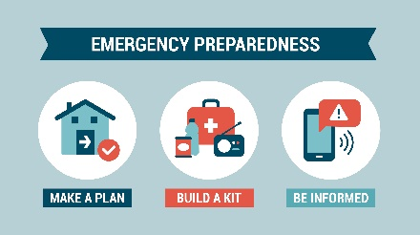

Everyone should work together to make sure people with disabilities are healthy and happy.

## Community Attitude

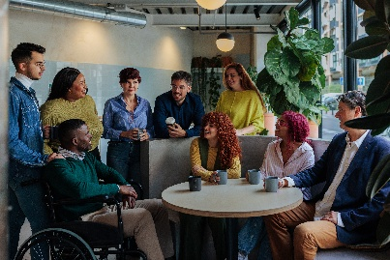People with disability should:

* be valued and treated the same as everyone else in the workplace.

We will work on:

1. 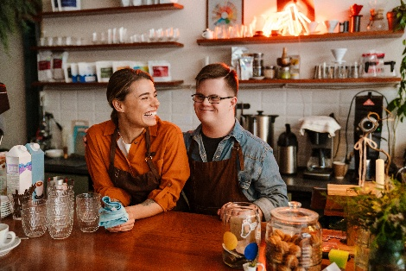People being employed for their skills and knowledge.
2. Professionals should be able to work with and understand the needs of people with disability.
3. 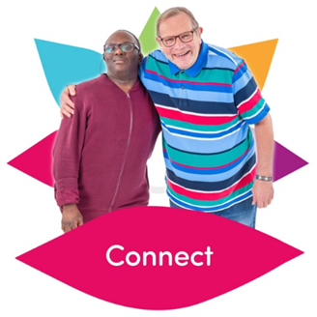We want people to think better about others in the community.

When people are kind and understanding, it helps make good changes happen in the community.

# More information

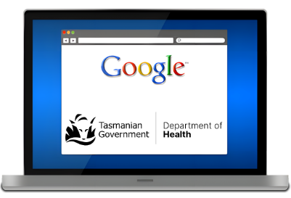

For more information on the Strategy, go to our website:

[Department of Premier and Cabinet - Tasmania’s Disability Strategy 2025-2027](https://www.dpac.tas.gov.au/divisions/cpp/community-and-disability-services/tasmanias-disability-strategy)

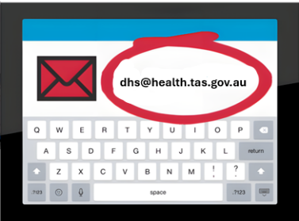

You can also email us at:   
[disability@dpac.tas.gov.au](mailto:disability@dpac.tas.gov.au)

Speak Out Tasmania created this Easy Read document using Photosymbols and custom images. The images may not be reused without permission. For any enquiries about the images or Easy Read, please email: [easyread@speakoutadvocacy.org](mailto:easyread@speakoutadvocacy.org)