Transforming Selves
Our ways of working and capability matrix
October 2025

Contents
Building a Trauma-Informed Workforce 3
Aspiring to a Trauma-Informed Workforce 3
Transparent Capabilities and Expectations 3
A Quick Refresh 5
Trauma Capability Framework Structure 6
Understanding capabilities 6
Capability groups - Our Ways of Working 6
What each group represents 7
Behavioural Indicators 7
Practice Levels and Workforce Application 8
Capabilities and Practice Levels 9
Ways of Working: Trauma Aware Level (Our Minimum Capability) 11
Trauma Capability Matrix 12

Building a trauma-informed workforce
We are committed to building and maintaining a responsive and compassionate workforce that supports all Tasmanians in their interactions with government services. Our workforce must be equipped to deliver services with an understanding that every person has a unique story shaped by past experiences.
Our role is not to judge or make assumptions about what people have experienced, how they have coped, or whether they have sought help. Instead, we aim to recognise what is helpful or harmful, respond with care and compassion, create space for people’s voices to be heard, and support their right to make choices, while actively resisting re-traumatisation or further harm.
To achieve this, we are committed to developing a trauma-informed, skilled and supported workforce. This includes prioritising culturally safe workplaces and practices, adopting person-centred approaches and learning together. This commitment requires every worker to:
- Prioritise social connection and the recovery of relationships at every opportunity.
- Avoid actions that may cause further harm or re-traumatisation.
- Consistently apply trauma-informed practices in every interaction, regardless of whether trauma has been disclosed or is visibly present.
This collective effort is grounded in respect, honesty, and kindness, ensuring that our approach to trauma is both effective and compassionate.

Aspiring to a trauma-informed workforce
To realise our goal of building a trauma-informed, skilled and supported workforce, it is essential that all workers, across all service sectors, demonstrate the knowledge and skills appropriate to their role. This aligns with our broader commitment of creating a public sector that is not only trauma-aware, but also capable of responding with empathy and effectiveness to trauma in all its forms.

Transparent capabilities and expectations
Our Ways of Working is outlined in the Trauma Capability Framework: Building Trauma Awareness in the Tasmanian Public Sector (the framework), providing a clear description of the capabilities expected of all workers in the Tasmanian State Service (TSS). It supports consistent, trauma-informed practices across all areas of workforce management, including:
- Workforce management applications
  - Standardised job design and role descriptions aligned with capability requirements.
  - Recruitment practices that focus on assessing role-specific capabilities.
  - Performance development practices that clarify expectations and areas for development.
  - Mobility supported by consistent role and capability descriptors.
- Learning and development applications
  - Learning and development activities aligned to specific capabilities.
  - Career planning that supports capability growth and progression.
  - Workforce planning that identifies current and future capability needs and gaps.
This document includes two components to help you navigate and apply the framework:
- Trauma Capability Framework structure.
- Trauma Capability Matrix.
Together, these sections provide the detail needed to understand how trauma-informed practice applies to your role and support meaningful conversations with your manager as part of ongoing performance development and management.

A quick refresh
Our goals are to build a trauma-informed, skilled and supported workforce that prioritises culturally safe workplaces and practices, is person-centred and learns together.
Our principles are grounded in six core principles, which are Safety, Trustworthiness, Choice, Empowerment, Collaboration and Intersectionality.
Our ways of working are grouped into five domains (Ways of Being, Knowing, Doing, Advising and Guiding) that describe behavioural indicators reflecting the level of knowledge, skill and ability expected at different levels. These indicators are not an exhaustive list and can be adapted to roles to help employees and managers clearly describe the behaviour expected in specific roles.
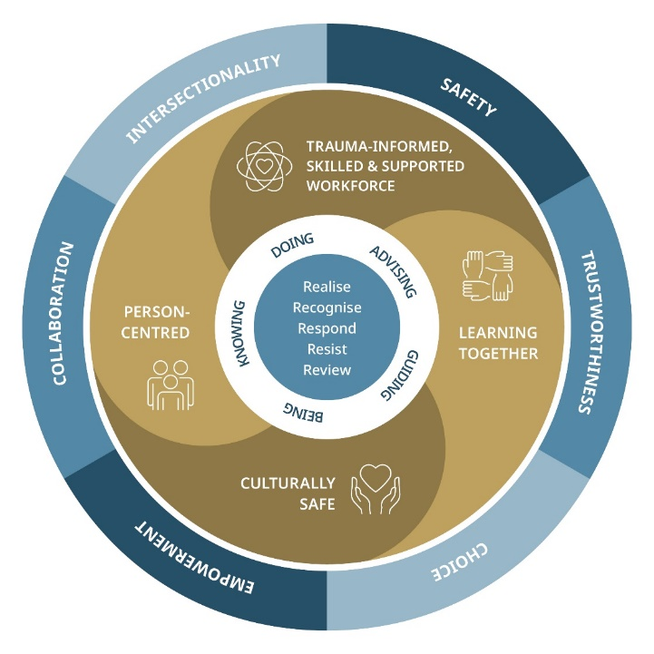
Figure 1. Trauma-Informed Model
Our practice levels help group roles in our organisation meaningfully so that all employees understand the level of capability required to be trauma-informed. There are three practical levels, starting with Trauma-Aware, progressing to Trauma-Skilled, and advancing to Trauma-Enhanced.
Note: Transforming Selves is a supporting document of the framework and should be read alongside it for a comprehensive understanding.

Trauma Capability Framework structure

Understanding capabilities
In the context of trauma-informed practice, capabilities refer to the essential attribute that enable individuals to perform their roles effectively. These include:
- Knowledge – theoretical or practical understanding of a subject.
- Skills – developed through training, experience or practice.
- Abilities – qualities of being able to do something needed to perform a role.

Capability groups – Our ways of working
Our capabilities are organised into five groups, centring Tasmanian and Tasmanian Aboriginal worldviews. Together they reflect the holistic needs of a contemporary worker and form the foundation of Our Ways of Working.

Figure 2. Our Ways of Working

Group overview
- Ways of being, Ways of knowing and Ways of doing apply to all roles.
- Ways of advising apply to most roles, particularly those supporting back-end functions such as finance, technology, policy, procurement and contract management, and project management.
- Ways of guiding apply to roles with leadership and management responsibilities.

What each group represents

Ways of being
Adopting a mindset and attitude that recognises and respects the unique experiences and needs of each individual. This group reflects intrinsic qualities, such as empathy, cultural humility and self-awareness, that shape how we interact and respond to others.

Ways of knowing
Having the knowledge, language and awareness to identify signs of trauma and understand how best to support recovery. This group focuses on interpersonal skills, communication and collaboration, essential for building trust and fostering safe relationships.

Ways of doing
Implementing practical actions and procedures that reflect trauma-informed principles, ensuring that our responses are effective and compassionate. This group supports operational effectiveness, ensuring systems and processes are inclusive, adaptive and culturally safe.

Ways of advising
Providing guidance on the ethical and efficient management of resources, systems, and processes to support sustainable operations. This group supports alignment, accountability and quality outcomes.

Ways of guiding
Leading with empathy and integrity to create safe, empowering environments. This group encompasses the leadership capabilities needed to embed trauma-informed principles into organisational culture and practice.

Behavioural indicators
Each capability includes behavioural indicators that are specific, observable actions that demonstrate effective trauma-informed practice. These indicators show how a capability is put into practice and provides guidance on performance expectations. Not all indicators apply to every role, and they are not an exhaustive list.

Practice levels and workforce application
Trauma-informed capability is defined across three practice levels, each aligned to the nature of roles, responsibilities and frequency of contact with individuals affected by trauma. The following table outlines these levels and their application across the workforce.
Table 1. Practice levels and workforce application
Practice level | Definition | Workforce Application
Trauma Aware | Foundational understanding of trauma and its impacts. All staff are expected to apply basic trauma-informed principles in their daily work. | Required for everyone in the workforce (paid or unpaid). Reflects a commitment to doing things differently to prevent harm and promote wellbeing.
Trauma Skilled | Builds on the foundational level. Required for roles with direct or substantial contact with individuals who may be affected by trauma. | Builds on the Trauma Aware foundation. Required for roles with direct and/or substantial contact with individuals (from children through to adults) who may be affected by traumatic events, whether trauma is known or not. This includes staff from statutory services, human services organisations, and emergency services.
Trauma Enhanced | Applies to roles with regular, intensive contact with individuals known to be affected by trauma. It includes statutory and therapeutic responsibilities and may support professional accreditation requirements.  For those working in clinical and therapeutic specific roles, there are specific knowledge, skills and behaviours detailed to support accreditation requirements from professional bodies. | Applies to roles with regular, intensive contact with individuals (children and adults) known to be affected by traumatic events. Relevant to, but not limited to health, mental health, substance misuse services, corrections, child safety and homelessness services.

Capabilities and practice levels
The next section of Our Ways of Working provides a practical tool to help you identify the practice level that best aligns with your current role, and the capability sets relevant to your work.
We recommend completing the decision tree on the next page and discussing your practice level with your manager or supervisor. This process supports reflection and ensures alignment with your responsibilities and professional goals.

How to navigate the capability information
People absorb information in different ways, so we have provided multiple formats to help you the capabilities:
- Page 12 – A one-page summary of the minimum capabilities required by everyone.
- Page 13-14 – A capability matrix showing all capabilities across the three practice levels (Trauma Aware, Trauma Skilled, Trauma Enhanced).

Choosing your practice level
It is up to you to identify which level best applies to current role. We acknowledge that you may bring significant knowledge, skills and experience from previous roles, but may not be required to routinely respond to victims and victim-survivors in your current position.
These practice levels are not intended to be prescriptive. You have the flexibility to:
- Focus on the capabilities recommended for your level, or
- Explore additional knowledge, skills and practice tips from other levels.
If you are unsure which level applies to you, we encourage you to discuss with your line manager or during professional supervision.

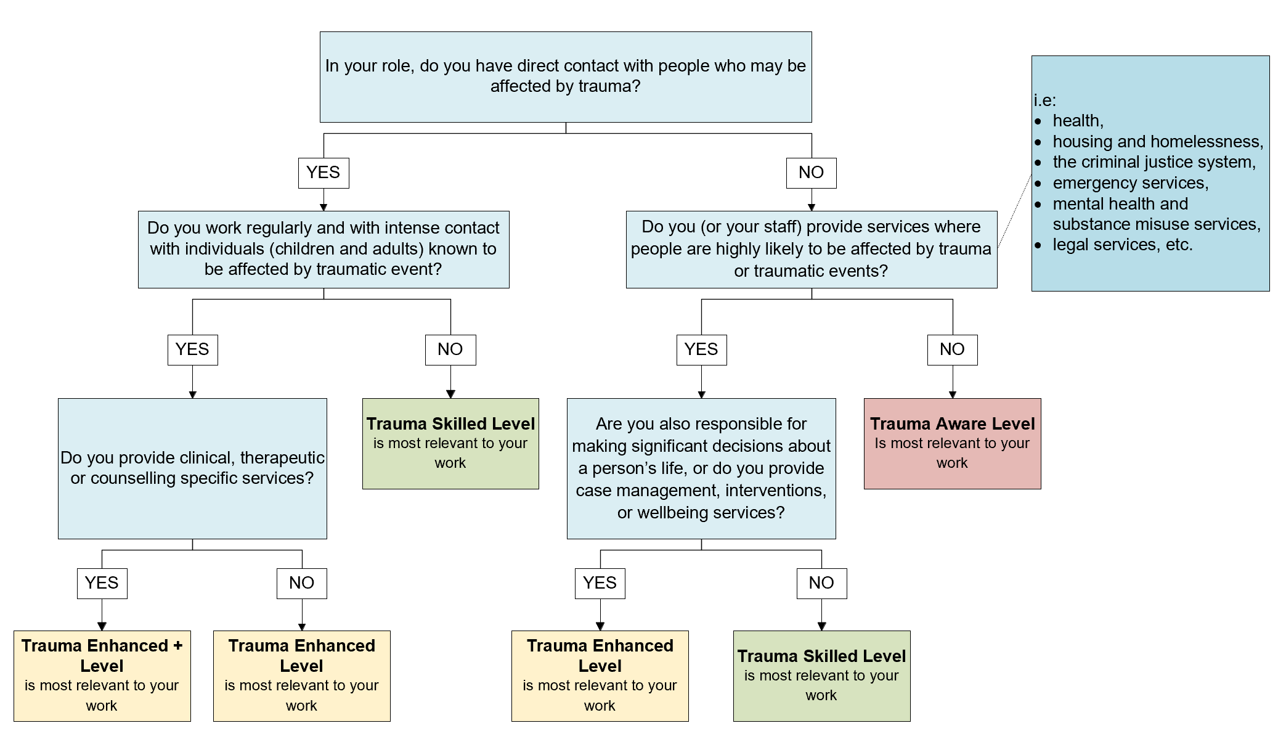
Figure 3. Practice level decision tree

Ways of Working: Trauma Aware Level (Our minimum capability)
Ways of being | Ways of knowing | Ways of doing | Ways of advising | Ways of guiding
Demonstrates a foundational understanding of what trauma is, its prevalence, effects across the lifespan, including neurological impacts and socio-economic functioning, and its signs and risk factors.  Acknowledges and respects Truth Telling in relation to cultural safety, ongoing impacts of invasion and colonisation, the Stolen Generations, racism, and conscious bias perpetrated against Aboriginal and Torres Strait Islander people.  Acknowledges and respects the experiences of and impacts on diverse cultural communities, including marginalised and underrepresented groups, and recognises the unique challenges they face.  Recognises the emotional impact of working with trauma survivors and actively engages in self-reflection and psychological self-care. | Makes sense of the behaviour of trauma victims and survivors, utilises empathy and active listening skills with attention to tone, pace, and language, and prioritises safety during interactions.  Ensures that communication is accessible and inclusive, respecting personal information and privacy, including when engaging with families and communities.  Maintains clear professional boundaries, understands power dynamics in relationships, and ensures transparency in reporting and informed consent in disclosures. | Ensures services are accessible and inclusive, providing private, safe, and culturally respectful spaces for all clients.  Supports collaborative engagement through effective communication and compliance with Information Sharing Consent Agreements.  Knows where to access or find information on local trauma-specific support services and understands their role in referral and support processes. | Makes decisions based on a basic understanding of trauma-informed principles, ensuring no further harm and promoting self-efficacy and self-determination.  Understands and adheres to legal and ethical responsibilities, including the Child and Youth Safe Organisations Framework, Reportable Conduct Scheme, and work health and safety risk management processes.  Actively participates in feedback processes and advocates for the integration of trauma-informed practices in policies and procedures. | Understands the role of leadership in a trauma-informed organisation, including responsibilities under the Child and Youth Safe Organisations Framework and Reportable Conduct Scheme.  Leads cultural improvement programs to prevent and address bullying, harassment, and discrimination, ensuring processes are trauma-informed.  Provides appropriate supervision and support for staff in trauma-related roles, recognising the importance of professional support to mitigate vicarious trauma and burnout.

Trauma Capability Matrix
Grouping | Trauma Aware | Trauma Skilled | Trauma Enhanced
Ways of being  Understanding trauma and who we work with | Demonstrates a foundational understanding of what trauma is, its prevalence, effects across the lifespan, including neurological impacts and socio-economic functioning, and its signs and risk factors.  Acknowledges and respects Truth Telling in relation to cultural safety, ongoing impacts of invasion and colonisation, the Stolen Generations, racism, and conscious bias perpetrated against Aboriginal and Torres Strait Islander people.  Acknowledges and respects the experiences and impacts on diverse cultural communities, including marginalised and underrepresented groups, and recognises the unique challenges they face.  Recognises the emotional impact of working with trauma survivors and actively engages in self-reflection and psychological self-care. | Demonstrates an advanced understanding of the impact of child sexual abuse, sexual violence, and adverse childhood experiences (ACEs) on individuals and communities, as well as a trauma-informed approach.  Recognises and appreciates the uniqueness of every victim and survivor and the importance of intersectionality, ensuring that responses to trauma are inclusive and sensitive to diverse experiences.  Utilises techniques to manage emotions in stressful situations and supports others in regulating or co-regulating their emotions effectively. | Demonstrates an advanced understanding of complex trauma, including its developmental, cultural, family and kinship bonds as well as social impacts, and effectively supports colleagues in managing secondary trauma.  Recognises the intersectionality of different forms of sexual violence, abuse, and neglect, and coordinates service responses that are person-centred and culturally safe across multiple agencies.  Utilises relevant risk screening tools to appropriately manage risks within their practice area, understanding the links between trauma, poverty, and crime.
Ways of knowing  Communicating with compassion | Makes sense of the behaviour of trauma victims and survivors, utilises empathy and active listening skills with attention to tone, pace, and language, and prioritises safety during interactions.  Ensures that communication is accessible and inclusive, respecting personal information and privacy, including when engaging with families and communities.  Maintains clear professional boundaries, understands power dynamics in relationships, and ensures transparency in reporting and informed consent in disclosures. | Responds effectively to disclosures of trauma, actively advocating for appropriate support and understanding the potential impacts of re-traumatisation.  Builds and maintains collaborative relationships within diverse teams, sharing information to reduce re-traumatisation and improve trauma-informed care.  Applies advanced communication techniques tailored for trauma survivors, using empathy, strengths-based language, and appropriate disclaimers or trigger warnings. | Effectively navigates complex relational dynamics, putting aside personal biases, and engages with a broad range of stakeholders in trauma-informed care and case management.  Resolves conflicts within trauma-affected environments, promoting recovery and stability through positive reinforcement and encouragement.  Provides psychoeducational services, encouraging emotion regulation, healthy sleep practices, and engagement in meaningful activities to support recovery, as well as referring onto other services and specialist trauma therapies based on the individual's preferences and needs.  + Builds and maintains a strong therapeutic alliance with each individual ensuring risk, safety and therapeutic needs are appropriately balanced and managed to maintain the relationship.
Ways of doing  Transparency with trauma | Ensures services are accessible and inclusive, providing private, safe, and culturally respectful spaces for all clients.  Supports collaborative engagement through effective communication and compliance with Information Sharing Consent Agreements.  Knows where to access or find information on local trauma-specific support services and understands their role in referral and support processes. | Ensures that information relating to disclosures is recorded accurately, informs individuals of consent and reporting requirements, and understands when disclosures must be shared for safety reasons.  Advocates for access to care, support, advocacy, and justice services in line with individuals’ stated preferences, recognising the importance of cultural safety and person-centred approaches.  Demonstrates an understanding of how trauma histories may affect individuals’ ability to manage long-term health conditions and their interactions with complex systems (for example, child protection, criminal justice, family court). | Integrates evidenced-based practices into service delivery, ensuring alignment with legislative and statutory requirements to enhance trauma-informed care.  Encourages and supports self-efficacy and self-advocacy among service users, including participation in feedback, reporting, and right to information requests.  Gauges willingness for legal disclosure and provides relevant information, integrating evidence-based information, integrating evidence-based practices with legislative requirements in service delivery.  + Where relevant or required by your current role, maintain registration and/or accreditation with your professional body.
Ways of advising  Sharing power and choice | Makes decisions based on a basic understanding of trauma-informed principles, ensuring no further harm and promoting self-efficacy and self-determination.  Understands and adheres to legal and ethical responsibilities, including the Child and Youth Safe Organisations Framework, Reportable Conduct Scheme, and work health and safety risk management processes.  Actively participates in feedback processes and advocates for the integration of trauma-informed practices in policies and procedures. | Incorporates trauma-informed care and practice into decision-making processes, ensuring that decisions prioritise safety, well-being, and the needs of trauma-affected individuals their families.  Creates and maintains environments that support recovery and well-being, particularly for individuals who are stressed, distressed, or emotionally dysregulated.  Actively seeks feedback and adapts practices to improve operational processes and enhance the experience of individuals receiving trauma-informed care. | Prioritises professional supervision and development, and skilfully integrates feedback from managers, colleagues, and clients into ongoing practice improvements, remaining person-centred and trauma informed.  Recognises the responsibility to document disclosures and take appropriate action in line with local and national risk-management policies and procedures.  Develops and implements clear, specific, and collaborative contact plans with clients, ensuring shared decision-making and appropriate closure of relationships.
For managers and leaders, it is important to think about what level or practice is expected should consider the expected practice required by the organisation’s service model to determine the appropriate foundation level. The capabilities listed below are intended to build upon that selected foundation.
Grouping | Supervisors, Team Leaders and Senior Team Members | Managers and Senior Managers | Senior Executive Service Officers or equivalent | Heads of Agencies or equivalent
Ways of guiding  (Leadership or Manager)  Leading with care | Understands the role of leadership in a trauma-informed organisation, including responsibilities under the Child and Youth Safe Organisations Framework and Reportable Conduct Scheme.  Leads cultural improvement programs to prevent and address bullying, harassment, and discrimination, ensuring processes are trauma informed.  Provides appropriate supervision and support for staff in trauma-related roles, recognising the importance of professional support to mitigate vicarious trauma and burnout. | Provides training and support to teams on trauma-informed practices, fostering a culture that is both trauma-informed and culturally safe.  Demonstrates advanced cultural competence in leadership, particularly in trauma contexts, and addresses the impacts of trauma, including child sexual abuse, on cultural safety within the organisation.  Promotes staff resilience and well-being through effective supervision, support, and access to professional development opportunities focused on trauma-informed care. | Develops and supports strategies for measuring and evaluating outcomes, implementing complex operational strategies, and leading cultural change toward trauma-informed practices across the organisation.  Mentors and develops future trauma-informed leaders, ensuring that operational practices are up-to-date and aligned with the latest evidence-based approaches.  Selects staff appropriately for roles involving trauma-affected individuals, ensuring they have the necessary training and qualifications, and fosters a safe environment for open supervision discussions. | Leads organisational change towards trauma-informed practices, driving innovation and excellence in trauma-informed care, and ensuring the long-term sustainability of these practices.  Develops and implements advanced strategic planning and organisational development initiatives in trauma contexts, ensuring that trauma-informed leadership practices are sustained and evolve with emerging needs.  Drives innovation in trauma-informed practices across the organisation, ensuring that the latest research and best practices are integrated into service delivery and organisational culture.

