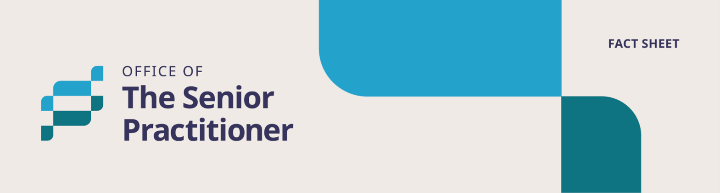

Independent Person



Easy Read Fact Sheet
About our Fact Sheets?
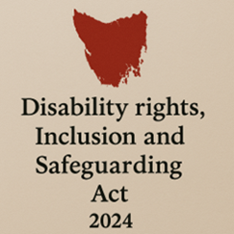
We have a new law in Tasmania.
It is called the Disability Rights, Inclusion and Safeguarding Act 2024.

We call it the Act for short.

There are lots of changes being made because of the new Act.
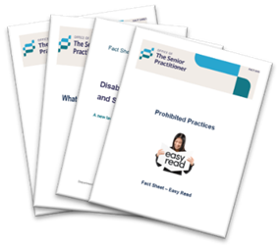
We have written some fact sheets explaining the changes.

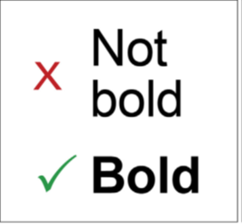
We wrote some hard words in bold.
This means the letters are thicker and darker.
We explain what the hard words mean.

What is an Independent Person?

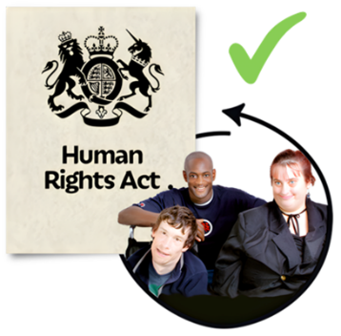
An Independent Person helps to protect your rights when a restrictive practice is being planned.


A restrictive practice is something that stops you from moving freely or doing what you want.

It can take away your rights.


A restrictive practice can only be used to keep you or others safe.

You should have an Independent Person when a provider wants to use a restrictive practice on you.

What does an Independent Person do?

They:
- Support you when a restrictive practice is being planned or used.

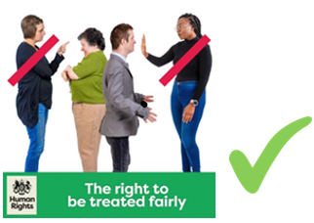
- Tell you your rights.

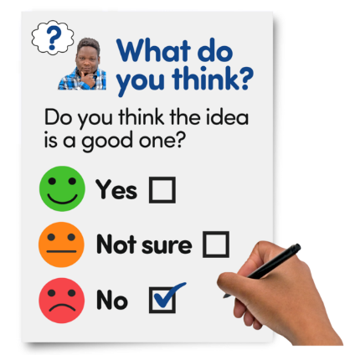
- Help you to say what you want, or what you would like to happen.

- Help ask for a second look at decisions you do not agree with.

- Help you understand any changes to your Behaviour Support Plan.

When must they speak up?


The Independent Person must tell the Senior Practitioner if:


- You do not understand what is being planned.

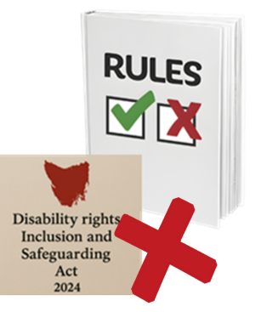
- The rules in the Act are not being followed.

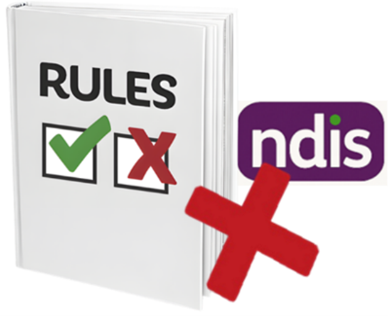
- The NDIS rules are not being followed.

Who can be an Independent Person?


An Independent Person should be someone you know and trust.

This could be a:


- Family member

- Friend

- Guardian


They must care about your wellbeing.

Who cannot be an Independent Person?

An Independent Person cannot be:

- The person who owns or runs the service you use.



- Your support worker


- Someone who works for your service provider.

- Someone who Volunteers for the provider
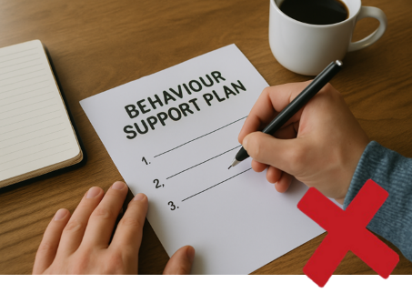
- Someone who helped write your Behaviour Support Plan.

A Behaviour Support Plan is understanding why someone is acting a certain way and finding kind and safe ways to support them.

This is then written into a plan called a Behaviour Support Plan.

What are the rules they must follow?

An Independent Person must follow the rules in the Act.

The rules say:


- Only use a restrictive practice as a last choice.

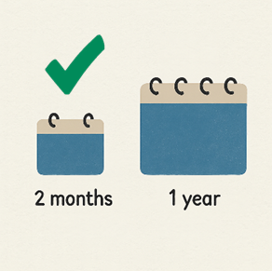
- Be the least restrictive and used for a short time.

least restrictive means, giving you as much freedom and choice as possible, while keeping you safe.


- They must protect your safety and rights.

Who chooses an Independent Person?


The Appointed Program Officer (APO) chooses the Independent Person.

They will ask you who you would like to be your Independent Person.


An Appointed Program Officer is a worker chosen by a disability service provider to help with restrictive practices.

How are they arranged?

Once you choose your Independent Person, the APO must ask the Senior Practitioner to approve them.

The Senior Practitioner can say:
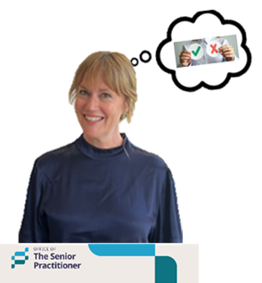
- Yes

- Yes, but with rules

- No

They will let you know what they decide.

Can decisions be questioned?


Yes.
If you do not agree with the decision, you can:

Ask the Senior Practitioner’s Office to think it over again.


If you are still unhappy, you can go to the Tasmanian Civil and Administrative Tribunal
We say TASCAT for short.

TASCAT is a place where people can go to get help to solve problems or disagreements in a fair and safe way.

TASCAT helps with many areas of the law.

For more information


For more fact sheets and information about the Act, go to:
Department of Premier and Cabinet


Speak Out Tasmania created this Easy Read document using Photosymbols and custom images. The images may not be reused without permission. For any enquiries about the images or Easy Read, please email: easyread@speakoutadvocacy.org

