Disability Services

Strategic Plan

2019-2021

How to use this paper
This paper is written in an easy to read way.
We use pictures to explain some ideas.
You can ask someone to help you read this paper.
Maybe a friend, family member, support person or advocate.
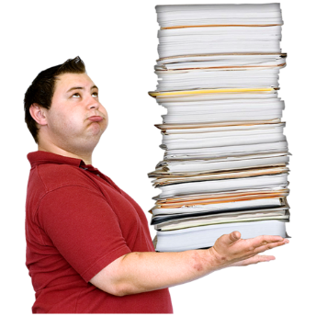
This easy read paper is a short version of a bigger paper.

You can find the bigger paper on our website at
www.dhhs.tas.gov.au/disability/plan/disability_services_strategic_plan_2019-2021

What is this about?

The Disability Services Strategic Plan is a plan to make life better for people with disability.
It helps Disability Services know what to do for the next 3 years.

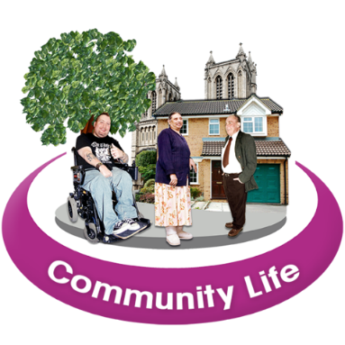
The plan makes sure Tasmanians with disability can:
- have a say about the law

- have choices

- be part of the community.
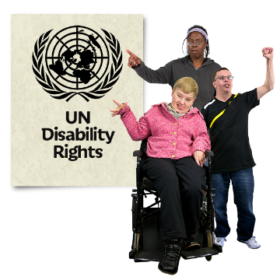
It fits with other important laws and papers like:
        - the UN Convention on the Rights of Persons with Disabilities
      - the National Disability Strategy 2010-2020

        - Accessible Island, Tasmania’s Disability Framework for Action 2018-2021.

About Disability Services

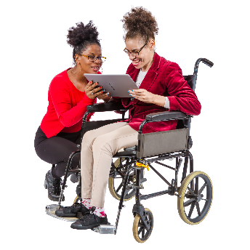
From 1 July 2019 Disability Services will no longer fund most services.
This will be done by the NDIS.
Even though lots of things have changed Disability Services still has important jobs to do.

Like

- helping people with disability and service providers with the change to the NDIS.
- helping people with disability who are not eligible for the NDIS.
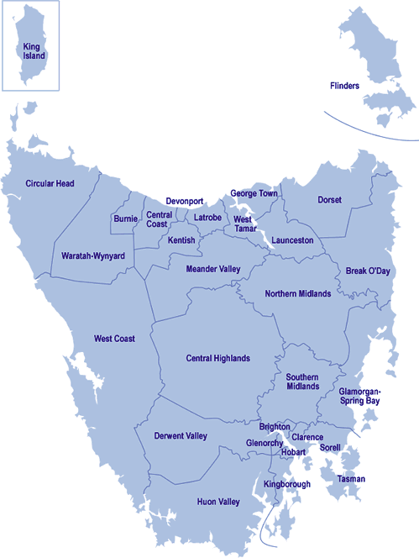
Eligible means that you meet certain rules for the NDIS. Like you are an Australian citizen.

- helping the Tasmanian Government make Tasmania a good place for people with disability.

Disability Services are:
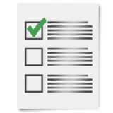
Helping to fund the NDIS and check how it is going.

Making sure organisations follow the Disability Services Act 2011.

The Disability Services Act is a law. These are rules that organisations must follow.
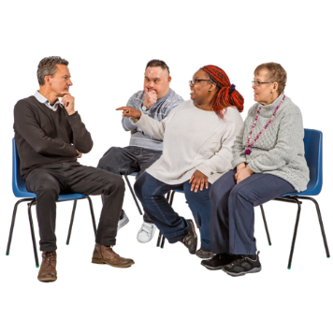
Asking people with disabilities what they think.
Working with the NDIA.
Getting the government and departments to work well together.

The strategy is working on 4 main areas they are:

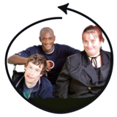
1. Being part of the community

Everyone is respected and can join in.

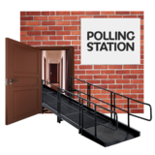
Places and buildings are well planned and easy to get around.

Disability Services will:

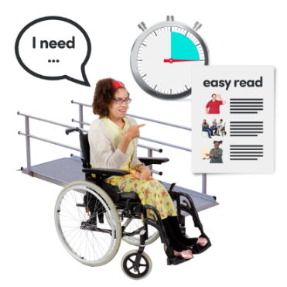
- make opportunities for people with disability to do things with their community
- support people to take part and be equal
- support other government departments to give good services to people with disability
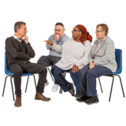
- make information easy to understand
- ask people with disability what they think about laws, programs and policies that affect them.
Policies are rules that help organisations know what to do.

2. Rights and laws

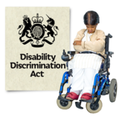
Protecting the rights of people with disability.

Making sure laws work well.

Disability Services will:
- check the Disability Services Act 2011 is
up-to-date and works well with other laws

- fund advocacy services to help people have choice, control and speak up
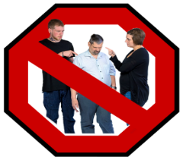
- make the job of the Senior Practitioner strong so services and safety gets better.

3. Personal and community support
- People with disability and their families and carers get the support they need to live independently
- be part of the community.

Disability Services will:

- help people with disability get into the NDIS
- ask people with disability and families how the NDIS is going
- give advice to the NDIA and government about ways to improve the NDIS
- keep giving help to people who are not eligible for the NDIS

- helping to train disability support workers.

Good quality services

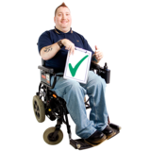
People with disability can find and use services that:
- do a good job
- meet their needs.

Disability Services will:

- make sure services follow laws like the
Disability Services Act 2011 and
Nationals Standards for Disability Services
- check that support workers are safe and follow the rules
- help services keep improving
- make sure services respond to people with disability and their needs.

How do we know if it is working?
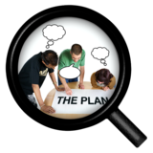
Communities Tasmania is a government department that keeps an eye on the Strategy.

They keep an eye on the Strategy by:

- getting reports on how things are helping make life better for people with disability
- asking people with disability and families what they think
- write a plan each year about what they will do to make things better
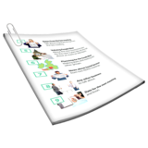
- The plan will say who will do these things and when they will do them
- Writing a report every year that you can read on the internet
They will write about the good things and things that need to get better.

This Easy English document was created by Speak Out Tasmania using PhotoSymbols, stock and custom images. The images may not be reused without permission.
For any enquiries about Easy English translations or the images, please visit www.speakoutadvocacy.org

