

Restrictive Practices –

Information for Providers



Easy Read Fact Sheet

What is this fact sheet about?

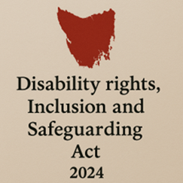
We have a new law in Tasmania.
It is called the Disability Rights, Inclusion and Safeguarding Act 2024.

We call it the Act for short.

There are lots of changes being made because of the new Act.
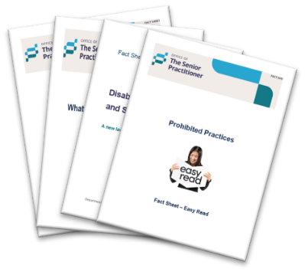
We have written some fact sheets explaining the changes.

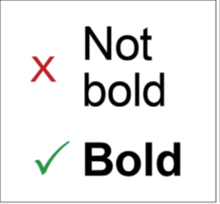
We wrote some hard words in bold.
This means the letters are thicker and darker.
We explain what the hard words mean.

Who is this fact sheet for?

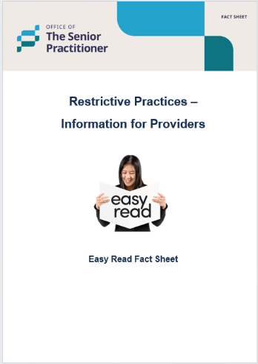
This factsheet is for disability service providers who want to use restrictive practices when supporting a person with disability.

What is a Restrictive Practice?


A restrictive practice is something that stops a person from moving freely or doing what they want.

It can take away their rights.
It must only be used when needed to keep someone safe.

What does the law say?
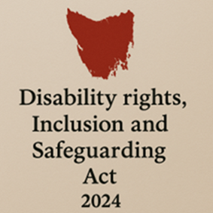
The Disability Rights, Inclusion and Safeguarding Act 2024 says:

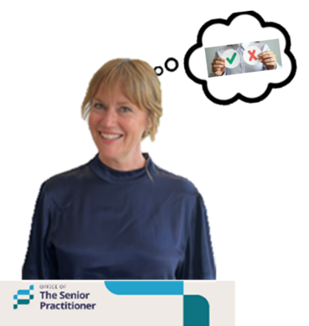
You must have permission from the Senior practitioner to use a restrictive practice.

Permission means to have consent or to say okay to something.

When is it okay to use a Restrictive Practice?


Only when:

- It is the last option.


- It is the least restrictive way.

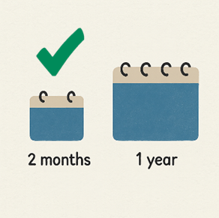
least restrictive means, giving you as much freedom and choice as possible, while keeping you safe.

- It is used for a short time.


- It protects the safety and rights of the person.

Ethical Thinking

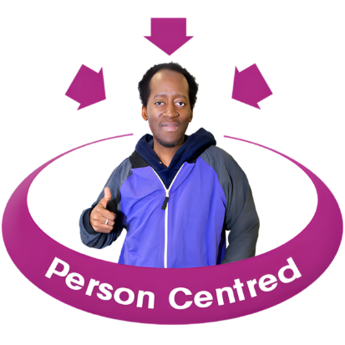
Before using a Restrictive Practice, providers must:

- Think about what is best for the person.

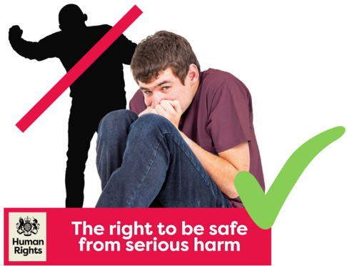

- Avoid doing harm



- Respect what the person wants

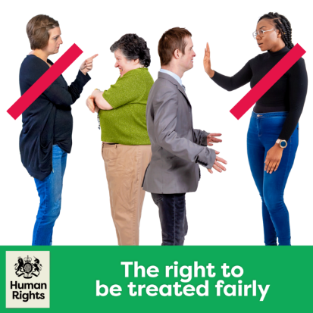

- Make sure things are fair

What types of Restrictive Practices are there?
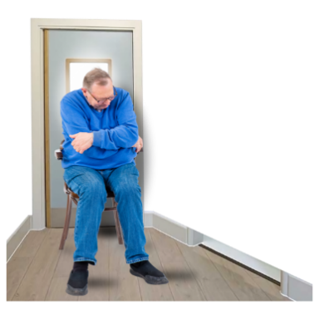
- Seclusion
Locking someone in a room alone so they cannot leave.


- Chemical restraint
Using medicine to control behaviour (not for health conditions)

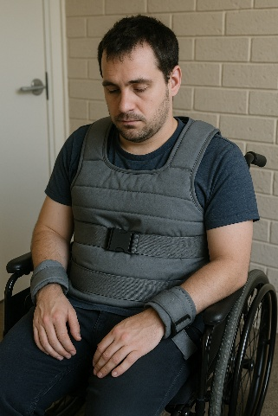
- Mechanical restraint
Using equipment to stop movement


- Physical restraint
Holding someone’s body to stop movement (not gentle guiding)

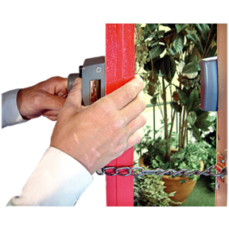
- Environmental restraint
Stopping access to spaces, items, or activities.

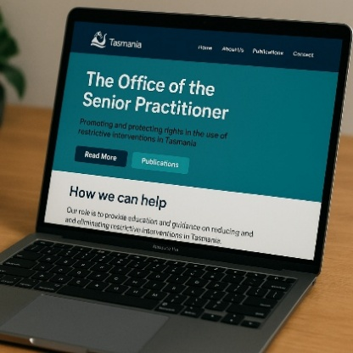
- Other practices
Decided by the senior Practitioner.

They will be published on the website here.

What if there is an emergency?


Sometimes a restrictive practice is used quickly in an emergency to stop serious harm.


It must be the least restrictive.

Providers must report it to the Senior Practitioner within 5 days.

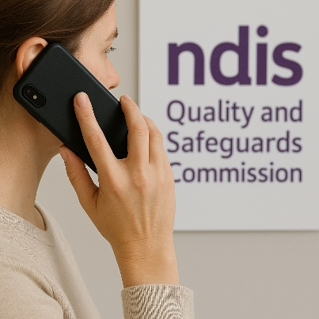
It may also need to be reported to the NDIS Commission.

What are Prohibited Practices?
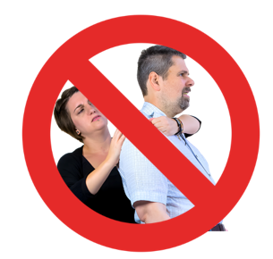
These are dangerous and must NEVER be used.

They are illegal and may be abuse or neglect.

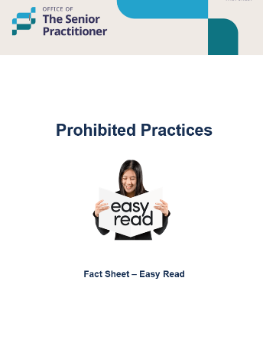
For more, see the ‘Prohibited Practices’ Factsheet.

How do providers get permission?

To use a Restrictive Practice, providers must apply to the Senior Practitioner.

The Senior Practitioner can:
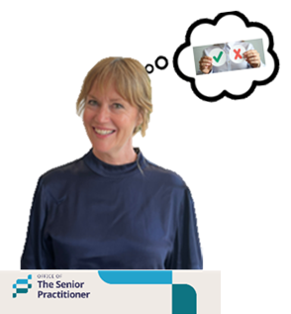
- Say yes

- Say yes, with rules

- Say no

If the Senior Practitioner says no, the provider can:

- Ask the Senior Practitioner to think about it again, or


- Go to the Tasmanian Civil and Administrative Tribunal.
We say TASCAT for short.

TASCAT is a place where people can go to get help to solve problems or disagreements in a fair and safe way.

Important Principles


The law says that restrictive practices should:

- Only be used when nothing else works


- Be the least restrictive way

- Be used for a short time



- Be fair and only be used to keep someone safe.

What is Positive Behaviour Support?

Positive Behaviour Support is a respectful and safe way to support someone.


It:

- Understands why behaviour happens


- Teaches new skills

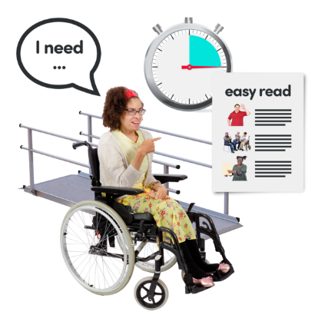

- Changes the environment



- Helps the support team work better

- Improves quality of life.

For more information


For more fact sheets and information about the Act, go to:
Department of Premier and Cabinet


Speak Out Tasmania created this Easy Read document using Photosymbols and custom images. The images may not be reused without permission. For any enquiries about the images or Easy Read, please email: easyread@speakoutadvocacy.org

