2013 workforce Survey

Overview

Responses and respondents
A total of 5 136 Tasmanian state service employees responded to the Tasmanian State Service Workforce Survey 2013. This represents a response rate of 32 per cent. Apart from a stratified sample in Education that excluded schools, the results can be confidently taken to express the views of the state service population.

The following profiles respondents across three key demographics (gender, age and years of service).

Of the 5 136 who completed the survey 63.97 per cent were female, 34.78 per cent were male and 1.25 per cent registered in the ‘other’ category.

Highest responses (35.46 per cent) were in the 45-54 year age range followed by 24.39 per cent 35-44 years and 22.11 per cent were 55-64 years. Lowest responses 1.44 per cent were from those 65+ followed by 2.16 per cent in the 15-24 years and 14.44 per cent were 25-34 years.

The majority (24.54 per cent) indicated they had worked in the State Service for 5 years to less than 10 years followed by 23.73 per cent with more than 20 years of service. 5.72 per cent of respondents have been in the service less than 1 year.

Issues during the Survey
Reporting of response problems were part of a wider problem of coverage by the Telstra core infrastructure and the Quinntessential servers. SSMO worked with both Networking Tasmania and Quinntessential to resolve the issue during the survey. Most activity was recorded on Wednesday 22 May with 99 per cent of successful requests to the survey site.
A similar issue at the reporting end for Agencies accessing reports has also now been resolved.

Minimising and improving access before the next survey
The factors which influenced the coverage and response rates were not directly attributable to the proxy infrastructure or the survey methodology. Followup activities for the next survey will include backend infrastructure management.

Achieving and maintaining acceptable response levels requires good management with repeating surveys and, if neglected, nonresponse tends to increase over time. This can be because frames and samples need to be kept to a common date timeframe.

Minimising the total load placed on respondents by stratifying questions further will also help to maintain or improve response levels. Other strategies include:
- good communication practices and relationship management
- sound operational management
- good record of protection of the confidentiality of information provided

Emerging trends
The following table shows a summary of top 5 questions grouped by the number of respondents who answered positively. Percent positive is the number of respondents who selected a rating point of ‘strongly agree’ or ‘agree’. This excludes those who selected ‘don’t know’ or did not provide an answer.

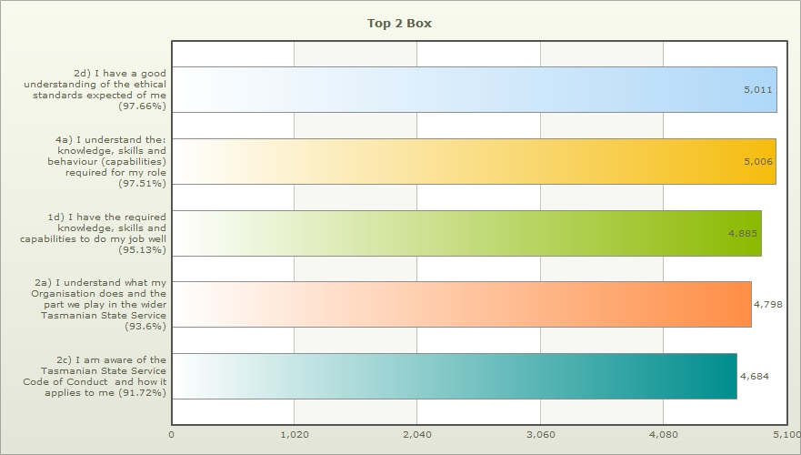
Performance management overall scores are lowest (32.76 per cent) for the management of poor performance. While employees generally have positive experiences of their own performance management, ratings of how poor performance is handled are low.
The table below shows a summary of bottom 5 questions grouped by the number of respondents who answered negatively ie ‘Disagree’ and ‘Strongly Disagree’.
