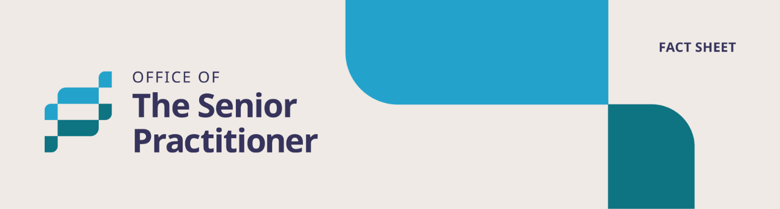

**Prohibited Practices**



# **Fact Sheet – Easy Read**

**What is this fact sheet about?**

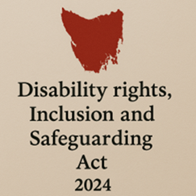

We have a new law in Tasmania.

It is called the *Disability Rights, Inclusion and Safeguarding Act 2024.*

We call it the Act for short.

There are lots of changes being made because of the new Act.

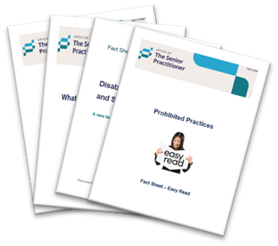

We have written some fact sheets explaining the changes.

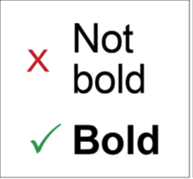We wrote some hard words in **bold**.

This means the letters are thicker and **darker**.

We explain what the hard words mean.

## Warning

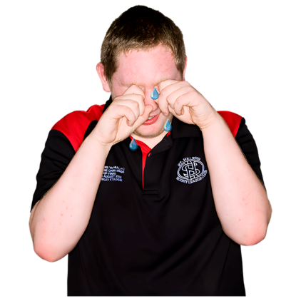

In this fact sheet we talk about things that might upset some people.

There are also pictures of abuse.



If you think these might be upsetting, ask someone to help you read it.

A blue text on a white background. Lifeline logo.



You can also call lifeline if you need to talk to someone.

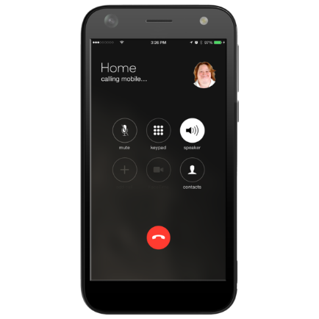

Phone:

13 11 14

## What are Prohibited Practices?

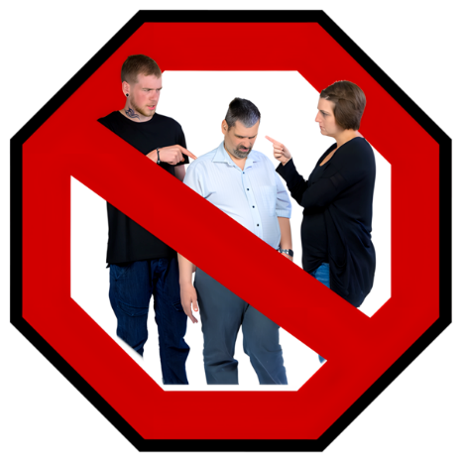

Some actions are very dangerous and must never be used on a person with disability.



These actions can hurt your body or mind.

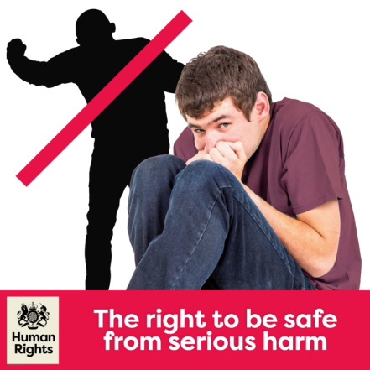

They can also take away your human rights.

These actions are called prohibited practices

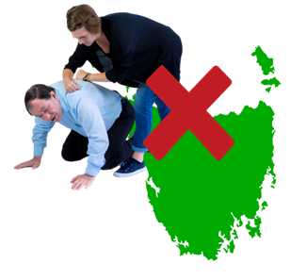Prohibited practices are not allowed in Tasmania.

They are against the law

## What are banned practices?

Here are some examples of things that are not allowed:

Physical restraints – holding or forcing you in a dangerous way.



1. Forcing you face-down on the floor.

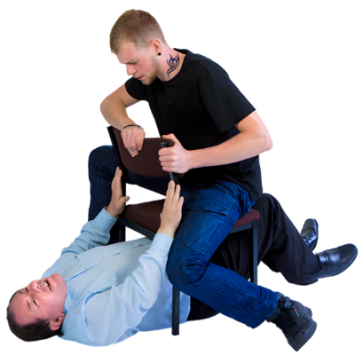

1. Forcing you face-up on the floor.

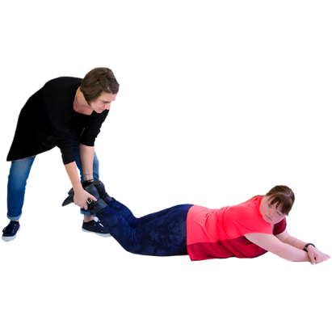

1. Holding down your arms or legs.



1. Someone wrapping their arms or legs around you.

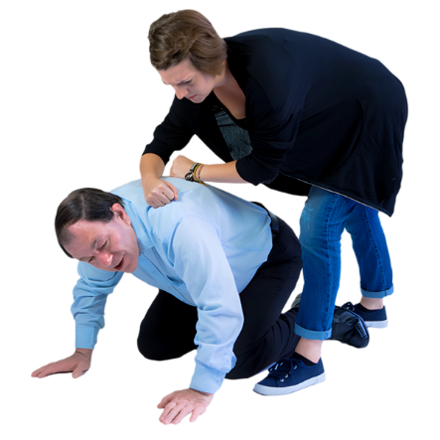

1. Forcing you to the ground.

A woman holding a a man around the throat.



1. Holding you is a way that makes it hard to breathe or eat.
2. 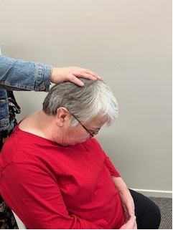Pushing your head down to your chest
3. Using pain or pressure to make you follow the rules

## Punishments - hurting someone on purpose

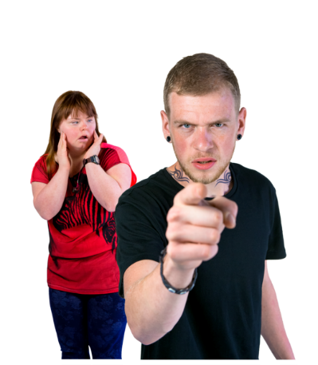

1. Hurting you to stop you behaving in a certain way – like using chilli, cold water or threats.

A male support worker pointing at a woman who is scrubbing the floor, she looks upset.



1. Making someone do too much - like cleaning the whole house because they made a small mistake.

A woman with Down Syndrome holding a picture of her family. A support worker is holding up his hand suggesting she cannot see them.


1. Being stopped from seeing family or using important things - like toilet paper.
2. Saying or doing mean or shameful things.
3. a Traditional Indian woman with a by a  person covering her mouth with their hand.

   Stopping someone from taking part in their culture, language or community.



1. Taking away something good as a punishment – like cancelling a fun outing.

## These actions are never okay.

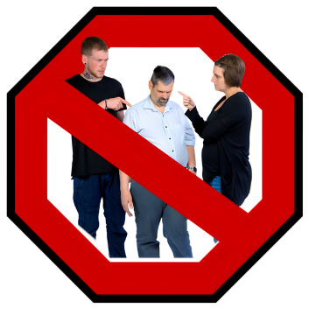

Having any of these things done to you can be abuse or neglect.

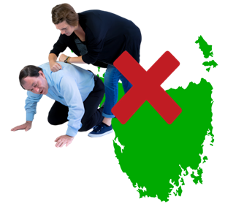

They are banned under Tasmanian law.

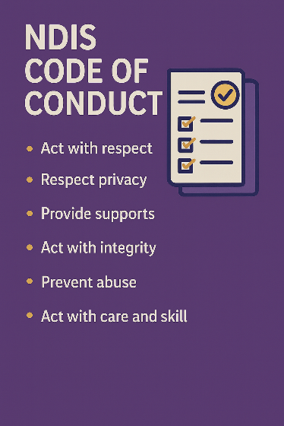

They also break the NDIS **Code of Conduct**.

**Code of Conduct** are rules of how people must behave and act if they provide services to you.

## What must services do if this is happening?

If a worker or service, see or hear of any of this happening:

They must:

* Stop the practice
* Make sure the person is safe

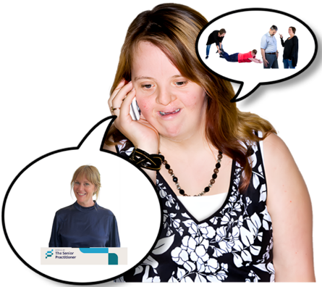

* Tell someone in charge
* Report it

They can tell:

* The Senior Practitioner Tasmania
* Tasmania Police
* Tasmanian Disability Commissioner



* NDIS Quality and Safeguarding Commission
* Strong Families Safe Kids (if the person is under 18)
* Office of the Independent Regulator

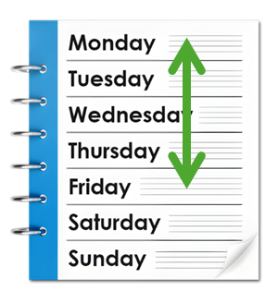

Services have 1day to report any of these actions.

## Your Human Rights

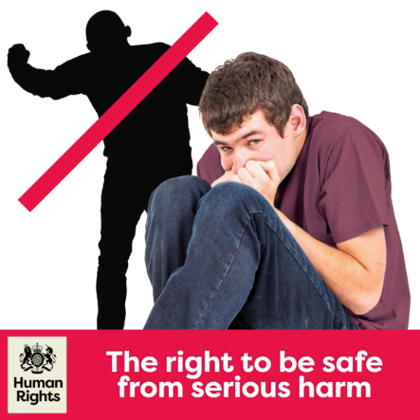Everyone has the right to be:

* Safe
* Treated with Respect
* Free from harm or abuse

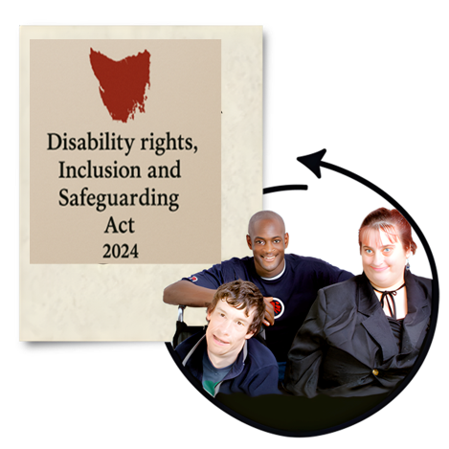People with disability must be treated fair and equally like everyone else in Australia.

## For more information and fact sheets



For more information about the Act and Fact Sheets go to:

[Department of Premier and Cabinet](https://www.dpac.tas.gov.au/divisions/cpp/community-and-disability-services/office-of-the-senior-practitioner)



Speak Out Tasmania created this Easy Read document using Photosymbols and custom images. The images may not be reused without permission. For any enquiries about the images or Easy Read, please email: easyread@speakoutadvocacy.org