Agency Implementation of the Disability Framework for Action 2017
  - Premier’s Disability Advisory Council
Communities, Sport and Recreation
Department of Premier and Cabinet
November 2017

Copyright State of Tasmania
ISBN :
Date :
Version:

Disclaimer for as many lines as needed Epuditis quatis moloreped quam consequi bea quatem. Itatect urepudis maio. Nem fugiant que velis aboreptatque res excea sam, unt, voluptas erum faci reperias de saperfer Dae. Git eius experiaecte de sae conseris ellenis sin coratur magnimo luptatur sae nosam nihilit que del in niendis imagnienimus maionsequia con et voluptatint que ducipiduciis earia a vel ius expediorem inusapi ciliti alite voluptasitas et ea sinia
Table of Contents
Acronyms 5
Purpose of this report 6
Role of the Premier's Disability Advisory Council in monitoring the DFA 6
Attendance of Heads of Agencies at formal PDAC meetings 6
Executive Summary 7
PDAC activity 7
Key achievements in each action area 7
Whole of Government recommendations 12
PDAC’s recommendations to Agencies 12
Background 15
The Disability Framework for Action 2013-2017 15
The National Disability Strategy 15
Tasmanian Government’s membership of Australian Network on Disability (AND) 16
Agency by agency 17
Key progress across government 17
Which agencies stood out? 18
Future reporting 18
What works well? 19
What needs improvement? 19
Department of Health and Human Services/Tasmanian Health Service (DHHS/THS) 19
Department of Education (DoE) 21
TasTAFE 24
Department of Treasury and Finance (Treasury) 26
Department of Police, Fire and Emergency Management (DPFEM) 27
Department of Justice (DoJ) 28
Department of Premier and Cabinet (DPAC) 30
Department of State Growth (State Growth) 33
Department of Primary Industry, Parks, Water and Environment (DPIPWE) 34
Appendix 1 – Disability Governance – The reporting framework 37

Acronyms

DAP Disability Action Plan
DDA Disability Discrimination Act 1992 (Cth)
DFA Disability Framework for Action 2013-2017
DHHS/THS Department of Health and Human Services and Tasmanian Health Service
DoE Department of Education
DoJ Department of Justice
DPAC Department of Premier and Cabinet
DPFEM Department of Police, Fire and Emergency Management
DPIPWE Department of Primary Industries, Parks, Water and Environment
ICT Information and Communications Technology
IEP Individual Education Plan
NDS National Disability Strategy
NDIA National Disability Insurance Agency
NDIS National Disability Insurance Scheme
PEEP Personal Emergency Evacuation Plan
PDAC Premier’s Disability Advisory Council
State Growth Department of State Growth
Treasury Department of Treasury and Finance
WCAG 2.0 Level AA Web Content Accessibility Guidelines 2.0 Level AA (current accepted standard for web accessibility for all levels of Government in Australia)

Purpose of this report
The Disability Framework for Action 2013-2017 (DFA) is a whole-of-government policy aiming to remove barriers and enable people with disability to enjoy the same rights and opportunities as all other Tasmanians. It identifies four action areas for the annual agency reports:
- Access to services and programs;
- Access to employment opportunities, career development, retention and recruitment;
- Access to buildings, facilities, venues and off-premises events; and
- Access to information (printed materials, websites, audio and video).
The Premier’s Disability Advisory Council (PDAC) reviews agency actions and outcomes in relation to the DFA that have been achieved over the last 12 months. All members are invited to review the Agency reports. This report brings together their feedback to:
- highlight agencies that have made substantial progress and/or achieved significant outcomes;
- showcase initiatives that demonstrate good practice;
- note areas where stronger commitment and concerted action is required from agencies; and
- make recommendations to inform agency and whole-of-government actions and priorities over the next 12 months.

Role of the Premier's Disability Advisory Council in monitoring the DFA
PDAC is chaired by the Premier of Tasmania and includes the Minister for Human Services as a permanent member. The 11 community members are people with disability or people who have strong community connections to people with disability, their families and carers. The Chair of the Minister’s Disability Advisory Council, which reports to the Minister for Human Services, is an ex-officio member of PDAC.
PDAC’s role is to:
- provide advice on services, policies and programs that have an impact on people with disability;
- promote awareness of the needs, rights and aspirations of people with disability; and
- monitor the Government’s progress in removing barriers to the participation of people with disability.
The governance of the DFA and other initiatives relating to improving outcomes for people with disability are outlined in Appendix 1.

Attendance of Heads of Agencies at formal PDAC meetings
Since 2008, Heads of Agencies have met formally with PDAC to discuss their agency’s implementation of the DFA.
On 12 December 2016, the Secretary of the Department of Education (DoE) and the Deputy Secretary of Department of Primary Industries, Parks, Water and the Environment (DPIPWE) met with PDAC to report on the progress their agencies are making in relation to the DFA. On 3 July 2017, the Secretary of the Department of Justice (DoJ) and the Secretary of the Department of State Growth also reported to PDAC.
PDAC thanks Ms Jenny Gale (DoE), Mr Tim Baker (DPIPWE), Mr Simon Overland (DoJ) and Mr Kim Evans (State Growth) for their presentations. PDAC members find these meetings with agency heads extremely valuable. Members appreciate the candour of the discussion and the commitment to improving outcomes for people with disability.

Executive Summary

PDAC activity
PDAC members continue to be very active in supporting the Tasmanian Government to implement its disability agenda. In addition to attending two formal and three out-of-session meetings, PDAC members have:
- Assisted with the recruitment and selection of new PDAC members.
- Participated in community consultation on the Disability Framework for Action 2018-2021.
- Represented Tasmania on the National Disability and Carers Council.
- Chaired the Minister’s Disability Advisory Committee.
- Held a workshop with the Regional Manager of the National Disability Insurance Agency (NDIA) to discuss implementation and rollout issues.
- Participated in the Metro Tasmania Disability Action Plan (DAP) 2011-2022 consultation forums.
- Met with Metro Tasmania about bus infrastructure in Launceston.
- Contributed to the development of the Disability Justice Plan.
- Met with the Department of State Growth and Hobart City Council in regard to the regulation of Accessible Parking Permits.
- Discussed pedestrian crossings and refuges with the Department of State Growth and local government.
- Contributed to the development of improved performance indicators for the DPAC Disability Action Plan.

Key achievements in each action area
This will be the last report under the current DFA. PDAC members have taken the opportunity in reviewing Agency Action Plans to reflect on the achievements to date, noting that there is still work to be done.

Action area 1: Access to services and programs
Agencies recorded strong performance over the year in Action area I. Actions included improving the provision of services aimed at people with disability such as the National Disability Insurance Scheme (NDIS), as well as improving accessibility to events such as AgFest. Staff training was a major focus for agencies.
Department of Health and Human Services (DHHS)/Tasmanian Health Service (THS)
- Plans approved for 1877 participants in the NDIS.
- Commencement of transition for Tasmanians aged 4-11 years old to the NDIS.
- Over 600 providers registering to deliver NDIS supports in Tasmania.

DoE
- Implemented the Family Partnership Model Program.
- Partnered with the Professional Learning Institute (PLI) and the University of Tasmania to develop a new Graduate Certificate in Inclusive Education for school teachers.
- Provided one FTE for each support/special school for the position of Education Support Specialist.
- Introduced a three-year Speech Language Pathology Literacy Project to support classroom teachers and literacy specialists with literacy outcomes.
- Provided an online professional learning package, Inclusive Teaching for Students with Disability, to all learning settings through the PLI.
- Provided home library services through LINC Tasmania to people who are unable to physically access a library themselves.
- Provided free attendance to carers supporting learners with disabilities to Community Learning courses. Three carers were recipients during 2016-17.
TasTAFE
- Phasing out the previous Learning Management System (LMS), Fronter, and replacing it with a contemporary LMS, Canvas.
- Provided teachers with a course suitability form, making them more aware of how accessible their courses are to the needs of students with disability.
- Worked with the Tasmanian Hospitality Association and Job Network providers on a Hospitality Awareness Program.
Department of Treasury and Finance (Treasury)
- The relocation of the Revenue, Gaming and Licensing Services to the Parliament Square development in September 2017. The building has improved accessibility for people with disability compared to the previous location, as a result of consultation with stakeholders and clients.
Department of Police, Fire and Emergency Management (DPFEM)
- Implemented an online mechanism for people with disability to provide feedback on barriers within the agency.
- Delivered training to all police trainees on interacting with people with disability.
DoJ
- Established and recruited a High Needs Support Counsellor – Disability role.
- Development of the Disability Justice Plan for Tasmania.
Department of Premier and Cabinet (DPAC)
- Completed review of Tasmania’s Structural Recovery Arrangements and drafted a revised State Recovery Plan.
- Develoed a whole-of-government Accessible Events Checklist for Government agencies.
State Growth
- Replaced Skills Tasmania’s Equity programs with the Training and Work Pathways Program.
DPIPWE
- Invested in new AgFest displays for the Aboriginal Heritage, Analytical Services and Water and Marine Resources stands to enable greater accessibility.

Action area 2: Access to employment opportunities, career development, retention and recruitment
PDAC noted that this was a strong area of development by most agencies. Agencies have worked to increase the accessibility of job vacancies to people with disability, as well as adapting the workplace for employees with disability. The strongest performing agencies were State Growth and Justice which developed new plans and established working groups to assist with policymaking and processes in this space.
DHHS/THS
- Supported the implementation of the Workplace Adjustment Policy through the Workplace Adjustment Procedure.
- Supported the whole-of-government initiative to establish a State Service eLearning module on disability awareness with the Australian Network on Disability (AND).
DoE
- Successfully implemented new HR selection procedures.
TasTAFE
- Reviewed employment application guidelines to raise awareness of candidates advising of any special access requirement.
- Reviewed selection procedures to highlight the ability to make reasonable adjustments to accommodate candidate’s access requirements as part of the selection process.
Treasury
- Introduced a formal policy and approach to flexible work which provides a framework to support an ‘if not, why not’ approach to decision-making on requests for flexible working arrangements.
- Providing unconscious bias training for all staff, including about people with disability.
DPFEM
- Personal Emergency Evacuation Plans (PEEPs) are now routine in most workplaces, including the Rokeby Academy.
DoJ
- Recruited six people from a Disability Employment Provider.
- Established a case management forum at Risdon Prison to discuss prisoners with disabilities and manage issues arising from their sentence and reintegration into the community.
DPAC
- Launched the Diversity and Inclusion Policy and Framework and the Workplace Adjustment Policy Template.
State Growth
- Developed the agency’s LMS.
- Finalised the Unpaid Work Framework.
DPIPWE
- Revised the Induction Checklist for new employees.
- Developed eInduction package.

Action area 3: Access to buildings, facilities, venues and off-premises events
Agencies have undertaken a significant level of works and redevelopment of properties and facilities to ensure accessibility for people with disability. Key projects include public walking trails being improved for wheelchair access, the redevelopment of education facilities for students with disability and improved accessibility for social housing.
DHHS/THS
- Worked closely with a disability access consultant to ensure DHHS/THS has an audit of the accessibility of all the facilities it directly manages and a prioritised list of recommended remedial actions.

DoE
- Redevelopment of Northern Support School Ravenswood campus, including a pool, hall, sensory room and outdoor play areas.
- Undertaken 37 projects to construct and upgrade ramps and grab rails, fencing and gates and toilet facilities at DoE-owned facilities.
- Undertaken the Capital Investment Programme 2016-17, which provides a range of new facilities and upgrades to existing facilities in schools.
TasTAFE
- Installed a lift to Service Block B at the Devonport campus.
Treasury
- Shared the accessibility initiatives from the fit-out design for Parliament Square with other agencies.
DPFEM
- Undertook minor works were undertaken to improve disability access to premises and facilities, including the main entrance of the Rokeby Academy, the Launceston Police Station and the Devonport Police Station.
DoJ
- Conducted building audits conducted to ensure DoJ-owned and leased properties provide appropriate access and support to people with disability.
- Undertook works to address access and support issues to DoJ-owned buildings, including the Hobart Supreme Court.
- Developed a departmental policy and procedure which specifies the disability access requirements that all new developments, rentals and refurbishments must meet.
- Require 100 per cent of Social Housing new builds in Tasmania to include accessibility in their design, with 20 per cent of those homes being built to the platinum universal standard.
DPAC
- Redeveloped the Glenorchy Service Centre during the LINC refurbishment to make it more accessible for people with disability.
State Growth
- Through a detailed accommodation review, the agency has been able to influence some design aspects of workspaces and processes as part of consultation processes with employees.
DPIPWE
- Parks and Wildlife Service has upgraded the popular viewing platform on the shore of Lake St Clair.
- A range of walking trails have been made accessible for people with disabilities, including the provison of wheelchairs to access these sites.

Action area 4: Access to information (printed materials, websites, audio and video)
Agencies continue to ensure websites are WCAG 2.0 Level AA to improve accessibility for people with disability. This has included training web designers and editors so they are skilled in developing and managing accessible webpages and web content. Accessibility is aimed at people with auditory or visual impairments as well as plain English for people with low literacy skills.
A number of agencies have also developed fact sheets that provide information to people with disability on accessing services agencies provide. A notable example is the State Growth fact sheets for people with disability who wish to drive vehicles.
DHHS/THS
- Incorporated accessibility requirements into the training that all website editors receive.
- Provided website editors with ongoing support and guidance about how to ensure that website content is accessible.

DoE
- Improved website accessibility in line with PDAC’s 2017 key recommendations, such as providing training workshops for content editors.
- LINC Tasmania hosted community events during Mental Health Week.
TasTAFE
- Tested new software to enable CISCO handsets to be more appropriate/suitable for employees with visual impairments.
- Internal development of a Microsoft Access frontend to record log entries and view some student data within the student management system for those with a visual impairment.
Treasury
- Migrated the agency’s website to a new platform that is in line with WCAG 2.0 Level AA accessibility guidelines.
- Provided training to employees on creating accessible web content.
DPFEM
- Tasmania Police Service, Forensic Science Service Tasmania (FSST) and State Emergency Service (SES) internet pages all meet WCAG 2.0 Level AA.
DoJ
- Completed the review and upgrade of three agency websites (Guardianship and Administration Board, Equal Opportunity Tasmania and Justice Corporate [internal]) to achieve compliance with accessibility requirements for content and design.
- Completed a review of Director’s Standing Orders on Prisoners with Disability to finalise and make available for routine disclosure on the DoJ website.
- Engaged a 26TEN contractor at the Tasmanian Prison Service to providing training to key staff around easy read material.
DPAC
- WCAG 2.0 Level AA compliance is now built into the editing environment, and has become part of web editing training.
- Implementing a ‘HTML First’ strategy to simplify the production of compliant documents for staff and consultants.
State Growth
- Development of educational material (Fitness to Drive – Physical Disability Fact Sheets) available on the internet for people with disability who wish to drive a car.
- All agency websites are WCAG 2.0 Level AA compliant.
DPIPWE
- Upgraded a number of websites to meet accessibility requirements, including Analytical Services Tasmania and Aboriginal Heritage Tasmania.

Whole of Government recommendations
PDAC recommends:
- Future reports to be more comprehensive, including providing updates on how the agency has responded to recommendations from the previous year.
- Initiatives relating to the employment of people with disability that have had positive outcomes to be shared between agencies as much as possible.
- Continue to engage with individuals with disability and organisations representing this cohort, and seek opportunities to improve levels of consultation.
- Agencies base improvements in service delivery and infrastructure on lead indicators instead of lag indicators, i.e. ensuring that infrastructure is compliant with existing guidelines instead of basing success on the number of complaints received from the public.
- Future reports provide timeframes on ongoing or commenced actions.
- Establish a goal to support people with disability accessing volunteer/work experience opportunities.
- Provide clear differentiations between outputs and outcomes in performance indicators.
- Ensure organisers of events, including private and not-for-profit organisations, who are receiving Government funding are aware of the Accessible Events Guidelines. PDAC recommends that this be made a condition of future funding agreements.

PDAC’s recommendations to Agencies

Department of Health and Human Services/Tasmanian Health Service
- Future reports should include a broader approach to disability beyond the transition to the NDIS, including to the carers and families of those with disability and Mental Health services.
- Progressing the action on providing children in Child Protection and Youth Justice with access to support and services funded through the NDIA as this is a particularly vulnerable group.
- Prioritise NDIS engagement strategies to assist people with disability who may not have engaged with services previously.
- Prioritise increasing access to employment opportunities for people living with psychiatric disability.
- Identify what success looks like of informing employers of the benefits of providing workplace flexibility.
- Future reports to include:
  - strategies to ensure employees with disability are appropriately supported and retained in the workplace;
  - updates on the number of staff who have completed the eLearning module and Plain English workshops.

Department of Education
- Ensure that staff and support staff use and make the most of the Student Support System.
- Future reports should detail the outcomes of Learning Plan audits in relation to the quality and appropriateness of the Individual Education Plans (IEPs), as well as the percentage of students achieving the goals identified.
- Consider collecting current baseline data on staff with disability to enable provision of trend data over time.
- Evaluation outcomes of the Family Partnership Model to be made available when completed.
- Future reports should:
  - Provide trend data on numbers of support teachers who feel confident in generating Learning Plans.
  - Include aggregated teacher assessments of the Inclusive Teaching for Students with Disability professional learning package.
  - Report outcomes of transitional support offered to school leavers with disability.
  - Provide updates in future reports of numbers of teachers completing a Graduate Certificate in Inclusive Education.

TasTAFE
PDAC acknowledges that TasTAFE faced time constraints in the preparation of its report, due to unforeseen circumstances. PDAC looks forward to hearing of TasTAFE’s developments in its Disability Action Plan (DAP) during the next reporting period in greater detail.
- Future reports to provide greater detail on feedback and outcomes of initiatives TasTAFE has implemented/is implementing, including:
  - Accessibility tools available on the TasTAFE intranet;
  - Project to review suitability processes across the organisation;
  - Capability development for managers;
  - Teaching Strategy personal development session;
  - Learning Access Plans;
  - TasTAFE Accessibility Policy.
- Share relevant materials in relation to personal evacuation plans with other agencies.
- Develop actions for ensuring that TasTAFE students who are attending the University of Tasmania Campus have access to accessible learning.
- Develop a plan to ensure all teaching materials are available in an accessible format for students on request.

Department of Treasury and Finance
- Share with other agencies the document used for selection panels addressing issues around the demonstration of merit and allowing reasonable adjustments be made for people with disability.
- Report on staff and community feedback from the sharing of accessible design features of the Parliament Square office accommodation.

Department of Police, Fire and Emergency Management
- Future reports to include updates on feedback and outcomes of initiatives such as the remodelling of the training package and the People Matter survey.
- Continue the review of the community alert systems used in emergency situations to ensure that people with disability can access emergency information in an accessible format.

Department of Justice
- Report on the outcomes of actions, including accessibility audits of DoJ facilities and assets, employment and work experience of people with disabilities, whole-of-government surveys and other initiatives.
- Explore further opportunities to consult with people with disability, particularly now that the development phase of the Disability Justice Plan is completed.
- Share information and learnings from a number of initiatives with other agencies, including:
  - The Disability Employment Provider;
  - Return to Work program;
  - The video tutorial on creating accessible documents.
PDAC looks forward to the release and implementation of the Disability Justice Plan, which will greatly improve access to justice for people with disability.

Department of Premier and Cabinet
- Improve levels of consultation with the disability community.
- Consult with PDAC on the Accessible Events Checklist for Government Agencies to ensure that emergency evacuation arrangements are included.
- Report on outcomes of the Accessible Events Checklist for Government Agencies and its promotion across agencies.
- Review the Action Plan reporting framework to better capture responses to recommendations in preceding year’s report.

Department of State Growth
- Share carer awareness information from online induction program with other agencies.
- Continue to fund programs such as Skills Potential, and share any learnings with the sector/key stakeholders.
- Continue to consult with the disability community on the Wheelchair Accessible Taxi framework.
- Report feedback on agency websites that have been modified to enable greater accessibility.
- Share the Reasonable Adjustment Passport with other agencies.

Department of Primary Industry, Parks, Water and the Environment
- Report on usage and feedback through the disability enquiries email account.
- Report on usage and feedback of the Engaging with People with Disability toolkit and other induction/training tools.
- Report on community feedback on improved accessibility of walking trails.

Background

The Disability Framework for Action 2013-2017
The DFA articulates a vision of a Tasmanian society that highly values and continually enhances the full participation of people with disability. Through the DFA, the Government has committed to a comprehensive rights-based approach to disability.
The DFA asserts that, like all Tasmanians, people with disability have the right to fully participate in and contribute to their community. However, it recognises that social, economic, structural and cultural barriers prevent people with disability from fully participating, contributing and achieving their potential.
The Tasmanian Government plays a significant role in ensuring the removal of barriers to participation as well as recognising and promoting the human rights of people with disability. The DFA describes the Tasmanian Government’s responsibility as follows:
- Undertaking meaningful consultation with people with disability, their families and carers to identify barriers to equitable access and participation in government programs, services, facilities and employment opportunities;
- enabling the meaningful participation of people with disability in the design and delivery of policies, programs and services; and
- ensuring that all employees understand, respect, and have the practical resources to respond to the rights of people with disability.
A new DFA for 2018-2021 is currently in development.

The National Disability Strategy
In 2011, all State and Territory governments and the Australian Government agreed to implement the National Disability Strategy 2010-2020 (the NDS). The current DFA is the Tasmanian Government’s implementation plan for the NDS.
The NDS sets out a ten-year national plan for improving life outcomes for Australians with disability, their families and carers. It plays an important role in protecting, promoting and fulfilling the human rights of people with disability. It helps ensure that the principles underpinning the UN Convention on the Rights of Persons with Disabilities are incorporated into policies and programs affecting people with disability, their families and carers. It also contributes to Australia’s reporting responsibilities under the Convention.
The NDS sets out six policy areas that are addressed in Tasmania’s DFA:
- Inclusive and accessible communities
- Rights protection, justice and legislation
- Economic security
- Personal and community support
- Learning and skills
- Health and wellbeing

Tasmanian Government’s membership of Australian Network on Disability (AND)
AND is a not-for-profit organisation that provides advice and support on disability issues to Australian, State and Territory Governments and private industry. Its corporate members include major banks, telecommunications companies, universities, and retailers. PDAC notes that in 2016, the Tasmanian Government commenced a 12 month trial as a gold member of AND.
As part of the trial membership, the Tasmanian Government agreed to pursue two key projects with the assistance of the AND – development of an online disability awareness training package and a whole-of-government Reasonable Adjustment Policy template. The template was completed during the reporting period and work is continuing on the development of the training package.
PDAC is pleased to note that all agencies agreed to renew the AND membership in 2017.

Agency by agency
This section provides an overview of each agency’s report, noting important initiatives. It makes recommendations for future action by each agency. PDAC thanks all agencies for their reports and acknowledges the commitment they have displayed over the past twelve months.

Key progress across government
Agencies made significant progress during the 2016-17 reporting period in improving employment opportunities and facility accessibility for people with disability.
Across government, agencies have been working on improving access to employment opportunities and career development for people with disability. A number of agencies (DoE, TasTAFE and DPIPWE) have undertaken new procedures to assist with the recruitment of people with disability, such as updating their selection procedures, improving induction procedures and reviewing application guidelines to assist candidates feel comfortable in disclosing their disability to agencies. These procedures will be reviewed regularly by agencies to ensure they match best practice.
Other agencies have established processes to improve current business practice and focus on making the work environment a safe place for employees with disability. For example, Treasury is providing unconscious bias training to staff, ensuring that employees become aware of behaviours that may inadvertently affect different people, including those with disability.
Most agencies have upgraded buildings and facilities to improve accessibility for people with disability. DPIPWE has upgraded many walking trails across the state and allowed for access to wheelchairs.
DoE has undertaken major works, including the redevelopment of the Ravenswood campus of the Northern Support School which saw the construction of a pool, hall and other facilities. DoE improved facilities through the construction of ramps, grab rails and toilet facilities. TasTAFE installed a lift at the Devonport campus of TasTAFE,
DPFEM and DoJ have improved facilities such as police stations and the Hobart Supreme Court to enable greater access to people with disability. This includes the construction of ramps and redevelopment of toilet facilities.
Other action areas have also seen some improvement over the period. Agencies have been working on improving access to services and programs, for example DHHS/THS are continuing the transition to the National Disability Insurance Scheme (NDIS). DoE partnered with the Professional Learning Institute and the University of Tasmania in order to develop a Graduate Certificate in Inclusive Education for school teachers.
DPIPWE invested in disability-friendly displays for stands for use at AgFest.
Agencies continue to work on ensuring their websites are WCAG 2.0 Level AA compliant, and to provide training web editors and designers to ensure they have the skills to make content accessible for people with disability.
Diversity and Inclusion Policy and Framework
In May 2017, the Tasmanian State Service launched the Diversity and Inclusion Policy and the supporting Diversity and Inclusion Framework.
The Framework addresses the overall barriers which prevent cohorts in Tasmania from equitable access to employment in the Tasmanian State Service, identifies strategies to support employees in the workplace, as well as ensure that within the State Service and across the community there is engagement and collaboration to support a diverse and inclusive workplace.
While the intent of the initiatives under the Framework is to address the barriers and promote inclusion for all diverse groups, there are some initiatives specific to people with disability. These are to:
- Establish a State Service Workplace Adjustment Policy template with the Australian Network on Disability; and
- Develop and implement an online eLearning package for all State Service employees to improve their awareness of ways to support people with disability when conducting government business, as well as in our workplaces.
PDAC notes that the Framework will complement and support other whole-of-government policies, including initiatives associated with the Disability Framework for Action.

Which agencies stood out?
A number of agencies stood out to PDAC members, for the successful implementation of actions in their DAPs and the quality of their reporting.
PDAC noted the report from DoE, finding it very thorough and detailed. DoE is to be congratulated on the range of initiatives recently introduced to implement the Ministerial Taskforce report and the KPMG consultation outcomes, as well as the Disability Discrimination Act 1992 Education Standards. DoE has demonstrated a strong intention to improve communication between various specialist staff, class teachers and parents. PDAC was also impressed with the level of data provided in the report, as well as comments provided by a teacher involved in the space. These show a real commitment on behalf of the agency to understand how service delivery is having an effect on students with disability.
State Growth and DoJ were also praised for their reports. These reports were well-written and highly detailed, and the candour of these reports was appreciated. These agencies have implemented initiatives that are positive and are likely to provide meaningful outcomes in accessibility for people with disability, either as clients or as employees, for example:
- State Growth recruiting an artist with disability to the Arts Advisory Board.
- State Growth helping to facilitate the employment of sixteen people with disability in the retail sector through the Skills Potential project.
- DoJ employing six people from a Disability Employment Provider, an increase of two from the previous year.
- DoJ having recorded messages built into the telephone queue at Risdon Prison to provide visitors with information about visits and visit rules.
PDAC would also like to acknowledge DPIPWE’s use of the colour-coding in its report, which made it more accessible to read.

Future reporting
This report is the final report of the DFA 2013-2017. PDAC, however, is of the view that agencies should not view this as an ‘end,’ and instead should view it as a foundation to build upon during the DFA 2018-2021.
PDAC acknowledges the strong results agencies have demonstrated under the current DFA, while also recognising that there are still areas that need improvement. PDAC is of the view that agencies should review feedback on their Agency Action Plans from this year and previous years. Agencies should continue to respond to and incorporate this in their reports under the DFA 2018-2021.

What works well?
Recruitment processes
PDAC congratulates DoJ and State Growth for the work they have undertaken to increase accessibility for employees with disability, as well as the recruitment of people with disability. PDAC recommends that learnings from these processes be shared across agencies to increase accessibility and employment opportunities on a whole-of-government level.
Accessible Events Guidelines
PDAC welcomes the introduction of the Tasmanian Government Accessible Events Guidelines by agencies. PDAC would like agencies to ensure that event organisers (including private and not-for-profit) who are in receipt of Government funding are aware of the Accessible Events Guidelines. PDAC recommends that this be made a condition of future funding agreements.

What needs improvement?
Comprehensiveness of reporting
PDAC continues to urge agencies to provide information on expected timeframes, outcomes of initiatives and feedback from staff and the public. There are examples in the agency reports of performance indicators lacking specificity and describing inputs, outputs and activities rather than outcomes. This was suggested as an area for improvement in the 2016 report. The development of the new Disability Framework for Action 2018-2021 provides an opportunity to review the reporting template for agencies to include follow-through on recommendations and suggestions in previous reports. PDAC welcomes DPAC’s commitment to review the reporting framework.
Consultation
PDAC would like to see improvement in consultation with people with disability. Overall, agencies indicated that they had engaged with the sector during the reporting period. In future reporting, however, PDAC suggests that agencies factor into planning processes the impact on people with disability. This should include activities and initiatives that are not specifically aimed at people with disability or the Disability Action Plan. Where possible, such assessments should seek to include specific consultation with representatives of people with disability. Each agency should establish effective consultative relationships with key people who could add value to agency activities.

Department of Health and Human Services/Tasmanian Health Service (DHHS/THS)
The report outlines the activities of both the DHHS and THS.
DHHS/THS have undertaken a number of policy and program developments over the reporting period to progess actions and targets in the Disability Action Plan 2013-2017. A significant focus for DHHS/THS has been the rollout of the NDIS. As at 31 March 2017, 1877 participants in the NDIS had approved plans.
Disability and Community Services secured $3.2 million in 2016-17 Sector Development Funding. During the coming reporting period a number of Sector Development projects will begin implementation, including:
- Establishment of an expert panel to enable capacity building for providers;
- Increasing the supply and availability of the allied health workforce in regional, rural and remote areas of Tasmania;
- Developing resources that support people with disability to access mainstream and community services and improving access in regional, rural and remote areas through the use of audio-visual equipment; and
- Developing and implementing engagement strategies to assist people with disability who may not have engaged in services previously to participate in the NDIS.
Work is underway to support people with disability in gaining employment in DHHS/THS, including the introduction of resources to provide workplace adjustments to support those working or seeking to work at the agencies. DHHS has been actively involved in a number of whole-of-government initiatives to support the employment of people with disability, such as the development of an online disability awareness training module for State Service agencies.
DHHS/THS remain committed to maintaining and strengthening their relationships with people with disability. During the reporting period, the agencies consulted with a range of stakeholders including community groups, organisations and individuals with disability to inform activities. Disability and Community Services continued to support the Minister’s Disability Advisory Committee (MDAC), and consulted MDAC in relation to a number of strategic projects and policy developments.
In future reporting, PDAC encourages DHHS/THS to expand their reporting on to include:
- The large cohort of people with disability who will be ineligible for the NDIS, and what developments in services are planned;
- Developments in the mental health sector;
- Progressing the action on providing children in Child Protection and Youth Justice with access to support and services funded through the NDIA as this is a particularly vulnerable group;
- Statistics and outcomes from developments in DHHS/THS staff, such as eLearning module training and Plain English workshops.

Action area 1: Access to Services and Programs
Achievements in this period include:
- Strong levels of access to the NDIS. As at 31 March, 1877 participants in the NDIS had approved plans. The NDIS continues to be the most significant reform for people with disability and providers of disability services in Tasmania.
- Commencement of transition for Tasmanians aged 4-11 years olds to the NDIS. An Early Childhood Early Intervention approach is being implemented to ensure that children with disability or developmental delay can access early interventions.
- Over 600 providers registering to deliver NDIS supports in Tasmania.

Action area 2: Access to Employment Opportunities, Career Development, Retention and Recruitment
Achievements in this period include:
- Launching the Workplace Diversity Plan, following the release of the State Service Diversity and Inclusion Framework and Policy. The Plan refers to a number of initiatives in relation to employment to support stronger outcomes for people with disability.
- Supporting the implementation of the Workplace Adjustment Policy through the Workplace Adjustment Procedure. This outlines the processes employees and managers can use to support current employees (and candidates for DHHS/THS vacancies) with disability to receive adjustments. A new Return to Work Guide has been developed which includes information for employees and managers about how to support workplace adjustments during the return to work process.
- Supporting the whole-of-government initiative to establish a State Service eLearning module on disability awareness with the AND.

Action area 3: Access to Buildings, Facilities, Venues and Off-Premises Events
Achievements in this period include:
- Working closely with a disability access consultant to ensure a DHHS/THS audit of the accessibility of all facilities that are directly manages and a prioritised list of recommended remedial actions.

Action area 4: Access to Information (printed materials, websites, audio and video)
Achievements in this period include:
- Incorporating accessibility requirements into the training that all website editors receive.
- Providing website editors with ongoing support and guidance about how to ensure that website content is accessible.

Recommendations:
- Future reports should include a broader approach to disability beyond the transition to the NDIS, including to the carers and families of those with disability and Mental Health services.
- Progressing the action on providing children in Child Protection and Youth Justice with access to support and services funded through the NDIA as this is a particularly vulnerable group.
- Prioritise NDIS engagement strategies to assist people with disability who may not have engaged with services previously.
- Prioritise increasing access to employment opportunities for people living with psychiatric disability.
- Identify what success looks like of informing employers of the benefits of providing workplace flexibility.
- Future reports to include:
  - strategies to ensure employees with disability are appropriately supported and retained in the workplace;
  - updates on the number of staff who have completed the eLearning module and Plain English workshops.

Department of Education (DoE)
PDAC congratulates DoE for a strong and comprehensive report for the 2016-17 period. PDAC notes DoE’s significant progress against the three recommendations made by PDAC in 2016.
DoE has undertaken an extensive consultation with a range of partners, leading to a revision and reissuing of IEPs and the Learning Plan Procedure, and has also committed to undertaking an audit of 33 per cent of all Learning Plans for students with disability. PDAC applauds DoE for its strong level of consultation with stakeholders and looks forward to seeing this continue in the future.
DoE delivered accessibility training for content editors during 2017. Resources for training are currently being updated and will be introduced by all identified content editors from August to December 2017. DoE has also focussed on improving the accessibility of public websites, including its homepage. This was updated in early July 2017 on the WordPress platform. 100 public school websites have been identified to be upgraded and this work is currently in progress.
The professional learning provided to teachers through the University of Tasmania is a notable achievement. PDAC would like to see updates in future reports on numbers of teachers completing Graduate Certificates in Inclusive Education.
PDAC was also pleased to see an independent evaluation process for measuring the satisfaction and experience of parents of children with disability, and the school staff working with students in Tasmanian Government schools.
PDAC is impressed with the level of work DoE has undertaken to improve accessibility and outcomes for students and employees with disability, and looks forward to advice on ongoing developments in future reports.

Action area 1: Access to Services and Programs
Achievements in this period include:
- Releasing the Nurturing Unique Abilities – Supporting Students with Disability 2017 booklet to provide an update on DoE’s progress in relation to implementing the recommendations from the Ministerial Taskforce Report.
- Addressing priority areas identified through the Ministerial Taskforce Report – Support for Students with Disability through programs and initiatives such as:
  - Establishing the Inclusion Advisory Panel to provide advice to the Minister on the opportunities and barriers to implementing the recommendations by the Ministerial Taskforce. The Panel is made up of stakeholders across Government, Catholic and independent schools.
  - Implementing the Family Partnership Model Program. Professional learning and school-based inquiry was fully booked for the 2016 program, with 29 schools participating. In 2017, 19 schools have participated to date.
  - Partnering with the Professional Learning Institute (PLI) and the University of Tasmania to develop a new Graduate Certificate in Inclusive Education for school teachers. 25 teachers so far have participated in this program.
  - Providing one FTE for each support/special school for the position of Education Support Specialist.
- Increased focus on Learning Plans. Following consultation with a range of partners, IEP guidelines and the Learning Plan Procedure were revised in 2016 and reissued in March 2017. These provide greater clarity to staff regarding DoE expectations of personalised planning for students with disability.
- Upgrading the Student Support System, enabling professional support teams to upload student information in a more efficient and accessible manner.
- Introduction of the three-year Speech Language Pathology Literacy Project to support classroom teachers and literacy specialists with literacy outcomes. This program has a 2.2 FTE allocation to support schools with professional learning, and in-school programs to support phonological awareness and literacy development.
- Revising the Respectful Schools, Respectful Behaviour booklet through consultations with internal and external stakeholders. The revision reinforces key messages of the Safe Homes, Safe Families Action Plan as well as the key drivers of inclusive practice.
- Achieving or exceeding all outcome targets of the More Support for Students with Disability National Partnership Agreement.
- Providing support teachers with professional learning to facilitate networking and collaboration. This includes attending professional learning during Term 2 2017 which focused on Nationally Consistent Collection of Data moderation activities.
- Providing an online professional learning package, Inclusive Teaching for Students with Disability, to all learning settings through the PLI.
- Providing home library services through LINC Tasmania to people who are unable to physically access a library themselves.
- Providing free attendance to carers supporting learners with disabilities to Community Learning courses. Three carers were recipients during 2016-17.

Action area 2: Access to Employment Opportunities, Career Development, Retention and Recruitment
Achievements in this period include:
- Successfully implementing the new HR selection procedures. These ensure that all selection processes are undertaken in a fair and transparent manner in accordance with the merit principle and include a provision for utilising alternative assessment formats where reasonable adjustment is required for applicants with a disability.

Action area 3: Access to Buildings, Facilities, Venues and Off-Premises Events
Achievements in this period include:
- Redeveloping the Northern Support School Ravenswood campus, including a pool, hall, sensory room and outdoor play areas.
- Undertaking 37 projects to construct and upgrade ramps and grab rails, fencing and gates and toilet facilities at DoE-owned facilities. It has also allowed space for the provision of height adjustable change tables and other minor works associated with improving access for students and community members with a disability.
- Undertaking the Capital Investment Programme 2016-17, which provides a range of new facilities and upgrades to existing facilities in schools. These improve access for people with a disability and meet the revised Building Code of Australia standards.

Action area 4: Access to Information (printed materials, websites, audio and video)
Achievements in this period include:
- Improving website accessibility in line with PDAC’s 2017 key recommendations, such as providing training workshops for content editors.
- LINC Tasmania hosting community events during Mental Health Week. In October 2016, the ‘All of Me’ expo involved 37 service providers and featured the launch of the new Glenorchy Suicide Prevention Network logo. The expo also ran a body image forum comprising concurrent workshops.

Recommendations:
- Ensure that staff and support staff use and make the most of the Student Support System.
- Future reports should detail the outcomes of Learning Plan audits in relation to the quality and appropriateness of the Individual Education Plans (IEPs), as well as the percentage of students achieving the goals identified.
- Consider collecting current baseline data on staff with disability to enable provision of trend data over time.
- Evaluation outcomes of the Family Partnership Model to be made available when completed.
- Future reports should:
  - Provide trend data on numbers of support teachers who feel confident in generating Learning Plans.
  - Include aggregated teacher assessments of the Inclusive Teaching for Students with Disability professional learning package.
  - Report outcomes of transitional support offered to school leavers with disability.
  - Provide updates in future reports of numbers of teachers completing a Graduate Certificate in Inclusive Education.

TasTAFE
PDAC notes TasTAFE’s ongoing work in supporting the Disability Framework for Action 2013-2017 over the 2016-17 reporting period. It is acknowledged that TasTAFE had difficulties with time constraints in the preparation of its report this year.
In 2017, a number of capacity building workshops on diverse topics including mental health awareness and working with students on the autism spectrum have been rolled out across the state. This builds on programs conducted in 2016 by a range of highly regarded community agencies with expertise in these areas.
PDAC looks forward to being advised on the outcomes of these workshops, as well as staff feedback of the Accessibility Policy and supporting toolkits.
TasTAFE continues to seek funding opportunities to support innovative projects which assist students with disabilities. During the reporting period, it secured Skills Tasmania Training and Work Pathways Program funding to support three new projects:
- Career Connect Mentoring project;
- I CAN Peer-to-Peer Mentor Support project;
- Working Well Living Well project.
PDAC looks forward to seeing continued, comprehensive progress from TasTAFE in its next Disability Action Plan.

Action area 1: Access to Services and Programs
Achievements in this period include:
- Phasing out the previous LMS, Fronter, and replacing it with a contemporary LMS, Canvas. This system conforms to global accessibility standards, including features such as a speed grader where voice feedback can be used as an alternative to text.
- Engaging VisAbility Australia to conduct a review of the system’s templates and features. VisAbility Australia has provided recommended changes to enhance accessibility, and these have been actioned.
- Supporting students with a disability by enhancing the provision of workshops for all staff on:
  - Working with students on the autism spectrum.
  - Bullying and harassment.
  - Suicide prevention.
  - Drug and alcohol issues (for apprentices and staff).
- Delivery teams providing input into the DAP report indicating their appreciation of the support, including:
  - Disability Liaison Officer’s presence on campus, team meetings and scheduled classes.
  - Course in Applied Vocational Study Skills Support presence on campus, team meetings and scheduled classes.
  - Online PD sessions in the above and other topics.
  - Providing teachers with a course suitability form, making them more aware of how accessible their courses are to the needs of students with disability.
- Introducing the 3C’s Communities of Practice, enabling professional practicing teachers to discuss in an open forum their delivery and the need to adapt it to ensure equity for all.
- Working with the Tasmanian Hospitality Association and Job Network providers on a Hospitality Awareness Program which aims to provide practical information sessions for people with barriers to assist them to engage in introductory courses in hospitality.

Action area 2: Access to Employment Opportunities, Career Development, Retention and Recruitment
Achievements in this period include:
- Reviewing employment application guidelines to raise awareness of candidates advising of any special access requirement.
- Reviewing selection procedures to highlight the ability to make reasonable adjustments to accommodate candidate’s access requirements as part of the selection process.
- Adopting the whole-of-government template provided by DPAC.

Action area 3: Access to Buildings, Facilities, Venues and Off-Premises Events
Achievements in this period include:
- Installing a lift to Service Block B at the Devonport campus.
- Inviting a student with disability to present on disabled parking bays and to be part of the working group developing plans to shift staff car parking arrangements to a user-pays system in the future.

Action area 4: Access to Information (printed materials, websites, audio and video)
Achievements in this period include:
- Testing new software to enable CISCO handsets to be more useable for employees with visual impairments.
- Internal development of a Microsoft Access frontend to record log entries and view some student data within the student management system for those with a visual impairment.
- Increasing promotion of disability issues and access requirements.
- Library staff conducting and including an ongoing review of current practice of standards of library services for people with disability in their planning processes.

Recommendations:
- Future reports to provide greater detail on feedback and outcomes of initiatives TasTAFE has implemented/is implementing, including:
  - Accessibility tools available on the TasTAFE intranet;
  - Project to review suitability processes across the organisation;
  - Capability development for managers;
  - Teaching Strategy personal development session;
  - Learning Access Plans;
  - TasTAFE Accessibility Policy.
- Share relevant materials in relation to personal evacuation plans with other agencies.
- Develop actions for ensuring that TasTAFE students who are attending the University of Tasmania Campus have access to accessible learning.
- Develop a plan to ensure all teaching materials are available in an accessible format for students on request.

Department of Treasury and Finance (Treasury)
Treasury has continued its progress during the 2016-17 reporting period and has been working to improve its diversity and agility as an organisation.
Treasury is a values-based organisation, and its decisions and behaviour are guided by the values of respect, camaraderie, integrity, passion and excellence. These values have contributed to Treasury’s success, including the establishment of a Diversity and Inclusion Reference Group.
PDAC commends Treasury’s focus on flexible working arrangements. PDAC hopes Treasury maintains this focus and works on addressing any systemic issues that may impede employees with disability from taking up flexible work arrangements.
PDAC congratulates Treasury for its approach to the recruitment of people with disability, specifically the initiative of asking selection panels to provide applicants with an equal opportunity to demonstrate merit and removing any artificial barriers to this. PDAC notes that Treasury has been open to sharing its initiatives with other agencies such as the development of personal emergency evacuation plans.
PDAC notes that Treasury identified its sharing of the accessibility initiatives from the fit-out design for the new government offices in the Salamanca Building in the Parliament Square development (Action Area 3) as its most significant change. Treasury has informed PDAC that whilst the Parliament Square development has been informed by a Disability Discrimination Act consultant and has been designed to comply with all planning requirements, building codes and legislative requirements, PDAC notes that the disability community has approached the developer of the site to raise concerns about access to the precinct for people in wheelchairs. The access arrangements are currently being considered by the Anti-Discrimination Tribunal.

Action area 1: Access to Services and Programs
Achievements in this period include:
- The relocation of the agency’s Revenue, Gaming and Licensing Services to the Parliament Square development in September 2017 resulting in improved accessibility to the workplace for people with disabilities. The client fit-out and accessibility of spaces cater for a broad range of occupants and users of the service.

Action area 2: Access to Employment Opportunities, Career Development, Retention and Recruitment
Achievements in this period include:
- Introducing a formal policy and approach to flexible work, using an ‘if not, why not’ approach to decision-making. An average of 78 per cent of employees access a flexible work arrangement, either on a regular or ad hoc basis. This has resulted in improved accessibility to all Treasury roles for external and internal candidates and employees with disability.
- Providing unconscious bias training for all staff, including about people with disability.

Action area 3: Access to Buildings, Facilities, Venues and Off-Premises Events
Achievements in this period include:
- Sharing the accessibility initiatives from the fit-out design for Parliament Square with other government agencies in order to improve outcomes in access to other buildings and facilities across government.

Action area 4: Access to Information (printed materials, websites, audio and video)
Achievements in this period include:
- Migrating the agency’s website to a new platform that is in line with WCAG 2.0 Level AA accessibility guidelines.
- Providing training to employees on creating accessible web content.

Recommendations:
- Share with other agencies the document used for selection panels addressing issues around the demonstration of merit and allowing reasonable adjustments be made to people with disability
- Report on staff and community feedback from the sharing of accessible design features of the Parliament Square office accommodation.

Department of Police, Fire and Emergency Management (DPFEM)
DPFEM has met the WCAG 2.0 Level AA for its Police, Forensic Science Service and State Emergency Service internet pages. DPFEM is currently appraising a business case for a significant redevelopment of its whole-of-agency internet pages. This will involve bringing the Tasmania Fire Service internet page up to WCAG 2.0 Level AA and ensure that any future agency web content is also compliant.
PDAC commends the efforts of DPFEM in the tenth annual Tasmania Police Charity Trust Bike Ride, coordinated by Constable Richard Douglas. Funds raised through the Ride are distributed through the Trust to various organisations supporting young people with disability or who are disadvantaged. Over 200 people have participated in the Ride as either a cyclist or in a support capacity over the past ten years. Their combined efforts have raised $400,000. PDAC agrees this is an outstanding commitment.
In 2016, DPFEM participated in the annual People Matter Survey. The results of this survey indicated that there was a small increase in people with disability employed compared to the 2015 results, however less employees in 2016 were disclosing their disability to their employer. PDAC urges DPFEM to commit to addressing any issues within the agency that may prevent employees with disability from disclosing this.

Action area 1: Access to Services and Programs
Achievements in this period include:
- Implementing an online feedback mechanism for people with disability to provide comment or suggestions on barriers within the agency.
- Providing training to all police trainees on interacting with people with disability.

Action area 2: Access to Employment Opportunities, Career Development, Retention and Recruitment
Achievements in this period include:
- Continuing recruitment of operational trainee firefighters and police, with the agency maintaining its commitment no to discriminate against applicants with disability.
- Making PEEPs routine in most workplaces, including the Rokeby Academy.

Action area 3: Access to Buildings, Facilities, Venues and Off-Premises Events
Achievements in this period include:
- Working to improve disability access to the Hobart City Police Station. This has now progressed to the planning and quotation phase.
- Minor works were undertaken to improve disability access to premises and facilities, including the main entrance of the Rokeby Academy, the Launceston Police Station and the Devonport Police Station. This includes ramps and grab rails in toilet facilities.

Action area 4: Access to Information (printed materials, websites, audio and video)
Achievements in this period include:
- Tasmania Police Service, FSST and SES internet pages meeting WCAG 2.0 Level AA.
- Ensuring agency capacity to employ a range of communication options to assist the wider community. These options include utilising Auslan interpreters for emergency situation reports, media releases and press conferences, uploading audio content from such reports to the Tasmania Police Soundcloud account, or recording and presenting media releases with subtitles.

Recommendations:
- Future reports to include updates on feedback and outcomes of initiatives such as the remodelling of the training package and the People Matter survey.
- Continue the review of the community alert systems used in emergency situations to ensure that people with disability can access emergency information in an accessible format.

Department of Justice (DoJ)
PDAC congratulates DoJ for providing evidence and data in its 2016-17 report, outlining the agency’s successes for the year. PDAC commends DoJ for its ongoing commitment to increasing access to the justice system for those with disability and low levels of literacy.
DoJ has continued to make progress in relation to the actions identified in its Disability Action Plan. DoJ has implemented a reporting mechanism in relation to its Action Plan, with all outputs reporting on a quarterly basis regarding their actions and initiatives. This is a key accountability mechanism which is proving to be effective in driving an ongoing focus on access to DoJ services for people with disability.
DoJ has consulted with people with disability in the development of the Disability Justice Strategy, with the development stage of this now completed. PDAC urges DoJ to explore further opportunities with people with disability.
PDAC looks forward to the release and implementation of the Disability Justice Plan, which will improve access to justice for people with disability.
DoJ has recruited six people from a Disability Employment Provider. This is an increase of two from the previous year. Due to the effectiveness of this process, PDAC suggests DoJ share its expertise with other agencies.
PDAC was also pleased with a number of initiatives undertaken by DoJ, including two staff attaining Professional Certificates in Web Accessibility, the Tasmania Prison Service engaging a 26TEN contractor to provide staff training and the provision of recorded messages built into the telephone queue at Risdon Prison.

Action area 1: Access to Services and Programs
Achievements in this period include:
- Establishing and recruiting a High Needs Support Counsellor – Disability role to provide support and develop strategies to engage prisoners with disability in prison programs and activities.
- Developing the Disability Justice Plan which identifies changes to service delivery arrangements required to ensure equality before the law. It recognises significantly higher rates of disability among those in contact with the justice system both as victims and offenders, and seeks to address underlying contributors toward offending behaviour and improve access to justice and equal protection by the law for those who are victims of criminal behaviour.

Action area 2: Access to Employment Opportunities, Career Development, Retention and Recruitment
Achievements in this period include:
- Updating recruitment and selection policies and procedures to require diversity (including disability) to be appropriately reflected on selection panels. Online training has also been updated to include information on workplace adjustments and employment of people with a disability employment register. Positions to be potentially filled by a person with a disability are identified through discussions between Human Resources and the Output Manager.
- Recruiting six people from a Disability Employment Provider.
- Establishing a case management forum at Risdon Prison to discuss prisoners with disabilities with a view to managing their sentence and reintegration into the community.
- Implementing additional steps at the Prison for promotion or advancement for all staff. Staff must attend decency, ethics and diversity (inclusive of disability) core training as a required ‘progression requirement’ within the pre- or post-assessment preparation for their new role.

Action area 3: Access to Buildings, Facilities, Venues and Off-Premises Events
Achievements in this period include:
- Conducting building audits to ensure DoJ-owned and leased properties provide appropriate access and support to people with disability.
- Undertaking works to address access and support issues to DoJ-owned buildings including the Hobart Supreme Court (entry ramp upgrade, wheelchair access to witness stands, etc).
- Developing a departmental policy and procedure which specifies the disability access requirements that all new developments, rentals and refurbishments must meet.
- Requiring 100 per cent of Social Housing new builds in Tasmania to include accessibility in their design, with 20 per cent of those homes being built to the platinum universal standard.

Action area 4: Access to Information (printed materials, websites, audio and video)
Achievements in this period include:
- Completing the review and upgrade of three agency websites (Guardianship and Administration Board, Equal Opportunity Tasmania and Justice Corporate [internal]) to achieve compliance with accessibility requirements for content and design. Other websites are currently being reviewed and updated.
- 19 staff receiving training in web content editing to increase readability of documents. 42 staff have attended Plain English workshops conducted by 26TEN. The Guardianship and Administration Board engaged a third party (Information Access Group) to create easy read fact sheets for their website.
- Completing a review of Director’s Standing Orders on Prisoners with Disability to finalise and make available for routine disclosure on the DoJ website.
- Engaging a 26TEN contractor at the Tasmanian Prison Service to provide training to key staff around easy-read material.
- Employing a Literacy Coordinator at the Hobart Corrections Centre to assist clients with literacy issues. The Coordinator has also undertaken a readability review of all forms and documents and provided advice on necessary amendments to facilitate offenders’ comprehension of the documents.

Recommendations:
- Report on the outcomes of actions, including accessibility audits of DoJ facilities and assets, employment and work experience of people with disabilities, whole-of-government surveys and other initiatives.
- Explore further opportunities to consult with people with disability, particularly now that the development phase of the Disability Justice Plan is completed.
- Share information and learnings from a number initiatives with other agencies, including:
  - The Disability Employment Provider;
  - Return to Work program;
  - The video tutorial on the creating accessible documents.

Department of Premier and Cabinet (DPAC)
DPAC has renamed its Disability Action Plan to the Accessibility Action Plan (AAP), representing a shift from disability to access to provide a positive focus and greater flexibility in the direction of the Plan.
DPAC launched the Diversity and Inclusion Policy and Framework and the Workplace Adjustment Policy Template. PDAC commends DPAC on the endorsement of the Reasonable Adjustment Policy template, agreeing that previously there was a fragmented approach to workplace adjustments within the State Service. PDAC looks forward to receiving more information about future plans for training in the use of the template and auditing its implementation.
DPAC has also reviewed the two-year Local Government Disability Action Strategy in partnership with local government. Going beyond the actions detailed in the AAP, DPAC has led the cross-agency implementation of the NDIS in Tasmania, and has been implementing actions internally to raise awareness of access issues among staff.
DPAC has commenced work to develop a campaign that aims to increase mental health awareness among staff and reduce stigma. This is often a hidden disability, and PDAC congratulates DPAC on this initiative.
One action DPAC committed to was to implement the Local Government Disability Action Plan. An output of this action was to increase the number of councils with disability initiatives in place. While PDAC agrees that this would be a positive measure, consideration of the population numbers of each council must be taken into account. For example, smaller, rural councils all implementing disability initiatives would have a much lesser effect than if larger, urban councils were to do so.
PDAC would like to see DPAC increase its level of consultation and engagement with people with disability. Specifically, the agency should consider including specific consultation with representatives of people with disability. PDAC suggests that the forum on experiences with disability services in the Tasmanian Aboriginal community be rescheduled.
PDAC notes DPAC has been unable to secure funding to undertake a new access audit of DPAC properties. PDAC urges that alternative sources of funding be investigated to ensure the audit to improve accessibility can proceed.
PDAC continues to have a strong interest in the procurement of information and communication technology that is accessible to people with disability, PDAC notes that DPAC and Treasury still need to undertake work in this area.

Action area 1: Access to Services and Programs
Achievements in this period include:
- Conducting two Disability Sport and Active Recreation Network Forums attended by members of the disability and sport sectors.
- Reviewing and updating the Accessibility Action Plan.
- Completion of the review into Tasmania’s Structural Recovery Arrangements and the drafting of a revised State Recovery Plan, which considers accessibility issues and associated arrangements.
- Development of a whole-of-government Accessible Events Checklist for Government agencies. This checklist is fully accessible and has been designed to be used electronically on a desktop, laptop, tablet or smartphone.
- Working across government to lead the implementation of the National Disability Insurance Scheme.
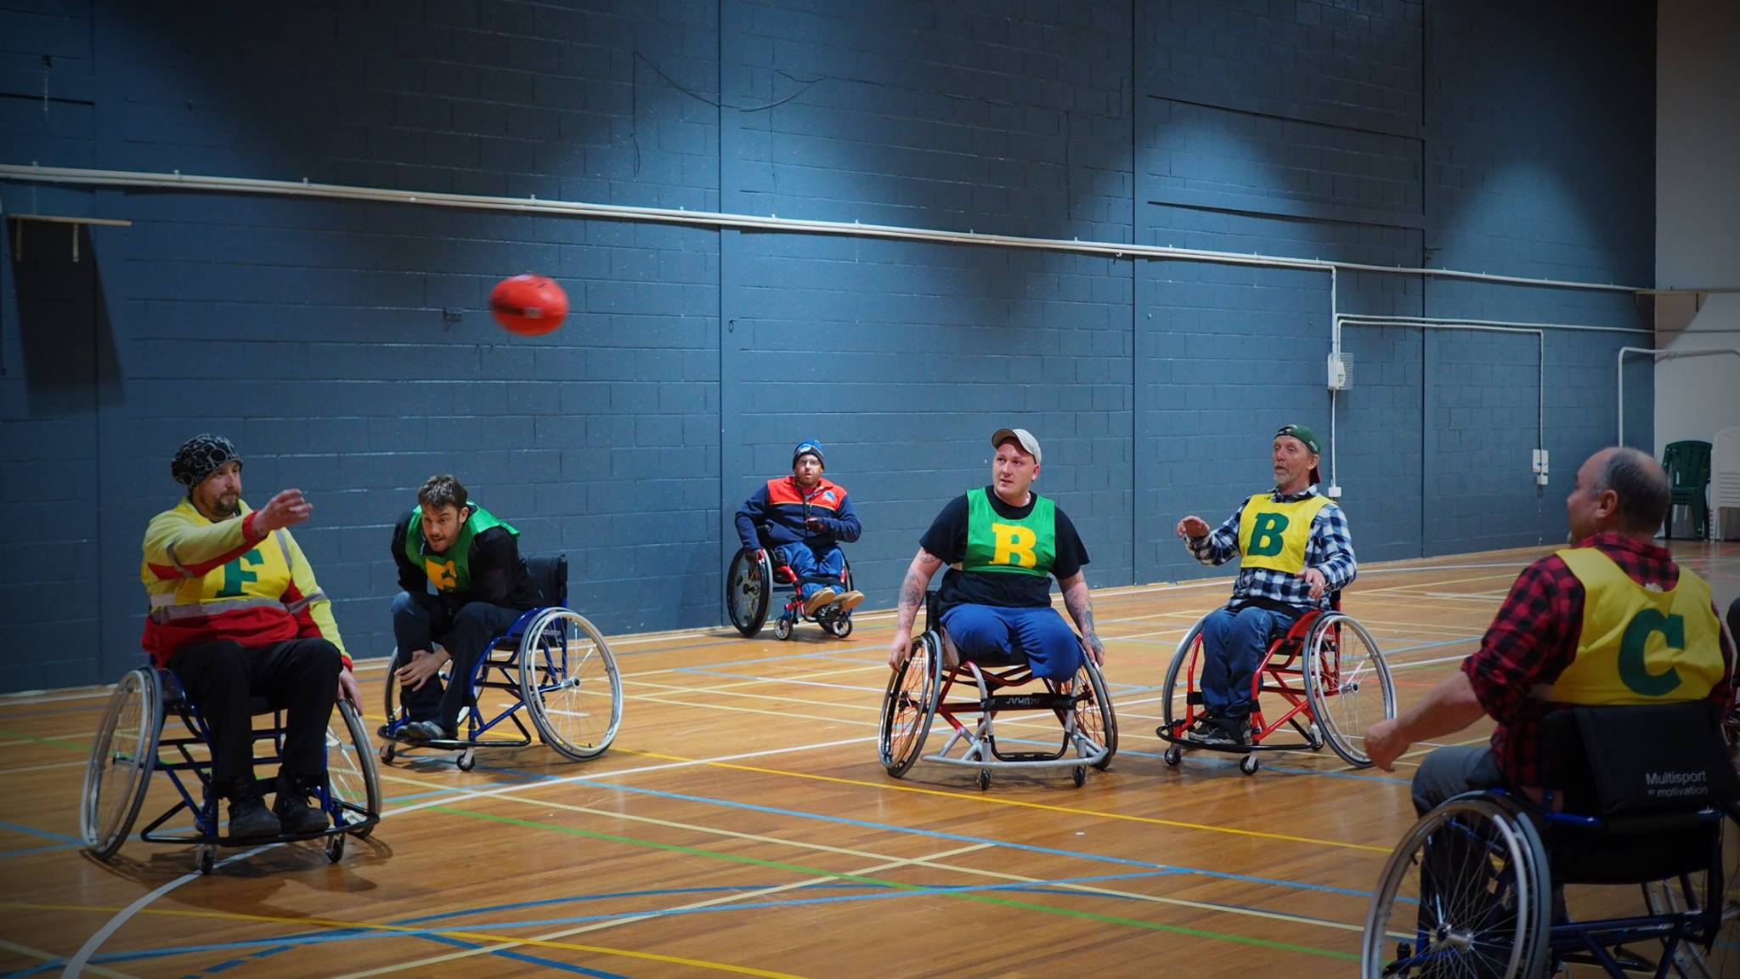
Social Wheelchair Aussie Rules at the YMCA Glenorchy

Action area 2: Access to Employment Opportunities, Career Development, Retention and Recruitment
Achievements in this period include:
- Launching the Diversity and Inclusion Policy and Framework and the Workplace Adjustment Policy Template. This reflects a new approach to diversity in the State Service – one that is focused on making employment practices more inclusive for all employees. The development of the policy was led by the State Service Management Office with involvement from all agencies, relevant community groups and stakeholders.

Action area 3: Access to Buildings, Facilities, Venues and Off-Premises Events
Achievements in this period include:
- Redevelopment of the Glenorchy Service Centre during the LINC refurbishment. The new style of ‘sit down’ counter is a significant improvement for clients using wheelchairs or those who rely on the aid of walkers. There is also now an automated queuing system that has removed the current requirement to wait in a physical queue.
- Converting the emergency evacuation procedure documentation of many key property holdings into an accessible PDF format.
- Coordinating a state-wide forum in conjunction with DoJ, the Local Government Association of Tasmania and councils. The forum was aimed at building surveyors and designers. It promoted universal access and aimed to create awareness of the barriers in the built environment for Tasmanians with disability or limited mobility. It encouraged builders and designers to go beyond the minimum access requirements using the principles of universal design.
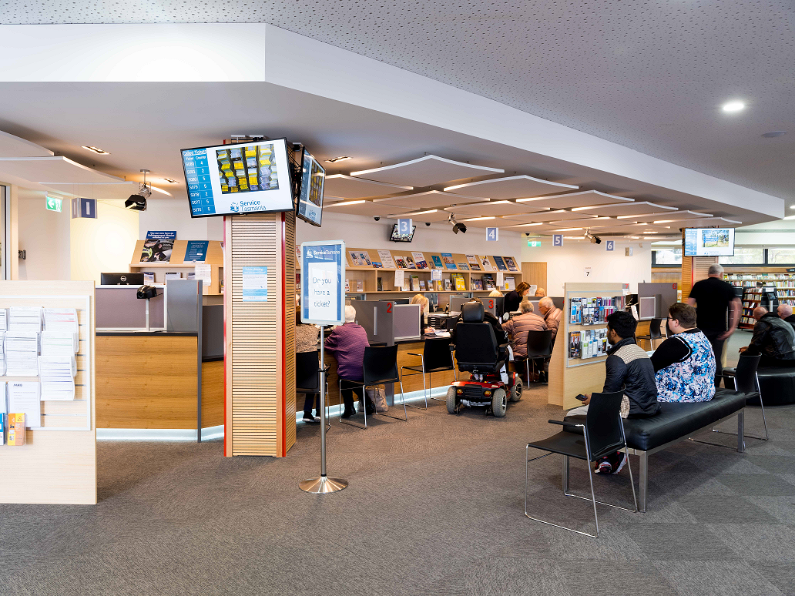
Redeveloped Glenorchy Service Centre

Action area 4: Access to Information (printed materials, websites, audio and video)
Achievements in this period include:
- Building WCAG 2.0 Level AA compliancy into the editing environment, and become part of web editing training.
- Implementing a ‘HTML First’ strategy to simplify the production of compliant documents for staff and consultants.

Recommendations:
- Improve levels of consultation with the disability community.
- Consult with PDAC on the Accessible Events Checklist for Government Agencies to ensure that emergency evacuation arrangements are included.
- Report on outcomes of the Accessible Events Checklist for Government Agencies and its promotion across agencies.
- Review the Action Plan reporting framework to better capture responses to recommendations in preceding year’s report.

Department of State Growth (State Growth)
State Growth is to be congratulated for the high standard of its report and the work it has achieved in the past twelve months. Its consultation with employees over the design aspects of workspaces is particularly impressive.
State Growth has shown strong results this year. A standout achievement is the Tasmanian Arts Advisory Board presenting the Minister for the Arts with an options paper. This paper details specific initiatives which it believes will make a difference to ensuring the arts are inclusive of all those who wish to practice, regardless of the barriers to their participation that may exist. Arts Tasmania appointed Ms Emma Bennison to the Tasmanian Arts Advisory Board. Emma is an artist living with disability, and has been a strong voice on the Board, sharing an understanding of the unique circumstances of artists with disabilities.
PDAC commends the agency with developing fact sheets on physical disability and driving, as well as providing carer awareness information in the new online induction program. PDAC agrees this latter initiative is particularly important and should be shared with other agencies.
PDAC congratulates State Growth on its Skills Potential project, which has so far resulted in sixteen employment outcomes. Sharing with sector/key stakeholders is recommended.
For future reports, PDAC recommends that State Growth provide reporting on outcomes of initiatives in progress.

Action area 1: Access to Services and Programs
Achievements in this period include:
- Replacing Skills Tasmania’s Equity programs with the Training and Work Pathways Program (TWPP) which changes the focus to better support opportunities for Tasmanians with a disability. The number of projects that are funded under the TWPP and explicitly support Tasmanians with a disability have increased each year since its inception. The programs in TWPP must include some form of work placement which is a critical step to increasing the employment opportunities for Tasmanians with a disability.

Action area 2: Access to Employment Opportunities, Career Development, Retention and Recruitment
Achievements in this period include:
- Developing the agency’s LMS to provide an opportunity to increase online access to disability awareness training for all employees. This will also provide training for recruitment and selection panels highlighting potential biases that may influence recruitment decisions. The LMS provides the agency with the opportunity to deliver a new induction package for employees, with access to various online modules and information that helps new employees to understand the culture of the agency and set expectations in relation to our values and behaviours that continues to support an inclusive workplace for everyone.
- Developing a flexible work practices framework with the State Service Management Office for application across the State Service.
- Finalising the Unpaid Work Framework, which supports unpaid work opportunities for people with a disability. The aim of the framework is to breakdown preconceived perceptions that employing people with a disability is ‘too hard’ and to provide work-like opportunities, experience and referees to people with a disability to increase their chance of success when applying for future paid work opportunities.

Action area 3: Access to Buildings, Facilities, Venues and Off-Premises Events
Achievements in this period include:
- Influencing some design aspects of workspaces and processes through a detailed accommodation review, as part of consultation processes with employees. This has resulted in changes such as the relocation of taps to ensure accessibility for all employees and a reduction in the need for individual adjustments.

Action area 4: Access to Information (printed materials, websites, audio and video)
Achievements in this period include:
- Developing educational material (Fitness to Drive – Physical Disability Fact Sheets) available on the internet for people with disability who wish to drive a car.
- Ensuring all agency websites are WCAG 2.0 Level AA compliant. Clear guidelines and regular audits ensure ongoing compliance. Accessibility guidelines will drive the decisions taken by the agency as it investigates future website platforms and opportunities.

Recommendations:
- Share carer awareness information from online induction program with other agencies.
- Continue to fund programs such as Skills Potential, and share any learnings with the sector/key stakeholders.
- Continue to consult with the disability community on the Wheelchair Accessible Taxi framework.
- Report feedback on agency websites that have been modified to enable greater accessibility.
- Share the Reasonable Adjustment Passport with other agencies.

Department of Primary Industry, Parks, Water and Environment (DPIPWE)
PDAC congratulates DPIPWE on a comprehensive report, particularly its use of colour-coding to make it more accessible to read, as well as acknowledging the efforts of individuals and teams.
DPIPWE has maintained its commitment to continuous improvement in accessibility for both its staff and its clients. DPIPWE reported significant achievements in the past twelve months, including upgrading Parks and Wildlife Services amenities and the implementation of an agency-wide Learning Management System.
PDAC congratulates the agency for the work done in making a number of AgFest stands more accessible, particularly providing adequate space and flooring materials to accommodate mobile assistance devices.
PDAC looks forward to advice on feedback and outcomes of ongoing initiatives from DPIPWE in future reports, reflective of the strong work they have shown so far.

Action area 1: Access to Services and Programs
Achievements in this period include:
- Investing in new AgFest displays for the Aboriginal Heritage, Analytical Services and Water and Marine Resources stands to enable greater accessibility, for example:
  - The height of displays, space around displays and tactile materials were considered to ensure the majority of access issues were addressed, and;
  - Adequate space and flooring materials were provided to accommodate mobile assistance devices, such as walking frames, mobility scooters and wheelchairs.
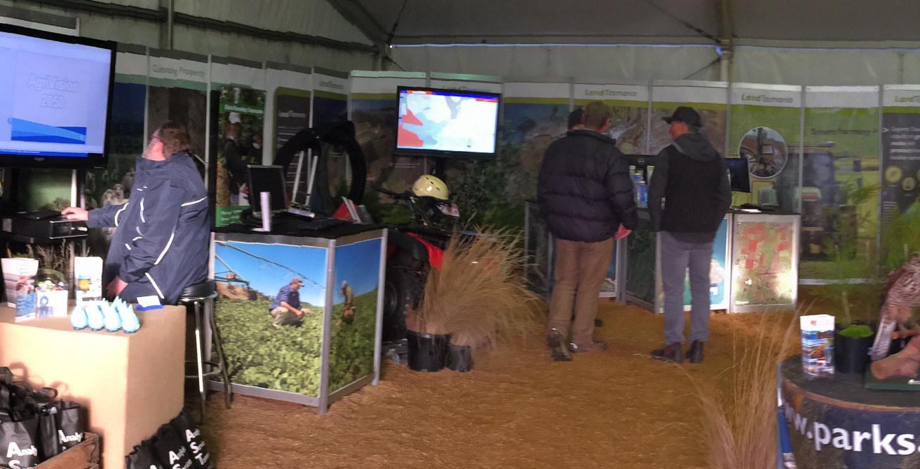
New accessible displays at AgFest

Action area 2: Access to Employment Opportunities, Career Development, Retention and Recruitment
Achievements in this period include:
- Reviewing the agency-wide induction process, resulting in the following actions:
  - Revising the Induction Checklist for new employees to incorporate disability awareness and accessibility requirements when inducting a new employee.
  - Developing an eInduction package to support DPIPWE’s commitment to providing services and employment that is equal, accessible and provides opportunity for participation and engagement for people with disabilities.

Action area 3: Access to Buildings, Facilities, Venues and Off-Premises Events
Achievements in this period include:
- Upgrading the popular viewing platform on the shore of Lake St Clair. The upgrade has significantly improved disability access, including an improved pathway to the lookout platform as well as a gently graded track down to the shore of the lake, allowing prams, walking frames and wheelchair access.
- Making a number of walking trails accessible for people with disabilities. Upgrades include:
  - Improving the Russell Falls circuit to allow independent chair access.
  - Purchase of Trailrider (all-terrain wheelchair) for access to popular walking tracks in the Mt Field National Park.
  - Purchase of a beach wheelchair to enable access to the beach and water at Maria Island National Park.
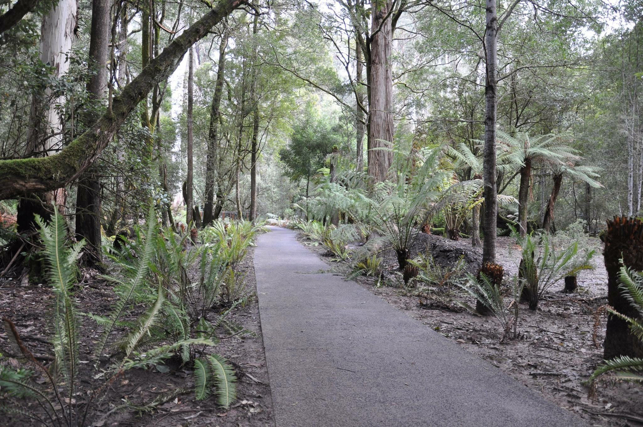
Upgraded gradient track at Russell Falls designed for independent chair access (Source: Facebook)

Action area 4: Access to Information (printed materials, websites, audio and video)
Achievements in this period include:
- Upgrading a number of websites to meet accessibility requirements, including Analytical Services Tasmania and Aboriginal Heritage Tasmania.

Recommendations:
- Report on usage and feedback through the disability enquiries email account.
- Report on usage and feedback of the Engaging with People with Disability toolkit and other induction/training tools.
- Report on community feedback on improved accessibility of walking trails.

Appendix 1 – Disability Governance – The reporting framework
United Nations Convention on the Rights of Persons with Disabilities (‘the Convention’)
Ratified by the Australian Government in 2008. The NDS is the primary mechanism for implementing the Convention in Australia.
International reporting
National Disability Strategy (NDS) 2010-2020
An initiative of the Council of Australian Governments (COAG). All states and territories have agreed to develop implementation strategies for the NDS. Tasmania’s DFA 2013-2017 is Tasmania’s implementation plan.
Australian Disability Ministers
Progress Report to COAG – every two years

National reporting
Tasmania’s Disability Framework for Action (DFA) 2013-2017
A whole-of-Government plan for people with disability. The DFA 2018-2021 is currently under development.

Tasmanian Government Agency Action Plans required under DFA 2013-2017.

Agencies provide annual reports on their Action Plans to PDAC.

Heads of Agency attend a PDAC formal meeting every two years (i.e. four agencies present each year).
Premier’s Disability Advisory Council (PDAC) reports on each Agency’s implementation of the DFA.
PDAC provides feedback to Agencies through its annual report to Cabinet on Agency Action Plans. PDAC’s report is published on DPAC website.

Department of Premier and Cabinet
15 Murray Street
HOBART TAS 7000
Phone: 1300 135 513
Email: disability@dpac.tas.gov.au
Visit: www.dpac.tas.gov.au
If you are deaf, hearing impaired or speech impaired, you can contact us through the National Relay Service
TTY users phone 133 677, then ask for 03 6232 7133
Speak and Listen users phone 1300 555 727 then ask for 03 6232 7133
Internet relay users connect to the NRS www.relayservice.com.au then ask for 03 6232 7133

DHHS and THS reported on their actions jointly.

