

Authorising Restrictive Practices

# A young woman holding a paper with the text 'easy read' and smiling.

# Easy Read – Fact sheet

**What is this fact sheet about?**

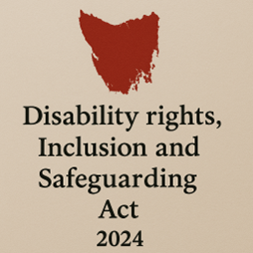

We have a new law in Tasmania.

It is called the *Disability Rights, Inclusion and Safeguarding Act 2024.*

We call it the Act for short.

There are lots of changes being made because of the new Act.

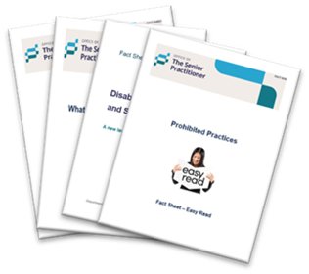

We have written some fact sheets explaining the changes.

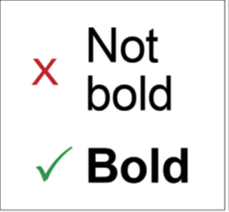We wrote some hard words in **bold**.

This means the letters are thicker and **darker**.

We explain what the hard words mean.

## What is a Restrictive Practice?

A **restrictive practice** is something that stops you from moving freely or doing what you want.

It can take away your rights.



It must only be used when needed to keep you or other people safe.

## What this law says about restrictive practices.

It says restrictive practices must be:



* The last option after trying lots of other ways.
* The **least restrictive** way.

**least restrictive** means giving you as much freedom and choice as possible.

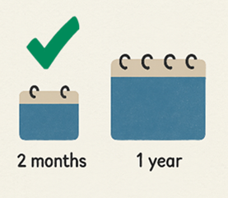

* Used only for a short time.



* Done in a way that protects your rights but keeps you safe.

An image of the Senior Practitioner. She is wearing a navy top, has blond hair tied up and is smiling. Below is the logo of the Office of the Senior Practitioner.
A green tick to the right of the image.


The Senior Practitioner must give permission for services to use a restrictive practice.

## Emergency Situations

Sometimes in an emergency, a provider might use a restrictive practice without permission.

It is okay if:

* It keeps someone safe from **immediate** danger.

**Immediate** means right now.

* Spiral-bound notebook with a week planner layout from Monday to Sunday.
  with green arrow pointing up and down.
  It is the least restrictive way.

The provider must tell the Senior Practitioner within one week that they have used a restrictive practice.

## How do services get permission to use restrictive practices?

The service must:

* Fill in the official form.



* Include a Behaviour Support Plan.
* Describe the practice clearly.

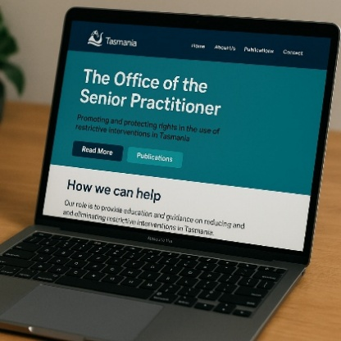

They must send it to the Senior Practitioner.

## What is a Behaviour Support Plan?



A Behaviour Support Plan tells services how best to support someone and keep everyone safe.

It helps everyone:

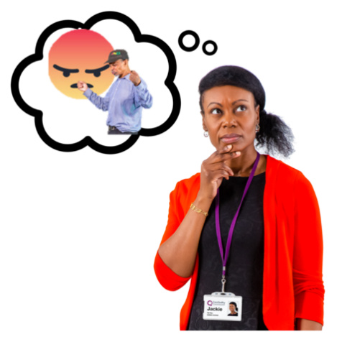

* Understand why behaviour happens.



* Learn new skills.

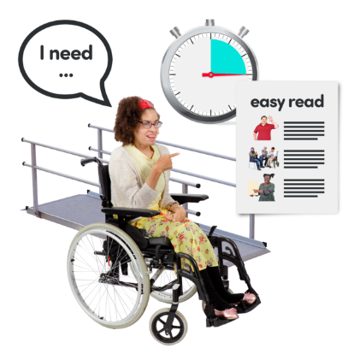

* Change the environment.



* Work together in a better way.
* Improves a persons quality of life.

The Behaviour Support Plan must be written by a **Behaviour Support Practitioner**.

A **Behaviour Support Practitioner** is someone who knows lots about how and why people behave the way they do.

## Talking to Others

The Senior Practitioner will talk to:



* You (or someone you choose)



* Experts in restrictive practices.

This is to help decide if the practice is okay.

## Who else is involved?

The provider must:



* Choose an Appointed Program Officer (APO).

See our fact sheet on APO.

The APO checks rules are followed.

* Make sure you have an Independent Person.

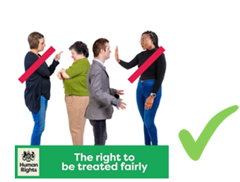

The independent Person protects your rights.

## What happens next?

The Senior Practitioner will:

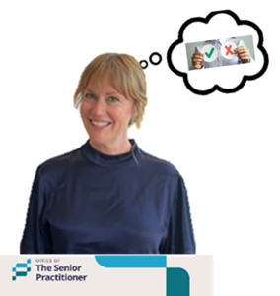

* Say yes or no to the restrictive practice.
* Send a letter with the decision.
* Add extra rules if needed.

## Can the decision be changed?

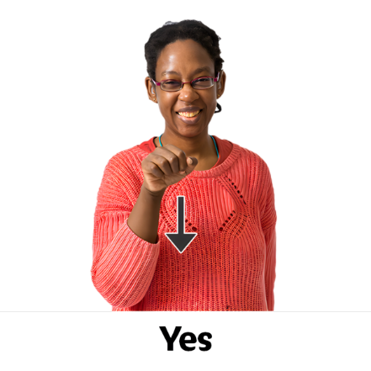

Yes.

The Senior Practitioner can:



* Change or cancel a decision
* Do a r**eview** at any time

A **review** means check the decision and have a think about it.

If you are still not happy, you can ask for a review.

* **A white background with grey text that says TASCAT, Tasmanian Civil and Administrative Tribunal. Beside it are green vertical stipes.
  **Go to the **Tasmanian Civil and Administrative Tribunal**.

We say **TASCAT** for short.

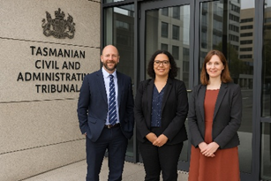

**TASCAT** is a place where people can go to get help to solve problems or disagreements in a fair and safe way.

## For more information and fact sheets



For more information about the Act and Fact Sheets go to.

[Department of Premier and Cabinet](https://www.dpac.tas.gov.au/divisions/cpp/community-and-disability-services/office-of-the-senior-practitioner)



Speak Out Tasmania created this Easy Read document using Photosymbols and custom images. The images may not be reused without permission. For any enquiries about the images or Easy Read, please email: easyread@speakoutadvocacy.org