Factsheet

Change Management:
Hold People Accountable
Change will only be fully embedded and the benefits fully realised if people are held accountable for adopting the new ways of working. This factor alone can make change programs fail or succeed. It’s unlikely that you will need to adjust formal measures for smaller changes, although individuals should still be held accountable. Use a formal accountability mechanism for large, complex change.

How to do it

1. Build change into performance management
Introduce performance measures for everyone who can impact the success of the program, right down to the front line if necessary. Consider output, outcome and control measures to understand how individual and team contributions will drive the project objectives. The key performance indicators may be specific to the change itself (eg productivity or output improvements) or more general behaviour such as your agency’s values and behaviours.
Individual performance leads to team performance, which drives project success and ultimately agency/departmental performance. To drive change, accountability for the change needs to cascade from the top to drive project and individual performance.
Stakeholder prioritisation will identify people who can impact the success of the program. Note that measures at an individual level will be a mix of formal and informal.

Figure 1: Relationship between performance and accountability.
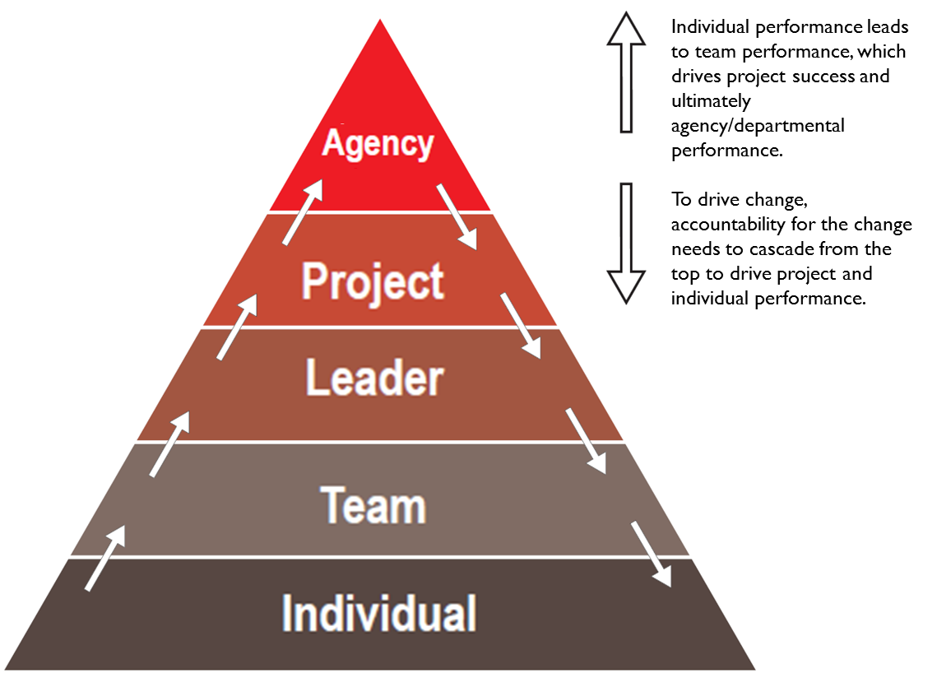

Formal measures for more complex projects are recommended.
In many cases, key outcome measures will already form part of leader, team and individual or performance plans. For example, individuals may have productivity measures on their scorecard which the change is trying to improve. In these cases, it may be enough to articulate to individuals that they will be better able to meet their existing key performance indicators if they embed the change.
In the case of transformational change, you may need to add to leader, agency and individual key performance indicators.
For example, you may need employees to achieve a certain productivity target to deliver the required benefits from a new system. Any changes need to be considered as part of the organisation’s performance management framework, and agreed with your Human Resources team.

Informal measures for more complex projects.
Leaders should informally reinforce the change as part of day-to-day people management processes.
Start by noting the behaviour that you expect from individuals, teams and leaders so they can be reinforced throughout the change process.

2. Act on measurement results for all projects
Once these measures are set, people should be held accountable to deliver to them. This should form part of the organisation’s overall performance management and should not be confined to formal review periods. Rather it should be continuous. You can send a powerful message that the change be adopted by recognising appropriate behaviour and questioning why activities are being ignored.
Formal and informal performance management will motivate employees if it is:
- Done regularly by managers who understand their employees
- Done formally and informally
- Aimed at improving not punishing
- Focused on building people’s strengths.

3. Provide feedback for continuous improvement
Providing day-to-day feedback is an important tool for performance management, continuous improvement and embedding change. It is also vital for engagement, retention and productivity.

