Tasmanian State Service
Annual Report
2025-26

State Service Management Office
Department of Premier and Cabinet
GPO Box 123
Hobart TAS 7001
Phone: 03 6232 7040
Email: ssmo@dpac.tas.gov.au
Web: www.dpac.tas.gov.au/working-in-the-state-service
ISSN (Print): 2202-8587
ISSN (Online): 2202-8595
October 2026
© Crown in Right of the State of Tasmania 2026

Acknowledgement of Aboriginal People and Country
Across the Tasmanian State Service, we acknowledge the ongoing custodians of Country and respect Tasmanian Aboriginal People’s continuous connections to Culture and Country, and their deep spiritual connections and relationships to Land, Sea and Sky Country since time began.
We acknowledge Aboriginal people working in the Tasmanian State Service and recognise and value the unique knowledge, skills and experience they bring to their workplaces.

Statement of Commitment to Child and Youth Safety
All children and young people have the right to feel and be safe, to be heard in matters that affect them and to be protected from harm.
Across the Tasmanian State Service, we are accountable for upholding these rights. We embrace our responsibility to guide and achieve positive change. We will work as one to put the rights and wellbeing of children and young people at the centre of what we do. We will build and maintain a workplace that is safe for children and young people. We will listen to the diverse needs of all children and young people, no matter their background, culture, abilities, or identity.
Our promise goes beyond just words. We are committed to making meaningful and ongoing changes to ensure the safety and wellbeing of children and young people. We will employ the right people. We will embed a culture of self-reflection and continuous improvement. Children and young people will influence decisions that affect them. We will listen to them and learn from them. We will have the courage to change what needs to be changed. We will regularly review our policies and structures through a child and youth safety lens. Our people will be equipped with the skills to recognise and respond to signs of harm.
Our culture will be one where everyone takes responsibility, shares information, and speaks up if something does not seem right. Together, we are creating a place where all children and young people are safe from harm. A place where we all protect young people and do what is right, for a safer Tasmania.

Letter of Transmission
15 October 2026
Hon Jeremy Rockliff MP
Premier
Minister Administering the State Service Act 2000
Dear Premier
In accordance with the requirements of section 19 of the State Service Act 2000,
I am pleased to present the Annual Report of the Tasmanian State Service for the year ending 30 June 2026.
Yours sincerely
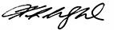
Kathrine Morgan-Wicks PSM
Head of the State Service

Contents
Acknowledgement of Aboriginal People and Country 3
Statement of Commitment to Child and Youth Safety 4
Letter of Transmission 5
About this report 7
Message from the Head of the State Service 8
State Service at a glance 9
Strategic priorities overview 11
Workplace experience 14
Workforce planning and recruitment 21
Workforce capability and leadership 26
Diversity, equity and inclusion 31
Workforce management and employment 40
State Service workforce profile 50
Information sources and definitions 56

About this report
The Tasmanian State Service Annual Report 2025-26 has been prepared in accordance with section 19 of the State Service Act 2000. It reports on the exercise of the Employer’s functions and powers during the year ended 30 June 2026.
The report provides a broad account of workforce, employment and management activity across the Tasmanian State Service (TSS) and is supported by a statistical profile of the workforce. Information is drawn from the Annual Agency Survey undertaken by the State Service Management Office (SSMO), the Workforce Information Reporting System (WiRS), and information provided by TSS agencies.
Further information about the report is provided in information sources and definitions.

Message from the Head of the State Service
I am pleased to present the Tasmanian State Service Annual Report 2025-26, my third report as the Head of the State Service.
During 2025-26, the Tasmanian State Service continued to deliver essential services to the Tasmanian community while responding to a period of significant reform, organisational change and evolving workforce challenges.
A key priority throughout the year was continuing to progress reforms arising from the Commission of Inquiry into the Tasmanian Government’s Responses to Child Sexual Abuse in Institutional Settings and the associated Woolcott Review. Important work continued to strengthen leadership, accountability, conduct and workforce governance arrangements, while supporting safer workplaces and services for children and young people.
The year also saw substantial progress across a range of workforce priorities. These included completion of significant wage agreements across many sectors of the Tasmanian State Service, investment in workforce capability and leadership development, advancement of strategic workforce planning initiatives and continued work to modernise workforce systems and employment frameworks.
The Tasmanian State Service is strongest when we work together. I am encouraged by the collaboration demonstrated across agencies throughout the year to support reform and continuous improvement.
While significant work remains ahead, the foundations established during 2025-26 will support a more capable, accountable and sustainable State Service that is well positioned to meet current and future service delivery needs.
I thank all State Service employees for their professionalism, commitment and service to the Tasmanian community.
Kathrine Morgan-Wicks PSM
Head of the State Service

State Service at a glance

Size of the State Service
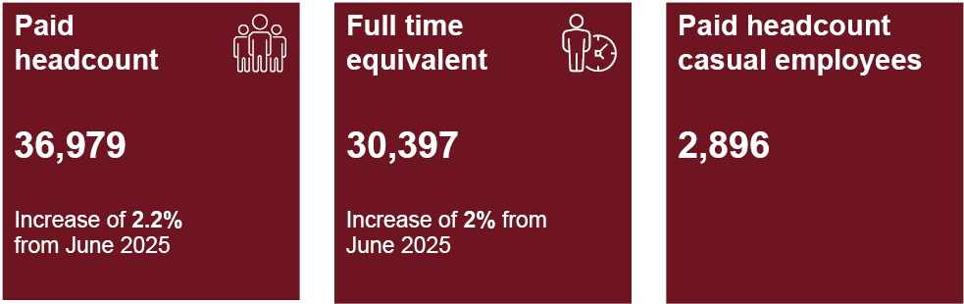
Description: Paid headcount: 36,979, this is an increase of 2.2 per cent from June 2025. Paid full time equivalent: 30,397, this is an increase of 2 per cent from June 2025. Paid headcount of casual employees is 2,896, this is a decrease of 137 from June 2025.

State Service employment
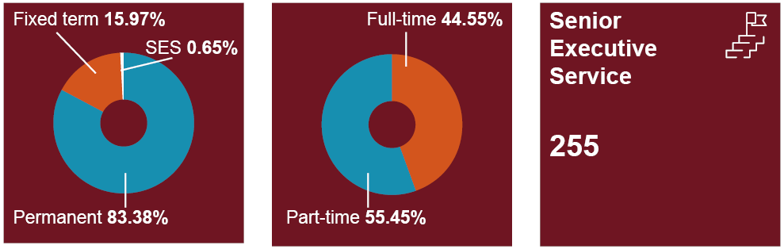
Description: State Service employees are split by 83.38 per cent of permanent staff, 15.97 per cent fixed term staff and 0.65 per cent of SES. The split of employment is 44.55 per cent full time and 55.45 per cent part time. There are 255 senior executive service employees.

State Service demographics
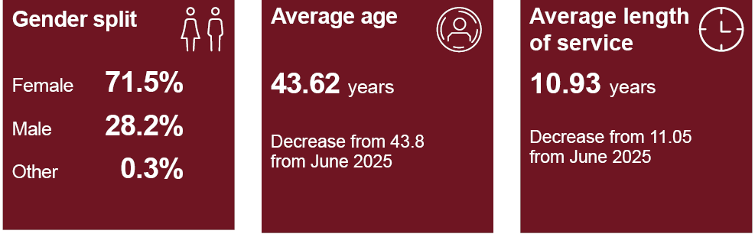
Description: State Service employees are split by 71.5 per cent female, 28.2 per cent male and 0.3 per cent other staff. The average age of State Service employees are 43.62 years, this is a decrease from 43.80 in June 2025. The average length of service is 10.93 years, this is a decrease from 11.05 in June 2025.

Across Tasmania
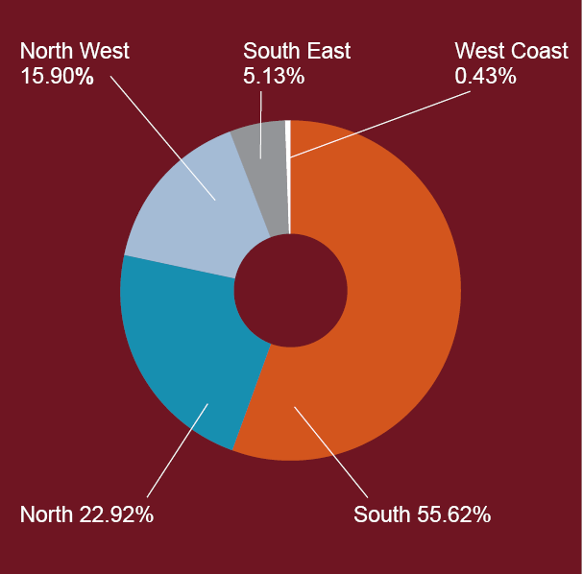
Description: State Service employees are spread across Tasmania as follows: 55.62 per cent in the South, 22.92 per cent in the North, 15.90 per cent in the North-West, 5.13 per cent in the South-East and 0.43 per cent on the West Coast.
Further workforce data is provided in the State Service workforce profile.

Strategic priorities overview

State Service Reform
During 2025-26, the Tasmanian State Service (TSS) continued to strengthen its workforce, governance and organisational reform frameworks to support a capable, accountable and sustainable public sector.
Agencies were required to balance the delivery of quality services with a renewed focus on workforce affordability, organisational effectiveness and the long-term sustainability of the TSS.
A significant focus during the year was continuing the implementation of recommendations arising from the Commission of Inquiry into the Tasmanian Government's Responses to Child Sexual Abuse in Institutional Settings (Commission of Inquiry) and the Woolcott Review. This included reforms to strengthen conduct and accountability arrangements, modernise employment frameworks, build workforce capability, enhance leadership, and improve systems and processes that support employment and workforce management.
Work also progressed to strengthen strategic workforce planning, support organisational redesign, improve workforce data and reporting, and modernise workforce systems and employment conditions. A significant round of wage agreement negotiations was completed across much of the TSS, delivering updated employment arrangements and contemporary workplace conditions that support employee wellbeing, inclusion and workforce participation.
Together, these reforms support a more capable, accountable and sustainable TSS that is better positioned to meet current and future service delivery needs.

Workforce priorities
The TSS continued to progress its workforce priorities of Size, Shape, Location and Enablers. Collectively, these priorities support a sustainable, capable and responsive workforce that can meet current service delivery needs while adapting to future challenges.

Size
The size priority focuses on ensuring workforce investments remain aligned with service delivery requirements, organisational priorities and the long-term financial sustainability of the State Service.
Agencies continued to strengthen workforce planning and establishment management practices, with a focus on maintaining critical capability, managing vacancies strategically and supporting informed workforce decision-making. This work assisted agencies to balance service delivery requirements with the need for sustainable workforce investment and prudent management of public resources.

Shape
The shape priority focuses on ensuring the TSS has the capability, leadership, culture and organisational structures required to respond to current and emerging service delivery priorities.
During 2025-26, this included capability framework development, leadership and management programs, diversity and inclusion initiatives, workforce renewal activities and reforms arising from the Commission of Inquiry and Woolcott Review. This involved work to strengthen conduct, accountability and workforce governance arrangements, alongside initiatives to support leadership capability, organisational effectiveness and child-safe practices across the TSS.
Feedback from agencies demonstrates ongoing challenges in recruiting and retaining skilled employees in a competitive labour market while managing workforce needs within tightening budget settings. These pressures reinforce the importance of workforce planning, capability development, and workforce shaping activities to ensure agencies can maintain critical capability and service delivery in a sustainable way.

Location
The location priority focuses on ensuring workforce capability can be accessed where it is most needed and supports workforce mobility across the TSS.
Agencies built on existing efforts to strengthen regional workforce initiatives, targeted attraction and recruitment strategies and workforce redeployment approaches to support changing service delivery requirements and workforce needs across Tasmania.

Enablers
The enablers priority focuses on the systems, policies, data and frameworks that support a modern and effective TSS workforce.
A major focus during 2025-26 was progression of the TSS Human Resources Transformation Project. The project represents a significant investment in the systems and foundations that support workforce management across the TSS and is intended to enhance workforce data, reporting, employee lifecycle processes and decision-making capability.
This work was complemented by broader initiatives to improve workforce data and analytics, build workforce planning capability, modernise employment arrangements, and support more consistent whole-of-service approaches to workforce management.

Human Resources Transformation Project (PeopleCentral)
Current Human Resource systems in the TSS and associated processes are at end-of-life, fragmented, costly, outdated and inefficient. The Department of Premier and Cabinet’s (DPAC) Human Resource Transformation Program (HRTP) is tasked with solving this long-term structural problem across government.
HRTP continues to deliver PeopleCentral, the whole-of-government workforce management platform. During the reporting period, establishment and position management capabilities were successfully implemented within DPAC. This provided improved visibility of workforce positions and supported more effective position management. A rostering pilot commenced with Tasmania Police, while work began with the Department of Health to prepare for the implementation of establishment management capabilities.
Alongside these implementation activities, a significant milestone was reached through the Enterprise Design for People, Positions and Pay. Over seven weeks, 79 representatives from agencies across government participated in 39 workshops, contributing more than 110 hours of collaborative design and decisions. Together, agencies reviewed and aligned 60 workforce processes, creating a shared foundation for the future management of people and pay across the TSS. These Enterprise Design outcomes established a collaborative and repeatable approach for PeopleCentral deployments.
As a key enabler of the TSS, this work supports consistent workforce management practices across agencies and contributes to a sustainable, contemporary and high-performing public sector. The HRTP is not simply an IT program, but a broader reform program responsible for modernising and cleaning up decades of manual, fragmented approaches to payroll, rostering and employee management.
PeopleCentral is about getting the fundamentals right: ensuring our people are paid correctly, rostered safely, able to apply for leave and have decisions transparently made, and be properly supported to do the jobs we ask of them.

Workplace experience
The TSS is committed to providing workplaces where employees feel supported, respected and equipped to perform at their best. Workplace experience is shaped by workplace culture, employment conditions, flexibility, wellbeing and the support available throughout an employee's career.
Agencies further strengthened workplace experience through initiatives that supported positive workplace cultures, flexible and inclusive work practices, employee wellbeing, respectful workplaces and psychologically safe working environments.

Culture
The culture of the TSS is shaped by shared expectations of integrity, accountability, safety, respect and service to the Tasmanian community.
During 2025-26, work arising from the TSS Cultural Insights Research Project moved from research into practical workforce and employment initiatives. The ‘meaningful work, meaningful place’ narrative continued to inform employer positioning, attraction and recruitment activities, and broader workforce initiatives across the State Service.
The redevelopment of the TSS Careers website, profiled in Workforce planning and recruitment, was a key practical outcome. A new Working in the State Service section on the Department of Premier and Cabinet’s website also brought together whole-of-service employment and workforce information, providing managers with easier access to resources relating to leadership, building capability, workplace culture, inclusion, and employment policies and guidance.
The TSS Cultural Insights Project continues to inform initiatives across the TSS aimed at strengthening employee experience, workforce attraction, leadership and organisational culture. Related cultural outcomes and priorities are reflected throughout this report.

Supporting employees with caring responsibilities
In August 2025, the TSS was accredited for three years as a carer-friendly employer under the Carers + Employers Program. The TSS was the first entire State Service nationally to achieve accreditation under the program, reflecting its commitment to supporting employees with caring responsibilities.
The TSS has a range of workplace measures in place to support employees who are carers as defined under the Carer Recognition Act 2023. These include the right to request flexible working arrangements and workplace adjustments, access to specialised Employee Assistance Program services and, for eligible employees, personal leave for caring purposes.
Achieving Accredited Carer Employer status fulfilled a commitment under Supporting Tasmanian Carers: Tasmanian Carer Action Plan 2021-2025. This focus will continue through the development of the next Carer Action Plan, with ongoing work to improve support for carers across the TSS.

Flexible working arrangements
Flexible working arrangements continued to play an important role in supporting employee wellbeing, workforce participation and organisational performance across the TSS.
Agencies supported flexible work through local policies, manager guidance and workplace practices, while balancing operational requirements and role-specific duties. Arrangements available across the TSS included remote work, flexible start and finish times, part-time work, compressed working weeks and purchased leave.
While the nature of some roles can limit the types of flexible arrangements available, agencies continued to support flexible options wherever possible and appropriate.

Employee support
Agencies continued to invest in initiatives that support employee wellbeing, early intervention and access to assistance when needed. These supports help employees navigate personal and workplace challenges, contribute to positive workplace cultures, and support workforce participation and retention. Employee support was delivered through wellbeing initiatives, workplace contact officer networks, employee assistance services and other resources designed to support employee health, safety and wellbeing.

Key support arrangements available across the TSS included:
- employee assistance programs
- flexible work policies
- wellbeing resource hubs
- workplace safety plans
- workplace contact officer networks
- referral pathways to specialist services.

Supporting employees experiencing family violence
Employment Direction No. 28 provides the whole-of-service framework for supporting employees experiencing family violence.
Practical and compassionate support continued to be provided to employees affected by family violence. Support included access to family violence leave, flexible work arrangements, workplace safety planning, referral pathways to specialist services, and guidance and assistance for employees and managers.
Agencies also raised awareness of family violence and developed workplace capability through initiatives such as participation in Family Violence Prevention Month, targeted awareness and training activities, family violence contact officer networks, guidance material, and the integration of family violence considerations into workplace policies, procedures and resources.
Agencies reported 51 applications for family violence leave and 227 approved leave instances.

Leave provisions
Leave provisions support employees through different life stages, caring responsibilities and personal circumstances. During 2025-26, employees across the TSS accessed a range of additional leave provisions that support workforce participation, wellbeing and inclusion, as outlined in Table 1.
Table 1. Access to additional leave provisions.
Leave provision | Number of days
Aboriginal cultural leave | 25
Additional paid secondary caregiver leave (12 weeks paid parental leave) | 494
Adoption leave (including primary caregiver, paid secondary caregiver, paid additional secondary caregiver and unpaid) | 0
Disability leave | 138
Foster and kinship leave | 32
Gender affirmation leave | 14
Grandparent leave (paid and unpaid where primary caregiver) | 4
Paid primary caregiver leave (18 weeks paid parental leave) | 1,373
Paid secondary caregiver leave (four weeks paid parental leave at time of birth) | 501
State Service accumulated leave scheme | 341
State Service purchased leave scheme | 948
Surrogacy leave | 0
Unpaid parental leave (including birth and non-birth parents and grandparents) | 864
Additional leave and employment conditions commenced during May and June 2026 as outcomes of the 2025-26 bargaining round. The changes represent a significant update to State Service standard conditions by strengthening support for employee wellbeing, caring responsibilities, family and domestic circumstances, gender affirmation, reproductive health, parental leave and work-life balance.
Key changes included:
- introduction of reproductive health leave
- standalone pregnancy loss leave provisions
- the right to disconnect
- increased family violence leave provisions
- increased carer leave provisions
- greater flexibility in accessing gender affirmation leave
- a reduced qualifying period for parental leave
- expanded access to personal leave for medical appointments
- improvements to recreation leave, compassionate leave and bereavement leave arrangements.

Respectful workplaces
Respectful workplaces are supported by clear expectations of behaviour, positive workplace cultures and accessible pathways for employees to raise concerns and seek support.
A range of initiatives relating to respectful workplace cultures and promoting positive workplace behaviours were delivered by agencies. These initiatives spanned values and recognition programs, training and development activities, workplace contact officer networks and the review and enhancement of workplace behaviour policies, procedures and guidance materials.

Our Watch Workplace Equality and Respect Standards
The Our Watch Workplace Equality and Respect Standards provide a framework for promoting gender equality, respectful workplace cultures and the prevention of workplace sexual harassment and gender-based violence.
The standards continued to be implemented by agencies through initiatives that strengthen respectful and inclusive workplace cultures, prevent and respond to family violence and enhance employee support and wellbeing. Agencies reported investment in training and awareness programs, respectful workplace initiatives, Family Violence Contact Officer networks, and the review and development of policies and procedures that support gender equality, flexible work and safe workplaces.
Work also continued on the development of a small set of outcome-focused indicators to support more consistent monitoring and reporting of implementation across the TSS. While this work is still being refined, a number of indicators have been incorporated into this year's annual report to support greater visibility of progress and ongoing accountability.

Grievance management
Grievance management arrangements provide a framework for workplace concerns to be raised and considered fairly and consistently.
Work continued towards a more consistent whole-of-service approach to grievance management, including the development of a TSS Grievance Management Policy. This work aims to support greater consistency in the management of workplace concerns across agencies and increasing confidence in grievances processes.
The Joint Consultative Committee, comprising representatives from the TSS and public sector unions, continued to provide a regular forum for consultation on whole-of-service workforce matters. Grievance management remained a priority area for collaboration, supporting the development of a more consistent approach across the TSS.
As part of this work, the confidence and capability of managers in preventing, responding to and resolving workplace concerns has been identified as a key area of focus. Future work will consider opportunities to strengthen manager development, guidance and support to promote the early and effective resolution of workplace concerns.
Grievance data, including in relation to bullying and sexual harassment, is reported in Workforce management and employment.

Work health, safety and wellbeing
The TSS is committed to providing workplaces that are safe, healthy and supportive for all employees. Agencies continued to strengthen work health, safety and wellbeing practices with a focus on preventing harm, supporting employee wellbeing, managing emerging workplace risks and fostering positive workplace cultures. This work increasingly recognises the connection between psychological safety, employee wellbeing, respectful workplace cultures and organisational performance.

Managing psychosocial hazards in the workplace
Safework Australia’s Managing Psychosocial Hazards at Work Code of Practice provides a framework for identifying, assessing and controlling psychosocial hazards in TSS workplaces.
Agencies continued to refine approaches to psychosocial risk management, recognising that psychosocial hazards can arise from factors such as workload, job design, workplace culture, workplace relationships, recruitment practices and resourcing. Efforts focused on embedding psychosocial risk management into existing work health and safety systems and building capability and supportive workplaces to identify and address risks before harm occurs.

Building Work Health Safety capability
Employment Direction No. 27: Work Health and Safety (WHS) establishes minimum WHS training requirements for employees, managers and supervisors, and officers.
A wide range of training and development programs were delivered to meet WHS training requirements and promote a culture of safety and wellbeing across the TSS. Training initiatives supported safe work practices, risk management and employee wellbeing, and included:
- de-escalation skills
- first aid and CPR
- manual handling
- mental health first aid
- occupational violence and aggression
- psychosocial hazards
- safeguarding children and young people
- situational awareness
- trauma and vicarious trauma.

Table 2. WHS training summary statistics.
 | 2023-24 | 2024-25 | 2025-26
Employees | 16,317 | 21,590 | 13,396
Managers and supervisors | 897 | 808 | 715
Officers | 244 | 102 | 108

In practice: Embedding ‘How We Work’ at NRE Tas
The Department of Natural Resources and Environment Tasmania (NRE Tas) strengthened its How We Work (HWW) approach in 2025-26, introducing new initiatives to embed its principles and behaviours in everyday work.
Launched in 2025, the HWW Strategy focuses on four areas: Sponsor, Learn, Communicate and Recognise to provide a practical framework for leadership, learning, communication and recognition across the agency.
In 2026, HWW Week was launched to bring these elements together. Activities included employee videos and intranet features showcasing HWW principles, a Lunch and Learn session on incorporating HWW into Performance and Development Plans, and new resources to support development conversations.
NRE Tas also launched the inaugural HWW Awards, building on its existing employee recognition program and providing a new way to recognise individuals who demonstrate the HWW Principles in practice. The first recipients will be announced in November 2026, supporting the continued visibility and embedding of HWW across the agency.

Workforce planning and recruitment
A sustainable TSS depends on having the workforce capability and capacity required to meet current and future service needs. Effective planning and recruitment helps agencies anticipate workforce needs, respond to changing service delivery requirements, and ensure workforce investment is aligned with long-term organisational priorities and workforce sustainability objectives.
During 2025-26, the TSS progressed key employment reforms, strategic workforce planning initiatives, and attraction and recruitment activities across whole-of-service and agency settings, to strengthen workforce sustainability and support agency workforce priorities.

Managing Positions in the State Service
The Managing Positions in the State Service (MPSS) framework provides agencies with workforce management tools to align workforce capability and capacity with current and future service delivery needs, including establishment and vacancy management, workforce planning, redeployment, Workforce Renewal Incentive Program (WRIP) payments, and Targeted Negotiated Voluntary Redundancies (TNVR).
In April 2026, the Head of the State Service reissued the framework to update the employment exclusion period applying to employees who separate from the TSS through a TNVR arrangement. The revised framework replaced the previous exclusion arrangements, which varied according to the separation payment received, with a standard two-year exclusion period for re-employment with the Crown.
Agencies continued to use MPSS (including TNVRs and WRIP payments) to support workforce planning, organisational redesign and workforce sustainability objectives, including responding to changing service delivery requirements and financial pressures.
In 2025-26, 16 employees exited the TSS through a TNVR arrangement, with a further 53 separating after accepting a WRIP payment.

Routine disclosure
Monthly publication of agency paid full-time equivalent and paid headcount data commenced in February 2026, providing visibility of workforce trends across the TSS. Reporting was also expanded to include the number and average cost of TNVR and WRIP payments at whole-of-service level.

Strategic workforce planning
Strategic workforce planning supports agencies to identify current and future workforce needs, understand future workforce risks and opportunities, and develop strategies to ensure the capability and capacity required to deliver services.
Development of a TSS Strategic Workforce Planning Framework and associated tools progressed in 2025-26 to support a whole-of-service approach to identifying and responding to current and future workforce needs.
Following the initial co-design in 2024-25, the second phase commenced in late 2025 with workshops for agency human resources representatives. The sessions focused on applying the framework and its tools in different operating environments and integrating strategic workforce planning with broader workforce and business planning functions.
Agency feedback highlighted both the importance of workforce planning and the challenges associated with embedding these practices. Agencies identified competing priorities, budget constraints and access to quality workforce data and analytics as key barriers to workforce planning activity. Workforce risks, most commonly identified by agencies, included the recruitment of skilled employees, retention of experienced employees and capability shortages in specialised occupations, including digital and technology roles. These findings reinforce the importance of strategic workforce planning to support workforce sustainability and service delivery across the TSS.
Further activities are planned during 2026-27 to support implementation of the framework and embed workforce planning practices across the TSS.
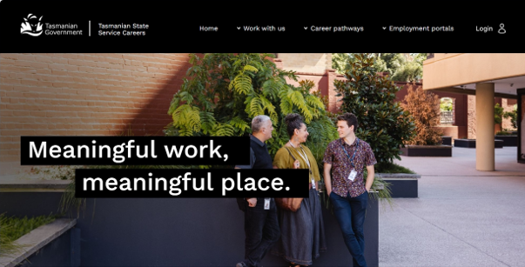
Figure 1. The homepage of the redeveloped TSS Careers website.

In practice: A new front door to careers in the TSS
The TSS Careers website was redeveloped in 2025-26, providing a refreshed and more accessible way for people to explore employment and career opportunities across the TSS.
Launched in May 2026, the new site has a distinctly Tasmanian look and feel and clearer content to help people find roles, understand career pathways and apply for opportunities across the State Service.
The redevelopment was a practical outcome of the TSS Cultural Insights Research Project undertaken across 2024-25, which identified ‘meaningful work, meaningful place’ as a unifying narrative and highlighted opportunities to strengthen how the TSS presents itself to prospective employees.
The website brings together job search, career pathways, information about working in the TSS and moving to Tasmania, and dedicated TSS employment portals for Aboriginal people, people with disability and veterans.
Centred on meaningful work, meaningful place, the new website provides a more consistent expression of the TSS as an employer and showcases the breadth of careers available to people locally and those considering making Tasmania home.
For more information, visit www.jobs.tas.gov.au

Recruitment system enhancements
As part of the TSS Careers website redevelopment, upgrades were made to the three PageUp Applicant Portals that support recruitment across the TSS.
The portals were transitioned from the legacy Cloud Careers dynamic template to the new Search and Apply platform, delivering improved functionality for recruiters and a more streamlined, user-friendly experience for candidates.
New features introduced as part of the upgrade include:
- Google for Jobs integration
- AI-powered job recommendations
- a ‘Jobs Near Me’ function
- enhanced job alert capabilities.
These improvements provide a more intuitive and personalised candidate experience, while ensuring visual consistency across all stages of the recruitment journey and alignment with the Tasmanian Government Corporate Brand Identity and Communications Policy.
These upgrades also help agencies attract and engage potential applicants more effectively.

In practice: Healthcare talent attraction
Brand Tasmania and the Department of Health partnered in 2025-26 to strengthen healthcare workforce attraction and promote Tasmania as a place to build a career and a life.
Joint activity included participation in a major healthcare recruitment event in Auckland, connecting with prospective candidates and building awareness of opportunities across Tasmania’s health system. The event generated new leads for an International Talent Register and insights to inform future activity.
The collaboration also supported targeted recruitment of graduate Oral Health Therapists from New Zealand and mainland Australian universities. Applications increased by 78.5 per cent in 2025-26 compared with the previous year.
The Be Tasmanian: Healthcare Talent Attraction project was shortlisted for Best Communications Strategy – Economic Development at the 2026 City Nation Place Global Awards, recognising the partnership’s approach to positioning Tasmania in a competitive healthcare talent market.

In practice: Campaign launched to strengthen Tasmania’s corrections workforce
The Tasmania Prison Service (TPS) launched a refreshed Correctional Officer Recruitment Campaign in 2025-26 to support attraction of a diverse and resilient corrections workforce.
The Bring your experience. Secure your future. campaign positions correctional work as a meaningful career and recognises the transferable skills and experience people bring from a wide range of professional backgrounds.
Featuring TPS staff, the campaign highlights the important contribution Correctional Officers make to community safety and rehabilitation in Tasmania.
Developed using in-house capability across the Department of Justice, the campaign combines staff stories with refreshed digital and advertising content across social media, podcasts, billboards, buses and the Corrections Careers website.
Strong engagement with the campaign during 2025-26 provided a positive foundation for its next phase in 2026-27.
For further information, visit www.correctionscareers.tas.gov.au

Figure 2. Digital banner from the Correctional Officer Recruitment Campaign.

Workforce capability and leadership
The TSS relies on a capable workforce and effective leadership to deliver contemporary public services and respond to emerging opportunities and challenges. Building capability and leadership capacity across the workforce enhances organisational performance, supports implementation of reforms and improves organisational effectiveness and workforce sustainability.
During 2025-26, agencies continued to invest in workforce capability, management development and leadership programs through a combination of whole-of-service, interagency and agency-led initiatives. Key areas included development of whole-of-service capability frameworks, shared learning opportunities, and leadership pathways for current and emerging managers and leaders.

Workforce capability
Learning and development across the TSS combined shared programs and agency-specific initiatives to build the confidence, skills and adaptability required across different roles and operating environments.

TSS Core Capability Framework
Development of the TSS Core Capability Framework progressed from initial design to whole-of-service co-design during the reporting period.
More than 40 employees from across the TSS participated in a series of consultation workshops to inform the first draft. A detailed design group was subsequently established to refine the framework and progress the next stage of development.
The framework is intended to provide a common foundation for capability across the TSS and strengthen alignment across recruitment, development, performance and career pathways, while supporting greater consistency in workforce capability expectations across agencies.

Shared learning and development
Shared learning and development activities supported a range of workforce capability and reform priorities during 2025-26. These included:
- change and resilience
- digital and AI capability
- management and leadership
- psychosocial risk
- safeguarding children and young people
- trauma-informed practice.
Agencies continued to invest in targeted capability development aligned to their operating environments and portfolio responsibilities, as part of performance and development processes, promotional pathways and succession planning.

TSS Trauma Capability Framework
Alongside the TSS Core Capability Framework, work progressed on a dedicated Trauma Capability Framework arising from the Commission of Inquiry.
Consultation during 2025-26 identified opportunities to streamline the proposed approach, strengthen alignment with related capability initiatives, and minimise duplication across existing frameworks and development activities.
A revised approach is planned for 2026-27.

Tasmanian Training Consortium
The Tasmanian Training Consortium (TTC) continued to provide shared access to professional learning across the TSS and broader Tasmanian public sector.
During 2025-26, the TTC delivered 98 calendar events to 1,592 participants and 18 in-house training sessions to 244 participants. The TTC had 24 member organisations and over 5,000 subscribers across various channels at 30 June 2026.
Demand for shared learning opportunities remained strong during 2025-26, reflected in increased participation across calendar events and continued engagement from member organisations.
Through its member and supplier networks, the TTC connected agencies with expert providers, facilitated interagency learning and provided professional development opportunities across organisational and geographic boundaries. The TTC continues to play an important role in delivering shared professional learning, building workforce capability and supporting collaboration and knowledge sharing across agency and geographic boundaries.
Table 3. TTC summary activity and participation.
TTC activity | 2023-24 | 2024-25 | 2025-26
Calendar events | 120 | 75 | 98
Calendar participants | 1,693 | 1,044 | 1,592
In-house training sessions | 38 | 23 | 18
Member organisations | 24 | 22 | 24

In practice: Learning together with the TTC
The Tasmanian Training Consortium (TTC) supported two major national awareness campaigns in 2025–26, creating shared learning opportunities that attracted 2,157 registrations across 15 free online events.
For the 30th anniversary of Adult Learners Week in Australia, the TTC worked with specialist providers to deliver six events on leadership, wellbeing, inclusion and future-focused capability, attracting 997 registrations.
During National Volunteer Week, the TTC partnered with Volunteering Tasmania to deliver a further nine events, attracting 1,160 registrations across topics including safeguarding, trauma-informed practice, volunteer engagement, neurodiversity awareness and wellbeing.
The strong response to both campaigns highlighted the value of accessible learning and the importance of creating opportunities for people across Tasmania to connect, build capability and learn together.
For further information, visit www.ttc.tas.gov.au

Developing managers and leaders
Management and leadership development across the TSS was supported through a combination of whole-of-service, interagency and agency-specific programs. These programs aimed to strengthen leadership capability at all levels, from emerging managers through to senior executives.
This approach provided shared development pathways while enabling agencies to build leadership capability suited to their specific workforce needs.
Strong management capability remains an important enabler of employee performance, workplace culture, wellbeing and organisational effectiveness across the TSS.

TSS Manager Essentials Program
The Manager Essentials Program (MEP) remained the primary whole-of-service development program for TSS managers and leaders during 2025-26.
The program combined structured management development with GENOS emotional intelligence assessments to strengthen self-awareness, people leadership and effectiveness in managing teams and performance.
Seven program intakes were delivered during 2025-26 with 93 enrolments.
Following a review undertaken in 2024-25, MEP entered its final delivery phase during 2025-26 after 10 years. Development of a contemporary successor program progressed during the reporting period, with delivery planned from 2027.
Since its introduction in 2017, the program has supported the development of over 1,000 managers across the TSS with more than 60 programs delivered. Lessons learned from the program are now informing the design of its successor program.

Leadership development across the TSS
More broadly, the State Service Strategic Management Program (S3MP) supported leadership development through an interagency learning experience delivered in partnership with Tasmania Police, SSMO and the University of Tasmania.
Alongside whole-of-service programs, agencies continued to invest in development initiatives for emerging, established and senior leaders. During 2025-26, this included strengthening leadership pathways and embedding safeguarding and other priorities arising from the Commission of Inquiry at all levels.
Employees were also supported to participate in development opportunities through the Australia and New Zealand School of Government and other specialist providers.

In practice: Building child-safe leadership
In response to the Commission of Inquiry, the Department for Education, Children and Young People (DECYP) strengthened its approach to developing managers to lead effectively in a child-safe organisation.
Recommendation 9.4 calls for leaders to have the knowledge, skills and capability to manage people and lead a child-safe organisation.
Launched in 2026, DECYP’s Manager Induction Program provides practical development for managers across the department. Designed for DECYP's operating environment, the program builds people management capability while embedding safeguarding, risk awareness and responsibilities for responding to concerns.
The program also reinforces DECYP's values of Connection, Courage, Growth, Respect and Responsibility and its responsibility to support the safety and wellbeing of children and young people in Tasmania.
The program will continue to reach managers across DECYP, supporting cultural and organisational change arising from the Commission of Inquiry and strengthening safeguarding through everyday leadership practice.

Diversity, equity and inclusion
A diverse, equitable and inclusive workforce enables the TSS to better understand and respond to the needs of the Tasmanian community it serves. Drawing on a broad range of backgrounds, experiences and perspectives strengthens decision-making, supports innovation and contributes to workplaces where all employees can participate and thrive.
Diverse and inclusive workplaces support workforce participation, broaden talent pathways and help ensure the TSS can attract, retain and develop the workforce needed to meet current and future service needs.
During 2025-26, the TSS continued to advance a range of whole-of-service and agency initiatives to support workforce diversity, inclusion and equitable employment opportunities.

Diversity and inclusion
Agencies progressed diversity and inclusion through local strategies, action plans, employee-led networks, awareness initiatives and capability development activities. Across the State Service, there was a strong focus of fostering inclusive, respectful and values-driven workplace cultures where employees feel supported to contribute and succeed.
At a whole-of-service level, work continued on the development of the next TSS Diversity and Inclusion Strategy. The TSS Diversity and Inclusion Reference Group continued to meet. Bringing together representatives from across agencies, the reference group provides a valuable forum for collaboration, sharing good practice, identifying emerging priorities and informing coordinated approaches to diversity and inclusion.
In April 2026, an internal TSS Diversity and Inclusion Calendar was introduced to support agencies in recognising and planning for significant diversity and inclusion dates observed throughout Tasmania, Australia and internationally. The calendar provides a practical resource to promote awareness, learning and inclusion across the State Service.
The TSS also continued as a member of Diversity Council Australia, providing whole-of-service access to contemporary research, resources, professional development opportunities and expertise to support contemporary diversity and inclusion practice.

Inclusive employment pathways
Creating equitable employment opportunities remains an important component of building a workforce that reflects the diversity of the Tasmanian community. Agencies continued to explore new and targeted approaches to attract candidates from underrepresented groups and expand participation in the TSS through targeted employment initiatives.
During the reporting period:
- 23 targeted roles were advertised to attract applicants from under-represented groups, including Aboriginal and/or Torres Strait Islander people.
- 16 appointments were made through these targeted recruitment processes.
Supporting Aboriginal employment remained a significant area of focus. During 2025-26, targeted recruitment initiatives resulted in 11 appointments within the Department for Education, Children and Young People and five appointments within the Department of Premier and Cabinet. Additional recruitment processes remained underway at 30 June 2026. These initiatives contribute to building a stronger Aboriginal workforce and creating pathways for Aboriginal people to pursue rewarding careers within the State Service.

Aboriginal employment
The TSS Aboriginal Employment Strategy continued to provide the foundation for whole-of-service efforts to improve employment outcomes for Aboriginal people during 2025-26. Through a focus on attraction, retention, development and cultural safety, the strategy supports a State Service where Aboriginal employees are valued, supported and empowered to contribute their knowledge, skills and perspectives. The strategy was supported by agency initiatives, employment pathways, employee networks and cultural capability development activities.
Informed by extensive consultation and engagement, the new strategy and associated action plan is planned for release in July 2026 and will help shape the next phase of Aboriginal employment and inclusion across the State Service.

TSS Aboriginal Employee Network
The TSS Aboriginal Employee Network continues to play an important role in connecting Aboriginal employees across agencies and providing a space for Aboriginal employees to contribute Aboriginal knowledge, experience and perspectives to employment initiatives and priorities.
With more than 100 Aboriginal employees in 2025-26, the network provided an important forum for connection, support, collaboration and the sharing of experiences across the State Service.
Members participated in quarterly workshops and the annual Aboriginal Employee Network Gathering at Carlton Beach, contributing their perspectives and insights to shared priorities including development of the next Aboriginal Employment Strategy.
The Aboriginal Employment Newsletter, distributed to more than 800 subscribers, continued to showcase employee stories, and highlight agency initiatives, employment opportunities and updates on work under the strategy.

In practice: A Yarn on Country
More than 1,000 TSS employees joined the 2025 NAIDOC Week livestream of A Yarn on Country: The Next Generation, hearing directly from Aboriginal employees who shared their personal stories, experiences and perspectives from across the State Service.
Reflecting the NAIDOC Week theme The Next Generation: Strength, Vision and Legacy, the event provided an opportunity to celebrate the contributions of Aboriginal employees while highlighting the importance of creating pathways for future generations. Three additional screenings further extended participation across agencies.
As part of the broader NAIDOC initiative, agencies were invited to identify opportunities for young Aboriginal people through the TSS School-Based Traineeship Program, linking the theme of the next generation with practical employment pathways.
These activities supported recognition of the vital contribution Aboriginal employees make, while helping create pathways for the next generation of Aboriginal people in the TSS.

Building cultural capability
The TSS Aboriginal Cultural Respect Training program continued to be delivered across Tasmania as a key initiative supporting cultural understanding, respect and inclusion.
Table 4. TSS Aboriginal Cultural Respect Training summary statistics.
 | 2023-24 | 2024-25 | 2025-26
Sessions delivered | 22 | 21 | 13
Participants | 180 | 402 | 243
Sessions delivered in Hobart, Launceston and Ulverstone provided employees with opportunities to deepen their understanding of Aboriginal culture, history and contemporary experiences. By building cultural capability across the workforce, the program contributes to culturally safe, respectful and informed workplaces.
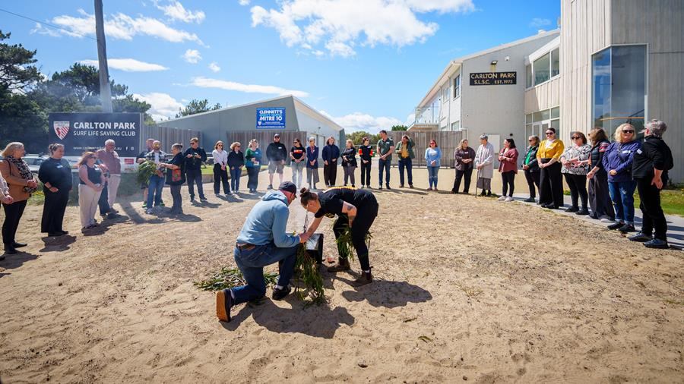
Figure 3. Guests at the 2025 TSS Aboriginal Employee Network Gathering at Carlton Beach.

Women in leadership
Supporting women to develop, progress and thrive as leaders remains an important part of building an inclusive, diverse and capable TSS workforce.
Women Supporting Women in Leadership is a whole-of-service program that provides opportunities for women across the TSS to share experiences, develop leadership capability, build professional networks and learn from the experience of others. The program recognises that women may face different career experiences and challenges and aims to support women at all stages of their leadership journey. The program is led by senior women across the TSS and is overseen by a State Service Steering Committee and Working Group.
The Women Supporting Women in Leadership Strategy 2024-27 provides the whole-of-service framework for advancing women’s leadership representation, development and experiences across the TSS. An annual action plan supports the implementation of the strategy and identifies priority activities to strengthen leadership capability, connection and career development opportunities for women.
During 2025-26, activities included:
- continuation of the quarterly Women Supporting Women in Leadership newsletter
- development of an evaluation framework to assess the effectiveness and impact of the strategy.
Table 5. Women in leadership.
Leadership role | 2023-24 | 2024-25 | 2025-26
Women in Senior Executive roles | 110 | 115 | 117
Women Heads of Agency | 6 | 9 | 9
Senior leadership data is provided in the State Service workforce profile.

In practice: Growing women’s leadership
The biennial TSS Women Supporting Women in Leadership Forums were delivered across Tasmania in November and December 2025, putting the strategy's focus on leadership development and connection into practice.
Three regional forums brought together 167 women and 36 speakers from across the TSS and broader Tasmanian community.
Participants at different career stages heard Tasmanian leadership perspectives, built connections and considered their own development and leadership aspirations. Feedback highlighted the diversity of perspectives and opportunity to connect with others across the TSS.
The forums continue to provide a statewide platform for women to build networks and engage with leadership development in the Tasmanian context.
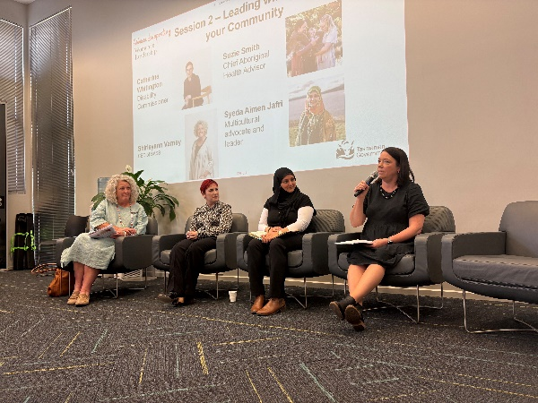
Figure 4. Presenters at a TSS Women Supporting Women in Leadership Forum.
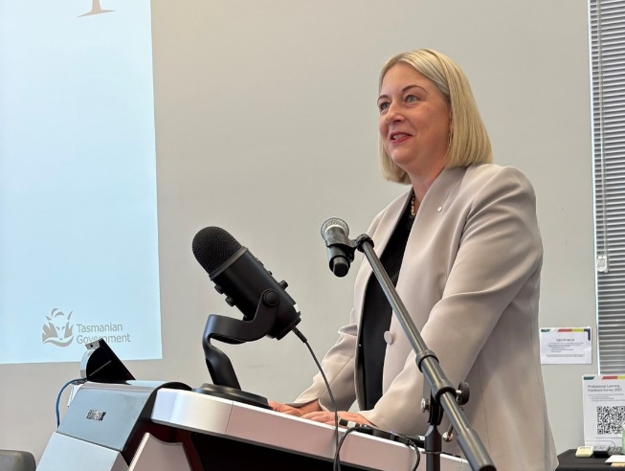
Figure 5. The Head of the State Service presenting at a TSS Women Supporting Women Leadership Forum.

Youth employment
Supporting young Tasmanians to enter the workforce and develop their careers remained a key priority, contributing to workforce renewal, capability development and future talent pipelines across the TSS.
Whole-of-service graduate and school-based employment programs continued to provide a structured entry point for young people in 2025-26. At the agency level, internships, cadetships, traineeships and graduate pathways were also increasingly used to meet particular workforce and specialist capability needs.
Together, these pathways provide young people with practical experience and development while contributing to the longer-term workforce needs of the TSS.
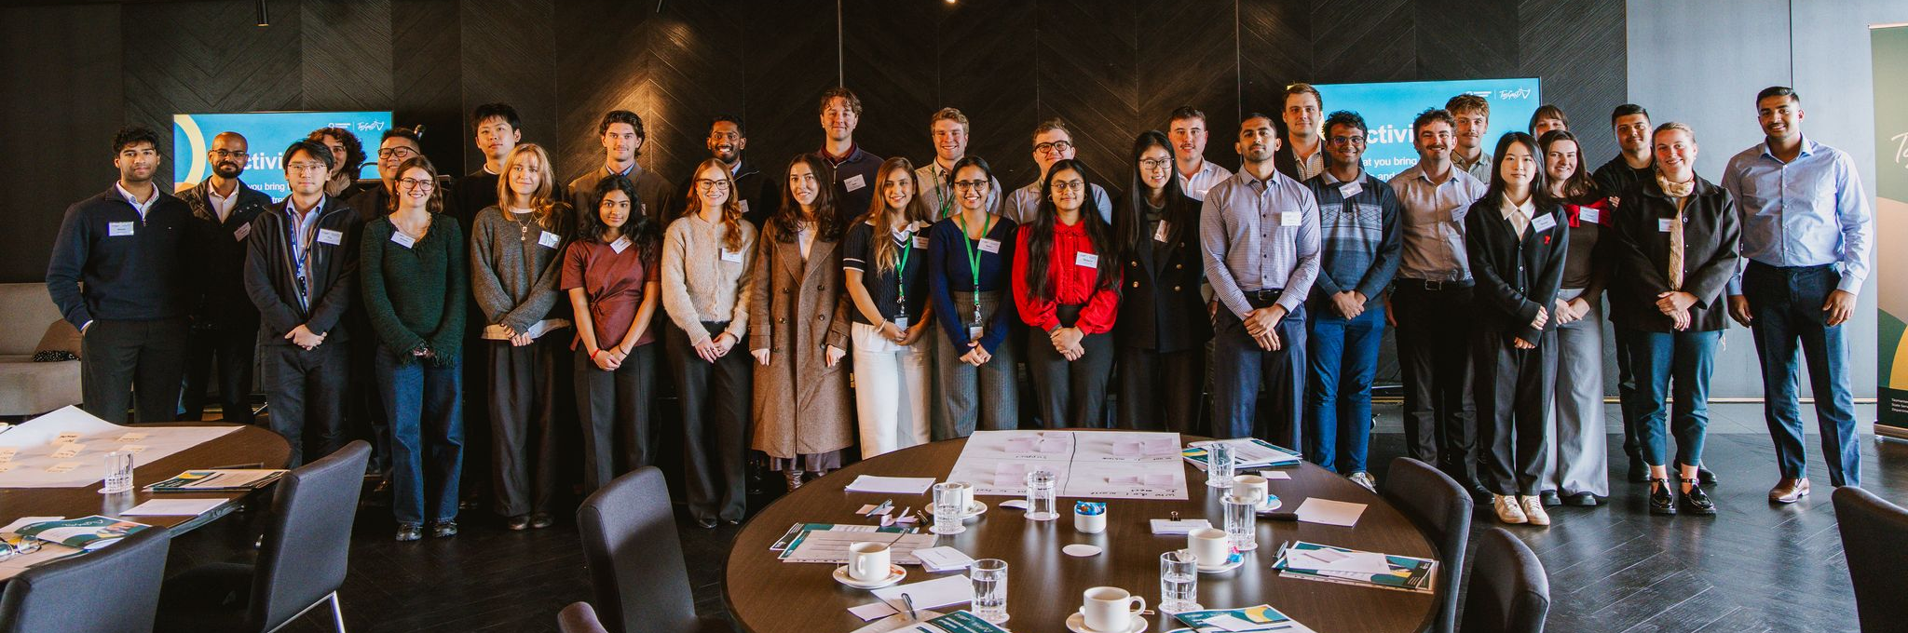
Figure 6. The TasGraD Program Class of 2026.

TSS Graduate Development Program (TasGraD)
The TasGraD Program continued as the primary whole-of-service graduate recruitment and development program for the TSS in 2025-26.
Thirty-three graduate officers commenced employment through TasGraD during the reporting period and were placed across participating agencies.
The program combines agency-based employment with shared development coordinated through the TTC, supporting graduates to build professional capability, networks and an understanding of working across the TSS.
Table 6. TasGraD Program summary statistics.
 | 2024-25 | 2025-26
TasGraD placements | 31 | 33
TasGraD development sessions | 19 | 15
Participating agencies | 8 | 9

TSS School-Based Traineeship Program
The TSS continued to provide opportunities for students to combine work, training and education through the TSS School-Based Traineeship Program.
Seven school-based trainees participated during 2025-26.
Through the program, college students gain practical workplace experience in an area of the TSS and work towards a nationally recognised qualification while completing their Tasmanian Certificate of Education.
Table 7. School-Based Traineeship Program summary statistics.
 | 2024-25 | 2025-26
School-based trainees | 10 | 7

Key agency initiatives
In addition to whole-of-service graduate and school-based employment programs, agencies continued to develop targeted pathways to attract and retain early-career talent in specialist professions and operational areas. These initiatives included cadetships, internships, professional graduate programs, traineeships and structured development pathways designed to address current and future workforce needs.

Department of Health
The Department of Health continued a range of profession-specific early career pathways, including Registered Undergraduate Student of Nursing and Midwifery (RUSON) positions, graduate paramedic programs, intern pharmacist placements, nursing transition-to-practice programs and medical training pathways for interns, resident medical officers and registrars. These programs support workforce supply across critical health professions.

Department of Justice
The Department of Justice continued its Legal Graduate Program, which supports recent law graduates to obtain their Legal Practising Certificate while employed as graduate legal practitioners. Participants receive structured development, mentoring from senior practitioners and a pathway to ongoing legal careers within the public sector.

Department of Treasury and Finance
Treasury expanded its youth employment offerings during 2025-26 through its established cadetship and finance graduate programs, while also piloting a traineeship pathway and introducing a policy graduate pathway. The initiatives combine formal and on-the-job learning to attract and develop future public sector professionals.

Port Arthur Historic Site Management Authority (PAHSMA)
PAHSMA continued to create employment opportunities for school-aged and tertiary students through seasonal tourism operations, workplace training and engagement with local schools. This approach helps provide practical work experience and pathways into the tourism and heritage sectors.

In practice: Early career pathways at NRE Tas
The Department of Natural Resources and Environment Tasmania (NRE Tas) provided a range of early career pathways during 2025-26, giving young people practical experience across Tasmania's natural resources and environmental workforce.
Twelve interns undertook placements through partnerships with the University of Tasmania, Charles Sturt University and Monash University, contributing across areas including policy, sustainability, biosecurity, veterinary science and land and water management.
NRE Tas also employed four school-based trainees across the Animal Health Laboratory, Biosecurity Tasmania's Entomology Laboratory and finance administration. The placements combined workplace experience with completion of a nationally recognised Certificate II in Workplace Skills.
The TSS School-Based Traineeship Program also supported an Aboriginal Trainee Wildlife Officer role, developed with education and Aboriginal engagement partners to create a culturally appropriate employment pathway for an Aboriginal young person.
The initiatives demonstrated how agency-led pathways can complement whole-of-service programs while responding to specialist workforce needs.

Workforce management and employment
Workforce management and employment arrangements provide the governance, employment and industrial framework that supports the effective operation of the TSS. The arrangements promote fair, consistent and accountable employment practices, enabling agencies to manage workforce risks, support organisational and workforce needs and effectiveness and maintain public confidence in the State Service.
During 2025-26, significant activity focused on wage agreement negotiations, conduct and accountability reforms, grievance management, investigation reform and employment-related determinations.

Wage negotiations
Workplace relations remained a major area of focus during 2025-26, with a significant bargaining round progressing across the TSS. Negotiations were coordinated by DPAC through SSMO in consultation with agencies and unions.
Of the 18 wage agreements, including Tasmania Police, 16 were finalised during the reporting period. Settled agreements included the Public Sector Wages Agreement, covering approximately 13,000 employees across all agencies, as well as agreements covering teachers, allied health professionals, radiation therapists, dentists, engineers, ambulance officers, medical practitioners, ministerial drivers and employees of the Port Arthur Historic Site Management Authority.
The Firefighters, Education Facility Attendants and Medical Practitioners Agreements were settled on a one-year basis and continued to be negotiated as part of the next bargaining round.
The negotiations were led with the appointment of a Lead Negotiator, with support from subject matter expertise from agencies and strategic guidance and support from SSMO.
For agreements negotiated on a three-year term, headline salary increases of 3 per cent in 2025, 3 per cent in 2026 and 2.75 per cent in 2027 were agreed. In addition to these increases, most agreements included structural salary adjustments and a range of classification and employment condition changes reflecting the operational requirements of different workforces.
The bargaining round also delivered significant modernisation of TSS employment conditions, including new and enhanced provisions supporting employee wellbeing, caring responsibilities, parental leave, family violence leave, gender affirmation leave and reproductive leave.
Alongside whole-of-service updates from the Head of the State Service, a dedicated TSS negotiations website was launched in March 2026 to provide employees, unions and agencies with a central source of information on bargaining process and agreement outcomes.
Table 8. Wage agreements finalised during the 2025-26 TSS bargaining round.
Agreement | Date registered
Public Sector Union Wages Agreement | 11/5/2026
Australian Workers Union Public Sector Union Wages Agreement | 12/5/2026
Allied Health Professionals Public Sector Union Wages Agreement | 11/5/2026
Ministerial Drivers Agreement | 7/5/2026
Port Arthur Historic Site Management Authority Staff Agreement | 7/5/2026
Education Facility Attendants Salaries and Conditions of Employment Agreement | 13/3/2026
Firefighting Industrial Agreement | 1/6/2026
Police Award | NA
Radiation Therapists Agreement | 7/5/2026
Dental Officers Agreement | 7/5/2026
Rural Medical Practitioners (Tasmanian State Service) Agreement | 13/5/2026
Medical Practitioners (Tasmanian State Service) Agreement | 13/5/2026
Teachers Agreement – finalised, with registration in 2026-27 | -
Ambulance Agreement – finalised, with registration in 2026-27 | -
Engineers Agreement - finalised, with registration in 2026-27 | -
Visiting Medical Practitioners Agreement - finalised, with registration in 2026-27 | -
For further information, visit www.tas.gov.au/tss-negotiations

Joint Consultative Committee
The Joint Consultative Committee (JCC) continued during 2025-26 as a key forum for strategic engagement between the Employer and public sector unions.
Jointly chaired by SSMO and union representatives, the JCC provides a regular mechanism for consultation on whole-of-service workforce matters, including major workplace change, workforce reform initiatives and employment policy developments.
The JCC continued to support collaboration on a range of strategic workforce priorities, including grievance management, workforce reform and employment framework matters. The committee provides an important opportunity to share information, identify emerging issues and support constructive engagement between the Employer and unions on matters affecting the TSS.

Conduct and accountability
During 2025-26, reforms to employee conduct and accountability arrangements progressed across the TSS, including work arising from the Commission of Inquiry.
Together, these reforms sought to strengthen consistency, transparency, accountability and timeliness in the management of employee conduct matters in the State Service.

Legislative reform
Legislative reform progressed to strengthen workforce governance, accountability and child-safe practices across the TSS, including development of the Commission of Inquiry (Miscellaneous Amendments) Bill 2026.
The Bill includes amendments arising from recommendations of both the Commission of Inquiry and the Woolcott Review. The proposed reforms seek to strengthen legislative protections for children and young people, modernise conduct and accountability arrangements, and support greater consistency in the management of employee conduct matters across the TSS.
A key focus of the proposed amendments is strengthening the State Service Code of Conduct. Proposed changes include expanding the application of conduct obligations in connection with State Service employment, introducing specific child-safety obligations, strengthening provisions relating to lawful and reasonable directions and confidentiality, and clarifying conduct expectations relating to integrity and public sector accountability.
The proposed amendments also update the State Service Principles to reinforce the expectation that the TSS operates in an apolitical, efficient, effective, impartial, ethical and professional manner.
As reform activity progresses into 2026-27, the focus will increasingly shift from design to implementation, supporting enduring improvements in capability, leadership, accountability and workforce governance across the TSS.

Code of Conduct
Section 9 of the State Service Act 2000 establishes the Code of Conduct that applies to employees, officers and Heads of Agency.
During 2025-26, 264 Code of Conduct matters were under investigation, including matters carried from previous years.
A total of 136 matters were finalised during the reporting period. Breaches of the Code of Conduct were determined in 112 matters, including matters carried forward and those initiated during 2025-26. Sanctions imposed ranged from counselling and formal reprimands through to termination of employment. Other finalised matters either did not result in a breach finding or were resolved through alternative means.
As at 30 June 2026, 129 matters remained under investigation and were carried forward to 2026-27.
Details of Code of Conducts matters by agency are provided in Table 26.

Shared capability and centralised investigations
The Shared Capability and Centralised Investigations (SCCI) unit, established within SSMO in 2024, continued to play a critical role in the case management and investigation of historical and contemporary Code of Conduct matters relating to the Ashley Youth Detention Centre (AYDC).
During 2025-26, the unit case managed 39 active matters, including 23 matters where it was the appointed investigator. Of the 39 matters, 16 were finalised during the reporting period, spanning both historical and contemporary allegations.
Barrister Ms Regina Weiss continued to support engagement with victim-survivors who may not have participated in investigations. This work enabled additional statements to be obtained and helped ensure victim-survivor perspectives were appropriately considered as part of investigation processes.
Beyond AYDC-related matters, the SCCI unit continued preparatory work to support a future centralised approach to serious misconduct investigations across the TSS. This work is intended to strengthen consistency, capability and confidence in investigation processes and support a more coordinated whole-of-service response to complex conduct matters.
A significant focus during 2025-26 was the contribution to the development of a contemporary whole-of-government Human Resources Case Management System. The system is intended to support more effective case management, data collection and reporting, while strengthening workforce capability and supporting consistent employment and conduct practices across the TSS.

Routine disclosure
The TSS continues to prioritise the public release of information relating to Code of Conduct investigations and matters arising from the Commission of Inquiry, ensuring information is disclosed wherever lawful and appropriate to do so.
Since 2021, the Head of the State Service has progressively expanded the scope of information published through monthly routine disclosure reporting. During 2025-26, reporting continued through a consolidated monthly report that brought together information from multiple data sources and provides explanatory commentary on significant movements and outcomes.
The reports include information on ongoing suspensions relating to allegations of child sexual abuse, assessments and actions undertaken by Heads of Agency in relation to current and former employees referred to in the Commission of Inquiry report, and the work of the multi-agency Joint Referral Review Team in reviewing matters identified through the Commission of Inquiry.
During 2025-26, aspects of the routine disclosure reporting framework were also considered as part of the independent Woolcott Review, providing additional assurance regarding the accuracy and integrity of published information.
Routine disclosure arrangements support transparency and accountability by providing regular public reporting on actions undertaken across the TSS in response to the Commission of Inquiry findings and related workforce matters.

Register of termination-related breaches
To support due diligence in recruitment, agencies continued to access the Practices, Procedures and Standards No.5 (PPS No.5) Register. The register records instances where an individual was terminated from the TSS or would have been terminated had they not ceased employment before such determination.
During the reporting period, PPS No.5 continued to be reviewed. Implementation of the revised PPS No.5 and a new system to host the register data is planned for 2026-27.

Suspension of employees
Under Employment Direction No. 4: Procedure for the Suspension of State Service Employees With or Without Pay, which governs the suspension of employees with or without pay, a total of 164 employees were suspended during 2025-26, compared with 176 in the previous reporting period.
The figure includes matters carried forward from 2024-25.

Reportable Conduct Scheme
In response to the Woolcott Review, the Tasmanian Government committed to strengthening the reporting of employee conduct matters through the TSS Annual Report, including State Service data relating to the Reportable Conduct Scheme.
The Scheme, established under the Child and Youth Safe Organisations Act 2023, is overseen by the Office of the Independent Regulator. It provides independent oversight of how organisations respond to and investigate allegations of reportable conduct involving children and young people.
For 2025-26, agencies reported making a combined 315 notifications under the Scheme.
This is the first year that agency-level Reportable Conduct Scheme data has been included in the TSS Annual Report. Reporting arrangements will continue to be refined as implementation of the Scheme matures across the State Service, supporting more consistent and robust agency-level reporting in future years.

Inability
Employment Direction No. 6 (ED6) provides a framework for investigating and determining whether an employee is able to efficiently and effectively perform their duties.
During 2025-26, 33 matters were managed under the ED6 process. Eight were finalised, with four resulting in a determination that the employee was unable to efficiently and effectively perform their duties and four finalised through alternative means.
Twenty-five matters will be carried forward into 2026-27.

Performance improvement
Performance improvement processes provide structured support where an employee requires assistance to meet the expected requirements of their role. The focus of these processes is to clarify expectations, address performance concerns early and support employees to achieve satisfactory performance.
Agencies may implement Performance Improvement Plans (PIPs) to establish clear expectations and provide targeted support, including additional training, supervision, role clarification or other development measures.
During 2025-26, 47 PIPs were in place across the TSS, an increase of 29 from the previous year. Twenty-four were successfully completed during the reporting period.

Terminations
Section 44(3) of the State Service Act 2000 provides for termination of employment on specified grounds, including Code of Conduct breaches, inability and other employment-related circumstances.
During 2025-26, 48 employees were terminated across nine agencies, compared with 29 in the previous reporting period.
Table 9. Employee terminations.
Reason for termination | Permanent | Fixed term | Total
Termination of a probationary employee | 10 | 0 | 10
Abandonment of employment | 2 | 1 | 3
Breach of the code of conduct (excluding child sexual abuse) | 24 | 1 | 25
Breach of the code of conduct (child sexual abuse) | 7 | 1 | 8
Inability (ED6 process) | 1 | 0 | 1
Termination following ED26 process | 1 | 0 | 1
Total | 45 | 3 | 48

Grievances

Internal grievances
Effective grievance management arrangements support workplace concerns being raised and addressed in a fair, transparent and timely manner.
During 2025-26, 293 formal grievances were lodged across 11 agencies, compared with 178 grievances reported across 13 agencies in 2024-25.
Of the grievances reported during the period, 62 involved allegations of workplace bullying and/or harassment, while three related specifically to allegations of sexual harassment.
Of the total grievances reported during the period, 48 were not upheld.
Table 10. Grievance outcomes.
Outcome of formal grievance | 2024-25 | 2025-26
Satisfactorily resolved by agreement | 42 | 51
Withdrawn/dismissed | 25 | 35
Upheld | 27 | 65
Not upheld | 17 | 48
Carried forward | 67 | 94
Total | 178 | 293
Thirty-two bullying and/or harassment grievances and one sexual harassment grievance were resolved in the reporting period. The remaining unresolved matters were carried forward into 2026-27.

External grievances
Employees may also seek external review or resolution of workplace matters through external organisations including the Office of the Anti-Discrimination Commissioner, the Tasmanian Industrial Commission and other tribunals.
During 2025-26, agencies reported 104 grievance matters that proceeded to external organisations, compared with 48 in 2024-25. These matters related to a range of workplace concerns, including:
- Management decisions (38)
- Process matters (35)
- Discrimination (6)
- Bullying and/or harassment (1)
- Inappropriate employee behaviour (1)
- Other (23).
Table 11 below shows the number of grievances referred to external organisations during the reporting period compared to 2024-25.
Table 11. Grievances referred to external organisations.
External organisation | 2024-25 | 2025-26
Office of the Anti-Discrimination Commissioner | 1 | 4
Ombudsman | 0 | 2
Tasmanian Industrial Commission | 39 | 38
Other organisational or industrial tribunals | 8 | 60
Total | 48 | 104

Employment determinations

Determinations by SSMO
Agencies refer specified employment matters to SSMO as the delegate of the Head of the State Service for determination in accordance with relevant Employment Directions and Practices, Procedures and Standards.
In 2025-26, SSMO administered 504 determination matters, including one carried forward from 2024-25. Of these, 501 were approved, two were not approved or withdrawn and one remained under consideration at 30 June 2026.

Table 12. Employment determinations by SSMO.
Request type | Carried over | New | Rejected or withdrawn | Approved | Carried forward
Agency-specific recruitment programs (PPS2) | 0 | 5 | 0 | 5 | 0
Pre-employment checks (ED7) | 0 | 4 | 0 | 4 | 0
Essential requirements (ED1, ED10, and ED18, and offices under section 29 of the Act) | 1 | 35 | 1 | 34 | 1
Extension of fixed-term employment beyond 36 months (ED1) | 0 | 40 | 0 | 40 | 0
Fixed-term and casual employment registers (PPS1) | 0 | 27 | 0 | 27 | 0
Appointment without advertising (ED1) | 0 | 12 | 0 | 12 | 0
Promotion without advertising (ED1) | 0 | 367 | 1 | 366 | 0
Secondments into the State Service (ED1 and offices under section 29 of the Act) | 0 | 6 | 0 | 6 | 0
Secondments out of the State Service (ED1) | 0 | 7 | 0 | 7 | 0
Total | 1 | 503 | 2 | 501 | 1

Determinations by Heads of Agencies
In July 2024, Employment Direction No 1 – Employment in the State Service (ED1) was reissued with updated provisions to support greater employment stability and flexibility across the TSS.
The revised direction introduced a pathway for fixed-term and fixed-term casual employees to transition to permanent employment after 12 months of continuous service, subject to eligibility criteria. It also enabled part-time employees to apply for a permanent increase in hours where additional hours had been worked regularly over a 12-month period.
Under section 37(4) of the State Service Act 2000, the Employer has delegated the authority to Heads of Agencies to approve changes in employment status where criteria in ED1 are met.
In cases where an employee does not meet the standard criteria, but special and exceptional circumstances exist, such as critical workforce needs or training pathways, Heads of Agencies may request approval from the Employer or their delegate.

Table 13. Employment determinations by Heads of Agency.
Employment determination | Approved
Change of employment status by a Head of Agency from fixed-term to permanent relating to a training pathway, transmission of business or critical risk (clause 12A, ED1) | 3
Change of employment status from fixed-term to permanent where an employee has completed 12 months continuous service and other set criteria are satisfied (clause 12B, ED1) | 966
Change of employment status for eligible fixed-term teachers (ED9) | 7
Total | 976

State Service workforce profile
The workforce profile provides a statistical overview of the size, composition, distribution and movement of the TSS workforce.
At 30 June 2026, the TSS had a paid headcount of 36,979 and paid Full-time Equivalent (FTE) of 30,397, an increase of 2.2 per cent and 2.0 per cent respectively from 30 June 2025.
Unless otherwise noted, workforce data is drawn from the Workforce Information Reporting System (WiRS) and relates to employees covered by the State Service Act 2000. Fixed-term casual employees are reported separately where relevant. Further information about data definitions, scope and methodology is provided in Information sources and definitions.

Workforce size and agency distribution
Table 14. Paid FTE by agency.
Agency | 30 June 2025 | 30 June 2026 | Variance  (#)
Department for Education, Children and Young People | 10,161.14 | 10,401.97 | 240.8
Department of Health | 12,835.57 | 13,209.16 | 373.59
Department of Justice | 1,740.26 | 1,788.58 | 48.32
Department of Police, Fire and Emergency Management | 1,217.17 | 1,235.83 | 18.66
Department of Premier and Cabinet | 557.70 | 505.50 | -52.20
Department of Natural Resources and Environment Tasmania | 1,372.84 | 1,346.39 | -26.45
Department of State Growth | 943.77 | 903.26 | -40.51
Department of Treasury and Finance | 327.49 | 334.58 | 7.09
Tasmanian Audit Office | 53.19 | 68.24 | 15.05
Brand Tasmania | 7.00 | 5.90 | -1.10
Environment Protection Authority | 116.50 | 108.76 | -7.74
Integrity Commission of Tasmania | 14.90 | 14.90 | -
Macquarie Point Development Corporation | 15.72 | 18.08 | 2.36
Port Arthur Historic Management Authority | 104.35 | 125.20 | 20.85
Homes Tasmania | 177.14 | 190.08 | 12.94
The Public Trustee | 73.74 | 74.45 | 0.71
Tourism Tasmania | 68.82 | 66.21 | -2.61

Table 15. Paid FTE and paid headcount - Fixed-term casual.
Fixed-term - casual | 30 June 2025 | 30 June 2026 | Variance (#)
Paid FTE | 1,234.26 | 1,160.91 | -73.35
Paid Headcount | 3,033 | 2,896 | -137.00
Table 16. Paid headcount by agency.
Agency | 30 June 2025 | 30 June 2026 | Variance  (#)
Department for Education, Children and Young People | 13,039 | 13,368 | 329
Department of Health | 15,736 | 16,227 | 491
Department of Justice | 1,841 | 1,900 | 59
Department of Police, Fire and Emergency Management | 1,282 | 1,302 | 20
Department of Premier and Cabinet | 624 | 567 | -57
Department of Natural Resources and Environment Tasmania | 1,502 | 1,473 | -29
Department of State Growth | 1,097 | 1,065 | -32
Department of Treasury and Finance | 350 | 357 | 7
Tasmanian Audit Office | 57 | 72 | 15
Brand Tasmania | 7 | 6 | -1
Environment Protection Authority | 127 | 118 | -9
Integrity Commission of Tasmania | 17 | 16 | -1
Macquarie Point Development Corporation | 16 | 20 | 4
Port Arthur Historic Management Authority | 127 | 130 | 3
Homes Tasmania | 187 | 203 | 16
The Public Trustee | 78 | 78 | -
Tourism Tasmania | 78 | 77 | -1

Employment profile
Table 17. Paid Headcount – Employment type and gender.
Employment Type | Female  % TSS | Male  %TSS | Other  %TSS
Permanent | 60.08 | 23.09 | 0.21
Fixed-term | 11.07 | 4.81 | 0.09
Officers | 0.35 | 0.30 | 0.00
Total | 71.50 | 28.20 | 0.30
Table 18. Average salary by agency and gender.
Agency | 2025  Female | 2025  Male | 2026 Female | 2026  Male
Department for Education, Children and Young People | $96,055.11 | $99,242.01 | $97,414.91 | $100,556.97
Department of Health | $103,422.18 | $126,339.51 | $107,802.24 | $130,474.57
Department of Justice | $101,329.09 | $103,887.72 | $106,391.46 | $108,964.24
Department of Natural Resources and Environment Tasmania | $97,900.53 | $100,893.39 | $102,431.87 | $106,170.17
Department of Police, Fire and Emergency Management | $95,333.84 | $104,607.05 | $100,261.72 | $108,358.89
Department of Premier and Cabinet | $102,488.86 | $109,043.97 | $107,485.60 | $113,788.81
Department of State Growth | $103,735.57 | $112,401.06 | $108,168.96 | $117,970.98
Department of Treasury and Finance | $107,255.56 | $110,827.59 | $110,778.01 | $115,270.67
Audit Tasmania | $102,276.16 | $104,120.44 | $103,633.44 | $107,524.51
Brand Tasmania | $117,367.80 | $99,482.00 | $124,590.00 | $105,852.00
Environment Protection Authority | $115,334.43 | $119,707.76 | $120,805.46 | $124,643.74
Homes Tasmania | $99,975.56 | $109,598.03 | $103,630.33 | $109,967.08
Integrity Commission of Tasmania | $100,596.17 | $117,275.25 | $116,843.62 | $116,466.50
Macquarie Point Development Corporation | $110,558.80 | $134,284.43 | $124,420.11 | $134,005.13
Port Arthur Historic Site Management Authority | $65,555.93 | $77,997.40 | $72,472.97 | $85,140.43
The Public Trustee | $90,491.90 | $97,474.80 | $96,119.35 | $100,744.28
Tourism Tasmania | $113,308.14 | $116,813.00 | $120,050.42 | $119,175.40
Total | $101,352.10 | $108,470.32 | $107,252.97 | $112,063.20

Workforce location
Table 19. Paid Headcount – Employment by region.
Region | % TSS
North | 22.92
North-West | 15.90
South | 55.62
South-East | 5.13
West Coast | 0.43

Age profile and workforce movement
Table 20. Paid Headcount – Age group.
Age Group | % TSS
19 and under | 0.61
20 to 29 years | 13.68
30 to 39 years | 26.58
40 to 49 years | 24.54
50 to 59 years | 22.86
60 to 69 years | 10.75
70 years and over | 0.98
Table 21. Paid Headcount - Separation by age.
Age Group | % TSS
19 and under | 0.14
20 to 29 years | 12.09
30 to 39 years | 23.90
40 to 49 years | 15.79
50 to 59 years | 15.46
60 to 69 years | 29.90
70 years and over | 2.72
Table 22. Paid Headcount - Commencement by age.
Age Group | % TSS
19 and under | 1.11
20 to 29 years | 30.81
30 to 39 years | 35.95
40 to 49 years | 17.70
50 to 59 years | 10.96
60 to 69 years | 3.33
70 years and over | 0.14
Table 23. Separations and commencements.
 | Headcount
Separations | 5,488
Commencements | 5,367
Table 24. TNVR and WRIP at TSS level.
 | Headcount | Average cost
Targeted Negotiated Voluntary Redundancy | 16 | $102,769.12
Workplace Renewal Incentive Program | 53 | $30,652.92

Senior leadership
Table 25. Senior Executive Officers by category and gender.
Category | Female | Male | Other | Total
Heads of Agencies | 9 | 8 | 0 | 17
Senior Executive Service | 117 | 90 | 0 | 207
Equivalent Specialists | 10 | 17 | 0 | 27
Prescribed Office Holders | 2 | 2 | 0 | 4
Total | 138 | 117 | 0 | 255

Code of Conduct
Table 26. Count of code of conduct investigations.
Agency | Carried forward from 2024-25 | New for 2025-26 | Finalised within the period | Carried over to 2026-27
Department for Education, Children and Young People | 85 | 45 | 56 | 69
Department of Health | 36 | 40 | 50 | 33
Department of Justice | 22 | 7 | 14 | 15
Department of Police, Fire and Emergency Management | 5 | 6 | 5 | 6
Department of Natural Resources and Environment Tasmania | 4 | 5 | 5 | 3
Department of State Growth | 3 | 0 | 3 | 0
Other | 2 | 4 | 3 | 3
Total | 157 | 107 | 136 | 129

Information sources and definitions

Workforce profile data
Data presented in the State Service workforce profile is provided by TSS agencies and reported through the Workforce Information Reporting System (WiRS).
WiRS is an employee reporting system that standardises workforce data using defined business rules and translation tables. It includes employees and officers appointed under the State Service Act 2000 within agencies listed in Schedule 1 of that Act.
Data is uploaded to WiRS quarterly and is subject to ongoing quality assurance and may be updated to correct coding or reporting errors, including those affecting historical paid headcount or FTE figures. As a result, historical data in this report may differ from figures previously published in TSS and agency reports.

Other information sources
Other information in this report is drawn from a variety of materials, including briefing material, custom reports and the Annual Agency Survey.
The Annual Agency Survey is completed by all TSS agencies and submitted to SSMO. It collects information on employment policies, workforce programs, management practices and other matters relating to the functions and powers of the Employer, as required under the TSS Employment Framework.

Gender reporting
TSS human resources information systems provide for gender to be recorded as Female, Male, Other or Undisclosed. To protect privacy where numbers are small, data recorded as Other or Undisclosed may be included in aggregate totals but not separately reported at more detailed levels such as agency, age group or employment category.

Relevant definitions
Paid headcount is an indicative number of employees and officers (excluding casuals) engaged and paid as at the reporting date, including employees on paid leave. It excludes employees who were not paid as at the reporting date, such as people on Leave Without Pay or on secondment out of the TSS. As this data is based on payroll, as opposed to establishment, headcount numbers reported here will differ to those reported by agencies.
Paid Full-time Equivalent (FTE) is the full-time equivalent value of employees and officers (excluding casuals) who are engaged and paid as at the reporting date (for example, two people working in a part-time role of 0.5 FTE each equals 1.0 FTE).
Officer means a person appointed under Part 6 of the State Service Act 2000 and includes Heads of Agencies, Prescribed Office Holders, Senior Executive Service officers and Equivalent Specialists.

For more information
For further information about the data in this report, contact SSMO at ssmo@dpac.tas.gov.au
Current and previous TSS annual reports are available at www.dpac.tas.gov.au/working-in-the-state-service

Reporting practices differ between agencies. Leave approvals may reflect multiple leave instances associated with a single application, and some agencies do not separately track applications and approvals, due to the need to protect employee confidentially and privacy.
Paid FTE by agency data is derived from agency fortnightly data returns to SSMO.
Department of Police, Fire and Emergency Management data does not include Sworn Police Officers.
Fixed-Term Casual figures reported separately, due to significant fluctuations.
Paid headcount by agency data is derived from agency fortnightly data returns to SSMO.
Genders other than Female and Male are not included in this chart due to limited representation.
Salary ranges reflect FTE salaries (excluding allowances) that have then been grouped equivalent to the General Stream band classifications in TSS Award, SES levels in Employment Direction 17 (ED17), and salaries above this for Heads of Agency, prescribed office holders and employees in specialist roles, effective 30 June 2025 and 2026. These salary ranges will change with any applicable salary increases.
Other includes the Department of Premier and Cabinet, Port Arthur Historic Site Management Authority, Homes Tasmania and The Public Trustee. Individual agency data is not reported separately in this instance due to small numbers and associated confidentiality considerations.

