Towards a Tasmanian Disability Inclusion Plan

  - Discussion paper
Easy Read version
November 2025

What is in this paper
What is in this paper 2
How to use this paper 3
Acknowledgement of Country 4
Support for you 5
About this paper 7
Sending a submission 9
Sessions 11
What we have already heard 12
Tell us about: 14
Feeling safe and included 14
Understanding disability 14
Information and decisions? 14
Transport 15
Education 16
Health Services 16
Criminal Justice System 17
Employment 18
Housing 18
Services 19
General 20
Contact 21

How to use this paper


The Tasmanian Government wrote this paper.

-When we say the word “we”, it means the Tasmanian Government.

We wrote this paper in an easy to read way.
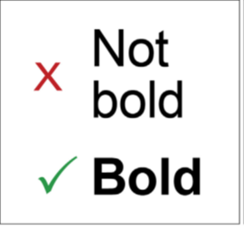
We wrote some words in bold.
This means the letters are thicker and darker.
We explain what the hard words mean.

You can ask for help to read this paper.

You could ask a friend, family member, support person or advocate.

Acknowledgement of Country


We recognise First Nations peoples as the traditional owners of the land we live on – Lutruwita/Tasmania.

They were the first people to live on and use the:
- Land

- Waters

Support for you
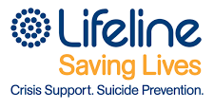
Lifeline is for people at risk of suicide.
This is when someone ends their own life.

Call Lifeline at any time on 13 11 14


13YARN is for Aboriginal and Torres Strait Islander people who need help.
Call 13YARN anytime on 13 92 73


Beyond Blue can support you with your mental health.
Call them anytime on 1300 224 636


1800Respect is for people in Australia who experience:
- Domestic and family violence
- Sexual violence
Call them any time on 1800 737 732


The Disability Gateway is for people with disability.
Call them Monday to Friday 8 am - 8 pm on 1800 643 787

About this paper
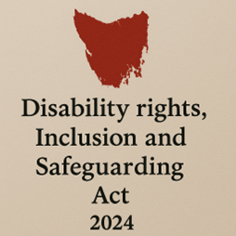
Tasmania has a new law called the Tasmanian Disability Rights, Inclusion and Safeguarding Act.

The Act say we must make a plan to:

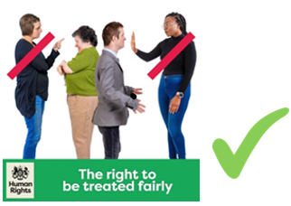
- Make your human rights stronger

- Make sure you can take part in the community

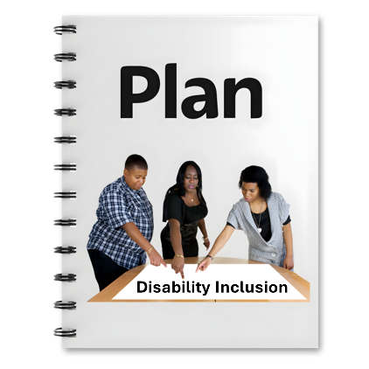
The plan is called the Tasmanian Disability Inclusion Plan.

We call it the plan for short.

We are writing the plan now.

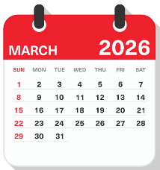
You can tell us what you think until 10th March 2026


We want to know what you think should be in the plan.

You can tell us in different ways.
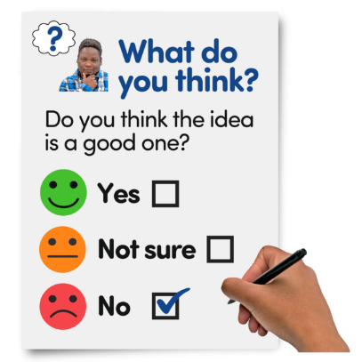

This paper has questions to help you.

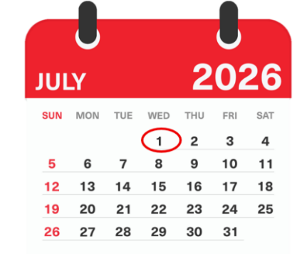
The plan will start on July 1st 2026.

Sending a submission
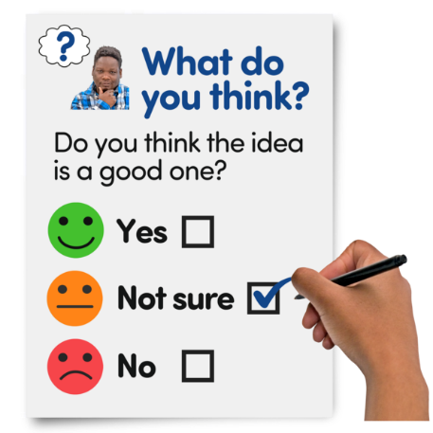
You can tell us what should be in the plan by sending us a submission

A submission is telling us what you think about something.

You can make a submission in a way that works for you.


A submission can be:

- In writing

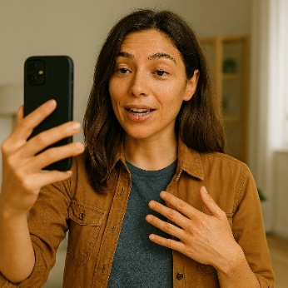
- A video


- A drawing or poem

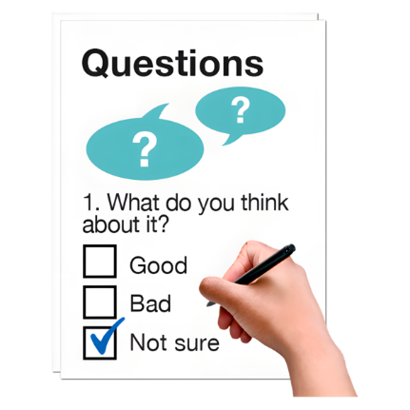
You can answer the questions in this paper in your submission.

You don’t have to answer all the questions


You can choose to answer the questions that are most important to you.


Submissions should be sent to disability@dpac.tas.gov.au

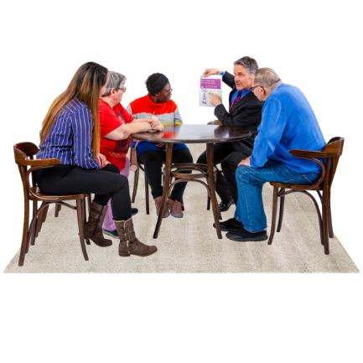
Sessions
We will have in person sessions to ask you what should be in the plan.

These sessions will include:
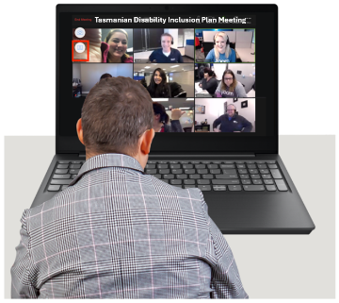
- Webinars


- Meetings with groups

- Forums


Information about these sessions can be found at www.dpac.tas.gov.au/disability-inclusion-plan


You can email us at: disability@dpac.tas.gov.au to ask for information about our sessions.

What we have already heard

We have already asked what was important to you in:

- The Disability Royal Commission


- The NDIS Review

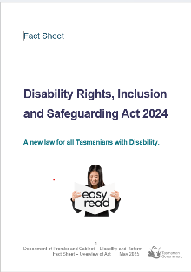
- Australia’s Disability Strategy

- The Tasmanian Disability Rights, Inclusion and Safeguarding Act


You told us you wanted to:

- Feel safe

- Be included

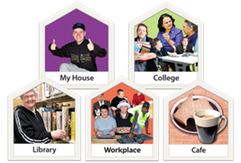
- Be able to go places like school and the doctor

- Get a job
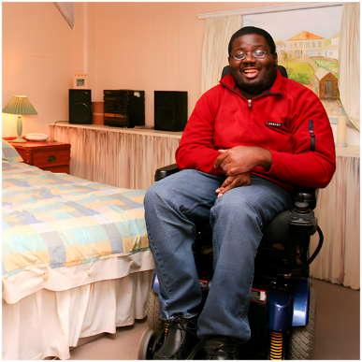

- Live somewhere you like

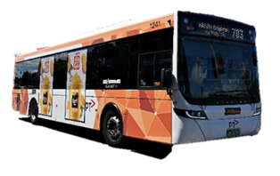

- Be able to access your community by using the bus

Tell us about:

Feeling safe and included


What makes you feel:

- Safe

- Included


Understanding disability

How can we help other people understand disability better?

Information and decisions?

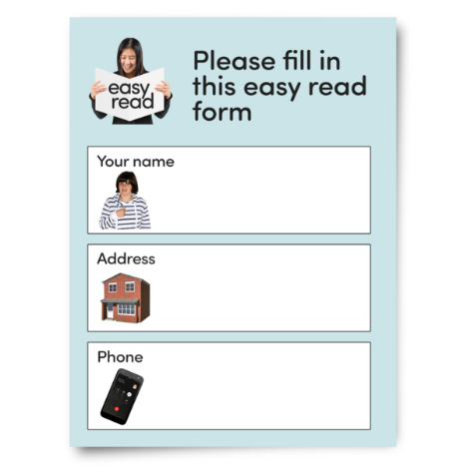
- What makes it easy for you to understand information?

- Where do you get your information from?

- What is the best way to ask you what is important to you?



- What makes it easier for you to make decisions?

Transport
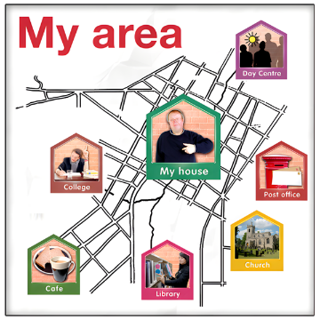
How can we make it easier for you to access the community?

For example:
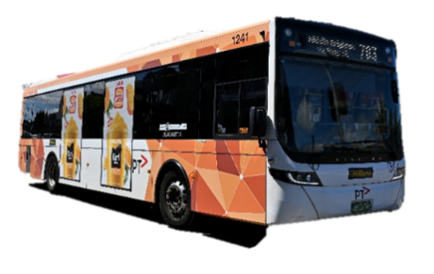
- On the bus



- In a taxi

Education

How can we make school better for children and young people with disability?

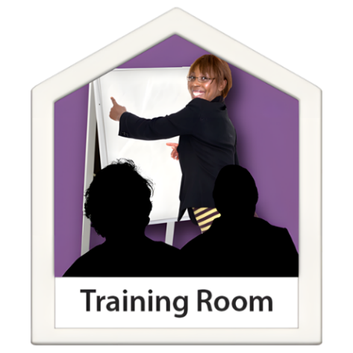

How can we make it easier to learn things as an adult

Health Services


How can we make it easier to access Health Services?

Health services are places such as:

- GPs


- Hospitals

- Dentists

What does a good health service look like?

Criminal Justice System

How can we make it better for you in the Criminal Justice System?

The Criminal Justice System includes:

- Police


- The courts

- Prisons

Employment

How can we make it easier for you to get a job?

How can we make you feel safe at work

Housing
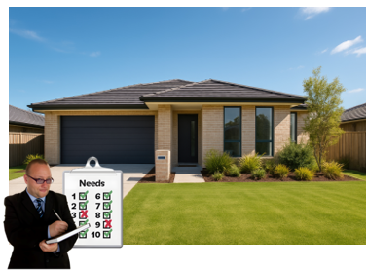
How can we make it easier for you to live where you want?

Services

What services are most important to you?

How can services better support you?


How can we make services better for people with disability who also:

- Are Aboriginal or Torres Strait Islander?


- Are LGBTQIA+?

- Are Older?
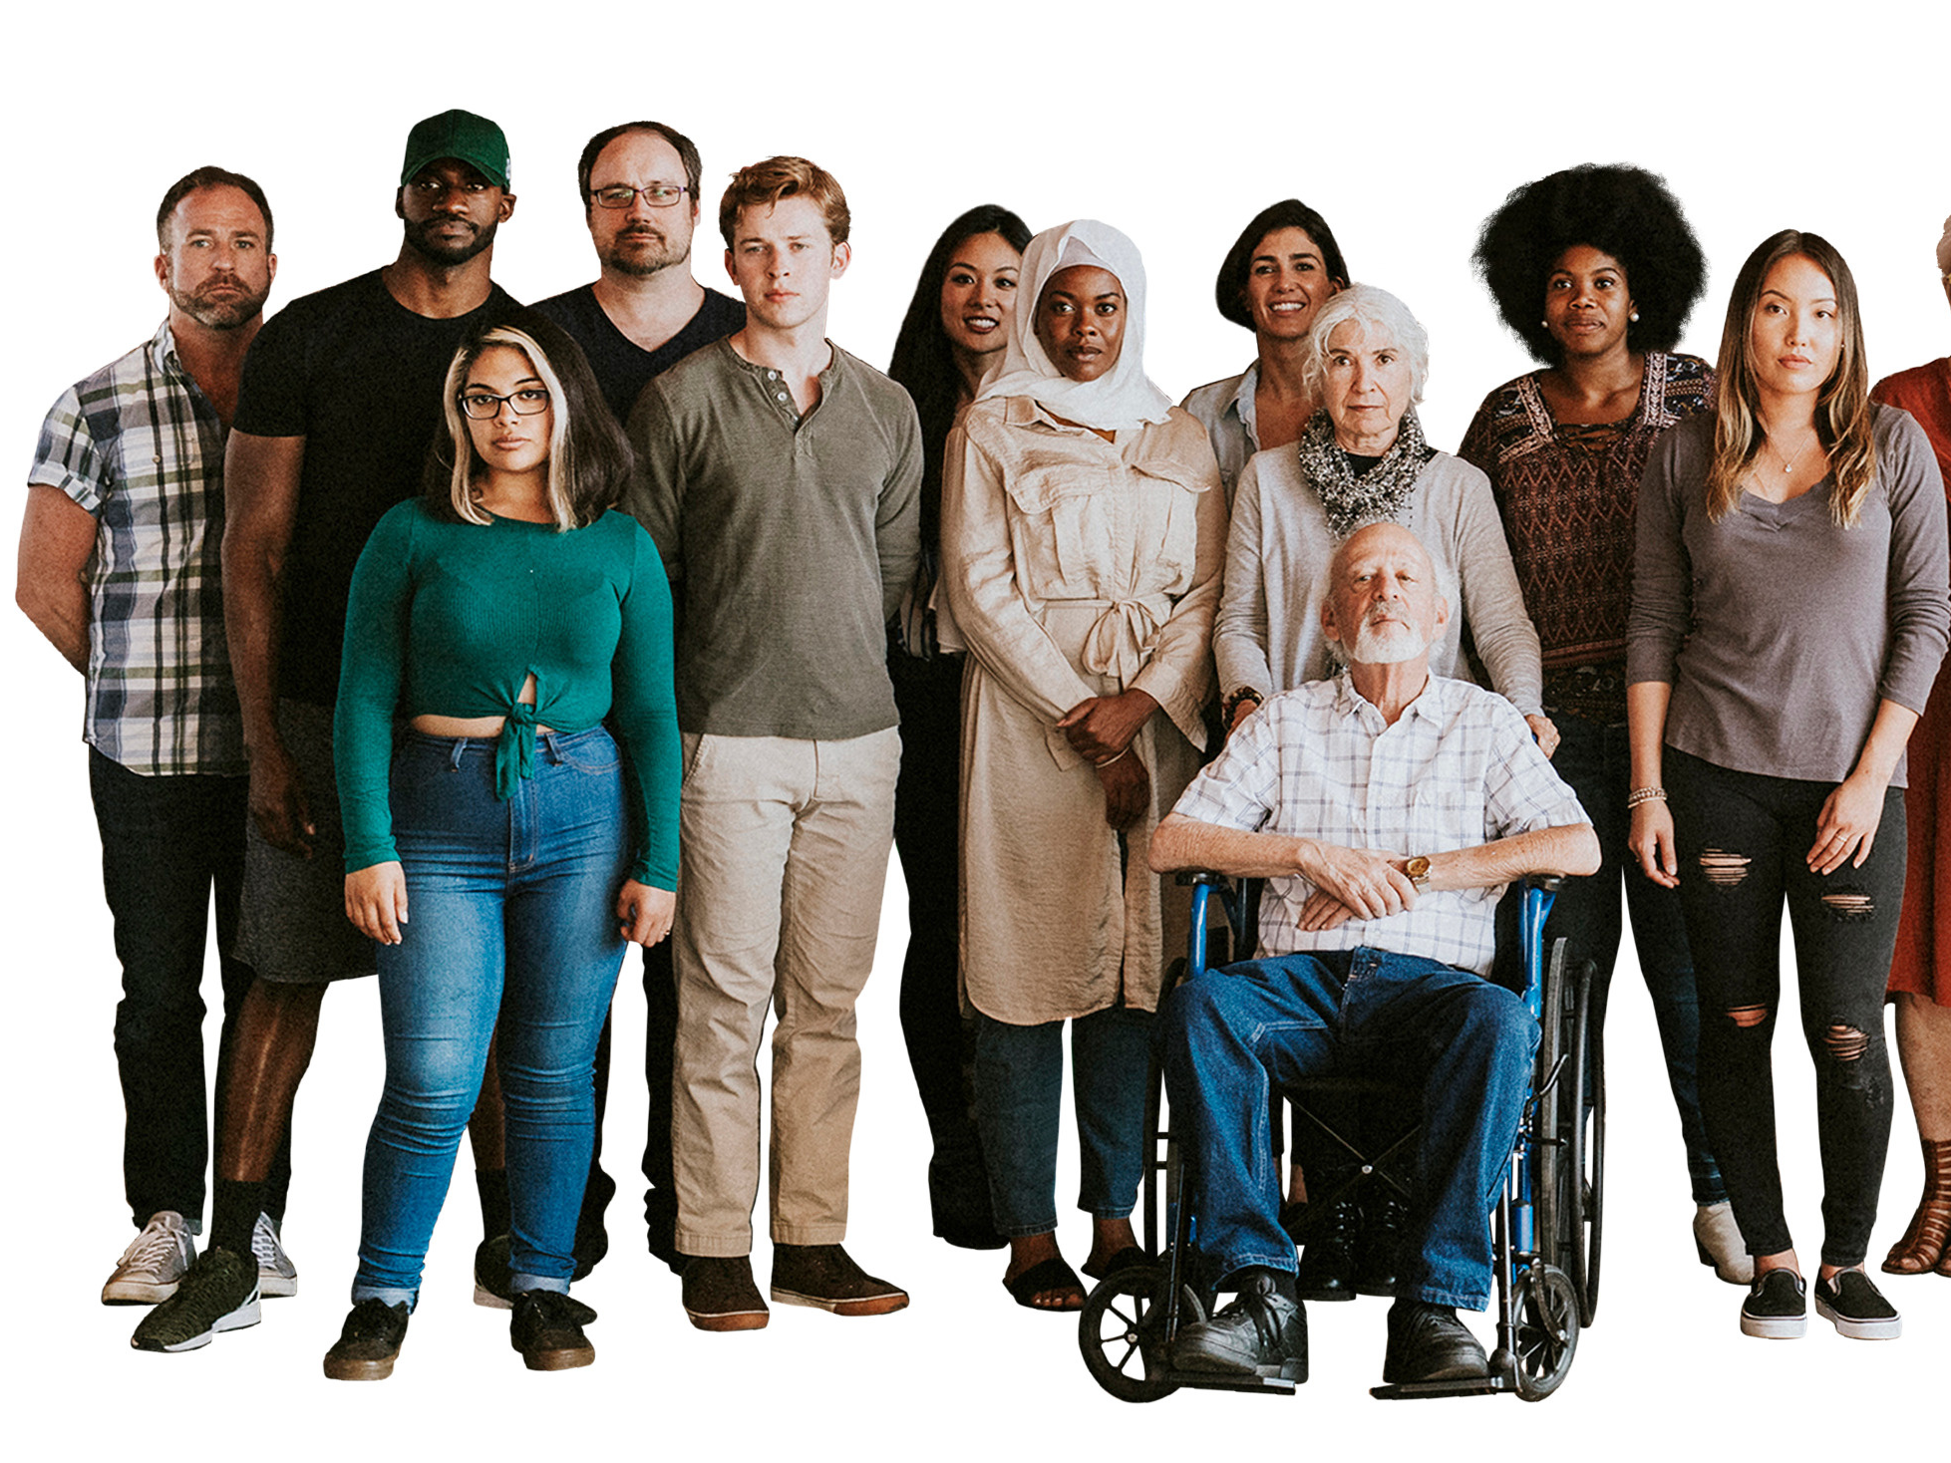
- Have different beliefs?

- Speak a different language?

General


Is there anything else we could include in the plan about being a person with disability in Tasmania?

Contact
You can contact us about this paper.

Email: disability@dpac.tas.gov.au


Phone: 1800 431 211


You can find more information at: www.dpac.tas.gov.au/disability-inclusion-plan



The images in this document may not be reused without permission. For any enquiries about the images or Easy Read, please email: easyread@speakoutadvocacy.org

