What is the Senior Practitioner?



Easy Read Fact Sheet

What is this fact sheet about?
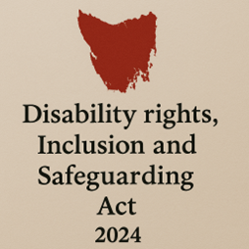
There is a new law in Tasmania.
It is called the Disability Rights, Inclusion and Safeguarding Act 2024.
We call it the Act for short.

There are lots of changes being made because of the new Act.
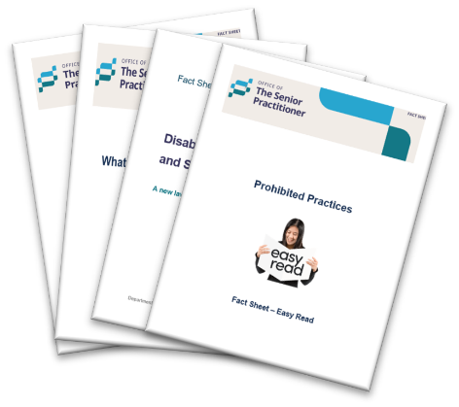
We have written some fact sheets about the changes.

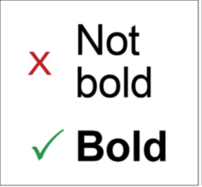
We wrote some hard words in bold.
This means the letters are thicker and darker.
We explain what the hard words mean.

What is the Senior Practitioner?
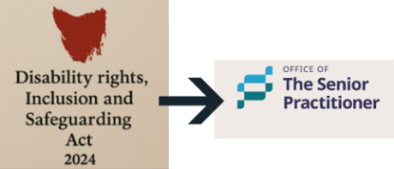
The Senior Practitioner is a job that was made under the new Act.

The Senior Practitioner helps protect the rights of people with disabilities in Tasmania.


They make sure the rules are followed when using restrictive practices.


A restrictive practice is something that stops you from moving around freely or doing what you want.

It can take away your rights.
It must only be used when needed to keep you or others safe.


The Senior Practitioner is Marita O’Connell.


She leads a team of people who are experts in areas like:


- Behaviour support
behaviour support is understanding why someone is acting a certain way and finding kind and safe ways to support them.


- Policy
Policy is the rules or plans that tell people the right way to do things.

What does the Senior Practitioner do?

The Senior Practitioner:

- Say yes or no to the use of restrictive practices.



- Makes sure that people with disabilities are safe and respected.


- Checks that providers follow the
rules.



- Tries to reduce or stop the use of
restrictive practices.

Other things the Senior Practitioner does.


- Gives information about people’s rights.


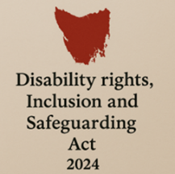

- Writes rules and guides for disability services.
They match the new Act.


- Approves Independent Persons.
An Independent Person helps you understand the restrictive practice.

They tell you your rights.


- Approves for someone to be an Appointed Program Officer.
We call them APO for short.

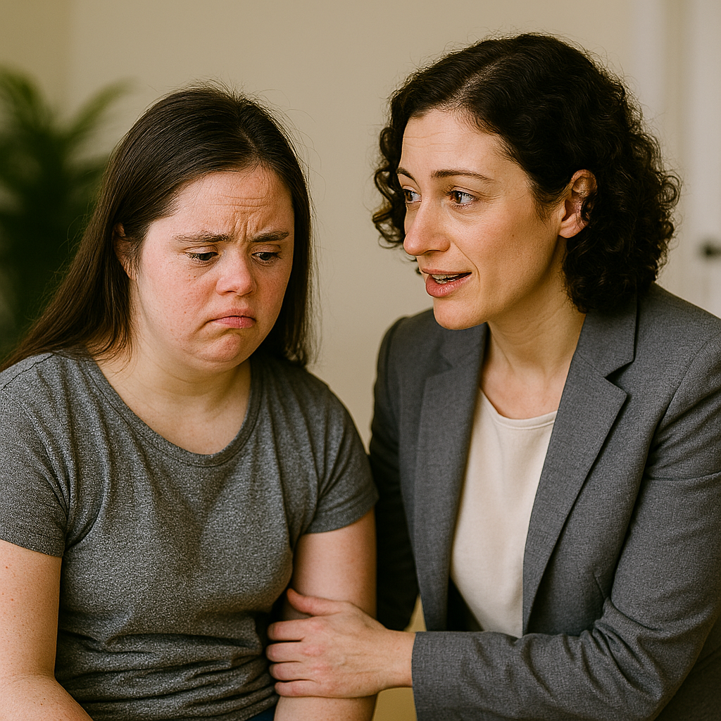
An APO is someone who works for a disability service provider.

Their job is to make sure you are treated fairly and safely if you have a restrictive practice.

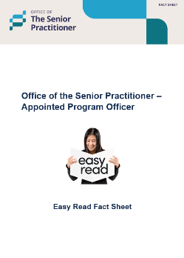
We have a fact sheet that tells you more about the APO.

Who can be the Senior Practitioner?

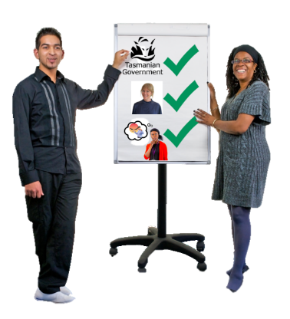
They must:
- Work for the Tasmania Government.

- Be a trained health professional.

- Have the right experience and knowledge.

Guiding principles

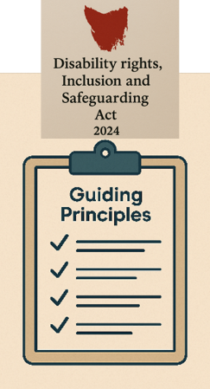
Guiding principles are the most important rules.

They help everyone make good choices and do the right thing when using the Act.
We must all follow them.


The Act says that Restrictive Practices should:

- Only be used when nothing else works.


- Be the least restrictive way.

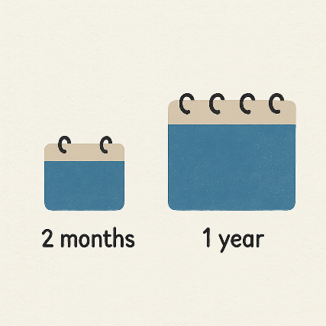


- Be used for a short time.



- Be fair and only be used to keep someone safe.

Can decisions be questioned?


Yes, if someone does not agree with a decision made by the Senior Practitioner, they can:
- Ask the Senior Practitioner’s office to think more about it.


If you are still not happy, you can go to
the Tasmanian Civil and Administrative Tribunal
We say TASCAT for short.

TASCAT is a place where people can go to get help to solve problems or disagreements in a fair and safe way.

TASCAT helps with many areas of the law.

For more information


For more fact sheets and information about the Act, go to:
Department of Premier and Cabinet


Speak Out Tasmania created this Easy Read document using Photosymbols and custom images. The images may not be reused without permission. For any enquiries about the images or Easy Read, please email: easyread@speakoutadvocacy.org

