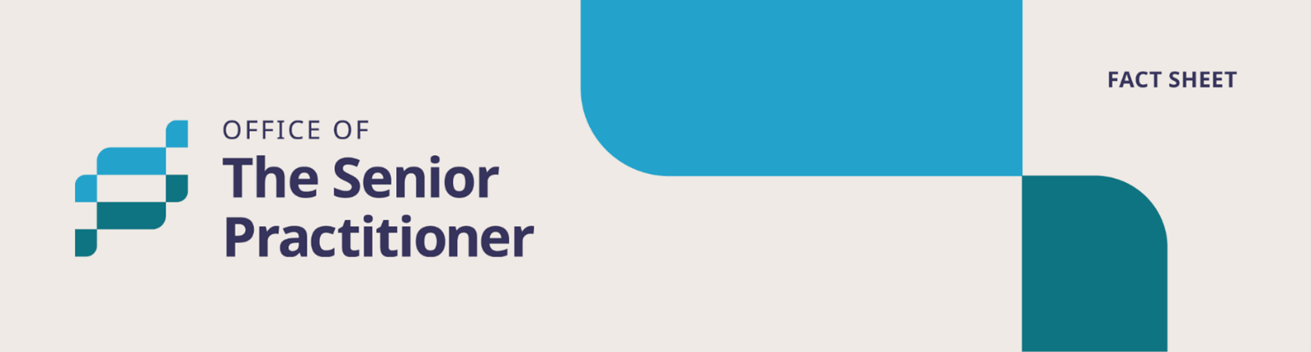

**Appointed Program Officer**



# **Easy Read Fact Sheet**

## What is this fact sheet about?

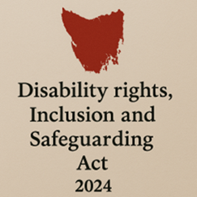

We have a new law in Tasmania.

It is called the *Disability Rights, Inclusion and Safeguarding Act 2024.*

We call it the Act for short.

There are lots of changes being made because of the new Act.

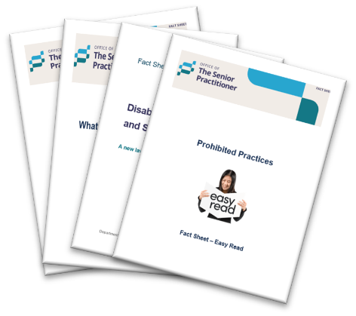

We have written some fact sheets explaining the changes.

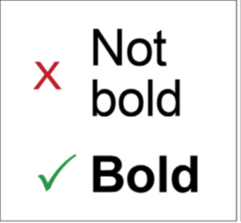We wrote some hard words in **bold**.

This means the letters are thicker and **darker**.

We explain what the hard words mean.

## What is an Appointed Program Officer?



An **Appointed Program Officer** is a worker chosen by a disability service provider to help with restrictive practices.

We say **APO** for short.

If you have a restrictive practice, the APO must:

* Promote and protect your rights.



* Make sure you are treated fairly and safely.

## What does the APO do?



The APO:

* Makes sure that any restrictive practice is only used as a last choice.

A spiral bound folder with a photo of a man giving a thumbs up. The words 'My Plan' is written at the top. There is a green tick at the bottom of the plan.



* Follows your behaviour support plan.

A man and a woman are looking at a document. the document is named 'Rules'. The woman is holding a magnifying glass.



* Makes sure your service follows the rules in the Act.



* Tries to reduce or stop the use of restrictive practices.

## When must there be an APO?

A young man looking angry with his arms crossed. He is looking at a cupboard which is locked. Below is an image of a woman with a green tick. 
The image infers the woman is an APO and must be involved.

A provider must have an APO if they want to use a restrictive practice.

## Who cannot be an APO?

* An APO should not be the person who is using the restrictive practice.

For example, it should not be your support worker.

## How is the APO appointed?



The APO must be approved by the Senior Practitioner.



The provider must fill out a form to ask the Senior Practitioner to say yes to the APO.

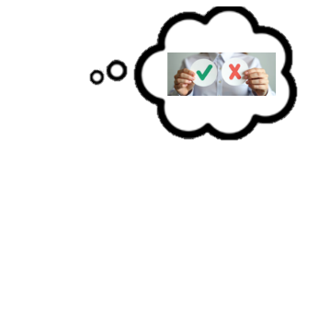

The Senior Practitioner can say:

* Yes or no
* Yes with some rules.

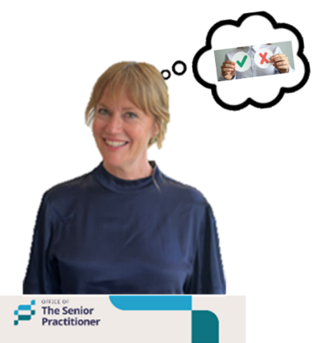If the Senior Practitioner says no, the provider can:

* Ask the Senior Practitioner to think about it again, or

**A white background with grey text that says TASCAT, Tasmanian Civil and Administrative Tribunal. Beside it are green vertical stipes.
**

* Go to the **Tasmanian Civil and Administrative Tribunal**.

We say **TASCAT** for short.

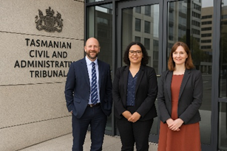

**TASCAT** is a place where people can go to get help to solve problems or disagreements in a fair and safe way.

## What skills and checks must an APO have?

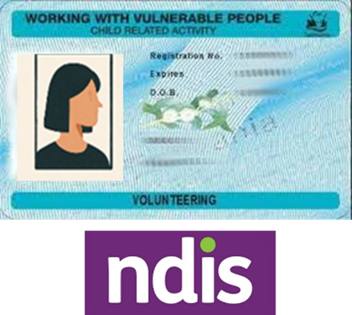An APO must have:

* Working with vulnerable people card that says they can work with the NDIS.



* Be trained in positive behaviour support.
* Keep learning and doing training.



* Understand the rules about restrictive practices.

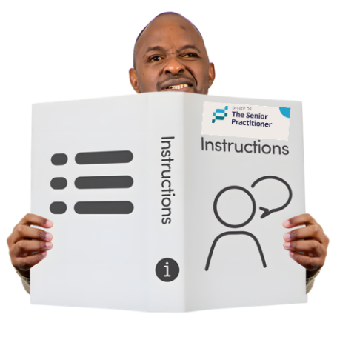

* Follow any instructions from the Senior Practitioner.

## What happens if the APO leaves their job?



The provider must tell the Senior Practitioner.

## Working with an Independent Person.

The APO must make sure you have an Independent Person.

* The Independent Person helps you to understand the restrictive practice.

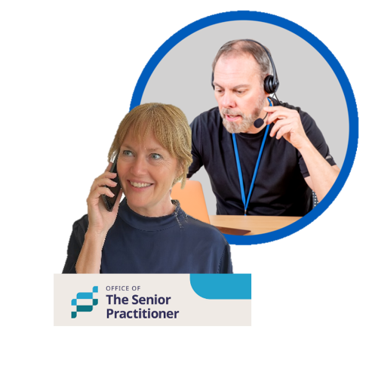

* If you do not have an independent person, the APO must tell the Senior Practitioner.

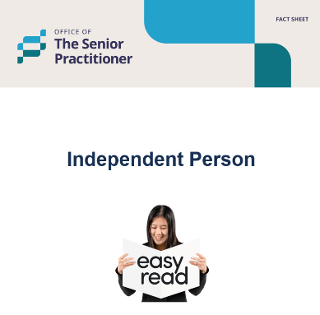

Read the Independent Person fact sheet to find out more about this.

## If there is a disagreement

Two people standing next to each other. They are disagreeing, speech bubbles above their heads have one saying yes, the other saying no.



If the APO and the Independent Person do not agree about a restrictive practice, they can ask the Senior Practitioner for help.

## For more information and fact sheets



For more information about the Act and fact sheets go to.

[Department of Premier and Cabinet](https://www.dpac.tas.gov.au/divisions/cpp/community-and-disability-services/office-of-the-senior-practitioner)

Speak Out logo with the words Speak Out Easy Read.



Speak Out Tasmania created this Easy Read document using Photosymbols and custom images. The images may not be reused without permission. For any enquiries about the images or Easy Read, please email: easyread@speakoutadvocacy.org