Factsheet

Managing Individual Reactions to Change

Change Curve: An Experiential Model
People dealing with personal loss and bereavement often experience a cycle ranging from initial shock, denial, anger and anxiety before moving to acceptance/action (commitment). It’s not unusual for people to experience a similar journey during major change. The speed and duration of the cycle varies depending on the individual, the degree of change and its impact. And it’s not always a one-way journey. People may feel they have come to terms with a change only to have something unexpectedly throw them off course and they find themselves back experiencing worry or anger. This sort of ‘flip-flopping’ is quite common.

Figure 1: Examples of change curves.

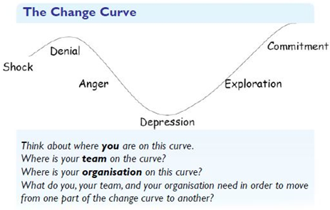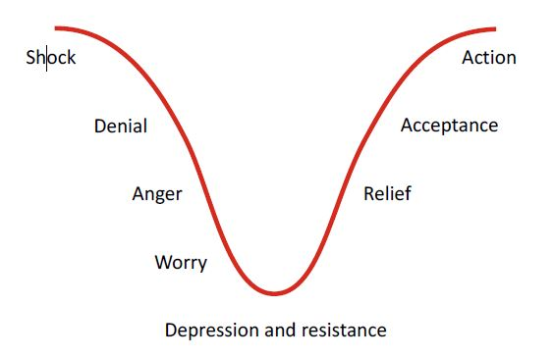
There are ways to help people through the change curve:
Shock. | Denial/anger. | Worry/confusion. | Relief and acceptance.
- Get everything out in the open with as much information as possible and repeat it.  - Be realistic with promises even if it means saying ‘I don’t know. I’ll have to get back to you’.  - Be alert to how people are reacting.  - Be available, patient and non-defensive. Don’t argue too much.  - Accept there will be strong emotions – good and bad feelings – and don’t tell people how they should feel.  - Allow time for people to absorb what’s happening. | - Offer clear instructions.  - Check for understanding, challenge assumptions and deal with concerns and rumours.  - Be specific about what is required.  - Establish shorter time frames.  - Follow up and keep checking in with people.  - Empathise. | - Accept emotional displays.  - Provide opportunities to sound off.  - Listen and be supportive.  - Keep people involved, motivated and build success experiences.  - Continue direct control with clear expectations.  - Tolerate mistakes and some inefficiency.  - Communicate. | - Expect some setbacks. People will ‘flip back’ at times.  - Allow for differences in recovery time.  - Reinforce hopefulness and be optimistic.  - Continue to build the team spirit.  - Manage closely and provide constructive feedback.  - Reward and emphasise achievements.  - Highlight benefits and positive.
Adapted with permission from material attributed to: The Office for the Public Sector, the Government of South Australia, Change Management Resources 2014, Sourced on 3 February 2016, http://publicsector.sa.gov.au/culture/change-management-toolkit/

