

Restrictive Practices

What has Changed?



Easy Read - Fact Sheet

What is this fact sheet about?
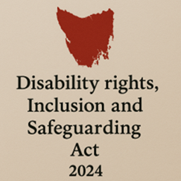
We have a new law in Tasmania.
It is called the Disability Rights, Inclusion and Safeguarding Act 2024.

We call it the Act for short.

There are lots of changes being made because of the new Act.
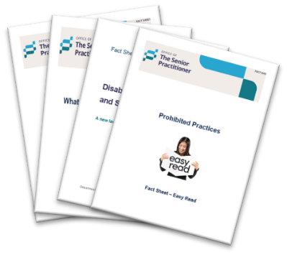
We have written some fact sheets explaining the changes.

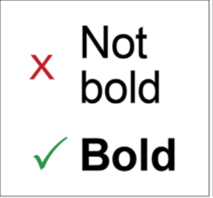
We wrote some hard words in bold.
This means the letters are thicker and darker.
We explain what the hard words mean.

Restrictive Practices – What has Changed


From 1 July 2025, the rules about restrictive practices changed in Tasmania.

What is a Restrictive Practice?

A restrictive practice is something that stops you from moving freely or doing what you want.

It can take away your rights.


It must only be used when needed to keep you safe.

Why are these changes happening?


The new Act changes how restrictive practices are talked about and agreed on.

The law and rules will now be clearer and fairer for everyone.

The new Act:
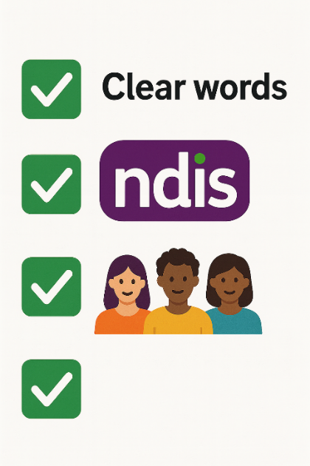
- Uses clear and updated words.

- Matches the rules used by the NDIS.

- Creates new roles to help protect you.

Examples of Restrictive Practices.

Under the new Act, a restrictive practice includes:
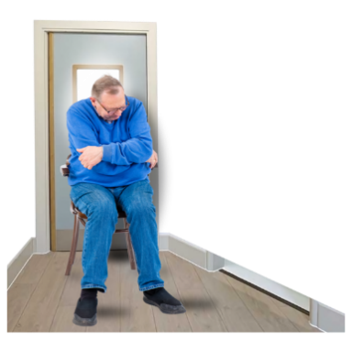
- Seclusion
Locking you in a room alone so you cannot leave.


- Chemical restraint
Using medication to control your behaviour (not for health conditions).

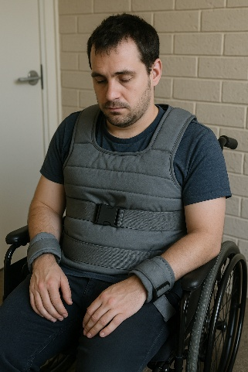
- Mechanical restraint
Using equipment to stop your movement.


- Physical restraint
Holding your body to stop movement (not gentle guiding).

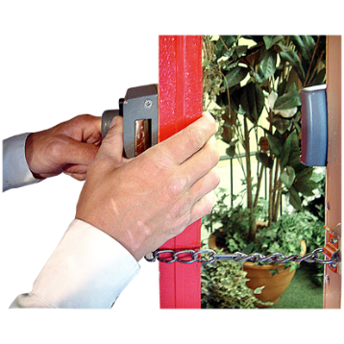
- Environmental restraint
Stopping you getting to spaces, things, or activities.

- Any other practice
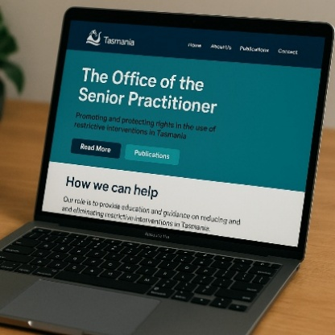
The Senior Practitioner can decide if other things are a restrictive practice.

If so they will be published on the website here.

When can a Restrictive Practice be used?


A restrictive practice can only be used when:
- Nothing else works.

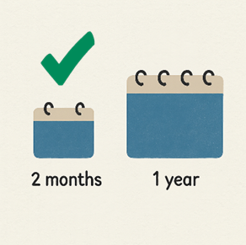

- It is only used for a short time.


- It keeps you or other people safe from harm.


It must be written in your Behaviour Support Plan by an NDIS registered practitioner.

Who can approve it?
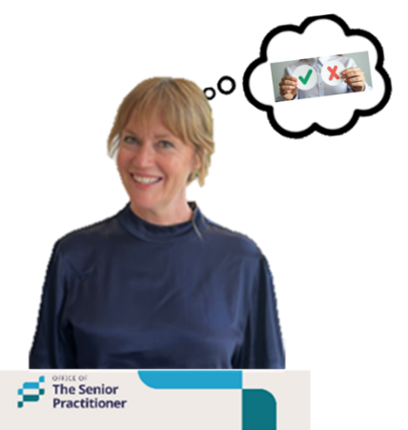
Only the Senior Practitioner can say if a restrictive practice can be used.


If a service wants to use a restrictive practice, they must ask the Senior Practitioner.

What is a Prohibited Practice?

The new Act says there are some things services are not allowed to do.

They are called prohibited practices.
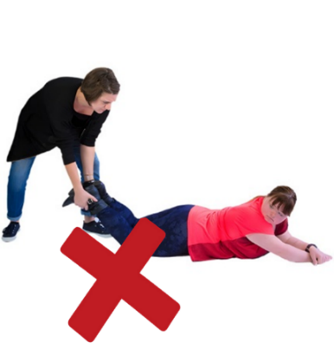
A prohibited practice is very harmful and must never be used.

Prohibited means not allowed.


It can cause you physical or emotional harm and take away your human rights.

These practices are not allowed in Tasmania.

New roles to protect the person.

There are two new roles to help with restrictive practices.


- Appointed Program Officer.
We call them APO for short.

An APO is someone who works for a disability service provider.

Their job is to check that the rules are followed.


- Independent Person.
An Independent Person helps you understand the restrictive practice.

They tell you about your rights when restrictive practices are used.

You can help the APO to choose the Independent Person.



Read more about each of these changes in our easy read fact sheets.

For more information


For more fact sheets and information about the Act, go to:
Department of Premier and Cabinet


Speak Out Tasmania created this Easy Read document using Photosymbols and custom images. The images may not be reused without permission. For any enquiries about the images or Easy Read, please email: easyread@speakoutadvocacy.org

