

Appointed Program Officer



Easy Read Fact Sheet

What is this fact sheet about?
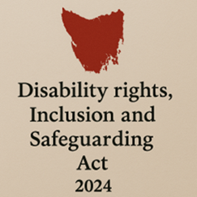
We have a new law in Tasmania.
It is called the Disability Rights, Inclusion and Safeguarding Act 2024.

We call it the Act for short.

There are lots of changes being made because of the new Act.
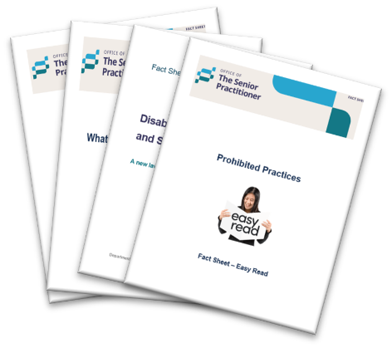
We have written some fact sheets explaining the changes.

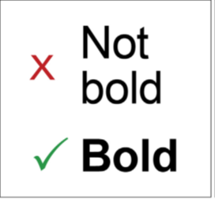
We wrote some hard words in bold.
This means the letters are thicker and darker.
We explain what the hard words mean.

What is an Appointed Program Officer?

An Appointed Program Officer is a worker chosen by a disability service provider to help with restrictive practices.

We say APO for short.


If you have a restrictive practice, the APO must:
- Promote and protect your rights.


- Make sure you are treated fairly and safely.

What does the APO do?

The APO:
- Makes sure that any restrictive practice is only used as a last choice.



- Follows your behaviour support plan.


- Makes sure your service follows the rules in the Act.



- Tries to reduce or stop the use of restrictive practices.

When must there be an APO?

A provider must have an APO if they want to use a restrictive practice.

Who cannot be an APO?


- An APO should not be the person who is using the restrictive practice.

For example, it should not be your support worker.

How is the APO appointed?

The APO must be approved by the Senior Practitioner.


The provider must fill out a form to ask the Senior Practitioner to say yes to the APO.



The Senior Practitioner can say:

- Yes or no

- Yes with some rules.

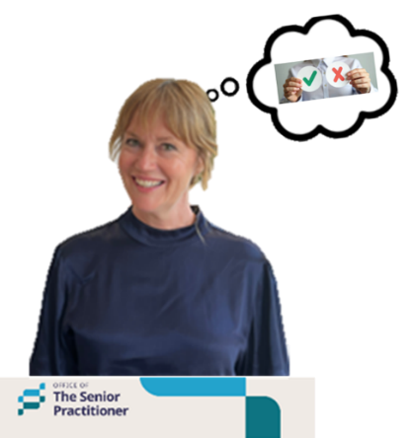
If the Senior Practitioner says no, the provider can:

- Ask the Senior Practitioner to think about it again, or


- Go to the Tasmanian Civil and Administrative Tribunal.
We say TASCAT for short.

TASCAT is a place where people can go to get help to solve problems or disagreements in a fair and safe way.

What skills and checks must an APO have?

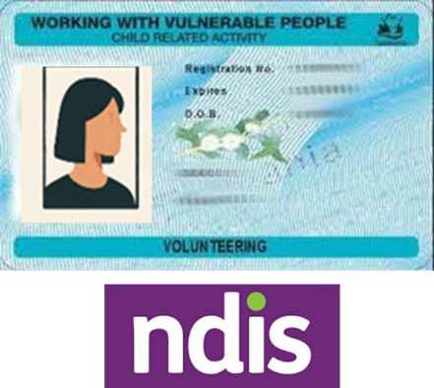
An APO must have:
- Working with vulnerable people card that says they can work with the NDIS.

- Be trained in positive behaviour support.

- Keep learning and doing training.


- Understand the rules about restrictive practices.

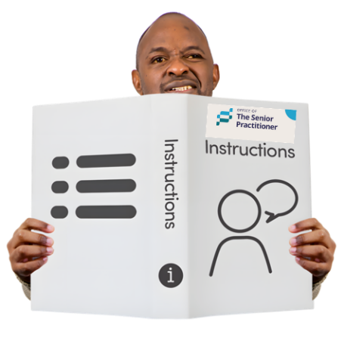
- Follow any instructions from the Senior Practitioner.

What happens if the APO leaves their job?


The provider must tell the Senior Practitioner.

Working with an Independent Person.


The APO must make sure you have an Independent Person.

- The Independent Person helps you to understand the restrictive practice.



- If you do not have an independent person, the APO must tell the Senior Practitioner.

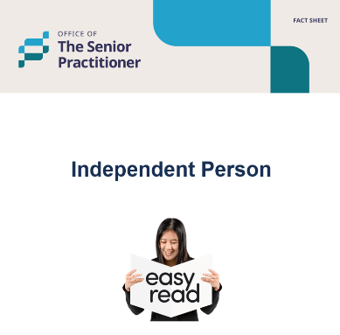
Read the Independent Person fact sheet to find out more about this.

If there is a disagreement

If the APO and the Independent Person do not agree about a restrictive practice, they can ask the Senior Practitioner for help.

For more information and fact sheets


For more information about the Act and fact sheets go to.
Department of Premier and Cabinet


Speak Out Tasmania created this Easy Read document using Photosymbols and custom images. The images may not be reused without permission. For any enquiries about the images or Easy Read, please email: easyread@speakoutadvocacy.org

