How to complain or give feedback.
Compliments and Complaints

Easy Read

Disability and Community Services are part of the government.

We call them DCS for short.

DCS pay service providers to run services.

Most disability and community services are run by community organisations.

They are called service providers.

They are services like:
- Gateway Service
- Neighbourhood House

And other services that help with:
- Personal support
- Accommodation
- Counselling

It is important that DCS know if service providers are doing a good job.

It is also important to know when there are problems.

It is important for us to know if you are not happy with the services you use.

Your feedback is important.

It can help make services better for you and other people.

What is feedback?
Feedback is when you tell someone they gave you a good service.

Feedback is also when you tell someone you are not happy with a service.

It is when you tell someone or make a complaint.

Who can give feedback?
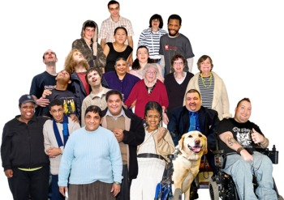
Anyone can give feedback.

People with disability, families, carers, advocates or people living in the community.

You can give feedback about a service you get, or you can give feedback for someone else.

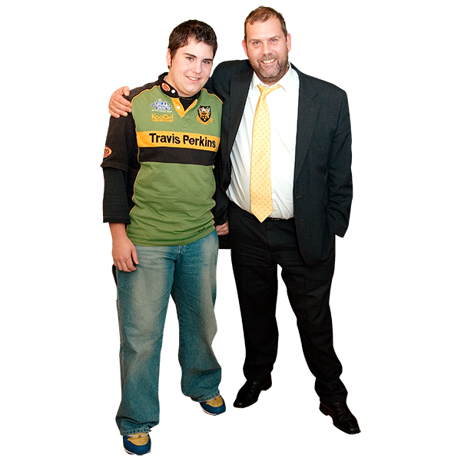
Can someone help me give feedback?
Yes. You can ask a family member, carer or friend to help.

You can also use an advocacy service.

Advocacy will work with you to help you speak up for yourself.

An advocate is on your side.

They will make sure you are heard and understood.

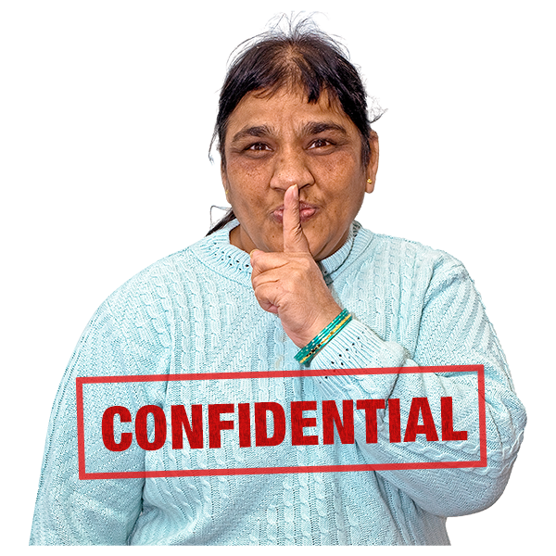

Advocacy is free and confidential.

How can I give feedback?

You can give feedback:
- in writing

- in person

- on the phone

- by email

- Or on a special form from the service provider

Think about what you want to put in your feedback, like:

- what happened or did not happen

- who was involved

- what have you done to try to fix the problem?

- has anyone else tried to help?

- what do you want to happen next

- any ideas for making things better

How to give a compliment?
If you want to tell a service provider they have done a good job, you should just tell them.

How do I make a complaint about a service provider?
Go to your service provider first.

They may be able to fix the problem.
You can ask someone like an advocate to help you.

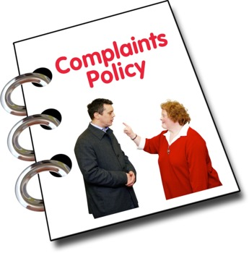
Service providers who get money from DCS must have a way to make a complaint.

The service provider must help to sort out your complaint.

Remember, you can ask an advocate to help you.

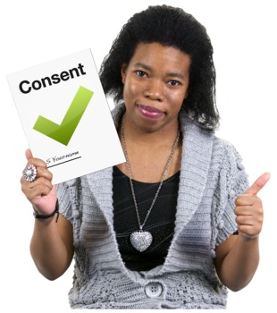What happens after I make a complaint?
The service should let you know that they got your feedback.

If your complaint is small and easy to fix, it should be fixed straight away.

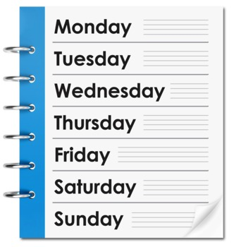
If it is a bigger complaint it might take longer.

You should be told what is happening and how long it might take.

If you are worried or have not heard anything for a while, you should contact the service provider again.

If you are still unhappy you can ….
Talk to the Community Partnership Team (DCS) in your area.

They can help you work out the problem with the service provider.

If you are still unhappy, you can talk to the Director of DCS.

If you are still unhappy and you have followed all these steps you can contact the Ombudsman.

The Ombudsman’s job is to look into problems with public bodies like DCS.

The Ombudsman will only look into your complaint if you have followed all the steps we’ve just talked about.

What if I want to make a complaint about abuse?
Abuse is when someone hurts you.

Abuse is never ok.

It could be by:
- physical abuse - hurting your body

- emotional abuse - hurting your feelings or threatening you
- financial abuse - taking or controlling your money

- sexual abuse - does something to you in a sexual way that is not ok

- neglect - not looking after you properly

You should report all abuse to the National Abuse and Neglect Hotline.

Their phone number is 1800 880 052

You could also talk to the DCS Manager in your local area.

The contact details of all the people we have talked about are listed here.

Disability and Community Services South | 6166 11237
Disability and Community Services North | 6777 1060
Disability and Community Services North West | 6477 7609
Disability and Community Services Director | 6166 3578
Advocacy Tasmania | 1800 005 131
Speak Out Advocacy Service | 6231 2344
Association of Children with Disability | 1800 244 742
Ombudsman | 1800 001 170
National Abuse and Neglect Hotline | 1800 880 052

