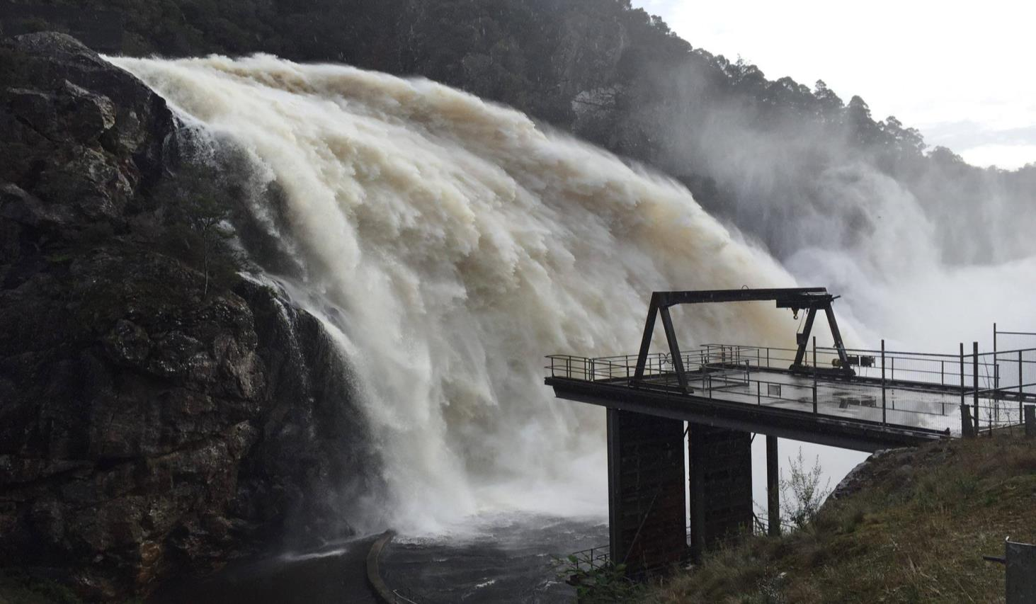

Kentish Council submission to the review of the June 2016 floods in Tasmania

16th November 2016
- INTRODUCTION

The municipality of Kentish covers an area of some 1170 square kilometres extending from South Spreyton to the tip of Cradle Mountain and it embraces the four main regions of Railton, Sheffield, Wilmot and Cradle Valley. The Kentish municipality has a population of 6312 persons and is growing (2011 Census). About one third of the population resides in the towns of Railton and Sheffield, with the balance being spread across smaller townships and farming areas.

On Sunday 5th June Sheffield recorded a rainfall of 57.8mm which was followed by high winds. A further 215.8mm of rain was recorded at Sheffield on Monday 6th June. The effect of this weather event proved to be devastating for the Kentish municipality.

20 houses plus 27 businesses and farm properties had severe water inundation, and 70 residents were isolated in Lorinna for close to a month during the flood event of June 6, 2016 in the Kentish Municipality. 9 properties were not fit to live in for a period with 2 properties still have no foreseeable date to move back home. Many other properties were impacted to a lesser extent from services being interrupted to driveways being washed out.

Council works on the day of the flood:
- Sandbagging, trucks delivering sand, road and bridge closure signs erected throughout the municipality.
- Staff recalled from RDO and Annual Leave on day of floods and worked the weekend following the floods.

Council rectification works post flood:
- Assessed damaged infrastructure
- Spreadsheet prepared which included roads, bridges and other assets reporting damage.
- Cleared and made safe transport infrastructure.
- Assisted residents as requested.
- Assessed damaged bridges.
- Clearing and gravelling an emergency access road into the Lorinna community to provide 4wd access.
- Continued communication through media, council facebook and website and informal meeting outlets keeping all Kentish residents fully informed.

Estimated Bridge Repair Costs

Bridge | Road | Estimated Cost ($)
Dasher River Bridge | Beulah Road | 510,000
Bull Creek Bridge | Dolcoath Hill Road | 204,000
Mersey River Bridge | Mersey Lea Road | 1,245,000
Mersey River Bridge | Kellys Cage Road | 581,000
Mersey River Bridge | Dynans Bridge Road | 621,000
Total |  | 3,161,000

The approximate cost of damage to Kentish Council is $8.0 M.

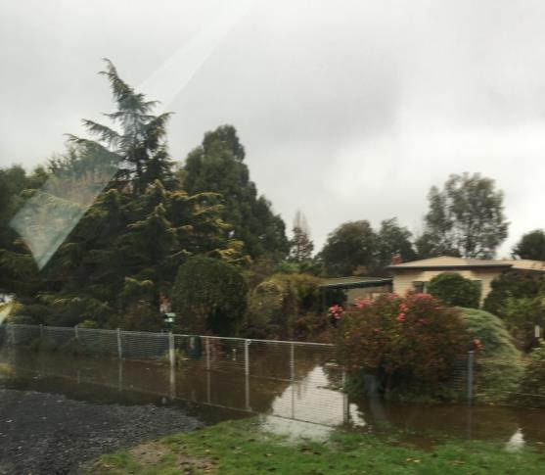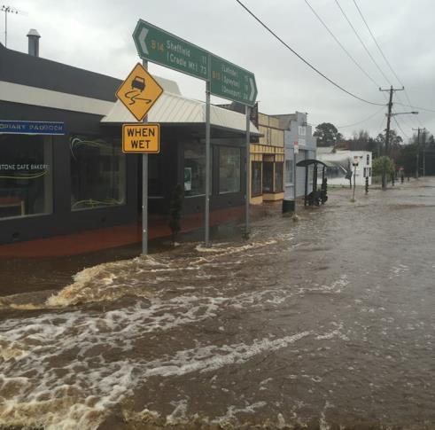

Flooding in the township of Railton.

- TERMS OF REFERENCE

  - The effectiveness of the strategies, preparedness and plans related to managing flood risk in Tasmania that were in place prior to the June 2016 floods occurring; including existing and potential levee systems.

Kentish Council has completed a Railton Flood Plan which details some $2.5 million of funding needed to complete the project. The Railton Flood Plan 2016 can be accessed on Council website at: http://www.kentish.tas.gov.au/page.aspx?u=1561.
Council was awaiting the announcement of The National Disaster Resilience Grants Program (NDRGP) when the June 2016 floods occurred. Availability of funding under NDRGP for the whole of Tasmania in 2016 is $2.6 million over 2 years there is not enough funding available to implement the recommendations under the Railton Flood Plan.

At an estimated $700,000 there is a lack of commitment from TasRail to contribute to upgrading their bridge in Railton. This bridge upgrade is identified as a high priority recommendation in the Railton Flood Plan. If TasRail committed to doing this works it could be used as in-kind funding towards the co-contribution needed in the NDRGP. This would be a large boost to assist a small regional Council implement the recommendations of the Railton Flood Plan.

The Mersey River Flood Plan has been prepared by Entura with Latrobe, Kentish and Meander Valley Councils with the assistance of the Mersey Leven Emergency Management Committee. The Plan identifies properties across three different Municipalities that would be inundated in differing flood events. Whilst this study was useful to an extent it was lacking in currency of information and relevant detail such as property identification numbers so Council could promptly contact those people impacted by the flood. There should be some central repository where all this information is stored so it can be accessed by all emergency service personnel, including Councils. One possibility is the Central Operating Platform (COP).

Council was given access to the COP after the June 2016 event. The access level to any information is very limited, basically identifying property owners only. Allowing Council access to more ongoing information, allowing flood information to be populated over time, will facilitate the response and recovery process.

2.2 Community preparation, resilience and awareness, including awareness of insurance matters, relating to major flood events in Tasmania.

Council and the Railton community were better prepared in 2016 than in the 2011 floods. It is still very difficult to adequately warn residents of a pending flood as it is a small catchment and flooding occurs quickly.

Many residents had to fight with insurance companies just to have claims assessed. Some residents are still waiting on insurance companies to assess claims four (4) months post floods. Through the recovery process a number of properties have been referred to the Insurance Council of Australia and legal representation arranged.

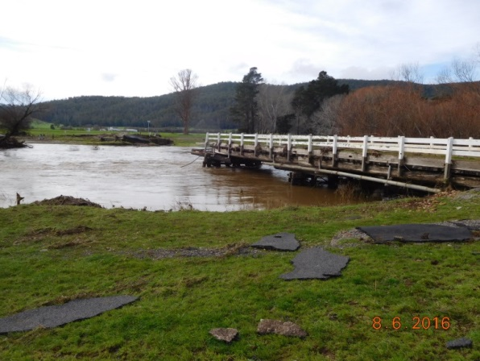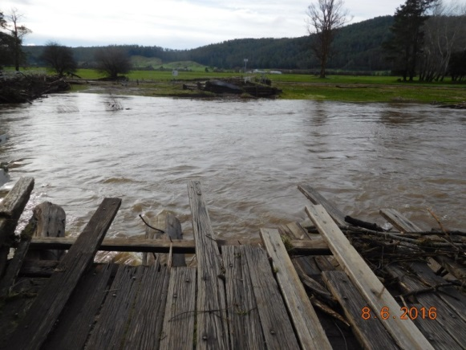

The Merseylea Bridge was partially swept away by flood waters.

2.3 The causes of the floods which were active in Tasmania over the period 4 – 7 June 2016 including cloud-seeding, State-wide water storage management and debris management.

Locals reported that trees and debris were caught at the Kimberley Rail Bridge causing water to build up like a dam behind part of the bridge. When the railway finally gave way it was reported that the water rushed down Mersey River like a “tsunami”. Various parties believe it is necessary to see the Kimberley Rail Bridge extended to a proper bridge. Currently the bridge is only part way across the river span. If the bridge was built the full width of the river, allowing a wider span for trees and debris to flow under, the “tsunami” effect may not have occurred. This bridge was repaired after flooding in the 1970s. Back then locals requested the bridge be repaired to span the full width of the river but this didn’t happen. The same situation will probably occur again. The Kimberley Road Bridge, just up the river, spans the full width of the river and did not give way like the rail bridge.

It was further reported that inadequately maintained forest plantations also contributed, including trees from an abandoned former Gunns Plantations Holdings on the flood plain and river banks. Trees and debris caused much of the blocking of the Kimberley Rail Bridge. Property owners should be made to better maintain their properties. A State Government Department needs to be responsible in managing compliance by plantation owners.
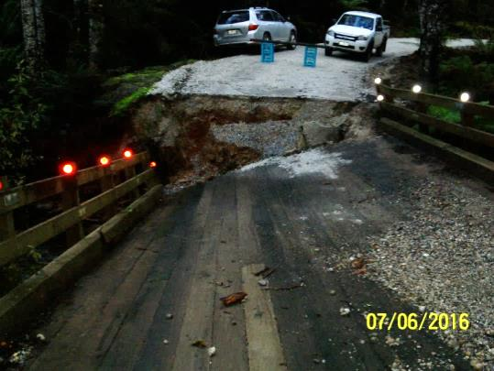

Collapsed bridge on Dolcoath Road, Moina.
2.4 The use and efficacy of forecasting, community alerts, warning and public information by authorities in responding to flood events.

There didn’t seem to be a coordinated approach and appropriate communication which could have resulted in earlier evacuation had it been appropriate. The late mobile text warnings exacerbated the situation and due to the short timeframes and quick inundation of water, residents could not get out in certain areas.

SES was severely under resourced to respond to the 2016 flood in Railton. Council understands that there were many volunteers assisting with the search for a missing person in the Narawntapu National Park area. In addition, with Latrobe flooding before Railton, volunteers were deployed to assist in Latrobe. SES is a lead agency in the event of storms and floods but was the last agency on site in Railton.

There was little prior warning of the flooding in Railton. In both 2011 and 2016 the Tasmania Fire Service Railton volunteer personnel were the first on scene in Railton. These volunteers took the initiative to door knock Railton Residents in the dark to alert property owners. Currently Council’s Works Department and the SES North West Regional Manager are working towards a Railton Flood Action Plan where the Tasmania Fire Service Railton Volunteer personnel play a key role in the initial response.

It was also reported that in the upper catchments of the Mersey River, flooding and damage occurred well before the lower catchment. It is Council’s understanding that a major road slip in the upper catchments caused a surge in the river flow, flooding the lower catchments. Some warning should be developed in the future to alert properties downstream if this was to occur again.

There is also no warning for the township of Railton specifically. It is a township that has particular needs for flooding. The Bureau of Meteorology (BoM) should develop and monitor a Railton specific warning system.

Warnings on mobile phones were extremely late. A text message was sent at 9.00am regarding flood preparation warnings for Railton; however they were already underwater and the level was receding at this time.

There was still an expectation from residents for Council to deliver sandbags, including the rain events following the June 6 flood. Residents are not taking responsibility for their own property in this area.

2.5 The effectiveness of transition from response to recovery in the week following the June floods; including capacity and priorities for infrastructure repair, and immediate assistance payments.

The transition from the evacuation centre to recovery was not well communicated. Kentish Council staff, with the responsibility of community/social recovery roles, was not informed when the decision was made to close the evacuation centre in East Devonport and open a local recovery centre in Latrobe. In addition, the decision to transition the local recovery centre to a regional recovery centre was not conveyed.

The North West Coast has a very good Regional Community Recovery Committee that works extremely well and communicates very effectively. Communication and coordination for this committee sits within DHHS but during the June 2016 flood emergency and recovery phase this communication structure was little to non-existent. When an emergency occurred in the past in one Council area communication is very effective. This was the first time regional recovery was put into action. Possibly this communication structure can be incorporated into existing emergency plan communication protocols. Council would encourage the State Government Departments to set up better protocols for communication to recovery staff when an event involves more than one Council area. Existing protocols are inadequate.

Availability of different grants programs were not being adequately communicated and Council staff were informed by State Government Staff to look on the TasAlert website to find out any information. A central State Government Department could coordinate communication within a day or two after an emergency.

Council was in regular contact with flood affected residents who were confused and frustrated about the grants that were available. Some residents received some grants but were not sure if they were entitled to access others. There were many reports of residents ringing the grants hotline number where someone would take their details and suggest someone would get back to them. After not hearing back for days some people went to the Latrobe Recovery Centre for help. Maybe the State needs to contribute more resources to assist residents with grant queries.

There was a bottle-neck at the Latrobe Recovery Centre with residents waiting in some cases over an hour to talk to the 2 staff members from Child & Family Services about the availability of emergency grants. Government Departments may need to allocate more resources into staffing levels to assist at Recovery Centres.

Many NGO’s came out after the flood event offering money to flood victims. This created a situation where people were receiving money from State Governments as well as NGOs. Some NGOs sort assistance and direction from Council. Council rang State Government employees to request information regarding what grants residents had accessed. Barriers were put up citing privacy issues. Staff didn’t want to know what amount of funds was paid but what grants they did qualify for. This created a situation there funds from NGOs may not have gone towards families in most need? The State Government should consider setting up a central database that records who receives what assistance from all sectors including NGOs. This may assist funding going to those in most need.

Also communication flow needs to be 2-way. Council assisted State Government staff giving out names and addresses of flood affected victims when requested. In emergency situations and recovery phase privacy restrictions should be relaxed.

There was a large gap (in terms of proportion) between rural properties and those ‘hobby’ farmers that generate less than 51% of their income from their property, in relation to funding support available to assist with recovery.

Small business is a sector that seemed disadvantaged during the recovery process given there were no financial assistance packages or grants designed specifically for that sector.

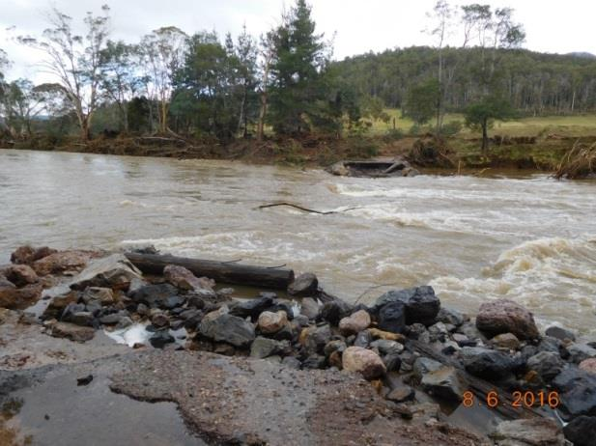

The Kelly’s Cage Road Bridge was swept away by flood waters.

2.6 Consideration of the detrimental environmental effects of the flooding upon the landscape, and what effective mitigation measures may be necessary to avoid similar events.

As a result of the June flood events there is now a lot of debris on the banks that should be removed or there will be a loss of infrastructure again. Forward debris management needs to be a key focus.

For the past couple of decades Landcare groups in Kentish have been proactive in removing willows (a declared weed) from the water edge. This may or may not have been a contributing factor to the speed in which the water caused destabilisation of banks. They also claim that the past removal of native vegetation and replanting with forests has dramatically increased water runoff.

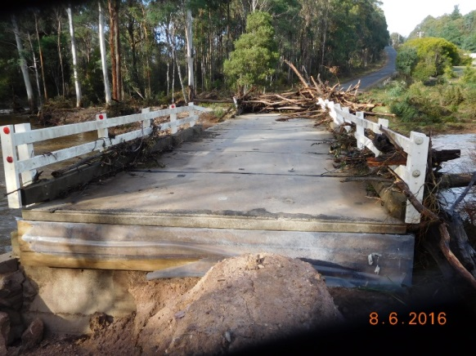

Damage to the bridge on Beulah Road, Stoodley.

2.7 And any other matter relating to the terms of reference including matters relating to the floods in Huonville.

The community of Lorinna was isolated for an extended period of time. Not only were roads washed out but they were without land lines or mobile phone reception for days. The residents were quite vulnerable for an extended period of time. Some residents were able to access part of the Emergency Assistance grants but there was very little other assistance for Lorinna residents.

The Lorinna residents being isolated caused much work for Council. Many possible scenarios were investigated to assist with transport and supplies without success. Some State Government organisations made it unnecessarily frustrating. Part of the Lemonthyme Road was washed out. When Council approached Hydro Tasmania about its repair, Council was told it’ Forestry Tasmania’s responsibility to fix. When Council contacted Forestry Tasmania we were told it’s Hydros responsibility. This toing and froing about responsibility and funding caused Council undue extra work and frustration during a very busy time. Road management responsibility has been sorted out by the organisations well before the floods occurred. The fact it wasn’t shouldn’t have held up the investigation of the scope of the repair and the commencement of the repair.

Council was disappointed when our request to use the Army Reserve’s Unimog to assist with access into Lorinna was refused. Council was informed that the Unimog would only be released if requested by SES. When requested through SES Council was informed it would only be accessed and used in the period of an emergency i.e. the day or two of the event. Access to the Unimog would have assisted greatly in the early days post emergency.

Council acknowledge the assistance Tasmania Police gave in organising SES to transport one family to and from the Mersey Community Hospital for an important medical appointment. Council can also commend Forestry Tasmania on the short time it took to approve an emergency access track into Lorinna over Wilks Road extension and also a track into the Gog Range Plantation at the back of the Kellys Cage Road area.

Council has been encouraged by the State Government to upgrade infrastructure where possible when it’s warranted. State owned Hoggs Bridge is a significant access across the Mersey River in the Kentish Municipality. Council encouraged the Department to consider upgrading the bridge without success. Council was also disappointed in the time it took to investigate design, scope and tender for the repair of Hoggs Bridge.

Council has heard there has been consideration by Government to reduce the contribution to councils under the Tasmanian Relief and Recovery Arrangements to Local Government from 75:25 to 50:50. This would put considerable extra strain on the resources of small rural councils like Kentish Council. Council has estimated that in the June Floods the eventual clean-up bill will be around $8 million and could go even higher. Under the current arrangements Kentish Council will contribute around $2 million. In recent years Kentish has experienced the 2011 Railton Flood, a couple of major storm events and now the 2016 floods.
Effective communications are vital during emergency situations. On Monday 6th June Sheffield had no mobile or land line phone communication for 9-10 hours. This left Kentish Council without communications for the day making the emergency response very difficult. Wilmot had no mobile or land lines most of the day, Acacia Hills and South Spreyton had no mobile reception or land lines available for 4 hours. Residents in Lorinna were cut off for days with no land lines or mobile reception. This situation makes communities very vulnerable especially the sick, elderly and frail. Council encourages the State Government to raise this issue with Telstra to ensure adequate backup to minimise communication disruption in the future.

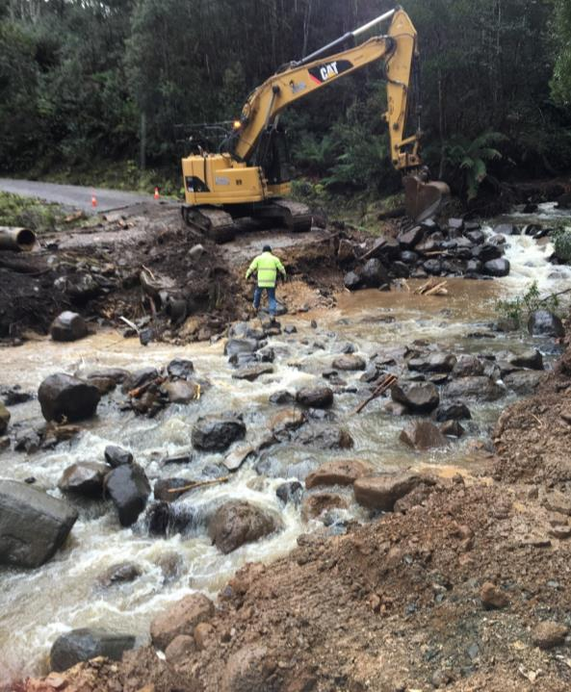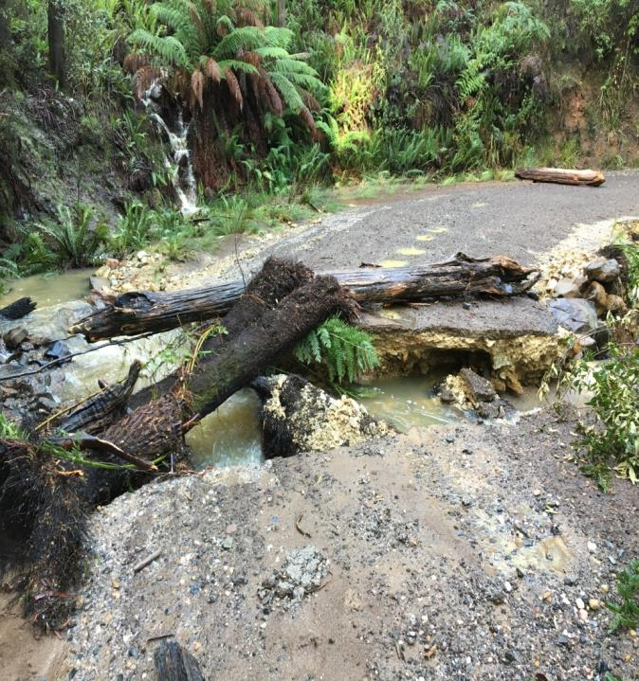
Damage to River Road effectively cut off the residents of Lorinna.

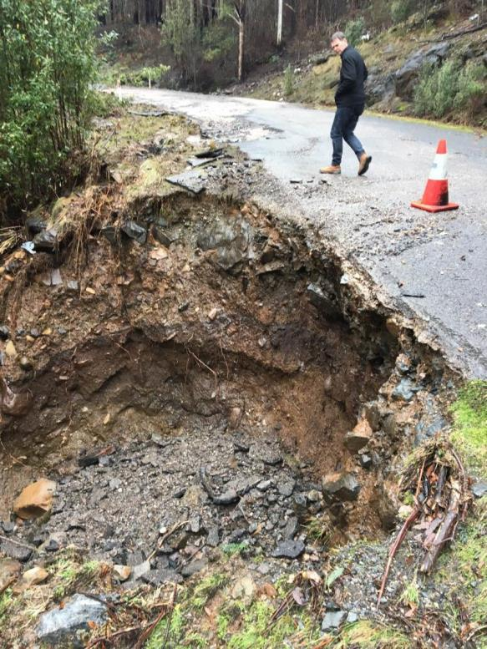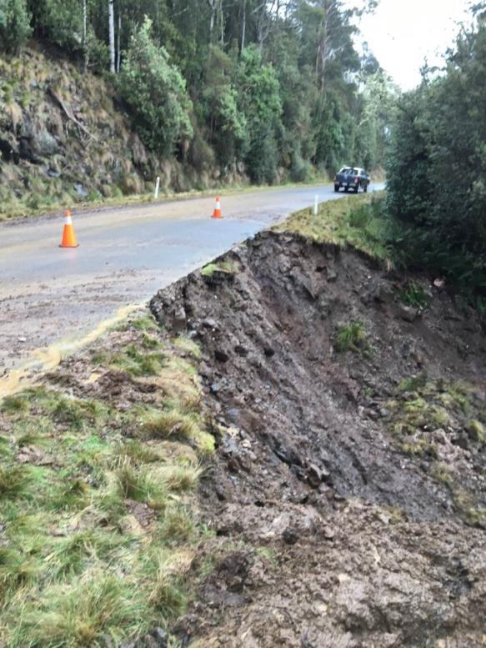
Land Slips on Lemonthyme Road.

- CONCLUSIONS AND RECOMMENDATIONS

There are three key areas for improvement required to prepare for future emergency events, including the need to provide more efficient and effective warning and alert systems, increased funding levels to assist implementation of the Railton Flood Plan and long term program of river maintenance. Improvements in these areas would ensure better use of time and resources of key personnel and organisations so an effective coordinated approach could be implemented to minimise the impact of emergency.

Warning and Alert Systems
It is critical that communications be more accurate and timely, with better early warning systems.

To enable this to happen, improvements need to made to preparedness and planning for flood events. Definitions of minor, medium and major flood heights need to be quantified by the Bureau of Meteorology with specific relevance to Redwater Creek and the Mersey River upper and lower catchments. The development of an early warning system for Railton is crucial.

Council also suggests that a potential cross council register with State Government Departments of vulnerable properties and their current contact details including the inclusion of property identification numbers be kept for prompt notification to those high risk properties.

Increased Funding Levels to assist with the implementation of the Railton Flood Plan
The current level of funding under the National Disaster Resilience Grants Program (NDRGP) is not adequate to implement the Railton Flood Plan let alone funding set aside for the whole state over 2 years. Council would like to see, with greater assistance from the State implementation of the Railton Flood plan in its entirety over the next 2 years. A greater commitment from TasRail to contribute to upgrading their bridge in Railton is also required to implement the plan.

Long term program of river maintenance
Council also believes that the severe flooding and environmental impacts have highlighted the need to have a long term program of river maintenance, with particular emphasis on the removal of logs and management of riverside forestry operations/plantations. Consideration also to be given to the management and/or the planting of appropriate vegetation on riparian reserves.

In conclusion, Council would like to acknowledge the work done during the flood response by the many emergency personnel and volunteers. The Kentish Volunteer Fire Brigade, Council employees, SES and Police officers deserve Council’s praise and recognition.

General Manager
Kentish Council

