Factsheet

Common Reactions to Change
Remember that everyone is different and therefore will experience change and the change process differently. There is no ‘right’ or ‘wrong’ to the process and different people may move through each stage at a different pace. The key is to be aware of where people may be and help them through that stage with clear information, consultation and support.

Figure 1: Stages of reactions to change
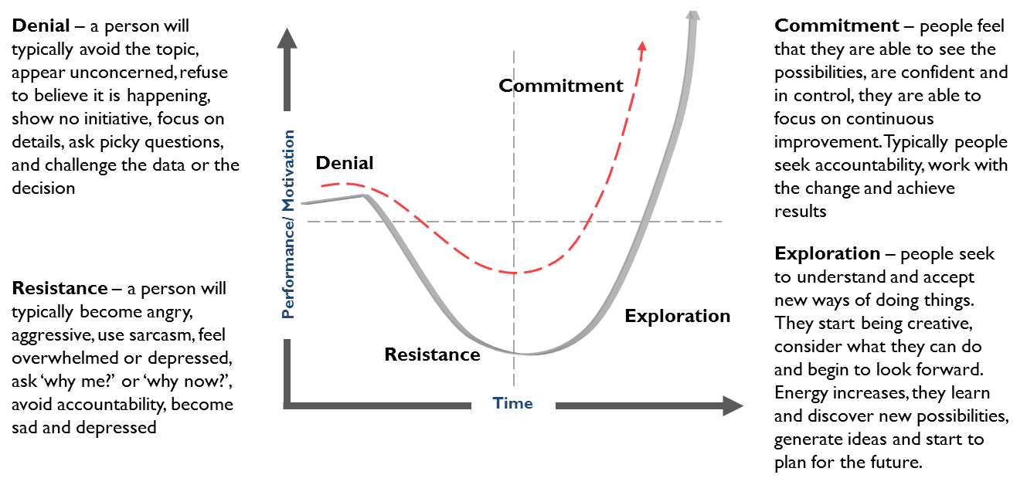

STAGE: DENIAL
The stage of denial can be prolonged if employees are not encouraged to register their reaction, or if management acts like employees should just move directly into the new ways. Denial is harmful because it impedes the natural progression of healing from loss (i.e. the old way of doing things) to moving forward … Because people are often blind to problems during the denial phase, a manager can mistakenly think that he or she has jumped directly to the final phase of commitment.
What you see | What you should do
Withdrawal  No noticeable reaction – “business as usual”  Focus on the past  Apathy/numbness – the announcement of change doesn’t seem to sink in  Evidence of activity, but not much gets done  Provide individuals with facts and information about the change | Reinforce that the change definitely will happen  Explain what to expect and suggest actions they can take to adjust to the change  Give them time to let things sink in  Arrange a planning session to talk things over

STAGE: RESISTANCE
Resistance is not only a predictable part of change it is probably the most difficult phase to deal with. People resist for good reasons, even though we would rather they didn’t. These reasons include: their security is threatened, the change threatens their sense of competence, they fear they will fail at new tasks, they are comfortable with the status-quo and they have vested interests in the existing systems.
What you see | What you should do
Pre-occupation, wondering where they stand/how they will be affected  Anger, blame, anxiety, complaints  Stubbornness, negativity  Apathy, sick leave, withdrawal  Significantly lowered productivity  Listen and acknowledge feelings | Encourage support  Don’t try to talk people out of their feelings or tell them to change or pull together  Respond to concerns as effectively as possible  Facilitated “dealing with change” sessions can provide a forum for expression of feelings which is helpful in moving through this stage  Make effective use of organisational “rituals” ie parties, barbecues, luncheons.

STAGE: EXPLORATION
During the Exploration phase, energy is released, as people focus their attention on the future and towards the external environment once again. Another word for this phase is “chaos”. During exploration people tend to draw on their internal creative energy to figure out ways to capitalise on the future.
What you see | What you should do
Confusion  Chaos and energy  New ideas, but lack of focus | Focus on priorities  Provided needed training  Set short term goals  Conduct brainstorming and planning sessions

STAGE: COMMITMENT
During this phase employees are ready to focus on the plan. They are willing to recreate their mission and build action plans to make it work. They are prepared to learn new ways to work together, and have re-negotiated roles and expectations. This is a phase where they are willing to solidly identify with a set of goals and be clear about how to reach them
What you see | What you should do
Improved co-operation  Better focus  Working together with a plan | Set medium and long term goals and objectives  Concentrate on team building  Acknowledge good efforts by both individuals and teams

