Tasmania’s Disability Strategy 2025-2027
– Easy Read
  - April 2025

What is in this book

About this book 3
About Tasmania’s Disability Strategy 3
Vision 5
Principles 5
Language 6
Ableism 6
The social model of disability 9
Tasmania 10
Australia’s Disability Strategy 11
Areas for Action 12
Tasmania’s Disability Strategy actions 13
Employment and financial security 14
Inclusive homes and communities 15
Safety, rights and justice. 16
Personal and community support 17
Education and learning 18
Health and wellbeing 19
Community attitude 20
More information 21


The Tasmanian Government acknowledges Tasmanian Aboriginal people as the Traditional Custodians of lutruwita/Tasmania.

We recognise their continuing connection to Land, Sea, Waterways, Sky and Culture and pay our respects to Elders, past and present.

The Tasmanian Government acknowledges the lived experience of people with disability and their families, carers and supporters.

We acknowledge that people with lived experience of disability have helped to make this strategy.

We acknowledge the people that have worked to make sure people with disability have their human rights.

About this book

The Tasmanian Government wrote this.

When you see the words ‘we’ or ‘us’ it means “The Department of Premier and Cabinet”.


We wrote it in a way that is easy to read.
We use pictures to explain some ideas.

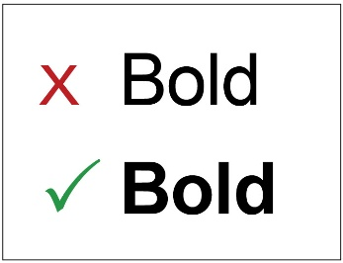
Some hard words are written in bold.

This means the letters are thicker and darker. We explain what the hard words mean.


You can ask for help reading this book.
You could ask a friend, family member, support person or advocate.

About Tasmania’s Disability Strategy

The Tasmanian Government would like to make a plan so that all parts of government work together for people with disability.

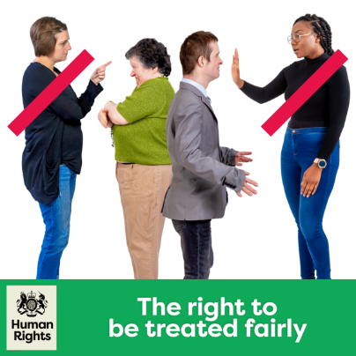
The plan is called: Tasmania’s Disability Strategy.
We will call it the strategy for short.
It means people with a disability will be treated fairly.
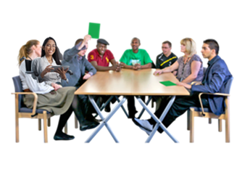
The government worked with lots of people to understand the needs of people with disability in Tasmania.

Vision
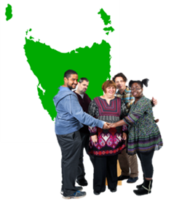
The Tasmanian Government wants all Tasmanians with a disability to be treated fairly.
They want people with disability to be a part of the community.

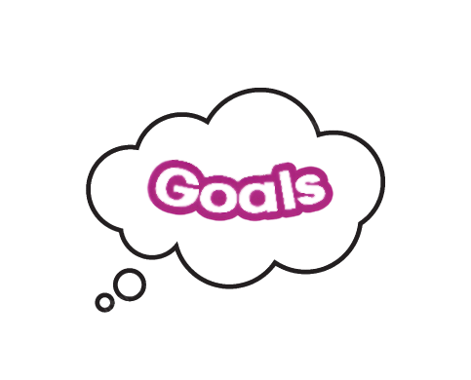
People with a disability should be able to:
- follow their dreams
- make their own choices
- have a say in things that affect them.

Principles

We made this strategy using the rules from:
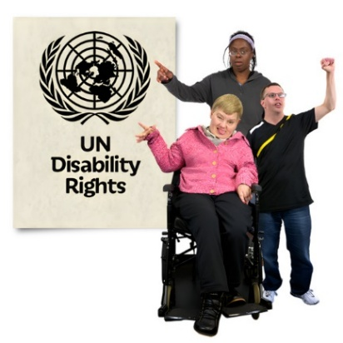
The United Nations Convention on the Rights of Persons with Disabilities, UNCRPD for short.

The UNCRPD is an international law the Australian Government agreed to.

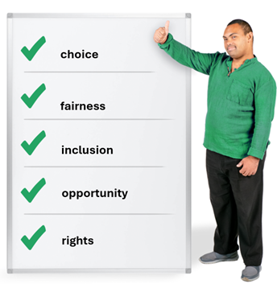
Under the rules of UNCRPD you can:
- make your own choices
- be treated fairly
- be included in everything
- be given the same opportunities as everyone else.

Opportunities means to be given the same choices.
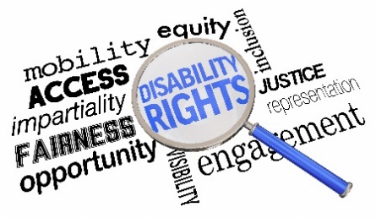
The strategy makes sure people with disability have their rights met.

Language

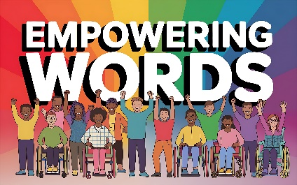
We want to make sure the words we use in the strategy are right.

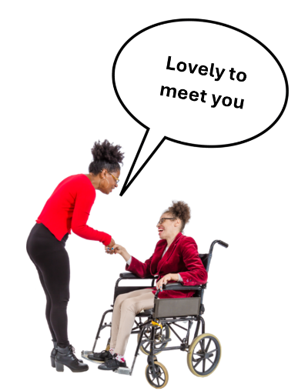
Words can:
- change the way people think
- show we care and respect people with disability.

Ableism
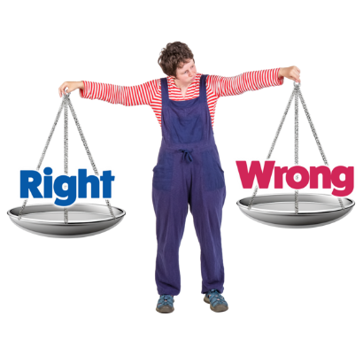
Ableism can make life hard and unfair.
Ableism means to treat people with disability unfairly.


Ableism can affect many groups but can be worse for:

- Aboriginal and Torres Strait Islanders
- LGBTIQA+ people
- older and younger people.

It is important to treat everyone fairly.
Everyone should have the same chances and be safe and free from harm.

The social model of disability

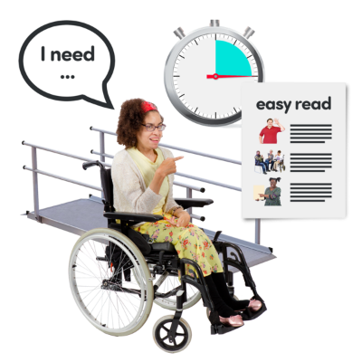
Tasmania’s Disability Strategy uses the social model of disability.

This model says that barriers stop people with disability from being part of their community.

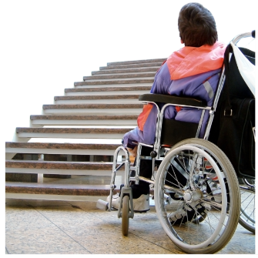
A barrier is something that stops you from doing what you want to do

Barriers can be:
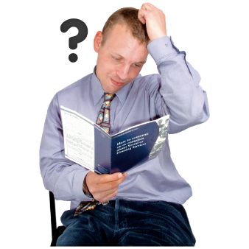
- Physical
- Social
- Communication
- The opinion of others

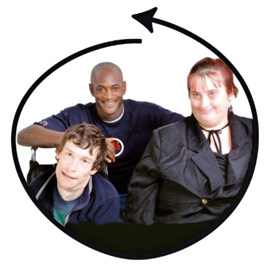

The social model says we should change other things, not the person with disability.

This means changing the community and how other people think.

This helps people with disability to be included.

Tasmania

There are lots of people living with disability in Tasmania.

People in Tasmania can find things hard because of:

- Where they live
- Age
- Disability
- Gender
- Religion or culture
Everyone with a disability has different experiences.

Australia’s Disability Strategy

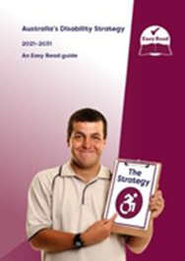
Australia has a Disability Strategy.

It is a plan to make sure the government works together to support people with disability live good lives.

Areas for action

It has 7 goals for people with disability:

- Employment and financial security
You should get help to find a job and have enough money to live well.


- Inclusive homes and community
You should be able to live in a home that meet your needs.

Communities should be accessible and inclusive.

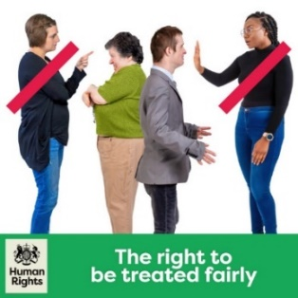
- Safety, rights and justice

Everyone should be told their rights and be treated fairly by the law.

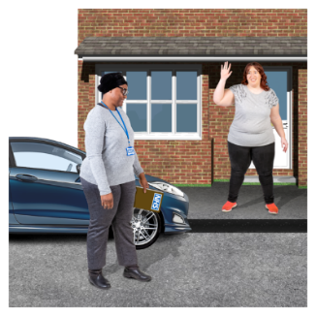
- Personal and community support You should be able to get help if you live alone and to access the community.
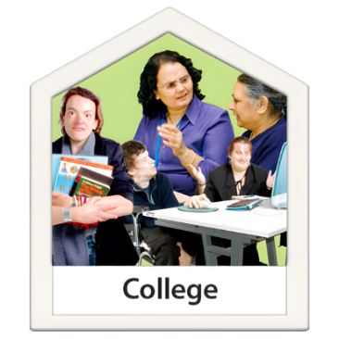
- Education and learning
Support to go to school and learn new things.


- Health and wellbeing
Have access to healthcare that suits your needs.

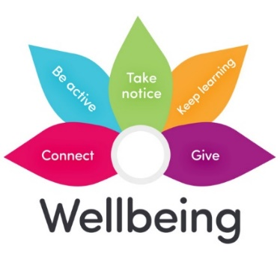
- Community attitudes
This is about helping everyone understand and support the needs of people with disability.

Tasmania’s Disability Strategy actions
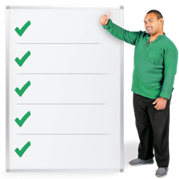
The Tasmanian Disability Strategy also has 7 goals for people with disability.

Employment and financial security


We want people with disability in Tasmania to have enough money to feel safe.
We want you to be able to plan for your future.

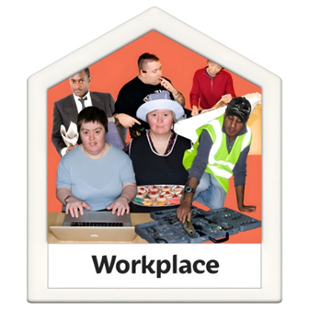
We will work on:
- More jobs for people with disability.

- Making it easier for young people to move from school to work.

- People with disability have more control over their money.

Inclusive homes and communities

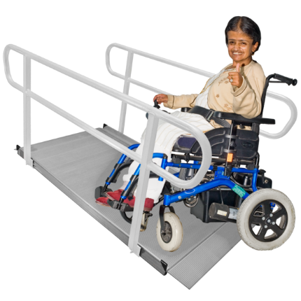
People with disabilities should:
- live in homes and communities that are easy to access and welcoming.

We will work on:

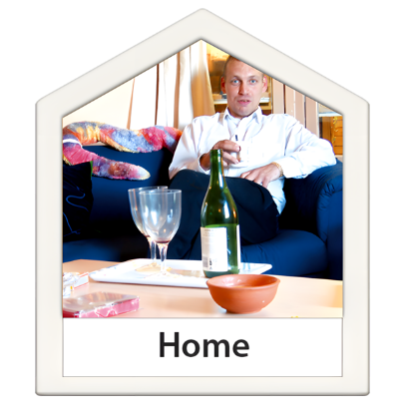
- Making homes more budget friendly.

- We think that you should choose where you live and who you live with.

- Being able to join in activities in the community.


- Everyone being able to access buildings and outdoor areas.

- Transport should be easy for everyone.

- Information and communication should be easy and work well for everyone.

Safety, rights and justice

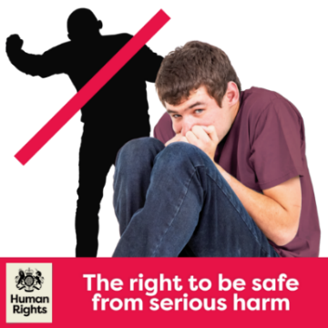
People with a disability:
- should have their rights protected
- feel safe and be treated fairly by the law.

We will work on:

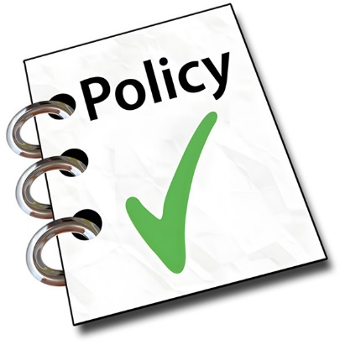
- People being safe and free from harm and abuse.

- Better rules and policies to support for people who have experienced trauma.

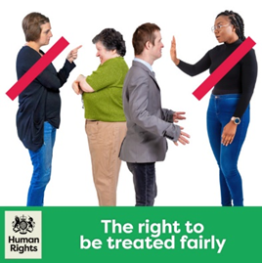
- The rights of people with disabilities should always be supported and protected.

This means making sure they are treated fairly.

- People with a disability being told their rights and being treated fairly by the law.

- The justice system having rules to help people with disability be treated fairly.

Personal and community support

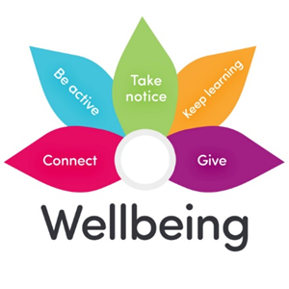
People with a disability should get help to:
- live on their own
- join in with their community.

We will work on:

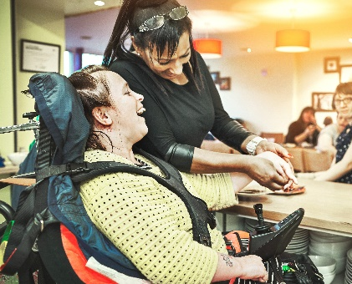
- People getting the right support for them.

- People on the NDIS getting the right support and tools that meet their needs.

- We understand and support the role of informal supports.

Informal supports are the unpaid help from family and friends.

- People having tools and technology that help with their disability.

Education and learning
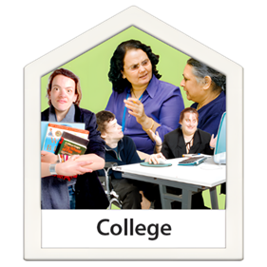
People with disability should:
- have access to a good education
- learn in the best way for them.

We will work on:

- Children with disability getting good care and early education.

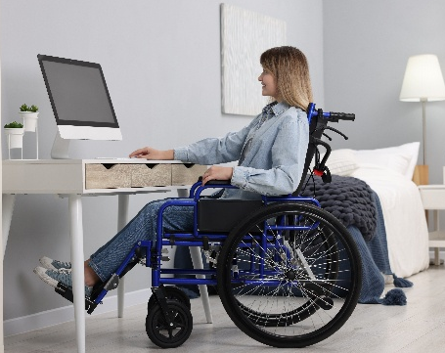
- All teachers being able to work with students with disability.

- More options for learning.

These options should be easy to access.
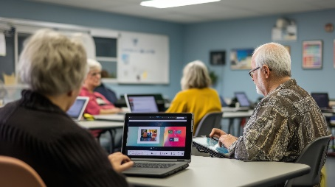
- More options for being able to learn at any stage of life.

Health and wellbeing


People with a disability should be able to live healthy lives.

We will work on:
- Health services should work well with people with disability.
- Healthcare being fast and easy stopping problems before they start.

- Mental health support being easy and working well.

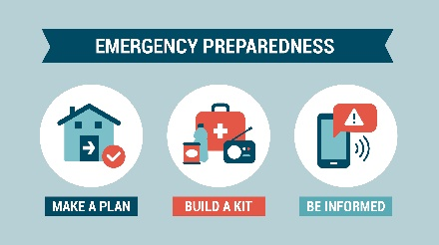

- Planning for emergencies should include people with disability.
Everyone should work together to make sure people with disabilities are healthy and happy.

Community attitude


People with disability should:

- be valued and treated the same as everyone else in the workplace.

We will work on:

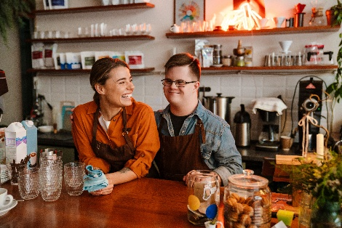
- People being employed for their skills and knowledge.

- Professionals should be able to work with and understand the needs of people with disability.

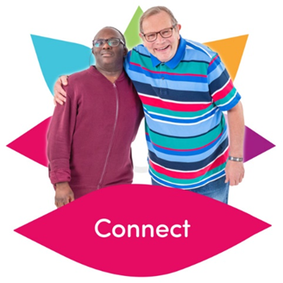
- We want people to think better about others in the community.

When people are kind and understanding, it helps make good changes happen in the community.

More information

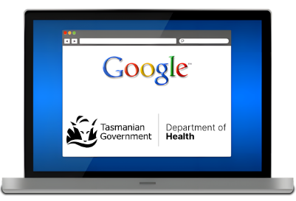
For more information on the strategy, go to our website:
Department of Premier and Cabinet - Tasmania’s Disability Strategy 2025-2027

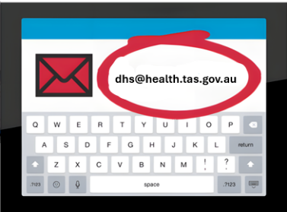
You can also email us at:
disability@dpac.tas.gov.au


Speak Out Tasmania created this Easy Read document using Photosymbols and custom images. The images may not be reused without permission. For any enquiries about the images or Easy Read, please email: easyread@speakoutadvocacy.org

