Factsheet

Model of How People Respond to Change

Change Curve: Conner’s Organisational Change Model
Daryl Conner’s Organisational change response model, which is based on the work of Dr Elizabeth Kubler-Ross, suggests 8 stages of transition for organisational change. Remember that everyone is different and therefore will experience change and the change process differently.
There is no ‘right’ or ‘wrong’ to the process and different people may move through each stage at a different pace. The key is to be aware of where people may be and help them through that stage with clear information, consultation and support.

Figure 1: Conner’s Organisation Change Model.
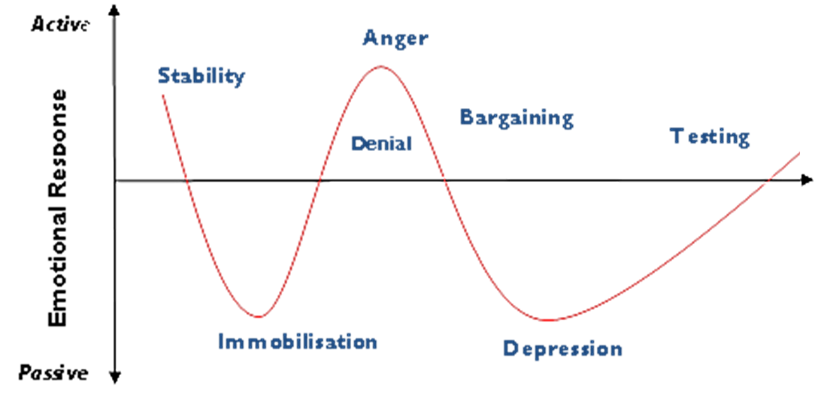
Acceptance
Time
Resistance can be expressed throughout the different phases.
Stage. | Stage description. | Typical statement.
- Stability | Precedes the change announcement. | N/A
- Immobilisation | Initial reaction to negatively perceived change is a shock. Reactions may vary from confusion to disorientation. Impact of change is alien to a person’s frame of reference. | I don’t understand why.  I can’t comprehend this.
- Denial | Characterised by inability to assimilate new information into current frame of reference. Information about change may be rejected or ignored. | This isn’t happening.  This won’t last.  It won’t go ahead.  It won’t affect me/us.
- Anger | Frustration and hurt, lashing out. Emotions directed at those in close proximity (manager, organisation, colleagues), treats targets with hostility, blame and criticism. | I won’t agree.  After all our hard work.  The union will fix this.  They’re liars.
- Bargaining | Negotiation to avoid negative impact. Takes many forms (request for deadline extensions, reassignments etc). Individual is coming to terms with the new reality. Starts to move to acceptance. | I’ll agree if they...  What about...
- Depression | Normal response to negatively perceived major change. May be expressed as resignation, feeling victimised, and lack of emotional or physical engagement. Is unpleasant, but may be a positive step in the acceptance process as person seeks answers and way through. | Things will never be the same.  I don’t care anymore.  It’s not worth the effort.
- Testing | Regaining sense of control. Start to acknowledge new situation by exploring new ways to make it possible to succeed within the new framework. | It’s happening; let’s make the most of it.
- Acceptance | Respond to change realistically (but doesn’t mean they will like the change). Just means they are more grounded and productive in the new context. | How can...  What can I do...  Let’s make sure that...

