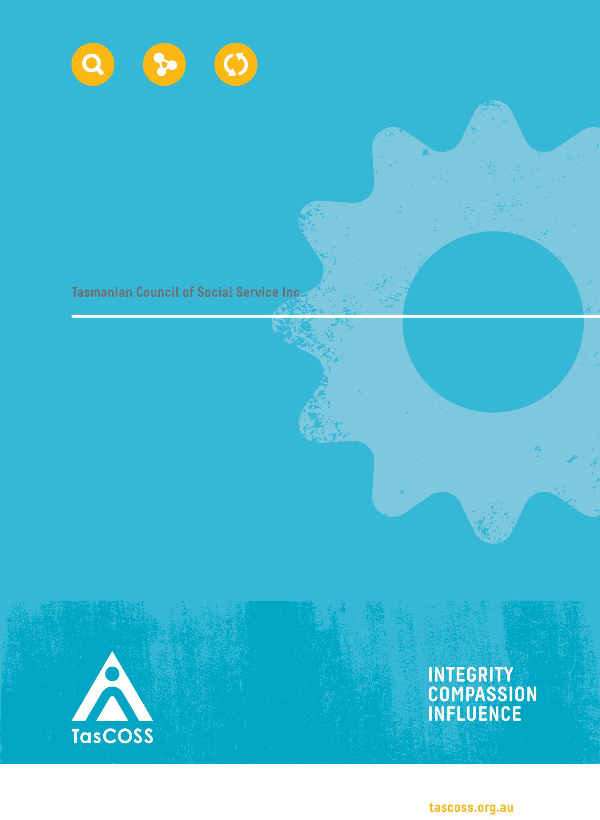

Disability Inclusion Bill
September 2023

Page | 1

About TasCOSS

TasCOSS’s vision is for one Tasmania, free of poverty and inequality where everyone has the same opportunity. Our mission is two-fold: to act as the peak body for the community services industry in Tasmania; and to challenge and change the systems, attitudes and behaviours that create poverty, inequality and exclusion.

Our membership includes individuals and organisations active in the provision of community services to Tasmanians on low incomes or living in vulnerable circumstances. TasCOSS represents the interests of our members and their service users to government, regulators, the media and the public. Through our advocacy and policy development, we draw attention to the causes of poverty and disadvantage, and promote the adoption of effective solutions to address these issues.
Please direct any enquiries about this submission to: Dr Charlie Burton
Acting Chief Executive Officer
Phone Number: (03) 6231 0755
Email Address: charlie@tascoss.org.au

Page | 2

Introduction
Alongside our earlier submission on the Disability Services Act review,¹ TasCOSS welcomes the opportunity to provide further feedback to the Tasmanian Government in relation to legislative reform to better support Tasmanians with disability, their families and their communities.

We are concerned the review of the relevant legislation in Tasmania is taking place prior to the release of the final report from the Royal Commission into Violence, Abuse, Neglect and Exploitation of People with Disability (‘the Disability Royal Commission’), which is now due on 29 September 2023. We understand these concerns are shared by key community organisations and stakeholders in Tasmania and that a request has been made for the Bill to be withdrawn until the release of the final report, to ensure any proposed changes are aligned with the recommendations of the Disability Royal Commission. TasCOSS supports this position, and our principal recommendation is that the Draft Bill be withdrawn for review at a later date, with additional time allocated for submissions to allow for genuine consideration of any recommendations contained in the final report and how our Tasmanian legislative framework could best support these recommendations.

Consistent with our previous recommendations, TasCOSS supports genuine and meaningful legislative and social reform to promote and enhance the rights of Tasmanians with disability. We acknowledge that the Disability Inclusion Bill (‘the Draft Bill’) includes provisions which reflect some of our previous
recommendations — for example, establishing the role of the Disability Inclusion Commissioner, and the Disability Inclusion Advisory Council. However, we are also concerned the Draft Bill has not sufficiently addressed some of the principal concerns raised in our previous submission.

Key Issues in the Draft Bill

Human rights framework
TasCOSS has strongly advocated for the implementation of a Tasmanian Human Rights Act and the development of a human rights framework as an appropriate model to both promote and enhance the rights of all Tasmanians,² as well as providing more effective options for the safeguarding and protection of these rights.

We believe elements of the Draft Bill are consistent with a human rights framework — for example, the expansion of the Inclusion Principles to include important principles, such as supported decision-making and the need to prioritise consultation and collaboration with people with disability.

We recommend the renaming of the Draft Bill to focus on the rights of people with disability, rather than the need for 'inclusion’ of Tasmanians with disability into mainstream services (which we believe may reinforce the ideas of difference or exclusion of people with disability). We also recommend the rewording of parts of the Draft Bill to ensure they are focused on the promotion of the rights of people with disability, rather than their protection from harm, as this is more consistent with.

1 TasCOSS, Submission to the Disability Services Act Review (December 2021).
2 For example, see ibid and TasCOSS, Submission to Tasmanian Law Reform Institute Review of Privacy Laws in Tasmania (July 2023).

Page | 3

As per our previous submission and recommendations, TasCOSS is strongly in favour of mechanisms to strengthen the human rights of all Tasmanians, as well as specific legislative and other changes to enhance and promote the rights of Tasmanians with disability. We believe the required changes go beyond legislative amendments and should address existing negative attitudes and beliefs about people with disability.

We reiterate our previous recommendations in relation to a human rights framework to support Tasmanians with disability, which include:
- Implementing a human rights instrument such as a Tasmanian Charter of Human Rights;
- Introducing comprehensive minimum standards for state-based disability services, similar to the
Disability Standards for Education 2005 (Cth);
- Engaging in comprehensive review of all legislation impacting Tasmanians with a disability; and
- Establishing a Disability Commissioner capable of leading the investment and innovation required to bring about the social, economic, cultural and infrastructure changes needed to promote and uphold the rights of Tasmanians with disabilities.

Inclusion principles
We support the introduction of provisions clearly outlining the rights of Tasmanians with disabilities. As outlined above, we believe the Draft Bill should enshrine the well-established rights of people with disability, rather than referring to ‘inclusion principles.’ As outlined by Disability Voices Tasmania in their submission,³ ‘[i]nclusion without promotion and protection of human rights and without opportunities to exercise power and engage in decision-making as partners falls short of what is required,’ and such practices ‘can become paternalistic where power remains in the hands of those doing the including rather than focusing on the relevant rights bearers’.⁴

We also highlight the importance of further education and support throughout the community to ensure the principles outlined in the Draft Bill are understood and effectively implemented. As highlighted above and outlined in our previous submission, there is a demonstrated need to address underlying attitudes and beliefs towards people with disability to ensure they are able to meaningfully participate in our community, and to ensure their rights are promoting and protected by governments, individuals and organisations.

We therefore recommend the following:
- The Inclusion Principles in clause 8 should be redrafted and renamed to instead reflect the rights of Tasmanians with disabilities and the positive obligation (on governments, entities and individuals) to respect those rights; and
- The Draft Bill should be accompanied by an extensive community education and information campaign to ensure all Tasmanians are aware of the rights of people with disability, as well as how they can respond to breaches of these rights.

Disability inclusion planning
The Draft Bill introduces a framework for disability inclusion planning within relevant organisations (those listed as ‘defined entities’ within the Draft Bill). We support the development of a disability inclusion planning framework but recommend provisions to ensure this planning is taking place within a wide

3 Disability Voices Tasmania, Community Consultation on Disability Inclusion Bill (September 2023).
4 Ibid, p. 3.

Page | 4

number of Tasmanian organisations and entities, and to include a greater level of detail. We note the recommendations of Disability Voices Tasmania in relation to the disability inclusion planning provisions, and recommend the following:
- Disability Inclusion Plans should be a requirement for all levels of government (state and local), all government entities and agencies, and any organisation contracted by or receiving funding from those bodies;
- The plans should contain key performance indicators and mechanisms to hold entities to account in relation to actions taken (or not taken) under a plan;
- Plans should be co-designed with people with disability;
- Plans should be published and available in accessible formats;
- Plans should include detailed information in relation to employment targets, the involvement of people with disability within the organsiation (for example, in service development, governance structures and/or advisory processes), and all accessible practices for employees (including, but not limited to, recruitment, induction and workplace policies and procedures).

Disability Inclusion Advisory Council
TasCOSS’s 2021 submission recommended the establishment of an advisory council (‘the Council’) to ensure all policies and laws are developed in consultation with Tasmanians with lived experience of disability or relevant expertise in a related field. We continue to recommend the Victorian legislation as a sound model, which mandates that the membership of the Council must reflect the diversity and cultural background of those with disabilities, explicitly promotes the inclusion of people with lived experience of disability, and provides a broad scope in relation to the powers and proposed activities of the Council.⁵

To ensure the Council is best able to fulfil its functions (as described in clause 20 of the Draft Bill), TasCOSS recommends amendments to ensure a higher proportion of members are Tasmanians with disability (ideally 80%, as recommended by Disability Voices Tasmania), and a requirement that the positions of Chair, Deputy Chair, and any spokesperson of the Council must be a person with disability.

The Draft Bill is unclear as to what obligations the Minister or Government will have in relation to any advice received by the Council. We recommend the inclusion of provisions to provide for the publication of all advice received by the Council, in formats which are readily available and easily accessible.

We reiterate our earlier recommendation that the Council must also be adequately resourced so they can provide advice through engagement with community, academic and professional experts, and relevant literature. This should also include opportunities for training, education and professional development.

5 Disability Act 2006 (Vic) s11 (3):
The Minister must ensure that members of the Victorian Disability Advisory Council are appointed from persons who:
- Reflect the diversity of persons with a disability;
- Reflect the cultural and indigenous backgrounds of persons with a disability;
- Have appropriate skills, knowledge and experience in matters relevant to persons with a disability, including children with a disability; and
- In so far as is possible have personal experience of disability.

Page | 5

We also seek confirmation on how the Council will interact with existing bodies such as the Premier’s
Disability Advisory Council,⁶ and the Minister’s Disability Consultative Group.⁷

Disability Inclusion Commissioner
TasCOSS previously recommended the inclusion of provisions to create the role of a Disability Commissioner.⁸ We advocated for a Commissioner with broad powers, including the following:
- Investigating complaints relating to disability services and regulated disability services, including the review of complaints to identify and potentially address causes;
- Reviewing and identifying causes of abuse and neglect in the provision of disability services;
- Providing advice, inquiring into or investigating matters, including conducting own motion investigations into the provision of services to persons with a disability;
- Facilitating conciliation between a person who has made a complaint and a provider;
- Keeping records of complaints and investigations;
- Considering ways of improving disability services complaints systems or complaints systems; and
- Providing education and information about various issues relating to the rights of persons with a disability, as well as conducting research into issues such as abuse and neglect within disability services.
TasCOSS acknowledges and supports the broad powers and functions for the Commissioner outlined in the Draft Bill. We recommend the inclusion of a power to compel entities to engage in activities/training
— for example, to improve performance of an entity or organisation in relation to its disability inclusion plan — as well as further options for enforcement (including conciliation/mediation).

We also note the concerns highlighted by Community Legal Centres Tasmania in their submission in relation to the Commissioner’s role and duties regarding disability inclusion action plans.⁹ We understand this is an issue currently under consideration in Victoria, where proposed legislative reform on their relevant legislation includes an expansion of the powers of the Commissioner in relation to disability inclusion plans.¹⁰ We agree the Commissioner should have the power to issue 'compliance notices' in instances where an entity has not prepared a plan, has not provided a copy of the plan to the Commissioner, or has not taken any material steps towards the reasonable implementation of the plan. We also recommend additional enforcement powers in cases where compliance notices are not complied with.¹¹

6 Premier’s Disability Advisory Council.
7 Minister’s Disability Consultative Group.
8 TasCOSS, Submission to the Disability Services Act Review (December 2021), pp. 4-6.
9 Community Legal Centres Tasmania, Submission to Disability Inclusion Legislation Project, Disability Inclusion Bill (18 September 2023), p. 2.
10 Disability Inclusion Bill Exposure Draft, Part 5 (Monitoring and Compliance).
11 For example, see Disability Inclusion Bill Exposure Draft, clause 30:
If a defined entity does not comply with a compliance notice by the date specified in the notice, the Commissioner may do one or more of the following:
- Accept a written undertaking by which the entity commits to take certain action to comply with this Act;
- Recommend that the Minister take any action that the Commissioner considers appropriate to ensure the entity's compliance with this Act;
- Publish on the Commissioner's website the name of the entity and the requirement of this Act with which the entity has failed to comply; and/or
- Apply to VCAT for an order directing the entity to comply with the notice.

Page | 6

Alongside these recommendations, we also urge the Government to ensure the Commissioner’s office is
sufficiently staffed and resourced in order to fulfill its statutory duties.

Restrictive Practices
A large part of the Draft Bill relates to restrictive practices, defined in the supplementary material as ‘any action that restricts the rights or freedom of movement or behaviour of a person’.¹²

We strongly support the recommendation from Disability Voices Tasmania that these sections of the Draft Bill be removed. We agree that the inclusion of these provisions within the Draft Bill is inconsistent with its objective to ‘advance and protect the rights of people with disability and to advance the full and effective inclusion of people with disability.’

As well as being inconsistent with the underlying objective of the Draft Bill, we are also extremely concerned that the continued inclusion of provisions relating to restrictive practices will only relate to ‘defined entities’ as defined in clause six of the Draft Bill. This means that, although the Draft Bill would regulate the use of restrictive practices on Tasmanians with disability — including through the introduction of oversight mechanisms such as the Appointed Program Officers and Independent Persons
- it would not apply to any other entities or organisations outside the scope of the Draft Bill. There are many other places or organisations in which restrictive practices are used which would therefore not be covered by the provisions of the Draft Bill, such as custodial settings, aged care facilities or within less formal setting (such as with family carers or support). As highlighted by Tasmania Legal Aid in their submission, restrictive practices in Tasmania are also regulated by other legislative instruments, such as the Mental Health Act 2013. We believe a more effective way of regulating these practices and raising awareness of both the impact of restrictive practices on human rights and access to oversight and support, would be to create standalone legislation dealing with restrictive practices in all settings.

Finally, although we support the introduction of additional oversight measures relating to restrictive practices, we are concerned that legislative provisions alone will have little impact on the use and extent of these practices without further education, training and resources for staff in institutions (including and beyond services working with Tasmanians with disability) where restrictive practices take place. We reiterate the need for comprehensive community education in relation to the rights of all Tasmanians, including those with disability, older Tasmanians and/or those in residential aged care settings, and prisoners or those in custodial/police settings.

We strongly recommend the following:
  - The sections of the Draft Bill relating to restrictive practices (including Parts 7, 8 and 9) should be removed;
  - A separate piece of legislation regulating the use of restrictive practices should be introduced, with sufficient time allowed for meaningful community consultation and engagement; and
  - This legislation should be accompanied by a comprehensive community education and awareness campaign in relation to human rights, and the impact restrictive practices may have of the exercise of those rights and the dignity of all Tasmanians.

12 Tasmanian Government, Department of Premier and Cabinet, Disability Inclusion Bill 2023: Consultation Overview Paper (August 2023), p. 19.

Page | 7

Other Issues
Aside from our concerns outlined above, we also note the following issues which we have raised previously in an earlier consultation on the Disability Services Act review and have not been addressed by the Draft Bill:

Interaction between the Act and the NDIS
The Draft Bill does not address the concerns we have raised previously in relation to current gaps in service delivery through the National Disability Insurance Scheme (‘the NDIS’). As we outlined in our previous submission, the Tasmanian Government remains responsible for meeting the service needs of Tasmanians ineligible for the NDIS but nonetheless living with substantial functional impacts. We must have processes and funded services in place to ensure the ongoing regulation of services to support all Tasmanians with a disability.

We further note there is a current review into the NDIS with a report due to be publicly released in October 2023. We anticipate this review will contain recommendations which could be relevant in the Tasmanian context, particularly in relation to how governments can better support those with disabilities, their families and care networks.

We reiterate our firm belief that, before presenting the Draft Bill to Parliament, the Tasmanian Government should await the recommendations from the final reports into both the Disability Royal Commission and the NDIS Review, to ensure our legislation and policies are consistent with any recommendations from these investigations/reviews. We also strongly recommend the development of a framework for a ‘provider of last resort’ model, with legislative provisions confirming ongoing access to mainstream services for those who are ineligible for the NDIS or unable to access supports.

Independent oversight
TasCOSS continues to believe the introduction of an independent oversight regime is needed to protect and promote the rights of Tasmanians with disability. Although the Draft Bill does contain provisions outlining an oversight regime in relation to restrictive practices with the introduction of the Independent Person, we continue to believe that a standalone oversight regime would support the underlying objective of the Draft Bill and the rights enshrined in international law, such as the United Nations Convention on the Rights of Persons with Disabilities. As per our earlier submission, we recommend the Draft Bill include provisions for establishing a Community Visitors Scheme, using the Victorian legislation as a model and also including provisions to allow the scheme to operate in premises provided through, and run by, the NDIS and private providers (such as boarding houses and caravan park operators).

Funding of community services
TasCOSS and other community service organisations have highlighted the need for increased funding and resourcing to promote and advance the human rights of Tasmanians with disability. As highlighted in our earlier submission, ‘[w]ithout ongoing, secure and adequate funding of these community organisations, many Tasmanians with disabilities would struggle to access the support they need’¹³ and ‘a lack of services places additional pressures on people with disabilities, their families and on service providers, which in turn can undermine their rights and ability to access necessary support.’¹⁴

13 TasCOSS, Submission to the Disability Services Act Review (December 2021), p. 15.
14 Ibid, p. 16.

Page | 8

TasCOSS supports Tasmania Legal Aid’s recommendation for the funding of a specialist disability legal
service, to provide comprehensive legal and non-legal support to Tasmanians with disability.¹⁵

We also reiterate our earlier recommendation in relation to additional funding for existing disability services organsiations across the community services industry.

Recommendations
PRINCIPAL RECOMMENDATION:
The Draft Bill should be withdrawn and reviewed at a later date, with additional time allocated for submissions to allow for genuine consideration of any recommendations contained in the final report of the Disability Royal Commission and National Review of the NDIS .

OTHER RECOMMENDATIONS:
- The Inclusion Principles should be redrafted and renamed to reflect the rights of Tasmanians with disability and the positive obligation (on governments, entities and individuals) to respect those rights.
- The Draft Bill should be accompanied by an extensive community education and information campaign to ensure all Tasmanians are aware of the rights of people with disability, as well as how they can respond to breaches of these rights.
- Disability inclusion planning should take place within a broader number of Tasmanian organisations and entities and include a greater level of detail:
  - Disability Inclusion Plans should be a requirement for all levels of government (state and local), all government entities and agencies, and any organisation contracted by or receiving funding from those bodies;
  - The plans should contain key performance indicators and mechanisms to hold entities to account in relation to actions taken (or not taken) under a plan;
  - Where possible, plans should be co-designed with people with disability;
  - Plans should be published and available in accessible formats; and
  - Plans should include detailed information in relation to employment targets, the involvement of people with disability within the organsiation (for example, in service development, governance structures and/or advisory processes), and all accessible practices for employees (including ,but not limited to, recruitment, induction and workplace policies and procedures);
- The Draft Bill should be amended to ensure a higher proportion of members of the Disability Advisory Council are Tasmanians with disability (ideally 80%) and that the positions of Chair, Deputy Chair, and any spokesperson of the Disability Advisory Council must be a person with disability.
- The Draft Bill should include provisions to mandate the publication of all advice received by the Disability Advisory Council (in formats which are readily available and easily accessible).
- The Disability Advisory Council must be adequately resourced to provide advice.

15 Tasmania Legal Aid, Submission to the Disability Inclusion Legislation Project, Disability Inclusion Bill (September 2023).

Page | 9

- The Tasmanian Government should clarify how the Disability Advisory Council will interact with existing bodies.
- The powers of the Disability Inclusion Commissioner should include the following:
  - A power to compel entities to engage in activities/training (for example, to improve performance of an entity or organisation in relation to its disability inclusion plan);
  - The power to issue 'compliance notices' in instances where an entity has not prepared
a plan, has not provided a copy of the plan to the Commissioner, or has not taken any material steps towards the reasonable implementation of the plan; and
  - Additional enforcement powers — for example, to act in cases where compliance notices (or other orders) are not complied with.
- The Tasmanian Government should adequately fund and resource the office of the Disability Inclusion Commissioner to ensure it can fulfill its statutory duties.
- The Tasmanian Government should reframe the legislative provisions around restrictive practices:
  - The sections of the Draft Bill relating to restrictive practices (including Parts 7, 8 and 9) should be removed;
  - A separate piece of legislation regulating the use of restrictive practices should be introduced, with sufficient time allowed for meaningful community consultation and engagement; and
  - This legislation should be accompanied by a comprehensive community education and awareness campaign in relation to human rights, and the impact restrictive practices may have of the exercise of those rights and the dignity of all Tasmanians.
- The Tasmanian Government should develop a framework for a ‘provider of last resort’ model, with legislative provisions confirming ongoing access to mainstream services for those who are not eligible for the NDIS or unable to access supports.
- The Tasmanian Government should establish a Community Visitor Scheme, enshrined in the Draft Bill and which should operate in a broad range of settings, including premises provided through and run by the NDIS and as well as private providers.
- The Tasmanian Government should find a specialist disability legal service to increase access to justice and promote the rights of Tasmanians with disability.
- The Tasmanian Government should increase the funding of existing disability services organisations to meet increased need of service provision and advocacy.
- The Tasmanian Government should commit to the implementation of a human rights instrument, such as a Tasmanian Charter of Human Rights.
- Comprehensive minimum standards should be introduced for state-based disability services, similar to the Disability Standards for Education 2005 (Cth).
- The Tasmanian Government should commit to a comprehensive review of all legislation impacting Tasmanians with a disability.

Page | 10

