Tasmanian State Service
Annual Report
2024-25

State Service Management Office
Department of Premier and Cabinet
GPO Box 123
HOBART TAS 7001
Phone: 03 6232 7040
Email: www.ssmo@dpac.tas.gov.au
Web: www.dpac.tas.gov.au/divisions/ssmo
ISSN (Print): 2202-8587
ISSN (Online, PDF): 2202-8595
October 2025
© Crown in Right of the State of Tasmania 2025

Contents

Letter of Transmission 4
Acknowledgement of Aboriginal People and Country 5
Statement of Commitment to Child and Youth Safety 6
About this report 7
Message from Head of the State Service 8
State Service at a glance 10
Tasmanian State Service workforce priorities 12
Our workplaces 14
Workforce planning and recruitment 21
Culture, leadership and capability 26
Diversity, equity and inclusion 35
Workforce management and employment 48
Our workforce metrics 58
Information sources used in this report 62

Letter of Transmission

Jeremy Rockliff MP
Premier
Minister Administering the State Service Act 2000
Dear Premier
TABLING OF THE TASMANIAN STATE SERVICE ANNUAL REPORT 2024-25
In accordance with the requirements of Section 19 of the State Service Act 2000, I enclose for sending to Parliament, the Tasmanian State Service Annual Report
2024–25.
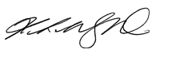
Yours sincerely
Kathrine Morgan-Wicks
Head of the State Service
29 October 2025

Acknowledgement of Aboriginal People and Country
Across the Tasmanian State Service, we acknowledge the ongoing custodians of Country and respect Tasmanian Aboriginal People’s continuous connections to Culture and Country, their deep spiritual connections and relationships to Land, Sea, and Sky Country since time began.
We acknowledge Aboriginal people working in the Tasmanian State Service and recognise and value their unique knowledge, skills and experiences that they bring to their workplaces.

Statement of Commitment to Child and Youth Safety
All children and young people have the right to feel and be safe, to be heard in matters that affect them and to be protected from harm.
At the Department of Premier and Cabinet, we are accountable for upholding these rights. We embrace our responsibility to guide and achieve positive change across the Tasmanian State Service. We will work as one to put the rights and wellbeing of children and young people at the centre of what we do. We will build and maintain a workplace that is safe for children and young people. We will listen to the diverse needs of all children and young people, no matter their background, culture, abilities, or identity.
Our promise goes beyond just words. We are committed to making meaningful and ongoing changes to ensure the safety and wellbeing of children and young people. We will employ the right people. We will embed a culture of self-reflection and continuous improvement. Children and young people will influence decisions that affect them. We will listen to them and learn from them. We will have the courage to change what needs to be changed. We will regularly review our policies and structures through a child and youth safety lens. Our people will be equipped with the skills to recognise and respond to signs of harm.
Our culture will be one where everyone takes responsibility, shares information, and speaks up if something doesn’t seem right. Together, we are creating a place where all children and young people are safe from harm. A place where we all protect young people and do what’s right, for a safer Tasmania.

About this report
The Tasmanian State Service Annual Report 2024–25 is an annual report to the Parliament of Tasmania in accordance with Section 19 of the State Service Act 2000, reporting on the performance and exercise of the functions and powers of the Premier of Tasmania, as Minister Administering the State Service Act, during the 2024-25 financial year.
This report provides information for all stakeholders and is developed with contributions across the Tasmanian State Service (TSS). It draws on data from the Annual Agency Survey, workforce reporting systems, and additional information provided by TSS agencies. The report also includes a comprehensive workforce profile of the TSS.

Message from Head of the State Service
I am pleased to share the Tasmanian State Service Annual Report 2024-25, which outlines our work over the past year to build a high performing, values driven public sector for the people of Tasmania. This is my second report as the Head of the State Service, and I am proud to reflect on the progress we have made together.
This year has been one of momentum and meaningful progress. We continued implementing reforms in response to the Commission of Inquiry into the Tasmanian Government’s Responses to Child Sexual Abuse in Institutional Settings, with a strong focus on cultural change, integrity and accountability. Our commitment to safe, respectful and inclusive workplaces remains unwavering.
We are investing in the future by strengthening leadership, building capability and modernising systems and practices. These efforts are essential to delivering responsive, high-quality services that meet the evolving needs of Tasmanians.
Across, the Tasmanian State Service we advanced a suite of workplace relations reforms, aimed at improving disciplinary processes, increasing transparency and supporting sustained cultural change in response to the Commission of Inquiry. These reforms were supported by strengthened governance, new operational structures and enhanced engagement with public sector unions and stakeholders.
A revised Employment Direction No.5 and guidance was issued by the Premier in August 2024. Both the Tasmanian State Service Review (TSSR) and the Commission of Inquiry recommended changes were incorporated to this important employment direction and the way it is applied in agencies. These changes have been through extensive consultation, and I want to acknowledge the input of all State Service agencies and key stakeholder groups, including public sector unions in advancing this work.
Improving how we manage disciplinary processes across the State Service is a critical component of the cultural change highlighted by the Commission of Inquiry to ensure as a State Service we are accountable, we uphold positive standards of conduct and behaviour, and we are focussed on keeping children and the vulnerable safe in our care and the services we provide to community.
We continue to strengthen our approach to investigations through the Shared Capability and Centralised Investigation Unit, working closely with the Department for Education, Children and Young People, with a specific focus on matters arising from the Ashely Youth Detention Centre. We have collaborated across agencies to improve our routine disclosure reporting requirements.
The HR Transformation Program is delivering PeopleCentral, a contemporary whole-of-government Human Resources Information System that will modernise the systems and processed supporting our people. By establishing a single source of truth for people and position data, automating routine services and improving data quality, PeopleCentral will provide real time workforce insights, unlock whole-of -service efficiencies and better enable strategic workforce decision making. The Program is well positioned to deliver lasting, system-wide workforce transformation.

Looking ahead
Over the coming year we will continue to strengthen employment frameworks and review State Service legislation to ensure it is fit for purpose State Service, guided by the findings of the Woolcott Review.
As we look ahead, we do so with optimism for the future of the Tasmanian public service. The challenges we face are complex, and the demands on our public sector services continue to evolve. Our strength is our collective willingness to reflect, learn and lead with integrity.
Every employee has a role in shaping a more trusted Tasmanian public sector that is inclusive, reflects the community we serve and develops the skills and capabilities required to deliver for Tasmanians.
I thank the many State Service employees across the sector who bring our values to life every day, serving the people of Tasmania with dedication and professionalism. I look forward to continuing this important work together as we build a public sector that is capable, inclusive and resilient and ready to meet the challenges of the future.
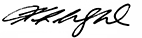
Kathrine Morgan-Wicks
Head of the State Service

State Service at a glance
More detailed information about the TSS workforce size, structure and composition can be found in the key metrics section of this report and is available on the State Service Management Office website.

Workforce profile

Size of the State Service
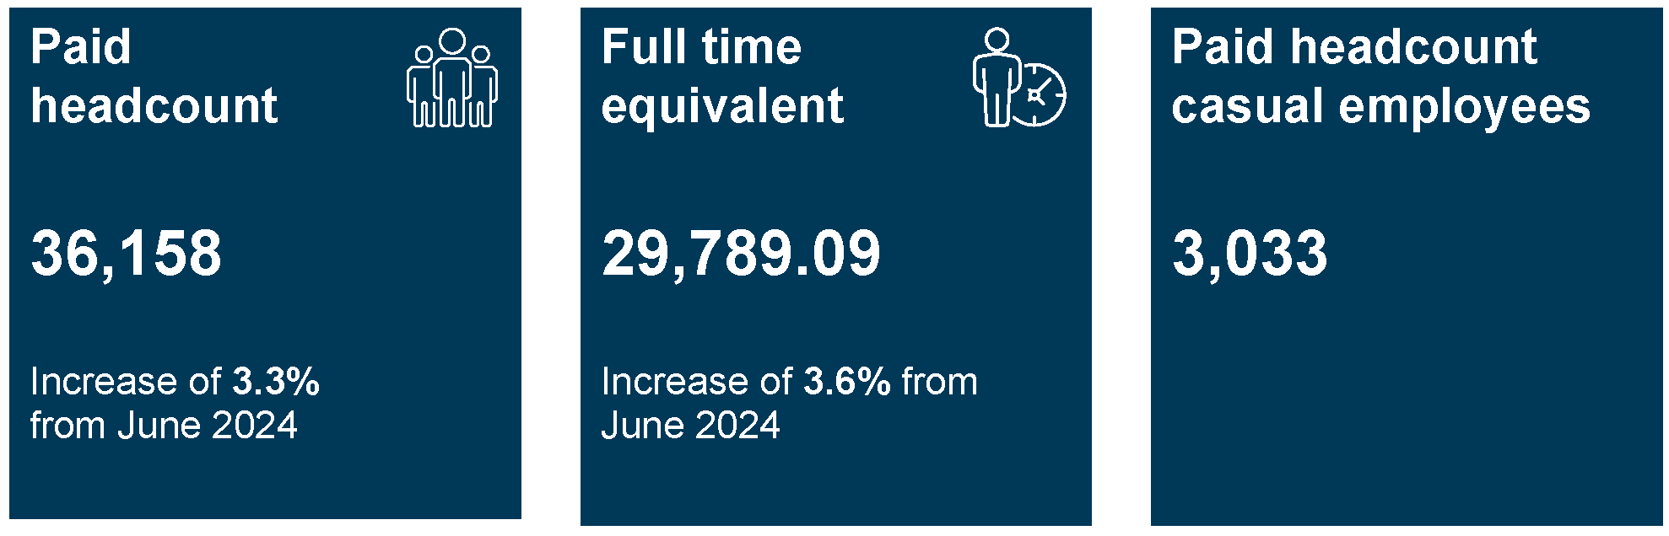
Description: Paid headcount: 36,168, this is an increase of 3.3 per cent from June 2024. Paid full time equivalent: 29,789.09, this is an increase of 3.6 per cent from June 2024. Paid headcount of casual employees is 3,033.

State Service employment
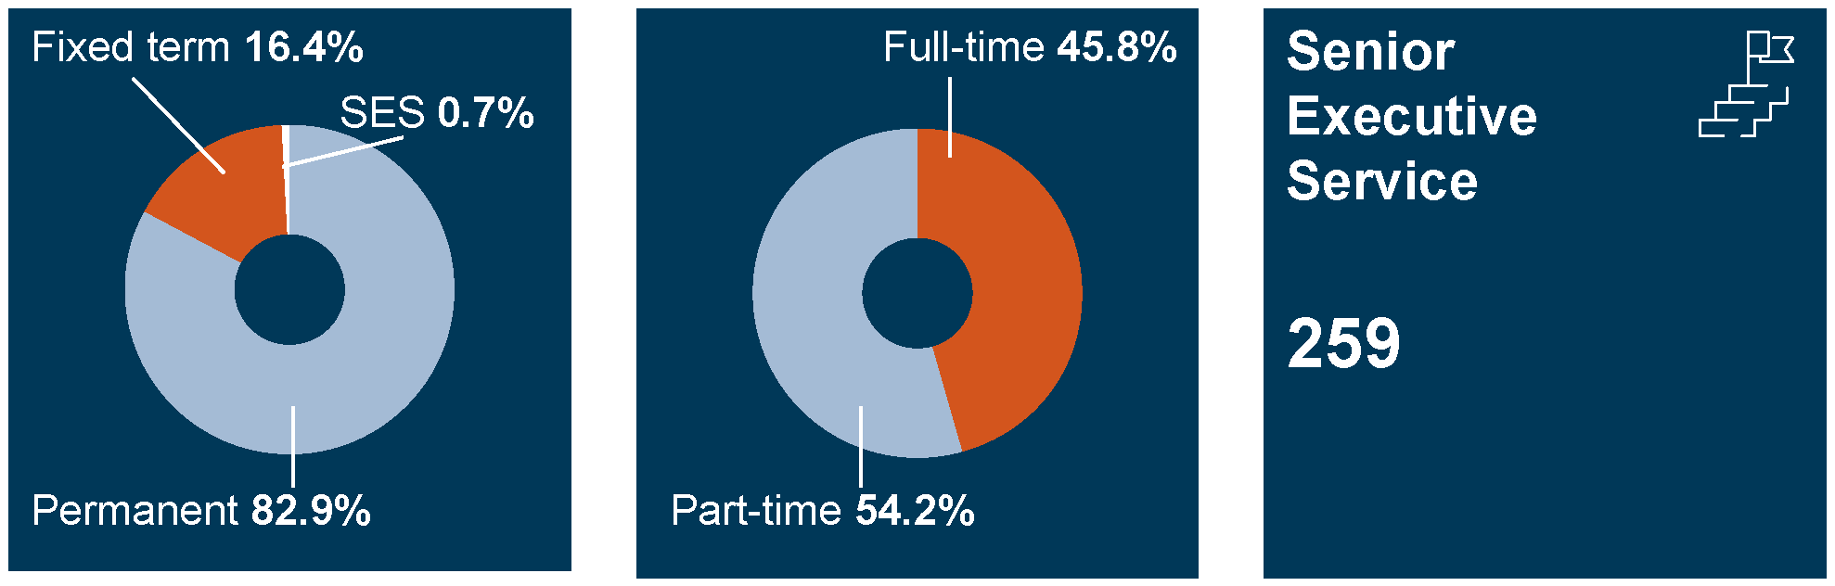
Description: State Service employees are split by 82.9 per cent of permanent staff, 16.4 per cent fixed term staff and 0.7 per cent of senior executive service. The split of employment is 45.8 per cent full time and 54.2 per cent part time. There are 259 senior executive service employees.

State Service demographics
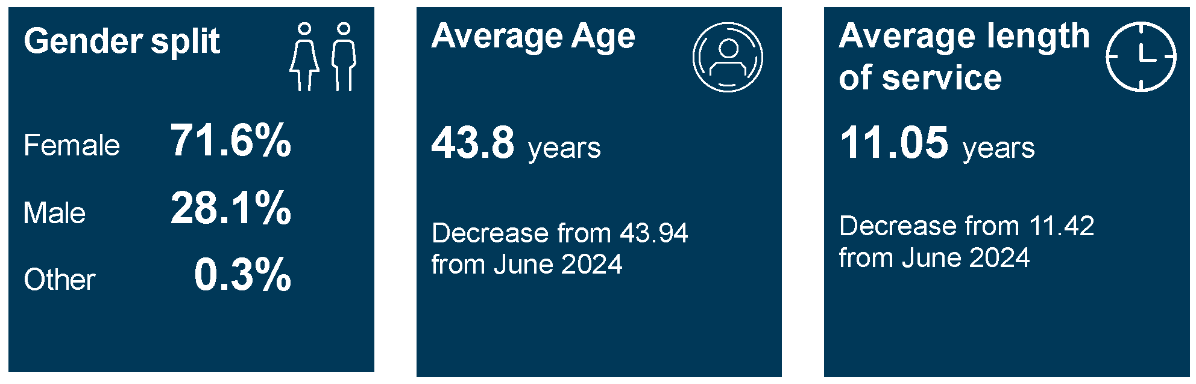
Description: State Service employees are split by 71.6 per cent female, 28.1 per cent male and 0.3 per cent other staff. The average age of State Service employees are 43.8 years, this is a decrease from 43.94 in June 2024. The average length of service is 11.05 years, this is a decrease from 11.42 in June 2024.

Tasmanian State Service workforce priorities
In 2024-25, the TSS continued its transformation toward a more sustainable, contemporary, and high performing public sector, one that is responsive to the evolving needs of the Tasmanian community. This transformation was guided by four strategic pillars: Right Size, Right Shape, Right Location and Right Enablers. These pillars also reflect the TSS commitment to implementing the recommendations from both the Commission of Inquiry into the Tasmanian Government’s Responses to Child Sexual Abuse in Institutional Settings and the Tasmanian State Service Review. Together, these efforts are reshaping the TSS to be more agile, capable and community-focussed.
Under the Right Size pillar, new vacancy control measures were introduced to enable targeted growth in essential roles while managing overall workforce size. The workforce planning framework was strengthened to better anticipate future service delivery needs, and enhancements to workforce data collection and reporting were made to support more evidence-based decision making.
The Right Shape pillar focused on building the capability and composition of the workforce. The maximum Workforce Renewal Incentive Payment (WRIP) was increased to support workforce renewal and role reprofiling. Development progressed on a TSS-wide core capability framework, alongside a trauma-informed capability framework, to build foundational skills across the State Service. Early career and youth employment programs were expanded, including the Tasmanian Graduate Development Program and School-Based Traineeships Program. In addition, a key project commenced in partnership with Brand Tasmania to define and promote a shared identity and culture across the TSS. This work lays the foundation for a compelling employee value proposition to support attraction and retention.
In support of the Right Location pillar, agencies implemented tailored regional workforce initiatives to meet local service demands and improve access to services for Tasmanians living outside urban centres. Flexible work arrangements were further embedded across many parts of the TSS, supporting both geographic diversity and employee wellbeing.
Finally, the Right Enablers pillar focussed on the systems and structures that support workforce effectiveness. Whole-of-service human resource transformation continued, with efforts to modernise systems, streamline processes, and improve workforce data and service delivery. Negotiations commenced for the Public Sector Union Wages Agreement (PSUWA), aiming to deliver fair, reasonable, affordable and sustainable outcomes while improving employment conditions and workforce mobility. Digital transformation efforts also progressed, with a focus on enhancing employee experience and improving integration of workforce data across the State Service.

HR Transformation Program
The HR Transformation Program is a major whole-of-government initiatives delivering a contemporary human resources information systems, PeopleCentral. PeopleCentral will streamline and standardise human resources processes across the State Service, including workforce planning, payroll, performance management, and work health and safety. This will enable consistent ways of working and unlock whole-of-service benefits. By building on earlier work by the Department of Health, the Program is focussing on increasing efficiency effectiveness and enablement across the State Service. The Program is laying the foundation for consistent, government-wide workforce management by improving visibility and management of people and position data. Key achievements include the delivery of a new whole-of-government HR Case Management System and agreement on standardised HR processes.

Our workplaces
The TSS is committed to creating safe, inclusive and supportive workplaces where employees can thrive and do the best jobs we can for the Tasmanian community. With a strong emphasis on flexibility, wellbeing, respectful behaviour, and tailored support for those affected by family violence, agencies are actively shaping environments that reflect the values and principles of the State Service and meet the evolving needs of the workforce.
Over the past year, agencies have taken meaningful steps to strengthen the foundations of their workplaces. This has included reviewing and refining structures, systems and ways of working to align with contemporary practices, promote work-life balance, and uphold the State Service principles. These efforts are critical to positioning the State Service as an employer of choice in an increasingly competitive employment landscape.

Photo of health workers
A gardener walking in the Royal Tasmanian Botanical Gardens

Flexibility
The TSS recognises that flexible work arrangements are essential to supporting a modern, diverse and resilient workforce. Flexibility enhances productivity, promotes employee wellbeing, and enables greater workforce participation by helping employees balance professional, personal and family responsibilities.
We are committed to offering flexible work options while continuing to deliver high-quality services to the Tasmanian community. Agencies consider operational requirements, role-specific duties, individual preferences, and any reasonable adjustments needed to support flexible work arrangements. These may include remote working, varied start and finish times, purchased leave, compressed work weeks and part-time agreements.
While not all roles can accommodate the same level of flexibility, the State Service remains committed to providing flexible options wherever possible and appropriate.
Flexibility is also reflected in the additional leave provisions introduced in 2023. The table below summarises the types of leave accessed and the number of employees who used each category in 2024-25.

Table 1: Access to additional leave provisions
Leave provision | Total
Paid primary caregiver leave (18 weeks paid parental leave) | 1,324
Paid secondary caregiver leave (four weeks paid parental leave at time of birth) | 395
Additional paid secondary caregiver leave (12 weeks paid parental leave) | 524
Unpaid parental leave (including birth and non-birth parents and grandparents) | 419
Grandparents leave (paid and unpaid where primary caregiver) | 7
Foster and kinship leave | 37
Surrogacy leave | 1
Adoption leave (including primary caregiver, paid secondary caregiver, paid additional secondary caregiver and unpaid) | 3
Aboriginal culture leave | 27
Disability leave | 105
Gender affirmation leave | 8
State Service purchased leave scheme | 899
State Service accumulated leave scheme | 353

Supporting employees experiencing family violence
During the 2024-25 reporting period, agencies continued to provide meaningful support to employees experiencing family violence, in line with Employment Direction No. 28: Family Violence – Workplace Arrangements and Requirements.
A total of 152 applications for family violence leave were submitted and approved across reporting agencies, an increase from the 114 applications received in the previous reporting period. It is important to note that not all applications or instances of support are formally recorded, due to the need to protect employee confidentiality and privacy.
Agencies remain committed to raising awareness and providing practical, compassionate support to employees affected by family violence. Initiatives this year included:
- annual family violence awareness training
- resources and guidance for managers
- access to flexible working arrangements
- clear referral pathways to external support services
- access to the State Service Employee Assistance Program (EAP)
- development and implementation of Workplace Safety Plans
- ongoing support through a network of trained Workplace Contact Officers.

Work health, safety and wellbeing
The TSS remains committed to fostering a safe, healthy and supportive workplace for all employees. Promoting work health, safety and wellbeing involves more than compliance, it requires a proactive and holistic approach to identifying and managing both physical and psychological risks.
Agencies continue to strengthen their systems, practices and cultures to ensure that employees feel safe, valued and supported in their work environments. This includes a focus on prevention, early intervention and continuous improvement to promote wellbeing and reduce harm.

Managing psychosocial hazards in the workplace
Since the release of the Psychosocial Hazards Code of Practice in January 2023, agencies across the TSS have continued to embed its principles into workplace practices. This includes strengthening systems to identify, assess, and manage psychosocial risks, and empowering employees to speak up and take action when concerns arise.
Agencies are adopting a holistic approach to managing psychosocial hazards, recognising that these risks can arise from a range of factors such as workload, job design, workplace culture, recruitment practices, and resourcing. By addressing these areas, the State Service is fostering environments that support employee wellbeing and reflect our commitment to contemporary, inclusive, and safe work practices.

Understanding and supporting work, health and safety
The TSS is committed to ensuring employees, managers and officers understand their responsibilities and the systems in place to support health and safety in the workplace.
During the 2024-25 reporting period, 102 officers, 21,590 employees and 808 managers completed training in accordance with the requirements of Employment Direction No. 27: Work Health and Safety. In addition to mandatory training, agencies delivered a wide range of programs designed to promote a culture of safety and wellbeing. These included:
- Work health and safety training
- Due diligence training
- Human Resources orientation for managers
- Supervisor/manager responsibilities
- Officer awareness training
- Situational awareness training
- Fundamentals of safeguarding children and young people
- Trauma-informed practice training
- Vicarious trauma awareness
- First aid and CPR
- Psychosocial risk management
- Psychosocial hazard training (for workers and managers)
- Safety essentials
- Occupational violence and aggression training
- Manual handling training
- Discrimination law: rights and responsibilities
- Respectful relationships
- People-focussed leadership
- Promoting a mentally healthy workplace
- De-escalation and managing difficult situations
- Mental health first aid
- Professional supervision
These initiatives reflect the State Service’s ongoing commitment to building safe, informed and resilient workplaces.

Case study: Operational safety review, Homes Tasmania
In 2024, Homes Tasmania (with the assistance of WorkSafe Tasmania) began a comprehensive review of its operational safety to confirm that existing protocols ensuring the safety of staff reflected the risks in the client group.
As a result, a new protocol for Operational Safety was introduced in late 2024. In particular, the protocol focussed on ensuring risk assessments of client interactions were as accurate as possible and where a risk factor was identified, every staff member knew the appropriate response and had the level of training required to enact the protocol’s safety responses.
Key to the success of the protocol, is the level of training and reinforcement of behaviours that elicit safety. To that end, training has been rolled out in 2025 to all operational staff and will continue annually to ensure staff are as prepared as possible, and that all new staff are quickly picked up in the training. Managers will continue to reinforce risk assessment practices and monitor behaviours to ensure staff remain vigilant to potential risks and are exhibiting safe behaviours.
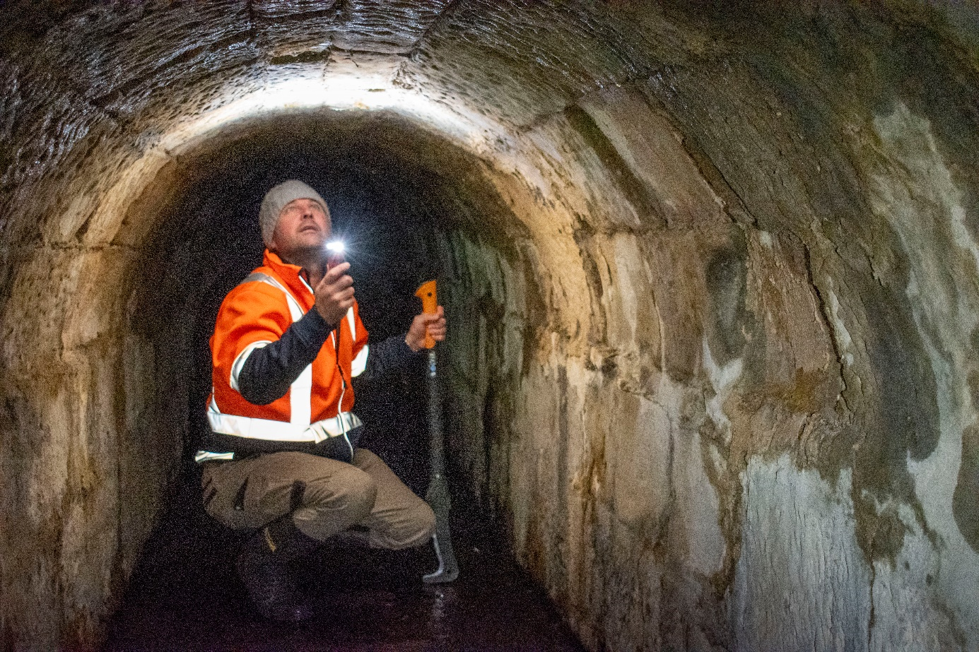
Senior Technical Officer undertaking a culvert inspection

Workplace behaviour and conduct
Workplace conduct defines the standards for how TSS employees interact with one another and the broader community. These standards are fundamental to building inclusive, respectful and psychologically safe workplaces where all employees feel valued and supported.
While a TSS Employee Survey was not conducted during the 2024-25 reporting period, the most recent results from 2024 show that 71 per cent had positive perceptions of workplace behaviour. This is consistent with 2023 and reflects an improvement from 68 per cent in 2020. While these figures are encouraging, there remains room for continued progress.
Throughout the reporting period, agencies continued to strengthen workplace values programs that define and promote respectful behaviours. Efforts also focused on developing supportive frameworks and practices that encourage employees to speak up when they witness inappropriate workplace behaviour. Human Resources teams and managers play a key role in fostering professional conduct and ensuring that all employees feel safe and supported in raising concerns.

Formal grievances
A detailed breakdown of formal grievances raised through agency grievance management processes during 2024-25 is provided in the Workplace Management and Employment section of this report.
Of the total grievances reported, 34 involved allegations of bullying and/or harassment, while four related specifically to allegations of sexual harassment. During the reporting period,18 bullying and/or harassment grievances and one sexual harassment grievance were resolved. The remaining unresolved matters have been carried forward into the 2025–26 reporting year.
It is important to note that grievance data may not capture all instances of inappropriate behaviour, as some matters are addressed informally or may not be reported due to confidentiality concerns.

Workforce planning and recruitment
The State Service advanced strategic workforce planning and modernised recruitment systems to support a sustainable, responsive and capable State Service. Key initiatives included the development of planning tools, targeted vacancy management, and system enhancements to streamline recruitment and improve workforce data.

Strategic workforce planning
During the reporting period, the State Service Management Office (SSMO) commenced a key project to develop a suite of flexible tools to support strategic workforce planning across the TSS. These tools are designed to be adaptable to agency-specific needs, enabling tailored approaches to workforce planning and assist the TSS to plan for our workforce needs for the future. The initial phase focused on co-designing the toolkit in collaboration with agencies, with ongoing refinement to ensure it meets the diverse operational requirements across the State Service.
The second phase of the project is underway, with a focus on building capability within human resources teams to embed strategic workforce planning practices more effectively. In early 2024, a Community of Practice group was convened, bringing together representatives from all agencies to share insights and identify opportunities for improvement. Discussions explored existing strengths and highlighted areas requiring further development to support a more responsive and sustainable workforce.
The TSS routinely reviews its strategic workforce priorities to ensure it can meet growing service demands while supporting its people. This includes maintaining a workforce that is sustainable in size and shape, located where services are needed most, and equipped with the right tools and resources to deliver high-quality outcomes for the Tasmanian community.

Vacancy management and workforce renewal
During the 2024-25 reporting period, the State Service undertook a number of strategic workforce initiatives aimed at managing vacancies and renewing its workforce to better meet future service needs. In March 2025, a refocus on non-essential recruitment was announced. Agencies reviewed their internal recruitment approval processes, with many establishing or updating recruitment committees. In consultation with the Head of the State Service, Heads of Agencies also reviewed vacancy management arrangements within their agencies.

Managing positions in the State Service
The Managing Positions in the State Service framework continued to support agencies in aligning workforce skills with future service needs. In January 2025, the framework was reissued with two key amendments:
- An increase to the maximum Workplace Renewal Incentive Program (WRIP) payment from $30,000 to $60,000, and
- An extension to the timeframe to fill a reprofiled role from six months to eight months.
These changes reflect the importance of reprofiling and support broader employment strategies, including youth employment and service delivery reform.
The WRIP is an important component of the State Service workforce strategy and provides our people with an opportunity to express interest in separating from the State Service. Agencies have the option to engage in a formal expression of interest process or manage on an individual employee basis.
In 2024-25, 15 employees exited the State Service through Targeted Negotiated Voluntary Redundancies (TNVRs), with an additional 15 leaving after accepting a WRIP payment.

Recruitment activity and system enhancements
Despite a decrease in external job advertisements compared to the previous year, recruitment remained a priority across the TSS. A total of 5,274 advertisements were published externally via the Tasmanian Government jobs website. Agencies continued to recruit locally, nationally and internationally for the talent needed to deliver essential services across the state.
To support efficient and effective recruitment, several key system improvements were implemented in the PageUp platform. Enhancements to the Whole-of-Government (WoG) application forms and the New Starter forms improved both user experience and data capture. The integration of LinkedIn Recruiter Connect enabled direct viewing of applicant profiles within PageUp, streamlining talent acquisition processes.
Further enhancements to the Talent Search functionality were informed by insights from the Department of Health and the Department for Education, Children and Young People. These improvements, available to WoG users, were supported by targeted training to help agencies build and manage talent pools across the State Service.
Following the transition from legacy to enhanced reporting in PageUp, WoG training was delivered to improve users’ ability to retrieve and analyse recruitment data. These improvements have increased efficiency and supported agencies to make evidence-based decisions and better align recruitment with operational needs.
Recruitment efforts continued to focus on priority sectors such as health and education. Responsiveness in recruitment remains critical to ensuring the right people are placed in the right roles at the right time, supporting the delivery of high-quality services to the Tasmanian community.

Refresh of Tasmanian Government jobs website
The Tasmanian Government jobs website is the central platform for employment opportunities within the TSS. It serves as a key entry point for individuals seeking to join the State Service or learn more about State Service agencies and authorities.
Initial planning for a website refresh commenced in March 2025, recognising that improved functionality and an opportunity to align with the broader ‘Tasmanian’ brand may incentivise job seekers to choose the TSS.
The refresh aims to deliver a modern, accessible and visually cohesive website that reflects the Tasmanian identity and enhances the user experience. Phase 1 of the project is currently underway and is scheduled for completion in December 2025. This phase will deliver:
- A refreshed design aligned with the outcomes of the recent cultural insights project of ‘meaningful work in a meaningful place’
- Improved functionality and accessibility
- Retention of some existing content and site architecture to ensure continuity.
Phase 2 will begin in early 2026 and will focus on further enhancing the user experience. It will also explore opportunities to position the website as a strategic gateway for promoting the Tasmanian brand to potential applicants locally, interstate and internationally.

TSS recruitment initiatives

Department of Health: Branding for nurse recruitment
The Department of Health is taking a strategic approach to talent acquisition that allows a wider pool of talent locally, nationally and internationally.
In 2024-25, the department partnered with Brand Tasmania to pursue international and interstate recruitment using a content-driven communications strategy. These activities centred around attending job fairs for clinical professionals in the United Kingdom, Canada, New Zealand and other parts of Australia.
Most jurisdictions in Australia use advertisements on seek.com.au or LinkedIn that look the same as every other advertisement. Their presence at job fairs and career expos is indistinguishable from other places. By showing our nurses, doctors, oral health therapists, and allied health workers doing what they do at work and, more importantly, outside of work, we could humanise the recruitment process and position Tasmania as a place where health workers can thrive professionally and personally.
Through storytelling, we highlight the unique professional and personal opportunities available in Tasmania: working in close-knit teams, access to decision-makers, and leadership opportunities, to living close to nature, pursuing creative interests, and being part of a community outside of work.
The United Kingdom and Canada job fairs in February and March 2025 generated 1,143 expressions of interest. This then led to 127 candidates registering for webinars on living and working in Tasmania. Following this, in May 2025 a bulk recruitment campaign for nursing attracted 449 qualified applicants, with the vast majority from overseas. Since April 2024, 1,095 staff members have relocated from interstate and overseas, underscoring that these national and international campaigns are having a significant impact.
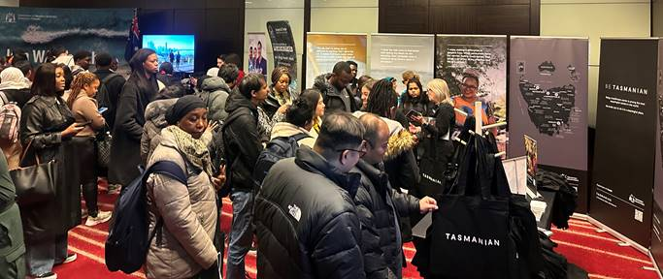
Department of Health stand at a job fair in London.
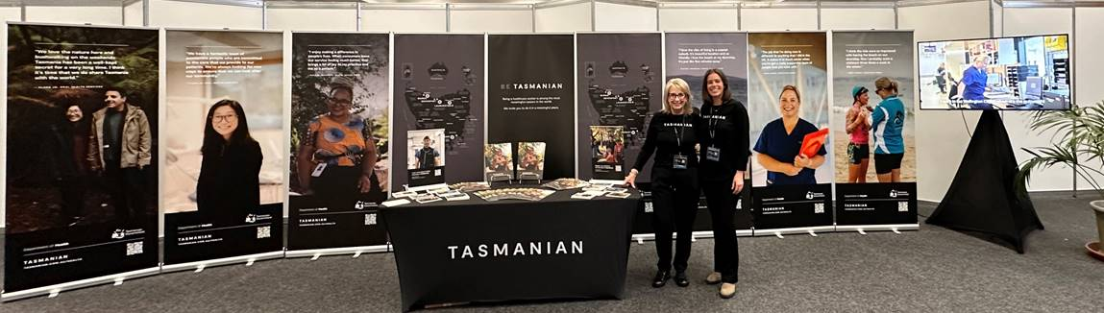
Department of Health stand at a job fair in Dublin.

Department for Education, Children and Young People: Supporting children and families
Child Safety Officers play a valued and critical role in our community by ensuring Tasmanian children, young people and families are safe, nurtured and well. Through compassionate engagement and professional expertise, Child Safety Officers build trusting relationships and work collaboratively with families, caregivers, and service providers to create safe and nurturing environments. Their work is both challenging and deeply rewarding, making a lasting difference in the lives of those they serve.
In 2024, the department launched a series of targeted recruitment campaigns for Child Safety Officers and Child Safety Wellbeing Workers. These campaigns showcased the meaningful nature of the roles and the positive impact they have on the wellbeing of children and young people across Tasmania.
Highlights of the impact include:
- A 25 per cent increase in Child Safety Officer staffing levels statewide since 30 September 2024.
- Enhanced capacity to deliver frontline services and respond to the needs of children and families more effectively.
- Strengthened workforce presence across regional and urban areas, improving service accessibility and continuity.
These outcomes mark a significant milestone in our commitment to building a resilient and responsive Child Safety Service. The department remains focused on sustaining this momentum through ongoing attraction and recruitment strategies, ensuring that every child and family in Tasmania receives the support they need.

Department for Education, Children and Young People: National teacher recruitment campaign
The national teacher recruitment campaign was advertised more broadly in 2025 using Seek and LinkedIn to reach suitable overseas candidates, in addition to a marketing firm to support reaching prospective teachers through social media, YouTube, Google and physical billboards within Tasmania. The proactive reach out to candidates through LinkedIn Recruiter functionality and through existing talent pools coupled with the broad advertising provided more reach than ever before and ended with a strong talent pool ready for interview in September.
On the back of this campaign, there will be additional talent pooling of international candidates with specialised qualifications who may be suitable for consideration of future Visa sponsorship once the final 2026 needs are identified at the conclusion of the national teacher campaign.

Department for Education, Children and Young People’s National Teacher Recruitment Campaign

Culture, leadership and capability
In a year marked by transformation and opportunity, our commitment to culture, leadership, and capability has remained central to enabling sustainable performance and preparing for the future. Guided by the recommendations of the Commission of Inquiry and ongoing reform initiatives, we have continued to foster a values-driven culture, strengthen leadership at all levels, and invest in the capabilities that empower our people to thrive in a dynamic environment. These efforts provide strong foundations and act as strategic levers, driving engagement, innovation, and meaningful impact across the State Service.
The Department of Premier and Cabinet, through the State Service Management Office (SSMO), leads cross-agency collaboration on strategic whole-of-service programs that promote a culture of learning, performance and continuous improvement. These initiatives support agencies to implement contemporary practices, frameworks, and employment standards, enabling the development and delivery of tailored, responsive workforce programs aligned to their unique needs.

Culture
Across the State Service, we are committed to fostering a culture grounded in integrity, safety, accountability and collaboration. This guides how we work together and serve the Tasmanian community. Our cultural priorities include:
- putting children at the centre of our decision making
- valuing inclusion and embracing diversity
- supporting culturally safe ways of working
- creating respectful, safe and supportive workplaces for all employees.
This shared commitment shapes not only our internal practices but also the way we deliver services to the people of Tasmania.


Cultural Insights Research Project
In mid-2024, SSMO, in partnership with Brand Tasmania, launched the Cultural Insights Research Project to explore and articulate the unique identity of the TSS. The initiative aimed to uncover what it truly means to be a TSS employee, with a focus on shaping a compelling employee value proposition and enhancing attraction strategies across the State Service.
Through 132 in-depth interviews with a diverse cross-section of TSS employees, we collated over 167,000 words of rich qualitative insights. From this, a unifying narrative emerged, ‘meaningful work in a meaningful place’. This story captures the essence of pride, connection and purpose felt by employees and reflects the culture of the TSS at its best.
These insights are already informing strategic initiatives, including international recruitment campaigns in the Department of Health and the redevelopment of the Tasmanian Government jobs website. These efforts aim to embed storytelling and brand aligned content into recruitment practices, creating a consistent and authentic representation of the TSS across agencies.
This foundational work will continue to shape a whole-of-service approach to recruitment and cultural engagement, celebrating the values and identity that makes the TSS unique.
We are taking a phased approach to implementation:
- Phase 1 – redesign of the Tasmanian Government jobs website, development of the TSS employee value proposition, and rollout of best practice recruitment branding and collateral for agencies, alongside streamlined recruitment practices.
- Phase 2 – development of a whole-of-service induction experience and initiatives to foster positive workplace culture.
- Phase 3 – focus on building TSS capability, leadership and management development.

Leadership
The State Service is committed to cultivating high-performing leaders who demonstrate stewardship, strategic vision and collaborative capability. Through cross-agency engagement and the promotion of functional and adaptive leadership practices, the State Service continues to build a leadership culture that supports innovation, adaptability and the delivery of public value.
SSMO facilitates a broad range of whole-of-service professional development services. These programs and initiatives range across the employee lifecycle with a strong focus on skill-based development programs in leadership and management. These complement and support agency specific development programs.

Manager Essentials Program
The Manager Essentials Program (MEP) is an award-winning program designed to strengthen leadership capability across the TSS. Delivered over nine months, the program compromises four core modules and is anchored by 180-degree and 360-degree emotional intelligence assessments, supporting participants to build self-awareness and grow as leaders.
In 2024, a comprehensive review of the program identified several strategic and operational opportunities to enhance its impact and shape a stronger leadership talent pipeline. In response, SSMO has commenced work to implement these recommendations, with refreshed content and delivery enhancements scheduled to launch in 2026.
Since its inception in 2017, MEP has delivered over 50 programs, enrolling more than 900 participants. Of these, 749 have completed either the full program or selected modules, while 90 participants remain active across current cohorts. During the 2024–25 period, six programs commenced with 127 participants enrolled. Due to the program’s rolling nature, 101 participants have graduated during the same period, demonstrating continued demand and value across the TSS.

State Service Strategic Management Program
The State Service Strategic Management Program (S3MP) is delivered in partnership with Tasmania Police, the University of Tasmania (UTAS) and SSMO. It provides targeted development opportunities for emerging and recently appointed senior managers and serves as a recognised pathway within the Tasmania Police Inspector Program.
S3MP fosters consistent, high-quality leadership across agencies and offers participants partial credit toward post-graduate qualifications at UTAS. This year, two State Service participants progressed to further study, reflecting the program’s role in supporting lifelong learning and leadership excellence.

ANZSOG Programs
SSMO also coordinates nominations for leadership programs offered by the Australian and New Zealand School of Government (ANZSOG), including:
- Executive Fellows Program
- Executive Master of Public Administration
- Towards Strategic Leadership.
These programs provide senior leaders with access to world-class public sector education, supporting the development of strategic thinking, policy capability and cross-jurisdictional collaboration.

Case study: Empowering leadership, Department of Natural Resources and Environment Tasmania

Overview
The Department of Natural Resources and Environment Tasmania (NRE Tas) is strengthening leadership capability across the department through an internal leadership strategy, aiming to build a high-performing department driven by its people and systems.

Background
The NRE Tas Strategic Plan 2022–2027 focusses on organisational capability uplift, with leadership recognised as a key enabler. Insights from the 2023 TSS employee survey highlighted leadership and career development as key areas for growth for the department. Despite having leaders across its four divisions, NRE Tas found they were missing a shared identity and consistent engagement, and there had been no internal leadership development pathway for years.

Leadership Strategy
In response, NRE Tas launched a comprehensive and sustainable Leadership Strategy focused on three pillars:
- Learn: Building leadership knowledge.
- Develop: Creating opportunities for application and reflection.
- Grow: Supporting long-term leadership growth.

Key initiative: Aspiring Leaders Program (ALP)
Introduced in 2024, the ALP is the department’s first internal leadership development offering. Open to all employees, it enhances technical and interpersonal skills, focusing on emotional intelligence, communication, collaboration, and trust. The program fosters cross-divisional engagement, including independent authorities like the Environment Protection Authority (EPA), and aligns with the department’s strategic plan and the ’How We Work’ framework.
The ALP features five interactive workshops designed as safe spaces for learning and growth, covering:
- leadership foundations and communication
- strengths-based leadership and culture
- team dynamics and psychological safety
- feedback, performance, change management, and personal growth.
The first cohort of 33 participants reported increased confidence and practical application of skills. The second cohort begins in August 2025.

Outcomes and future direction
NRE Tas is embedding emotionally intelligent leadership into its culture, making leadership development a core part of its employee value proposition. Upcoming initiatives include leadership masterclasses, fundamentals, and podcasts, reinforcing leadership as both a capability and a retention strategy.

Case study: CARE Chats - Culture Change through Compassionate Accountability, Department of Health
As part of the One Health Culture Program and in response to Recommendation 15.03 of the Commission of Inquiry, the development and implementation of CARE Chats has become a key strategy for strengthening our safety culture at the Department of Health.
CARE Chats are short, structured conversations grounded in our CARE values, Compassion, Accountability, Respect, and Excellence and designed to support proactive conflict resolution and safety culture across our teams.
The CARE Chats acronym has been designed as an easy-to-remember guide using these steps: Check for safety, Hear to understand, Accountability with compassion, Take action, and Support for self/other.
Clinical Nurse Educator, Ebony Russell, was recently introduced to CARE Chats, through her participation in the Elevate Leadership Development Program. Ebony applied the CARE Chats framework after previous conversations around an issue had been unsuccessful.
“I had previously planned out what I kind of wanted to get from the conversation. I was able to steer the person with what I needed to do. I was able to get them to take accountability for what actually happened, which was really a breakthrough.”
The structured nature of CARE Chats helped facilitate a conversation that was both respectful and resulted in the mitigation of a potential patient safety risk without escalation through our complaints processes.
“I’ve encouraged people to… get some information around CARE Chats and how they can incorporate that into their practice. I wish it was something that was around several years ago… it would have given [me] that structure that's needed to make it more comfortable.”
CARE Chats has been embedded in our internal leadership and management programs and since 2024, over 1,300 staff have participated in more than 80 staff collaboration workshops, and a further 580 have completed the associated Tasmanian Health Education Online (THEO) module. Awareness has been further supported through posters, lanyard cards, intranet resources, and a quick reference guide.
The development of CARE Chats is proving to be a critical enabler of our organisational commitment to safety, respect, and professional excellence. As demonstrated in this case, embedding CARE Chats into everyday practice equips our people with the confidence and tools to address issues early. By improving team dynamics and placing patient safety at the centre of everything we do, CARE Chats supports our work to care for the health and wellbeing of all in Tasmania.

Capability
Building workforce capability is central to delivering high-quality services and meeting the evolving needs of the Tasmanian community. Access to learning and development is a key enabler, not only of individual career growth but of a resilient, future-ready State Service.
By fostering a culture of continuous learning, we empower employees to build the skills, confidence and agility required to navigate complexity and drive innovation. Our approach prioritises development opportunities that are contemporary, inclusive and responsive, supporting both personal aspirations and organisational performance.
SSMO coordinates a suite of whole-of-service programs, courses and initiatives designed to uplift capability across the workforce. These are strategically designed, developed and delivered to meet current and emerging needs, and are complemented by agency-led programs that target specific skill areas and provide study assistance for formal education.

TSS Core Capability Framework
In 2024-25, SSMO commenced the development of a whole-of-service Core Capability Framework – a key strategic initiative designed to strengthen workforce planning, development and performance across the TSS.
The framework will provide a consistent and practical foundation for identifying, developing and aligning workforce capabilities across diverse operational contexts. Co-designed with agencies, it reflects the unique needs of the TSS while promoting a unified approach to capability uplift.
By clearly defining the core capabilities required now and into the future, the framework will:
- support agencies to identify skills gaps and workforce risks
- enable the design of targeted learning and development programs
- align recruitment, performance and career development practices
- foster a more agile, capable and future-ready workforce.
This initiative is a critical enabler of strategic workforce management and will help ensure the TSS is equipped to respond effectively to evolving government priorities and community expectations.

Tasmanian Training Consortium
The Tasmanian Training Consortium (TTC) plays a vital role in supporting professional development across the public sector by facilitating, coordinating and promoting high-quality, cost-effective learning and development opportunities. As a central link between member organisations and training providers, the TTC enables more efficient and responsive course development tailored to meet the specific needs of its diverse membership.
TTC member organisations include the TSS, federal and local governments, government business enterprises and state-owned companies. Professional development is delivered through a publicly available calendar of courses, as well as customised in-house training designed to meet to agency-specific needs.
2024-25 highlights:
- Delivered 75 courses publicly through the course calendar, with 23 available online.
- Engaged 1,044 participants across the calendar program.
- Delivered 46 courses in the south, and six across the north and north-west.
- Coordinated 23 in-house training sessions tailored to member needs.
- Partnered with 22 registered member organisations.
- Collaborated with 25 Tasmanian and six interstate training providers.
- Expanded the course catalogue with 15 new offerings, addressing emerging skill and capability gaps.
These achievements reflect the TTC’s ongoing commitment to responsiveness, relevance and accessibility in meeting the training needs of member organisations.
In addition to course delivery, the TTC undertook several initiatives to enhance its reach and impact:
- Implemented new communication methods to connect with more employees across the TSS than ever before.
- Re-established and strengthened relationships across the State Service to better identify and respond to evolving training and development needs.
- Partnered with training providers and launched a dedicated SharePoint site for resource sharing and regular updates.
- Commenced a review of the TTC membership model, redevelopment of the TTC website, and expansion of offerings in the North and North-West of the state, for delivery in 2025-26.
Further details about TTC programs, memberships and its achievements for 2024-25 are available on the TTC website.
In addition to the TTC-led initiatives, a range of other whole-of-service development programs were delivered during the reporting period, including the TSS Graduate Development Program and Aboriginal Cultural Respect Training, with further details provided later in this report.

Trauma-informed Care and Practice
Over the past year, significant progress has been made in embedding trauma-informed practice across the TSS. A series of one-day workshops have continued to be delivered, building on the initial Roadmap to Trauma Services delivered by the TTC in partnership with Lifeline Tasmania. These workshops, focussed on understanding trauma, trauma-informed practice, and trauma-informed organisations remaining publicly available. They have played a critical role in strengthening trauma awareness across the State Service. In addition to these shared offerings, many agencies have developed and delivered tailored trauma-informed training to meet the specific needs of their workforce and service areas. To support a coordinated and strategic approach, a review of trauma-informed training and development offerings across the State Service has also commenced.
SSMO has continued to evolve professional developing offerings to support the management of Code of Conduct matters. The advanced program Trauma-informed Practice for Workplace Investigations, developed in partnership with Wise Pty Ltd, remains mandatory for all members of the Tasmanian Government Investigation Panel and employees involved in Code of Conduct or performance-related investigations. A number of refresher programs have also been delivered during the reporting period to support ongoing capability and reinforce key principles.
The draft Trauma Capability Framework has undergone extensive review by SSMO to address identified gaps, simplify complex concepts and has been validated through targeted engagement. It provides a clear structure and practical tools to embed trauma-informed practices across Tasmanian organisations.
In December 2024, the Trauma Capability Framework was updated and refined following feedback from the Interagency Design Team and the Department of Justice’s Lived Experience Advisory Panel. The revised framework is now more accessible, written in plain English, and supported by a suite of accompanying documents. These are in final draft form and progressing through governance and consultation processes. Additional refinements to supporting materials were made in early 2025, and a draft consultation plan has been developed, pending finalisation of the consultation scope and approach.

Diversity, equity and inclusion
A diverse, inclusive and equitable workforce is essential to delivering responsive, high-quality public services that reflect and respect the Tasmanian community. Within the State Service, we are committed to attracting, celebrating and retaining talented individuals from all backgrounds, and fostering a workplace culture where everyone feels valued, respected and empowered to contribute.

Diversity and Inclusion Strategy
In 2024–25, SSMO commenced development of a new whole-of-service Diversity and Inclusion Strategy. This three-year strategy will guide workforce management practices and policies to ensure alignment with government priorities and the State Service principles.
Central to the strategy is a Diversity and Inclusion Maturity Model, which provides a practical framework for individuals, teams and agencies to assess, strengthen and continuously evolve their diversity and inclusion capabilities. The strategy is being
co-designed with agencies to ensure it reflects the diverse operational contexts and workforce needs across the State Service. Completion is expected in late 2025.

Agency-led initiatives
Across the TSS, agencies are actively implementing initiatives that promote diversity, equity and inclusion. These efforts reflect a shared commitment to creating safe, respectful and inclusive workplaces that value the contributions of all employees and reflect the diversity of the Tasmanian community.
The following examples highlight agency-specific actions across key target areas including Aboriginal employment, gender equity, support for older and younger employees, LGBTIQA+ inclusion, disability inclusion, and broader diversity and inclusion practices.

Table 2: Agency specific initiatives
Focus area | Initiatives
Aboriginal employment | - Promoted refreshed Aboriginal Cultural Respect training sessions  - Promoted NAIDOC week and activities, and supported employees to attend NAIDOC week events  - Increased use of Welcome to Country and Acknowledgement of Country for meetings, workshops, events and in plaques  - Displayed Aboriginal flag and local Aboriginal artwork  - Promoted the Aboriginal Employee Network and monthly newsletter  - Targeted recruitment of an Aboriginal school-based trainee  - Progressed development of Aboriginal employment action plans.
Gender equity | - Promoted International Women’s Day  - Shared resources on recognising and responding to disrespect towards women through agency intranets  - Supported and participated in initiatives of the whole-of-service Women Supporting Women network  - Provided accessible breastfeeding spaces for employees  - Continued implementation of the Workplace Equality and Respect Standards  - Developed dedicated gender diversity strategies in the Tasmania Fire Service and Tasmania Police.
Older and younger employees | - Supported youth recruitment through continuing participation in the TasGraD and School-Based Traineeship program  - Partnered with UTAS and other educational institutions to provide student placements  - Coordinated events to celebrate long serving employees  - Promoted Seniors Week.
LGBTIQA+ | - Participated in the whole-of-government LGBTIQA+ working group  - Promoted Pride Month, TasPride and Wear it Purple Day  - Updated toilet signage, where possible, to the more inclusive term “all gender”.
People with disability | - Delivered Disability Confident Workforces eLearning modules  - Developed Job Access partnerships  - Developed resources relating to neurodivergent employees  - Co-hosted a Job Access information session with Disability Employment Service providers  - Improved accessibility through building modifications.
Other activities | - Shared knowledge through the whole-of-government Diversity and Inclusion Reference Group  - Developed agency-specific Diversity, Equity and Inclusion Strategies and supporting action plans (including e-learning) and/or establishing reference or working groups to provide employee input into diversity, equity and inclusion initiatives  - Provided access to informative resources from the Diversity Council of Australia  - Delivered Trauma Informed Practice and Psychological Safety at Work training  - Provided access to Unconscious Bias training  - Provided access to Employee Assistance Programs and other mental health support resources  - Supported flexible working arrangements.

Case Study: Excellence in LGBTIQA+ inclusion at the Department of Health
In 2025, the Department of Health was honoured for the second consecutive year with a Dorothies Award - Tasmania’s premier award for LGBTIQA+ inclusivity - for Excellence in LGBTIQA+ Inclusion in the Workplace.
The award recognises the department’s sustained leadership and commitment to fostering an inclusive, safe, and culturally responsive environment for LGBTIQA+ communities, both among staff and in the health services we support.
A certificate of commendation was also awarded to our Child Health and Parenting Service (CHaPS) for their efforts to diversify their workforce and to create more inclusive spaces.
Last year, we celebrated the 25th anniversary of the Department of Health LGBTIQA+ reference group. The long-term collaboration with LGBTIQA+ communities and organisations shows the ongoing commitment to support inclusion and diversity within our health services.
We have also launched the LGBTIQA+ Action Plan 2024-2027 , which lists actions recognising the varying needs of LGBTIQA+ Tasmanians, while also acknowledging the complexities of health and wellbeing and our systems of care. The Action Plan includes building on past workplans of the Department of Health LGBTIQA+ reference group and draws on research and consultation, such as the Tasmanians’ Telling Us the Story report, Rethink 2020 and the Tasmanian Suicide Prevention Strategy.
Other important initiatives include our yearly participation in TasPride marches and the Rainbow Choir which performs at special occasions such as TasPride and International Day Against Homophobia, Biphobia, Intersex Discrimination, and Transphobia (IDAHOBIT) events.
Over 9,668 department staff have completed the Inclusive Healthcare e-learning module since 2021, equipping the workforce with knowledge to provide safety for LGBTIQA+ individuals.
The establishment of the LGBTIQA+ Champions Network in 2023, now 100 members strong, facilitates ongoing learning, dialogue, and support across all divisions of the workforce.
LGBTIQA+ Champion, Hayley Tristam says, “every time I act as a champion, I think of Department of Health staff, their families and friends, and of course the broader community we connect with, and the message of inclusivity we are sending, and I feel a great sense of pride and commitment in our organisation.”
Since May 2024, the department has allocated a dedicated resource to lead the Sex, Gender, and Sexual Orientation Reform Project to comply with legislation amendments. Tasmania is the first Australian jurisdiction to enact this reform, positioning the department as a national leader in LGBTIQA+ workplace inclusion.
We will continue to prioritise inclusion at the Department of Health to support our staff and the community we serve so we can improve the health and wellbeing of all Tasmanians.


Group of people participating in Tasmanian Pride Walk

Diversity and equity in employment
The TSS remains committed to building a workforce that reflects the diversity of the Tasmanian community. Agencies continued to advance inclusion and diversity by removing barriers to employment and expanding opportunities for underrepresented groups. These efforts are focused on ensuring that all members of the community, regardless of background, identity or circumstance, can access meaningful employment and contribute to a more inclusive State Service.
Throughout 2024-25, agencies implemented targeted recruitment strategies to improve equitable access to employment.
In 2024-25:
- 17 targeted roles were advertised to attract applicants from underrepresented groups, including Aboriginal and/or Torres Strait Islander people and people with disability.
- 23 successful appointments were made to targeted positions.
- 12 placements were made through engagement with Disability Employment Providers.
- Eight fixed-term or fixed-term casual appointments of Aboriginal and/or Torres Strait Islander people or people with disability were made through approved employment registers managed by the Department for Education, Children and Young People.

Aboriginal Employment Strategy
The Tasmanian Government continues to invest in building a culturally safe and inclusive State Service through the TSS Aboriginal Employment Strategy. In 2024-25, ongoing funding of $250,000 per annum supported the continued delivery of a range of initiatives aimed at attracting, retaining and developing Aboriginal employees across the TSS.
Strategic priorities are aimed at:
- Attracting and retaining Aboriginal people to TSS jobs.
- Developing and progressing the careers of Aboriginal employees.
- Delivering culturally informed best practice through the TSS Aboriginal Cultural Respect Training.
- Increasing culturally informed safe and respectful workplaces for Aboriginal employees.

Key highlights in 2024–25

Development of the TSS Aboriginal Employment Strategy 2025
Following key stakeholder consultation and approvals, the new strategy, along with an accompanying action plan, is scheduled for release by the end of 2025. It will guide future initiatives and embed culturally informed practices across the State Service.

TSS Aboriginal Cultural Respect Training
This high quality, culturally informed training is delivered by the SSMO Aboriginal Employment Team and empowers meaningful change in workplace practices. In 2024-25, 21 courses were delivered statewide, with 402 participants from across all State Service agencies and a number of other state entities.
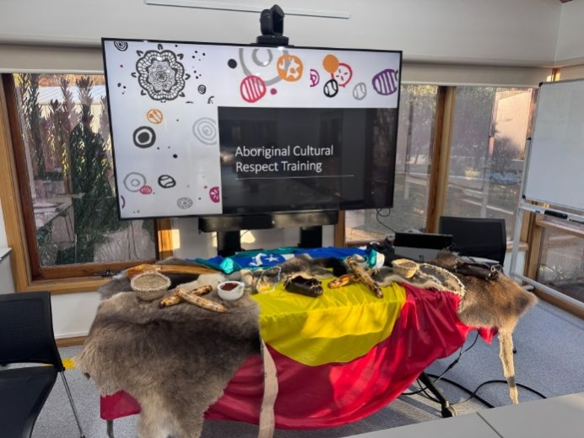
Aboriginal Cultural Respect Training set up.

A Yarn on Country - Keep the Fire Burning
Presented during NAIDOC Week 2024, A Yarn on Country – Keep the Fire Burning is a powerful video initiative featuring four Aboriginal employees from the TSS. Through personal storytelling, sharing their experiences, insights and aspirations the livestreamed event reached more than 1,000 viewers, with overwhelmingly positive feedback highlighting its impact on cultural awareness and driving meaningful workplace change. The video also supports the Aboriginal Cultural Respect training, as a complementary training resource, reinforcing key messages and deepening understanding across the workforce.

TSS Aboriginal Employee Network
The network includes105 Aboriginal members, who contribute to, and support the work under the TSS Aboriginal Employment Strategy. Members of the network meet four times a year in statewide workshops, including an end of year Gathering. The network plays a vital role in supporting Aboriginal employees and advising agencies on culturally informed employment practices.
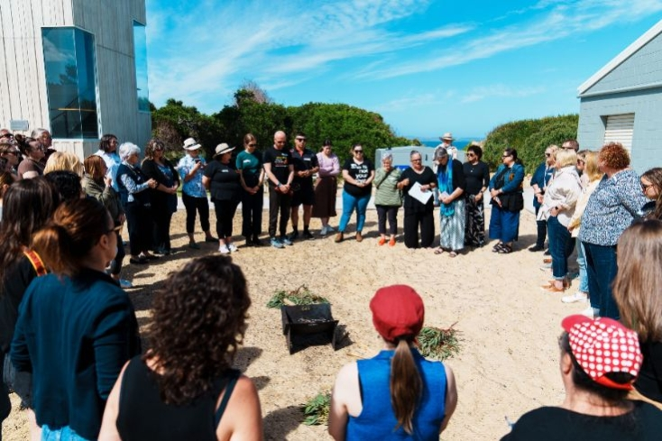
Aboriginal Employee Gathering.

TSS Aboriginal Employment e-newsletter
With 803 subscribers, the e-newsletter shared insights, updates and contributions from Aboriginal Employee Network members, helping to build awareness and connection across the TSS.

Youth employment
Supporting young Tasmanians to enter and thrive in the workforce remains a key priority for the State Service. Through targeted entry-level programs, the State Service is helping to build a diverse, future-ready workforce while contributing to broader social and economic outcomes for the State.
In addition to whole-of-service initiatives, many agencies offer dedicated graduate, cadet and trainee positions. Notably, the Departments for Education, Children and Young People, Treasury and Finance, Health, and Natural Resources and Environment Tasmania continue to lead in providing these opportunities.
As at June 2025, there were 5,431 employees under the age of 30 working in the State Service, an increase of 112 from the previous year, representing 14.2 per cent of the total workforce. Programs such as school-based traineeships, cadetships, and the TSS Graduate Development Program (TasGraD) are key to creating meaningful employment pathways for young people, including those in regional areas.
Looking ahead, we will continue working across agencies in 2025-26 to identify new opportunities and further strengthen youth employment pathways.

Graduate recruitment and development
The TasGraD continued to support early career pathways by employing recent university graduates in roles across various agencies. The program includes a 12-month structured learning program designed to build capability and deepen understanding of government through both formal and on-the-job development. Key topics of learning include design thinking, managing public finances, communicating with influence, writing for decision-makers, policy development, and navigating Cabinet processes and experience needed for a successful public sector career.
In 2024-25, seven agencies and one statutory authority participated in the program, employing 31 graduates. Since its inception in 2017, TasGraD and its associated talent pool have supported the recruitment of 294 graduates, the majority are young Tasmanians.
The TasGraD talent pool, managed by SSMO, remains open between recruitment rounds, allowing agencies to access graduate talent as workforce needs arise.

School-based Traineeship Program
The School-based Traineeship Program provides students in Years 11 and 12 with the opportunity to gain hands-on experience in the State Service while completing the Tasmanian Certificate of Education. Trainees work toward a nationally recognised qualification, helping them transition into the workforce with practical skills and confidence.
In 2024-25, 10 trainees were engaged through the program, bringing the total number of participants to 61 since the pilot began in 2018-19. By offering vocationally focused opportunities, the program contributes to improving Tasmania’s Year 12 retention rate and helps build a pipeline of skilled, work-ready young people.

Case Study: Youth Employment, Department of Natural Resources and Environment Tasmania (NRE Tas)
NRE Tas is committed to building a future-ready workforce by offering meaningful employment opportunities to young Tasmanians. Through various youth employment programs, the department equips students and graduates with practical skills, hands-on experience, and clear career pathways.
One key initiative is the School-based Trainee (SBT) Program, which enables year 11 and 12 students to gain work experience while completing their Tasmanian Certificate of Education. In 2024, four trainees successfully completed a nationally recognised Certificate II in Workplace Skills while working across different areas of the department.
Trainee highlights:
- Ava worked with the Threatened Species and Conservation Program, contributing to recovery efforts for the Orange-bellied Parrot.
- Charlotte supported tourism and visitor engagement with the Visitor Services team in Hobart.
- Luke, the department’s first IT trainee, helped roll out nearly 400 new hardware units with the Digital and Data Systems team.
- Jonty contributed to biosecurity monitoring at the Animal Health Laboratory and completed his Certificate II in 2024.
Beyond the SBT program, NRE Tas offers additional youth employment pathways:
- Cadetship Program: For undergraduate students at the University of Tasmania, allowing full-time work and part-time study across divisions. Currently, eight cadets are enrolled.
- Graduate Program: Open to recent graduates, this three-year rotational program includes TasGrad learning and development. There are 13 participants.
- Corporate Internships: In partnership with the University of Tasmania, this program offers 13-week placements each semester. In 2024-2025, 15 students participated.
These programs provide young people with valuable experience and skills, helping to shape a skilled, diverse, and high-performing public service workforce.

Jonty Tunks, Laboratory Officer Trainee at the Animal Health Laboratory, Mount Pleasant.

Equity in leadership
The TSS continues to make meaningful progress in advancing gender equity across its leadership cohort. In 2016, Heads of Agencies set a bold target to have women hold at least 40 per cent of senior executive positions by 2020. This milestone was not only met but surpassed ahead of schedule. As of 30 June 2025, women now occupy 52.7 per cent of senior executive roles, 136 out of 258 roles, demonstrating sustained progress and commitment.
Currently, nine of the 16 State Service agencies listed under Schedule 1 of the State Service Act 2000 are led by female Heads of Agency, reflecting the continuing impact of leadership efforts to promote gender diversity at the highest levels. These initiatives focus on identifying and removing barriers to women’s advancement, addressing unconscious bias and promoting flexible working arrangements that support inclusive leadership pathways.

Women Supporting Women in leadership
A key initiative advancing gender equity across the State Service is the Women Supporting Women in leadership program. Led by senior women leaders, the program provides opportunities for networking, skill development, shared learning and leadership growth.
In November 2023, the Women Supporting Women in Leadership Strategy 2024-2027 was launched, outlining five key impacts areas:
- building an inclusive culture
- acknowledging and respecting diversity and addressing bias
- promoting women’s wellbeing
- leadership development and support
- accountability for progress action.
Each year, an action plan identifies activities aligned with these priorities. Highlights during the 2024-25 reporting period include:
- A networking and information session with Tasmanian Lieutenant General Natasha Fox AO CSC, Chief of Personnel for the Australian Defence Force.
- ‘Speed Mentoring’ workshops connecting emerging leaders with experienced mentors.
- Continuation of the quarterly Women Supporting Women newsletter.
- The third Yarn on Country with Aboriginal Women from the Aboriginal Employee Network.
- Planning for the biennial Women Supporting Women forum, scheduled for late 2025.

Our Watch – Workplace Equality and Respect Standards
The TSS continues to embed the Our Watch Workplace Equality and Respect Standards across agencies, reinforcing a culture of zero tolerance for violence, promoting respectful relationships, and advancing gender equality in workplace practices.
Throughout 2024-25, agencies progressed implementation of the Standards through targeted action plans. Key areas of focus included:
- promoting and educating staff on family violence resources and support services
- providing training and access to contact officer networks
- applying a gender lens to the review of relevant workplace policies and procedures to ensure fairness and equity.
Table 3: Key Workplace Equality Respect Standard initiatives
Agency/area | Initiative
Whole-of-service | - Initiated a review of key performance indicators to align with the revised Standards and gender equality targets under the Workplace Gender Equality Act 2012. This included a review of governance arrangements and whole-of-service actions.  - Department of Health updated the Family Violence e-learning training package for rollout across the TSS in 2025-26, enhancing understanding of family violence, recognising warning signs, responding safely and effectively, and referring individuals to appropriate support services.
Department for Education, Children and Young People | - Refreshed family violence training package for managers and principals; updated the Staff Wellbeing Hub family violence resources to include intersectionality, sexual harassment and sexual violence.
Department of Health | - Developed a new Professional Conduct Policy to guide the identification and management of inappropriate workplace behaviours, including grievances, harassment and sexual harassment.
Department of Justice | - Reviewed Workplace Behaviour Policy and rolled out Respectful Relationships training program.
Department of Police, Fire and Emergency Management | - Delivered coercive contact training for Tasmanian Police employees and interested Department of Police, Fire and Emergency Management TSS employees.  - Conducted face-to-face training on sexual harassment, discrimination and prohibited conduct in targeted areas.
Department of State Growth | - Led the TSS Walk for Elimination of Violence Against Women and Children; maintained accreditation as a Breastfeeding Friendly Workplace with the Australian Breastfeeding Association.

Key initiative
The Department of State Growth collaborated across the TSS to hold the Walk for the Elimination of Violence Against Women and Children on 29 November 2024. The walk is a display of our commitment to ending gender-based violence and a clear, visible message that violence against women and children is not tolerated in, or by, the State Service. All agencies provided members to a working group to organise the walk, who contributed diverse skills and experience. The walk saw hundreds of our employees show their support by walking through the centre of Hobart. It culminated on Parliament Lawns where speakers including advocates and victim survivors shared stories and calls to action. Walkers wore the colour orange, which is the United Nations colour representing a brighter future, free from violence for women and children.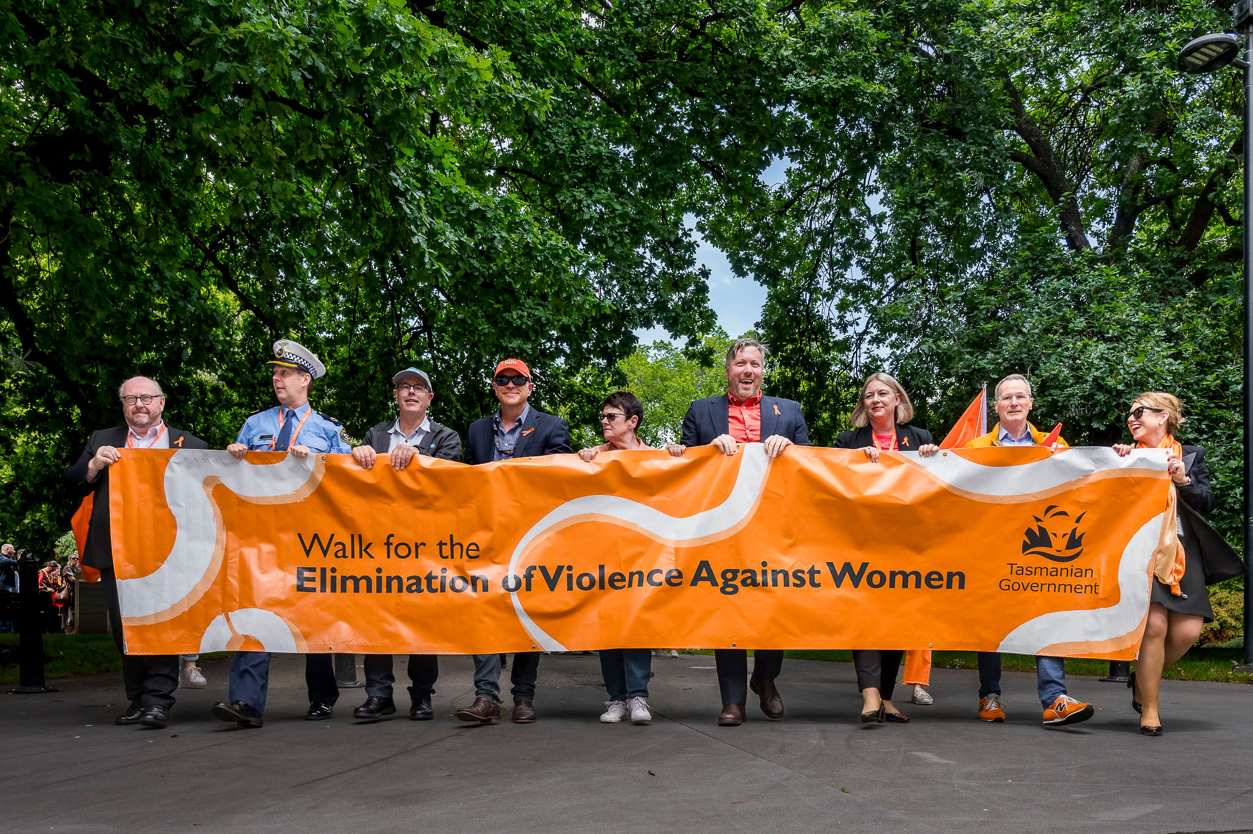
Tasmanian State Service – Walk for the Elimination of Violence Against Women

Workforce management and employment
Workforce management and employment plays a central role in shaping the employment landscape of the TSS. Operating under specific legislation, the function manages employment arrangements and terms and conditions on behalf of the Premier as the Employer. This includes the policy, development and oversight of workforce management and industrial relations policies, frameworks and agreements. Through high-quality policy, programs and governance arrangements, the function supports a sustainable employment and industrial framework that recognises and rewards capability.
Workforce management and employment collaborates with individual agencies on specific matters, assists with industrial disputes, and in planning, negotiating, and finalising non-wage agreements.

Workplace relations key reforms and initiatives
In 2024-25, the TSS advanced a series of significant workplace relations reforms, with a strong focus on improving disciplinary processes, enhancing transparency and supporting cultural change in response to the Commission of Inquiry. These reforms were underpinned by strengthened governance, new operational structures and enhanced engagement with unions and stakeholders.
A key development was the establishment of the Joint Consultative Committee (JCC), a new forum for strategic engagement between the Employer and all public sector unions. Meeting every eight weeks, the JCC is jointly chaired by the Deputy Secretary SSMO and the Secretary of the Community and Public Sector Union (CPSU) and provides a platform to discuss whole-of-service reforms and major workplace changes.
Further detail on the implementation of these reforms, including updates to Employment Direction No. 5, the establishment of the Shared Capability and Centralised Investigation Unit, and the routine disclosure of processes is outlined in the sections below.

Workplace relations, Awards and Agreements
SSMO continued to play a key role in supporting agencies across the TSS by providing authoritative and expert advice on workplace relations matters. This includes guidance on the interpretation and application of the State Service employment framework, encompassing the State Service Act and Regulations, Industrial Relations Act and Regulations, Employment Directions, and the suite of Practices, Procedures and Standards (PPS), as well as the management of State Service Awards and Agreements.
Throughout 2024-25, SSMO maintained its responsibility as the Employer’s representative in the Tasmanian Industrial Commission, overseeing the registration of new agreements, variations to awards, and other employment-related matters at a whole-of-service level. This ensured a consistent and collaborative approach to managing industrial relations across the TSS.
During the reporting period, two wage agreements were finalised and registered:
- The Tasmanian Visiting Medical Practitioners Agreement 2022
- The Rural Medical Practitioners (Tasmanian State Service) Agreement 2022.

Non-wage agreement matters
In addition to the wage agreements, several agency-specific non-wage agreements were also completed. These included the:
- Department of Police, Fire and Emergency Management (CPSU) Incident Management Operations and Planned Burns Agreement 2025
- Caseload Midwifery Industrial Agreement 2025
- Hard to Staff Schools Incentives Pilot Program Agreement 2024
- Child Safety and Youth Justice Incentives – Additional Child Safety Payment
- North West (NW) Settling-In Trial Payment Agreement 2024.

2025 bargaining round
This year also marked the commencement of the next major bargaining round, covering 16 agreements across the TSS and Tasmania Police that had expired or were due to expire in 2025. To support a consistent and coordinated approach, a single Lead Negotiator was appointed to oversee all wage negotiations. Formal negotiations commenced for many agreements where unions had submitted a log of claims, with the next scheduled salary increases anticipated in the first full pay period on or after 1 December 2025.
The Lead Negotiator remains committed to achieving fair and reasonable outcomes through good faith bargaining, ensuring timely and constructive resolutions that support both workforce needs and the delivery of high-quality public services.

Conduct and accountability
In 2024-25, the TSS continued to strengthen its approach to employee conduct and accountability, guided by the recommendations of the Commission of Inquiry. These recommendations informed a series of reforms aimed at improving consistency, transparency and timeliness of disciplinary processes across the State Service.

Employment Direction No. 5
A key development during the reporting period was the revision of Employment Direction No. 5: Procedures for the Investigation and Determination of Whether an Employee has Breached the Code of Conduct (ED5). The revised ED5, effective from 29 August 2024, introduced a more flexible approach and efficient framework for managing code of conduct matters across the State Service. Key changes included:
- prioritising child safety in all conduct-related processes
- enabling timely and efficient handling of serious allegations
- allowing Heads of Agencies to delegate and manage lower-level behaviours more effectively
- proving the option, in limited circumstances, to proceed without appointing an external investigator.
To support implementation, a ‘What’s Changed’ Guide was released to assist agencies in understanding and applying the update procedures.

Shared Capability and Centralised Investigation Unit
The Shared Capability and Centralised Investigation (SCCI) Unit, established within SSMO, continued to play a critical role in managing serious Code of Conduct matters. The unit’s initial focus remained on historical and current allegations of child sexual abuse and related conduct at the Ashley Youth Detention Centre (AYDC), many of which intersect with criminal, civil or coronial proceedings.
During the reporting period:
- The SCCI case managed 25 matters. Of the 25 matters, the SCCI investigated 13, with an external investigator appointed for the remaining 12.
- Barrister Ms Regina Weiss continued to assist in progressing and finalising complex historical cases and to provide strategic advice on improving investigative processes.
- The unit began refining a centralised model for future expansion to other child-facing agencies.
Beyond AYDC-related matters, the SCCI is working to enhance the overall capability and consistency of investigations across the TSS. This includes collaboration with the panel of investigators to promote trauma-informed practices, share insights and support ongoing professional development.

Routine Disclosure
To further strengthen transparency and public trust, the TSS expanded its Routine Disclosure framework during the reporting period. This initiative reflects the Tasmanian Government’s ongoing commitment to accountability and to protecting children and young people, particularly in response to the findings of the Commission of Inquiry.
The Head of the State Service continues to prioritise the public release of information relating to Code of Conduct investigations and outcomes, ensuring that disclosures are made to the community wherever lawfully and practically possible.
Since March 2021, the State Service has reported on the suspension of State Service employees due to allegations of child sexual abuse. In December 2023, this commitment was strengthened through the introduction of monthly updates detailing the actions taken by Heads of Agencies in relation to current and former employees referred to in the Commission of Inquiry report.
In August 2024, the scope of routine disclosures was further expanded to include data from the Joint Referral Review Team (JRRT), a multi-agency team reviewing matters of interest identified through the Commission. These disclosures will continue until all employment-related investigations have concluded.
Monthly disclosures now include:
- Actions taken by Heads of Agencies and Tasmania Police in relation to individuals named in the Commission of Inquiry report.
- Suspensions of State Service employees due to allegations of child sexual abuse (cumulative since October 2020).
- Data from the Joint Referral Review Team (JRRT) on matters of interest identified through the Commission of Inquiry.

Code of Conduct
Under Section 9 of the State Service Act 2000, all employees, officers and Heads of Agencies are bound by the Code of Conduct. Alleged breaches of the Code of Conduct are investigated in accordance with ED5 by Heads of Agencies for employees and officers. Allegation of breaches of the Code of Conduct by Heads of Agencies are investigated in accordance with processes regulated by the Premier.
In 2024-25, a total of 245 alleged breaches of the Code of Conduct were under investigation, including matters carried forward from 2023-24. Of the 94 matters finalised in the reporting period:
- A breach was determined in 70 matters, resulting in sanctions ranging from counselling and formal reprimands to termination of employment.
- The remaining matters were either resolved with no breach found, finalised through alternative means (other than a sanction), or carried forward into the 2025-26 reporting period.

Register of termination-related breaches
To support due diligence in recruitment, agencies continued to access the Practices, Procedures and Standards No.5 (PPS No.5) Register. This register records instances where an individual was terminated from the State Service or would have been terminated had they not ceased employment before such determination. During the reporting period, PPS No.5 was reviewed, and a new system was developed to host the register data, with implementation planned for 2025-26.

Suspension of employees
In accordance with Employment Direction No. 4: Procedure for the Suspension of State Service Employees With or Without Pay, which governs the suspension of employees with or without pay. A total of 176 employees were suspended during the 2024-25 reporting period, which increased by two from the previous reporting period. This figure includes matters carried forward from the previous reporting period and reflects the State Service’s commitment to upholding public trust while investigations are underway.

Inability
Employment Direction No. 6 outlines the procedures for investigating and determining whether an employee is able to efficiently and effectively perform their duties. This process ensures agencies have a clear and fair framework for managing situations where an employee’s capacity to meet role requirements may be in question.
In the 2024-25 reporting period, a total of 20 matters were under investigation for the alleged inability of an employee, including matters carried forward from 2023-24. Of the nine matters finalised during the period:
- In three matters it was determined that the employee was unable to efficiently and effectively perform their duties, and six were finalised through alternative means (other than a sanction).
- 11 matters were carried forward into the 2025-26 reporting period.

Managing performance
Performance management systems across the TSS provide a structured framework for regular, constructive discussions between employees and their managers. These conversations are designed to align individual performance and development with the strategic and operational objectives of each agency, while also supporting continuous improvement and accountability.
During the 2024-25 reporting period, agencies reported that 15,039 employees participated in a performance management process. This represents 41.6 per cent of the State Service workforce and reflects an increase from 14,799 employees in
2023-24. It is important to note that not all agencies currently capture or report on formal performance processes, which may affect the completeness of this figure.
Where additional support is required, agencies may implement Performance Improvement Plans (PiPs). These plans provide targeted assistance to employees through measures such as additional training, enhanced supervision, role clarification or skills assessments.
In 2024-25, a total of 18 PIPs were in place, an increase of eight compared to the previous year. Of these, 14 were successfully completed during the reporting period, demonstrating the effectiveness of structured support in helping employees meet performance expectations.

Terminations
Under Section 44(3) of the State Service Act 2000, employment within the TSS may be terminated on a range of grounds, including breaches of the Code of Conduct, inability to perform duties, or other employment-related matters.
During the 2024-25 reporting period, a total of 29 sanctions of termination of employment were imposed. These outcomes reflect the State Service’s commitment to upholding high standards of conduct and performance and ensuring that appropriate action is taken where serious breaches or incapacity are identified.

Table 4: Employee terminations
Reason for termination | Total
Termination of a probationary employee | 4
Abandonment of employment | 2
Breach of the code of conduct | 20
Inability | 3
Termination following ED26 process | 0
TOTAL | 29

Grievances

Internal grievances
Employees across the TSS have access to established grievance management processes within their agencies. These processes are designed to ensure that workplace concerns are addressed in a fair, transparent and timely manner, supporting a respectful and inclusive work environment.
During the 2024-25 reporting period, a total of 178 formal grievances were lodged across 13 agencies. This represents an increase from 157 grievances reported across nine agencies in 2023-24, indicating broader engagement with formal grievance processes. Of the grievances lodged in 2024-25, 17 were not upheld.
The outcomes of these grievances are summarised in the table below, providing a comparison with the previous reporting period.
Table 5: Grievance outcomes
Outcome of formal grievance | 2023-24 | 2024-25
Satisfactorily resolved by agreement | 43 | 42
Withdrawn/dismissed | 28 | 25
Upheld | 20 | 27
Carried forward | 66 | 67
TOTAL | 157 | 161

External grievances
In addition to internal grievance mechanisms, employees may seek external review of workplace matters through independent bodies such as Equal Opportunity Tasmania, the Tasmanian Industrial Commission, and other relevant tribunals.
During the 2024-25 reporting period, a total of 48 grievances were taken to external organisations for review or resolution. This represents a decrease from 61 grievances reported in 2023-24. The grievances raised externally related to a range of workplace concerns, including:
- Management decisions (29)
- Discrimination (4)
- Process matters (4)
- Bullying and/or harassment (4)
- Inappropriate employee behaviour (4).
Monitoring external grievance trends helps inform agency practices and supports continuous improvement in grievance management and workplace culture across the State Service.
The outcomes of these external grievances are summarised in the table below, providing a comparison with the previous reporting period.
Table 6: Grievances taken to external organisations
External organisation | 2023-24 | 2024-25
Equal Opportunity Tasmania | 7 | 1
Ombudsman | 1 | 0
Tasmanian Industrial Commission | 44 | 39
Other organisational or industrial tribunals | 9 | 8
TOTAL | 61 | 48

Employment determinations

Determinations by the State Service Management Office
TSS agencies are required to refer certain employment matters to SSMO for determination, in accordance with the powers of the Employer under the State Service Act 2000. These referrals are made in line with the relevant Employment Directions and the Practice, Procedures and Standards.
The table below outlines the status of requests for determination during the 2024-25 reporting period. It includes matters carried forward from 2023-24, new requests submitted during the year, and those still under consideration after 30 June 2025.
It is important to note that very few requests are rejected. This is largely due to agencies proactively seeking advice from SSMO before submitting formal referrals, ensuring that proposals align with policy and legislative requirements from the outsets.
Table 7: Employment determinations by the State Service Management Office
Request type | Carried over | New | Rejected or with-drawn | Approved | Carried forward
Agency-specific recruitment programs (PPS2) | 0 | 0 | 0 | 0 | 0
Pre-employment checks (ED7) | 0 | 13 | 0 | 13 | 0
Essential Requirements (ED1, 10, and 18 and Offices under s29 of the State Service Act 2000) | 0 | 31 | 0 | 30 | 1
Extension of fixed-term beyond 36 months (ED1) | 0 | 13 | 0 | 13 | 0
Fixed-term and casual employment registers (PPS1) | 0 | 12 | 0 | 12 | 0
Appointment without advertising (ED1) | 0 | 0 | 0 | 0 | 0
Promotion without advertising (ED1) | 0 | 79 | 0 | 79 | 0
Secondments into the State Service (ED1) | 0 | 7 | 0 | 7 | 0
Secondments out of the State Service (ED1) | 0 | 8 | 0 | 8 | 0
TOTAL | 0 | 163 | 0 | 162 | 1

Determinations by Heads of Agencies
In July 2024, Employment Direction No 1 – Employment in the State Service (ED1) was reissued with updated provisions to support greater employment stability and flexibility across the TSS. The revised direction introduced a pathway for fixed-term and fixed-term casual employees to transition to permanent employment after 12 months of continuous service, subject to eligibility criteria. It also enabled part-time employees to apply for a permanent increase in hours where additional hours had been worked regularly over a 12-month period.
Under section 37(4) of the State Service Act 2000, the Employer has delegated the authority to Heads of Agencies to approve changes in employment status where criteria in ED1 are met. In cases where an employee does not meet the standard criteria, but special and exceptional circumstances exist, such as critical workforce needs or training pathways, Heads of Agencies may request approval from the Employer or their delegate.
These determinations reflect the State Service’s commitment to providing secure and sustainable employment arrangements, while also supporting workforce flexibility and responsiveness.
Requests under the revised provisions are reflected in the table below.
Table 8: Change of employment status and increase in hours approvals by Heads of Agencies
Request type | Approved
Change of employment status by a Head of Agency from fixed-term to permanent relating to a training pathway, transmission of business or critical risk (Clause 12A of ED 1) | 1,022
Change of employment status from fixed-term to permanent where an employee has completed 12 months continuous service and other set criteria are satisfied (Clause 12B of ED 1) | 70
Change of employment status for eligible fixed-term teachers (ED9) | 79
Permanent part-time employees who had hours increased (Clause 13 of ED1) | 694
TOTAL | 1,865

Our workforce metrics
Table 9: Paid Full-time Equivalent by Agency
Agency | 30 June 2024 | 30 June 2025 | Variance (%)
Department for Education, Children and Young People | 9,870.34 | 10,161.14 | +2.9%
Department of Health | 12,276.28 | 12,835.57 | +4.6%
Department of Justice | 1,647.84 | 1,740.26 | +5.6%
Department of Police, Fire and Emergency Management | 1,145.00 | 1,217.17 | +6.3%
Department of Premier and Cabinet | 579.20 | 557.70 | -3.7%
Department of Natural Resources and Environment Tasmania | 1,397.92 | 1,372.84 | -1.8%
Department of State Growth | 881.30 | 943.77 | +7.1%
Department of Treasury and Finance | 322.61 | 327.49 | +1.5%
Tasmanian Audit Office | 58.32 | 53.19 | -8.8%
Brand Tasmania | 5.80 | 7.00 | +20.7%
Environment Protection Authority | 113.68 | 116.50 | +2.5%
Homes Tasmania | 178.52 | 178.93 | +0.2%
Integrity Commission of Tasmania | 18.90 | 14.90 | -21.2%
Macquarie Point Development Corporation | 15.72 | 15.72 | 0%
Port Arthur Historic Management Authority | 102.81 | 104.35 | +1.5%
Public Trustee | 74.74 | 73.74 | -1.3%
Tourism Tasmania | 71.03 | 68.82 | -3.1%

Table 10: Paid Full Time Equivalent and Paid Headcount - Fixed-Term Casual
Fixed-Term - Casual | 30 June 2024 | 30 June 2025 | Variance (%)
Paid Full Time Equivalent | 1,255.61 | 1,234.26 | -1.70%
Paid Headcount | 2,781 | 3,033 | +9.1%

Table 11: Paid Headcount by Agency
Agency | 30 June 2024 | 30 June 2025 | Variance (%)
Department for Education, Children and Young People | 12,608 | 13,039 | +3.4%
Department of Health | 15.149 | 15,736 | +3.9%
Department of Justice | 1,770 | 1,841 | +4.0%
Department of Police, Fire and Emergency Management | 1,204 | 1,282 | +6.5%
Department of Premier and Cabinet | 651 | 624 | -4.1%
Department of Natural Resources and Environment Tasmania | 1,541 | 1,502 | -2.6%
Department of State Growth | 1,027 | 1,097 | +6.8%
Department of Treasury and Finance | 348 | 350 | +0.6%
Tasmanian Audit Office | 61 | 57 | -6.6%
Brand Tasmania | 6 | 7 | +16. 7%
Environment Protection Authority | 124 | 127 | +2.4%
Integrity Commission of Tasmania | 21 | 17 | -19.0%
Macquarie Point Development Corporation | 16 | 16 | 0%
Port Arthur Historic Management Authority | 132 | 127 | -3.8%
Homes Tasmania | 186 | 190 | +2.1%
Public Trustee | 79 | 78 | -1.3%
Tourism Tasmania | 78 | 78 | 0%

Table 12: Employment type and gender
Employment Type | Female  % TSS | Male  %TSS | Other  %TSS
Permanent | 60.0% | 22.9% | 0.1%
Fixed-term | 11.3% | 4.9% | 0.1%
Officers | 0.4% | 0.3% | 0.0%
TOTAL | 71.7% | 28.1% | 0.2%

Table 13: Employment by region
Region | % TSS
North | 23.9%
North-West | 16.5%
South | 53.9%
South-East | 5.2%
West Coast | 0.5%

Table 14: Age group
Age Group | % TSS
19 and under | 0.4%
20 to 29 years | 13.7%
30 to 39 years | 26.3%
40 to 49 years | 24.2%
50 to 59 years | 23.4%
60 to 69 years | 11.1%
70 years and over | 0.9%

Table 15: Separations by age
Age Group | % TSS
19 and under | 0.2%
20 to 29 years | 13.5%
30 to 29 years | 20.5%
40 to 49 years | 14.6%
50 to 59 years | 16.6%
60 to 69 years | 32.2%
70 years and over | 2.4%

Table 16: Commencements by age
Age Group | % TSS
19 and under | 0.6%
20 to 29 years | 30.0%
30 to 29 years | 36.3%
40 to 49 years | 18.9%
50 to 59 years | 11.9%
60 to 69 years | 2.2%
70 years and over | 0.1%

Table 17: Senior Executive Officers by category and gender
Category | Female | Male | Other | Total
Heads of Agencies | 9 | 7 | 0 | 16
Senior Executive Service | 115 | 99 | 0 | 214
Equivalent Specialists | 11 | 14 | 0 | 25
Prescribed Office Holders | 2 | 2 | 0 | 4
TOTAL | 136 | 122 | 0 | 259

Information sources used in this report

Workforce profile data
The data presented in the workforce profile section is sourced from TTS agencies through fortnightly reporting and also collected via the Workforce Information Reporting System (WiRS). WiRS is a standardised employee reporting system that ensures consistency in reporting across the service through validation against defined business rules and translation tables. It includes employees engaged under the State Service Act 2000 and within agencies listed in Schedule 1 of that Act.
Data is uploaded to WiRS quarterly and undergoes manual review as part of an ongoing quality assurance process. This may involve correcting coding errors that affect historical paid headcount of full-time equivalent figures. As a result, historical data in this report may differ from figures published in previous TSS and agency annual reports.

Other data
This report also includes information sourced from a variety of materials, including internal briefing material, custom reports and the Annual Agency Survey. The Annual Agency Survey is completed by all TSS agencies and submitted to SSMO. It collects a broad range of information on employment policies, workforce programs, management practices and workforce statistics. This information supports reporting on the functions and powers of the Employer, as required under the TSS Employment Framework.

Gender reporting
Since June 2018, TSS Human Resources Information Systems have enabled the recording of a third gender option (Other). From June 2021, some agencies also introduced the option for employees to not disclose their gender (Undisclosed). To protect the privacy of the small number of employees who do not identify as male or female, or who choose not to disclose their gender, data relating to these individuals is included only in overall totals. It is not disaggregated by agency, age group or employment status/category.

Relevant definitions
Paid headcount is an indicative number of employees and officers (excluding casuals) employed and paid as at the reporting date, including employees on paid leave. It excludes employees who were not paid as at the reporting date, such as people on Leave Without Pay or on secondment out of the State Service. As this data is based on payroll, as opposed to establishment, headcount numbers reported here will differ to those reported by agencies.
Paid Full-time Equivalent is the full-time equivalent value of employees and officers (excluding casuals) who are employed and paid as at the reporting date (for example two employees each working in a part-time role of 0.5 full-time equivalent combine to equal 1.00 full-time equivalent).
An Officer is anyone appointed under Part 6 of the Act and includes Heads of Agencies, Prescribed Office Holders, Senior Executive Service, and Equivalent Specialists.

For more information
For further details regarding the information presented in the workforce profile section, please contact the State Service Management Office via email at ssmo@dpac.tas.gov.au
This report, along with previous Tasmania State Service Annual Reports, is available on the Department of Premier and Cabinet – Annual Reports page.

Senior Executive Service includes Heads of Agencies, Senior Executive Service, Equivalent Specialists and Prescribed Office Holders.
Department of Police, Fire and Emergency Management data does not include Sworn Police Officers
Fixed-Term Casual figures reported separately, due to significant fluctuations
Separation figures include permanent employees only
Commencement figures include permanent employees only

